Ministry of Education and Science of Ukraine

Nizhyn Mykola Gogol State University

Educational and Scientific Institute of Natural and Mathematical Sciences, Medical and Biological Sciences and Information Technologies

Department of Information Technologies, Physical and Mathematical and Economic Sciences

Educational program: Computer science

Specialty: 122 Computer science

QUALIFICATION WORK

to obtain a master's degree

**THE BUBNOV–GALERKIN METHOD FOR THE SIMULATION OF THE HEAT TRANSFER PROCESS**

By the magister student REN CHAO

Supervisor:

Lysenko Iryna Mykolaivna,

Candidate of Physical and Mathematical Sciences, Associate Professor

Reviewers:

Chernyshova E. O,

Candidate of Technical Sciences

Kompan S. V.

Candidate of Physical and Mathematical Sciences, Associate Professor

State University of Information and Communication Technologies

Admitted to the defense: : 2024

Head of the department

Prof. Kazachkov I.V.

Nizhyn − 2024

**Abstract:** The simulation of heat transfer processes is a critical aspect of engineering and scientific research, where accurate predictions are essential for the design and optimization of thermal systems. This paper presents a detailed investigation into the application of the Bubnov-Galerkin method, a powerful numerical technique for solving heat transfer problems. The study is structured to provide a comprehensive understanding of the heat transfer process, the mathematical modeling involved, and the implementation of the Bubnov-Galerkin method both theoretically and through software. The Introduction chapter sets the stage by outlining the significance of heat transfer in various engineering applications and the challenges associated with its accurate simulation. It highlights the need for robust numerical methods capable of handling the complexities of heat transfer processes, leading to the focus on the Bubnov-Galerkin method as a solution. Chapter 1, "Modeling the Heat Transfer Process," delves into the mathematical foundations of heat transfer. Section 1.1 discusses the mathematical modeling of heat transfer, detailing the derivation of governing equations. Section 1.2 explores heat transfer mechanisms, including conduction, convection, and radiation. Section 1.3 focuses on linear heat transfer problems, while Section 1.4 presents the statement of boundary value problems, which are essential for applying the Bubnov-Galerkin method. Chapter 2, "Bubnov-Galerkin Method for Solving the Heat Transfer Problem," provides an in-depth explanation of the Bubnov-Galerkin method. It discusses the theoretical basis of the method, the formulation of the weak form of the heat transfer equations, and the construction of trial and test functions. This chapter also addresses the advantages of the Bubnov-Galerkin method in terms of accuracy and efficiency compared to other numerical methods. Chapter 3, "Software Implementation of the Bubnov-Galerkin Method," shifts the focus to the practical application of the method through software. This chapter discusses the development of software that can effectively utilize the Bubnov-Galerkin method for heat transfer simulations. It presents the challenges and considerations in software development, as well as the performance results of the software in solving various heat transfer problems, demonstrating the method's effectiveness and accuracy. The Conclusions chapter summarizes the findings of the research, emphasizing the capabilities of the Bubnov-Galerkin method in accurately simulating heat transfer processes. It also suggests potential areas for further research and development to enhance the method's applicability and efficiency. The References provides a comprehensive bibliography of the works cited in the paper, offering a resource for readers interested in further exploration of the topic. This paper contributes to the field by demonstrating the Bubnov-Galerkin method's effectiveness in simulating heat transfer processes, providing both theoretical insights and practical software implementation. The research findings are expected to benefit engineers and researchers in the field of thermal engineering and related disciplines.

**Keywords:** Bubnov-Galerkin Method, Heat Transfer Simulation, Numerical Analysis

**Content**

Introduction 5

CHAPTER 1 8

MODELING THE HEAT TRANSFER PROCESS 8

1.1. Mathematical modeling 8

1.2. Heat transfer mechanisms 11

1.3 Fundamental Equations of Heat Transfer 14

CHAPTER 2 16

BUBNOV-GALERKIN METHOD FOR SOLVING THE HEAT TRANSFER PROBLEM 16

2.1 Overview of Numerical Methods in Heat Transfer 16

2.2 Historical Development and Theoretical Foundations 18

2.3 Formulation of the Bubnov-Galerkin Method 19

2.4 Construction of Test Functions 22

2.5 Assembly of the Global System of Equations 24

2.6 Application to Heat Transfer Problems 26

2.6.1 Case Studies: One-Dimensional Problems 26

2.6.2 Case Studies: Two-Dimensional and Three-Dimensional Problems 28

CHAPTER 3 30

SOFTWARE IMPLEMENTATION OF THE BUBNOV-GALERKIN METHOD 30

3.1 Problem statement and method algorithm 30

3.2 Construction of the function *u0(x,t)* 36

3.3 Modeling the heat transfer problem by the Bubnov-Galerkin method using the MathCAD 38

3.3.1 Метод Фур’є 39

3.3.2 Galerkin's method 41

CONCLUSIONS 49

REFERENCES 50

# Introduction

Heat transfer is a fundamental process in engineering and physics, playing a pivotal role in a wide array of applications, from the design of electronic components to the operation of power plants and the regulation of indoor environmental conditions. The ability to accurately simulate heat transfer is essential for optimizing system performance, ensuring safety, and predicting the behavior of thermal systems under various conditions. As technology advances, the complexity of these systems increases, necessitating the development of sophisticated numerical methods to model and analyze heat transfer phenomena effectively. The simulation of heat transfer processes involves using mathematical models to predict how heat energy is transferred within and between systems. These models are based on the principles of thermodynamics and the laws of heat conduction, convection, and radiation. Accurate simulation allows engineers to understand the thermal behavior of components and systems under different operating conditions, which is crucial for their design, analysis, and optimization. It enables the prediction of temperature distributions, heat fluxes, and thermal stresses, which are vital for assessing the performance and reliability of thermal systems.

In the automotive industry, heat transfer simulation is used to design efficient cooling systems for engines and manage the thermal loads in electric vehicle batteries. In aerospace, it is critical for the thermal management of spacecraft and the design of thermal protection systems for re-entry vehicles. In the electronics sector, heat transfer simulation is indispensable for the thermal management of microprocessors and other high-power electronic devices, ensuring their reliable operation and longevity. Despite heat transfer simulation's importance, real-world problems' complexity often defies analytical solutions. Traditional methods, such as finite difference or finite volume methods, while effective in many cases, can become computationally expensive and less efficient when dealing with problems involving complex geometries, variable material properties, or multiphysics coupling. This is where the Bubnov-Galerkin method comes into play, offering a versatile and powerful numerical technique for solving heat transfer problems. The Bubnov-Galerkin method is a variational method that transforms the original partial differential equations into a system of algebraic equations by using a weighted residual approach. This method is particularly well-suited for problems with complex boundary conditions and variable coefficients, as it can provide a high degree of accuracy with relatively fewer computational resources. Moreover, the method's flexibility allows for the incorporation of various element types and shapes, making it adaptable to a wide range of geometries and applications. In this paper, we aim to provide a comprehensive study of the Bubnov-Galerkin method, exploring its theoretical foundations, application to heat transfer problems, and software implementation.

The goal of this master’s thesis is to model the heat transfer process using the Bubnov-Galerkin method.

Research objectives:

1. Examine the concept of mathematical modeling, provide a characterization of the main heat transfer mechanisms, and formulate a linear problem of heat propagation.
2. Describe the Bubnov-Galerkin method for solving heat transfer problems.
3. Implement a software solution for the Bubnov-Galerkin method to model the heat transfer problem.

This paper demonstrates the Bubnov-Galerkin method's effectiveness in simulating heat transfer processes, providing theoretical insights and practical software implementation. The research findings are expected to benefit engineers and researchers in the field of thermal engineering and related disciplines.

# CHAPTER 1

# MODELING THE HEAT TRANSFER PROCESS

## 1.1. Mathematical modeling

A model is a material or conceptual object that, in the process of study or investigation, replaces the original object while preserving certain typical features essential for the given research. The process of constructing and using a model is called modeling. A model is created to reflect only part of the properties of the studied object and is therefore usually simpler than the original. Most importantly, a model is more convenient and accessible for research than the object being modeled [1].

Among various models, physical and mathematical models can be distinguished as primary ones. Let us focus more specifically on mathematical models. Mathematical models are the most characteristic ideal (conceptual) models in natural science research.

In mathematical modeling, the study of the properties and characteristics of the original object is replaced by the study of its mathematical models. Mathematical models are analyzed using mathematical tools (applied mathematics). The modern stage of mathematical modeling is characterized by the extensive use of computers and computational mathematics methods.

Thus, mathematical modeling is a means of studying a real object, process, or system by replacing them with a mathematical model (the most abstract of known models).

When constructing a mathematical model, the task arises to identify and exclude factors that have an insignificant impact on the final result (a mathematical model usually includes far fewer factors than those present in reality). Based on experimental data, hypotheses are proposed regarding the relationship between the variables representing the final result and the factors incorporated into the mathematical model.

Let us consider the various classifications of mathematical models [1, 2]. Based on their construction principles, mathematical models are divided into:

* Analytical – processes are expressed as explicit dependencies.
* Simulation models.

Analytical models are further classified by the type of mathematical problem:

* Equations (algebraic, transcendental, differential, integral),
* Approximation problems (interpolation, extrapolation, numerical integration, and differentiation),
* Optimization problems,
* Stochastic problems.

Mathematical models can be:

* Deterministic,
* Stochastic.

Deterministic models are typically described using algebra (random factors do not influence them). Stochastic models reflect the random nature of phenomena and employ the tools of probability theory.

Based on the type of input information, models are categorized as:

* Continuous,
* Discrete.

Based on their behavior over time, they are classified as:

* Static,
* Dynamic.

Depending on the degree of correspondence between the mathematical model and the real object, process, or system, mathematical models are divided into:

* Isomorphic – identical in form,
* Homomorphic – different in form.

To construct a mathematical model, it is necessary to:

1. Carefully analyze the real object or process.
2. Identify its most significant features and properties.
3. Determine the variables, i.e., the parameters whose values influence the main features and properties of the object.
4. Describe the dependence of the object's, process's, or system's main properties on the values of the variables using logical-mathematical relationships (equations, equalities, inequalities, logical-mathematical constructs).
5. Identify the internal connections of the object, process, or system through constraints, equations, equalities, inequalities, and logical-mathematical constructs.
6. Determine the external connections and describe them using constraints, equations, inequalities, and logical-mathematical constructs.

The modeling process can be broadly categorized into four main activities [1]:

* building,
* studying,
* testing,
* using the model.

While it may seem ideal for modeling projects to progress sequentially from building to use, this is rarely the case in practice. Typically, defects identified during the studying and testing phases require revisiting the building phase for corrections. It’s important to note that any modifications to the model necessitate repeating the studying and testing phases. A visual representation illustrates the possible pathways through these stages of modeling:

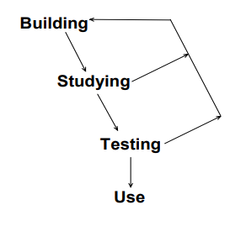

Fig. 1 – Stages of modeling

## 1.2. Heat transfer mechanisms

If a temperature difference arises anywhere in space, energy transfers from the region of higher temperature to the region of lower temperature. According to thermodynamic concepts, the energy transferred due to the temperature difference is called heat. Heat transfer refers to the process of transferring heat from a hotter ("hot") medium to a cooler ("cold") medium through a separating wall. Heat transfer is a complex thermal exchange consisting of a chain of distinct processes.

Heat is transferred from the hot medium to the wall via convective heat exchange. Within the wall, heat is transferred through conduction. From the wall to the cold medium, heat is again transferred through convective heat exchange. It should be noted that radiant heat exchange may also occur simultaneously with convective heat exchange. The intensity of heat transfer in each specific type of thermal exchange is determined using corresponding formulas.

Although thermodynamic laws pertain to energy transfer, they apply only to systems in equilibrium. As a result, these laws can calculate the amount of energy required for a system to transition from one equilibrium state to another but cannot determine how long this transition will take. Heat transfer theory complements the first and second laws of classical thermodynamics by providing methods to determine the rates of energy transfer.

To better illustrate the distinction between the types of information obtained through thermodynamics and heat transfer, let us consider the heating of a steel rod in hot water. Thermodynamic laws allow us to calculate the final temperature once the two systems reach equilibrium, as well as the amount of energy transferred during the transition from the initial equilibrium state to the final one. However, these laws do not enable us to determine the rate of heat transfer, the rod's temperature after a specific period of time, or how long it will take for the rod to reach a given temperature.

In contrast, heat transfer theory allows us to compute the rate of heat transfer from the water to the steel rod and, based on this information, determine how the temperatures of the rod and the water change over time.

There are three distinct mechanisms of heat transfer [3]: conduction, convection, and radiation.

The transfer of energy from hotter parts of a body to cooler parts due to thermal motion and particle interaction is called thermal conduction.

Heat convection is the process of heat transfer during the movement of macroscopic volumes of liquid or gas (fluid) in space from a zone with one temperature to a zone with a different temperature. In this case, heat transfer by convection is inextricably linked with the transfer of the medium itself (liquid or gas). Convection is possible only in a fluid medium. Heat convection is always accompanied by thermal conductivity. The joint process of heat transfer by convection and thermal conductivity is called convective heat transfer.

Thermal radiation is the process of heat transfer by electromagnetic waves, determined only by the temperature and optical properties of the radiating body. In this case, the internal energy of the body (environment) is converted into radiation energy. The process of converting the internal energy of a substance into radiation energy, transferring radiation and absorbing it by a substance is called heat transfer by radiation.

To properly design and analyze the operation of heat exchangers and energy converters, it is essential to understand the characteristics of all three heat transfer mechanisms and their interactions.

## 1.3 Fundamental Equations of Heat Transfer

The mathematical modeling of heat transfer processes is a critical step in understanding and predicting the thermal behavior of systems. It involves the use of fundamental equations that describe how heat energy is generated, transferred, and dissipated within a given system. These equations are derived from the principles of conservation of energy and the laws of thermodynamics and they form the basis for all heat transfer simulations and analyses. The most fundamental equation in heat transfer is the heat conduction equation, also known as Fourier's law of heat conduction [4]. It states that the rate of heat transfer through a material is proportional to the negative gradient of the temperature and the area at right angles to that gradient. Mathematically, it is expressed as

$q=-k∇T$.

where $q$ is the heat flux, $k$ is the thermal conductivity of the material, and $∇T$ is thetemperature gradient.

For one-dimensional steady-state conduction, Fourier's law simplifies to

$q=-k\frac{dT}{dx}$.

where $x$ is the spatial coordinate in the direction of heat flow.

The general form of the heat conduction equation, considering transient (time-dependent) and multi-dimensional heat transfer, is given by:

$pc_{p}\frac{∂T}{∂t}=∇∙\left(k∇T\right)+Q$.

Here, $p$ is the density of the material, $c$ is the specific heat capacity at constant pressure, $T$ is thetemperature, $t$ is time, and $Q$ is the heat generated per unit volume within the material.

The mathematical modeling of heat transfer processes also involves the application of boundary conditions, which define the problem's constraints. These can be Dirichlet conditions (specifying temperature), Neumann conditions (specifying heat flux), or Robin conditions (a combination of both). The choice of boundary conditions is crucial as it directly affects the solution's uniqueness and physical relevance.

# CHAPTER 2

# BUBNOV-GALERKIN METHOD FOR SOLVING THE HEAT TRANSFER PROBLEM

## 2.1 Overview of Numerical Methods in Heat Transfer

Numerical methods have become indispensable tools in the field of heat transfer, enabling engineers and scientists to solve complex problems that are beyond the reach of analytical solutions [5]. These methods are particularly crucial in scenarios where geometrical complexity, material heterogeneity, and multiphysics interactions are involved, which are common in modern engineering applications. The primary goal of numerical methods in heat transfer is to approximate the solutions to the governing partial differential equations (PDEs) that describe the thermal behavior of systems.

The finite difference method (FDM) is one of the earliest and most straightforward numerical techniques used for heat transfer problems. It involves discretizing the domain into a grid of points and approximating the derivatives in the governing equations using finite differences. While FDM is easy to implement, it can be computationally intensive for three-dimensional problems and may struggle with complex geometries.

The finite element method (FEM) is another widely used technique that offers more flexibility in handling complex geometries and varying material properties. FEM discretizes the domain into smaller elements, within which the solution is approximated using interpolation functions. The method transforms the continuous PDEs into a system of algebraic equations that can be solved numerically. FEM's adaptability makes it a popular choice for heat transfer simulations, especially in structural and thermal analysis software.

The finite volume method (FVM) is closely related to FEM and is particularly popular in fluid dynamics and heat transfer applications. FVM conserves quantities such as mass, momentum, and energy within control volumes, leading to a more robust solution, especially in cases involving discontinuities or sharp gradients.

Boundary element method (BEM) is a numerical method that reduces the dimensionality of the problem by discretizing only the boundaries, making it efficient for problems with infinite or semi-infinite domains. However, its application is limited to problems where the solution inside the domain can be expressed in terms of boundary values.

Monte Carlo Method is probabilistic technique is commonly applied to complex radiative heat transfer problems, particularly those involving irregular surfaces or scattering within a medium. The method approximates radiative heat transfer by simulating random photon trajectories.

Computational Fluid Dynamics (CFD): CFD combines various numerical methods (often FVM or FEM) to solve heat transfer problems involving fluid flow.

Spectral methods, such as the Galerkin method, use a set of basis functions to approximate the solution over the entire domain. These methods can achieve high accuracy with a relatively small number of basis functions, especially for smooth solutions. The Bubnov-Galerkin method, a variation of the Galerkin method, is particularly effective for solving heat transfer problems due to its ability to handle complex boundary conditions and its inherent stability. Each of these methods has its strengths and limitations, and the choice of method often depends on the specific problem at hand, including factors such as geometry, boundary conditions, and desired accuracy. In this paper, we focus on the Bubnov-Galerkin method, exploring its theoretical underpinnings, application to heat transfer problems, and software implementation. By understanding the capabilities and nuances of this method, we aim to contribute to the advancement of heat transfer simulation techniques and enhance the predictive capabilities of thermal system design and analysis.

## 2.2 Historical Development and Theoretical Foundations

The Bubnov-Galerkin method, a pivotal numerical technique in the field of heat transfer and structural mechanics, has its roots in the early 20th century with the pioneering work of Ivan Bubnov and Boris Galerkin. This method is a variational approach used to find approximate solutions to differential equations, particularly those arising in boundary value problems. The Bubnov-Galerkin method is based on the principle of minimizing the residual of the differential equation over a chosen set of test functions. This approach transforms the original differential equation into a system of algebraic equations, which can then be solved numerically. The method is particularly useful for problems where an exact solution is not feasible or is too complex to obtain. Sergei Mikhlin, another influential mathematician, played a crucial role in studying the Bubnov-Galerkin method and was the first to prove its convergence. His work provided a theoretical foundation for the method, showing that it could be used to find accurate solutions to a wide range of problems. The Bubnov-Galerkin method gained prominence due to its flexibility and applicability to a broad class of problems. It includes the absolute majority of known methods and can be adapted to various types of differential equations, including those encountered in heat transfer, fluid dynamics, and structural analysis. The method's flexibility lies in its ability to handle different types of boundary conditions and varying material properties. Over the years, the Bubnov-Galerkin method has been extended and generalized by various researchers. G. Petrov, for example, studied more general schemes with different spaces for coordinate and test functions, extending the method to eigenvalue problems. The least squares method and the Fourier method can also be considered as particular forms of the Bubnov-Galerkin method

In summary, the origins of the Bubnov-Galerkin method are deeply intertwined with the development of numerical methods for solving differential equations. Its historical significance is marked by the contributions of Bubnov, Galerkin, Mikhlin, and Petrov, among others. Today, the method stands as a cornerstone in the numerical analysis of heat transfer and other engineering problems, offering a robust framework for finding approximate solutions to complex problems.

## 2.3 Formulation of the Bubnov-Galerkin Method

Let us consider the essence of the Bubnov-Galerkin method [6]. The method is based on the property of orthogonality of functions. Let there be a family of continuous functions

 (2.1)

and the integral of the product of any two different functions of this family on the interval  is zero:

. (2.2)

Functions (2.1) form an orthogonal system in this interval.

For example, the family of trigonometric functions

 (2.3)

is an orthogonal system in the interval .

Really,

 (2.4)

Moreover, these integrals exhaust all possible combinations of two different functions of the family (2.3).

Let us consider an equation with some boundary conditions

 (2.5)

We will look for an approximate solution to the equation in the Bubnov-Galerkin method in the form of a sum

 (2.6)

where  is some continuous function that satisfies inhomogeneous boundary conditions (2.5), and ,  are basis functions (a set of known linearly independent functions) that take zero values at the ends of the segment,  for all .

Let's substitute an approximate solution (2.6) into the original equation (2.5), thereby determining the residuals of the approximate solution  as function, moreover

 (2.32)

Since the approximate solution is  оis limited by a linear combination of basis functions, we cannot expect that  to be an exact solution. The Bubnov-Galerkin method suggests choosing coefficients  so that the residuals are orthogonal to all basis functions , , that is,

,  (2.7)

Substituting into (2.7) the value of the residual, the specific form of which depends on the form of the original equation of the boundary value problem, as well as the expression of the approximate solution (2.6), we arrive at a system of linear equations of the form

 (2.8)

А is a matrix of dimension  with elements , , ; ,  is a vector of unknown coefficients, is a column of free members.

The accuracy of the method's solution depends on the choice of the basis function system. The most commonly used for problem (2.5) are the following:

## 2.4 Construction of Test Functions

The Bubnov-Galerkin method's prowess in tackling heat transfer problems is intricately linked to the art of constructing test functions, a pivotal element in the method's formulation. These test functions, alternately referred to as weight functions, serve as the projection mechanism that maps the residual of the differential equation onto a finite-dimensional subspace, facilitating the approximation of the solution. The selection of these functions is not a trivial endeavor; it is a step that demands precision and foresight, as their ability to mirror the system's behavior and meet the essential boundary conditions is paramount. The choice of test functions is critical because they are the gateway to accurately representing the system's dynamics and ensuring the solution's convergence to the exact solution as the number of basis functions increases. Typically, these functions are drawn from a pool of basis functions known to be solutions to the homogeneous version of the governing differential equation. The selection is deliberate, ensuring that the test functions form a complete set over the solution space, a requirement that guarantees the approximate solution's convergence.

In the realm of heat transfer, test functions are often identical to the basis functions used to approximate the solution, simplifying the mathematical operations, especially in linear problems. However, the scenario shifts in nonlinear problems or when higher accuracy is sought, necessitating the selection of different test functions to bolster the stability and accuracy of the solution. The construction of test functions must also take into account the nature of the problem, whether it is steady-state or transient, and the geometry of the domain. For instance, in heat conduction problems within a rectangular domain, test functions that capture the domain's symmetry and boundary conditions can be particularly effective.One of the key advantages of the Bubnov-Galerkin method is its flexibility in the choice of test functions. This flexibility is the method's hallmark, allowing it to adapt to a myriad of problems, including those with complex geometries and boundary conditions. The method's adeptness at handling various types of test functions also renders it suitable for problems involving variable material properties and nonlinearities.The Bubnov-Galerkin method's flexibility extends to its application in problems with varying levels of complexity. It can be applied to simple problems with straightforward geometries and boundary conditions, as well as to more complex problems involving irregular domains and multiphysics coupling. This flexibility is a double-edged sword, offering both a wide range of applicability and the challenge of selecting the most appropriate test functions for each specific problem.

The construction of test functions is also influenced by the desired accuracy and computational efficiency. Higher-order test functions can provide a more refined representation of the solution, but they may also increase the computational burden. Therefore, a judicious balance must be struck, taking into account both the desired level of accuracy and the available computational resources.In the context of practical applications, the Bubnov-Galerkin method's ability to accommodate different test functions is particularly valuable. It allows engineers and scientists to tailor the method to specific problems, such as heat exchanger design, electronic device cooling, or thermal management in buildings. By carefully crafting test functions that reflect the unique characteristics of each problem, the method can provide solutions that are both accurate and efficient. The Bubnov-Galerkin method's utility is further enhanced by its variational foundation, which provides a solid theoretical basis for the method and its applications. This foundation ensures that the method is not only flexible in its choice of test functions but also robust in its ability to deliver accurate and reliable solutions.

In conclusion, the construction of test functions in the Bubnov-Galerkin method is a critical step that significantly influences the accuracy and efficiency of the numerical solution. By meticulously selecting test functions that reflect the problem's characteristics and satisfy the boundary conditions, the Bubnov-Galerkin method can offer a robust and adaptable approach to solving heat transfer problems. The method's flexibility in the choice of test functions, combined with its variational foundation, positions it as an invaluable tool in the numerical analysis of heat transfer and a myriad of other engineering problems. As research and development continue, the Bubnov-Galerkin method stands poised to address an even broader spectrum of challenges in heat transfer simulation.

## 2.5 Assembly of the Global System of Equations

The assembly of the global system of equations is a critical step in the Bubnov-Galerkin method, which involves combining the contributions from each element to form a comprehensive system that represents the entire domain. This process is essential for solving heat transfer problems numerically and is analogous to piecing together a puzzle where each element's local behavior is integrated into a global solution. In the context of heat transfer, the Bubnov-Galerkin method begins with the discretization of the domain into smaller, manageable elements. Each element has its own set of basis functions and test functions, which are used to approximate the solution within that element. The choice of these functions is crucial, as they must accurately represent the physical behavior of the heat transfer process within the element. Once the local approximations are established, the next step is to assemble these local contributions into a global system of equations. This involves integrating the element equations over their respective domains and summing the contributions from all elements to form the global matrix and vector. The global matrix encapsulates the overall behavior of the system, including the interactions between different elements. The assembly process requires careful bookkeeping to ensure that each element's contribution is correctly placed within the global system. This includes aligning the degrees of freedom at the element boundaries, which are shared between adjacent elements. The continuity of the solution across these boundaries is crucial for the accuracy of the global solution. The global system of equations is typically large and sparse, reflecting the complexity of the problem and the efficiency of the numerical method. The sparsity of the system arises from the fact that each element only interacts with its immediate neighbors, leading to a banded structure in the global matrix. Once assembled, the global system of equations represents a set of algebraic equations that can be solved for the unknown coefficients of the basis functions. These coefficients define the approximate solution to the heat transfer problem within each element and, by extension, across the entire domain. The efficiency of the assembly process is crucial for the overall performance of the Bubnov-Galerkin method. Efficient assembly algorithms can significantly reduce the computational cost and time required to solve large-scale problems. This is particularly important in heat transfer problems, where the domain may be discretized into thousands or even millions of elements.

## 2.6 Application to Heat Transfer Problems

### 2.6.1 Case Studies: One-Dimensional Problems

The Bubnov-Galyorkin method has been widely applied to one-dimensional heat transfer problems, demonstrating its effectiveness in solving a variety of engineering challenges. One-dimensional problems are particularly useful for understanding the fundamental behavior of heat transfer processes and serve as a basis for more complex, multidimensional scenarios.One of the key advantages of the Bubnov-Galyorkin method is its ability to handle nonlinear heat transfer equations, which are common in many practical applications. The method's flexibility allows for the accommodation of various dependencies of transfer coefficients on potentials, as discussed in a paper that presents solutions for different dependencies and compares them with results from numerical experiments, showing the method's efficiency and applicability to engineering problems. In the context of one-dimensional steady-state heat conduction, the Bubnov-Galyorkin method has been used to determine potential distributions in semi-infinite and finite-dimension domains. This is particularly relevant in problems involving phase transformations, such as Stephan’s problem, and in calculating moisture fields. The method's efficiency is highlighted in the calculation of moisture content in materials using approximate methods .

Another interesting application of the Bubnov-Galyorkin method in one-dimensional problems is in the analysis of heat transfer in cylindrical channels with stabilized laminar fluid flow. This is crucial for understanding heat exchange processes in various industrial settings, such as in chemical reactors or heat exchangers .The method has also been applied to solve the Graetz problem for non-linear viscoelastic fluids in tubes of arbitrary cross-section, which is a classic problem in heat transfer. This application demonstrates the method's ability to handle complex fluid dynamics and heat transfer interactions .Furthermore, the Bubnov-Galyorkin method has been used to develop and investigate strongly non-equilibrium models of heat transfer in fluids, accounting for spatial and temporal non-locality and energy dissipation. This is significant for accurately predicting thermal behavior in fluids under non-standard conditions. In summary, the Bubnov-Galyorkin method has proven to be a versatile tool for solving one-dimensional heat transfer problems. Its applications range from steady-state heat conduction to more complex scenarios involving nonlinearities and fluid dynamics. The method's ability to provide approximate solutions that can be compared with numerical experiments makes it a valuable asset in engineering and scientific research.

### 2.6.2 Case Studies: Two-Dimensional and Three-Dimensional Problems

The Bubnov-Galyorkin method's application extends beyond one-dimensional problems to more complex two-dimensional and three-dimensional heat transfer scenarios, which are common in engineering and scientific studies. These higher-dimensional problems often involve more intricate geometries and boundary conditions, making the Bubnov-Galyorkin method a versatile tool for tackling such challenges.In two-dimensional heat transfer problems, the method has been employed to solve steady-state conduction through composite walls. This involves modeling heat flow in systems with different materials and properties, where the temperature distribution and thermal resistance are of interest. The method allows for the discretization of the domain into smaller elements, each with its own set of basis and test functions, which are then assembled into a global system of equations. This approach enables the detailed visualization of temperature and heat flux distributions, providing insights into the thermal behavior of the composite structures.The method has also been used to analytically solve 2D steady-state heat equations on thin, rectangular plates. This application demonstrates the Bubnov-Galyorkin method's ability to handle complex geometries and boundary conditions, offering a step-by-step solution using the method of separation of variables. The analytical solutions obtained are then compared with finite element analysis (FEA) solutions, validating the accuracy and effectiveness of the method.Transient heat transfer problems have also been addressed using the Bubnov-Galyorkin method. These problems involve the time-dependent behavior of heat transfer, requiring the solution of time-dependent heat equations. The method allows for the derivation of heat equations and the validation of unit consistency, providing symbolic solutions for transient heat transfer scenarios.In three-dimensional problems, the Bubnov-Galyorkin method has been applied to solve heat conduction problems with phase change under the heat source term approach and the element-free Galerkin formulation. This application highlights the method's capability to handle nonlinear heat transfer problems, which involve significant discontinuities in heat flux at phase change interfaces. The method's fixed domain approach considers different phases as a single continuum medium, offering a robust solution for complex phase change problems.Furthermore, the method has been used to solve non-linear heat transfer problems with non-linear boundary conditions. This application presents a numerical model based on the finite element method, formulating the tangential matrix of the Newton method and developing a solution approach based on the secant slope of a reference function. The method's application is demonstrated through examples, with numerical results comparable to those solved with the Newton method and commercial software like COMSOL.In summary, the Bubnov-Galyorkin method has been successfully applied to a range of two-dimensional and three-dimensional heat transfer problems, from steady-state conduction in composite walls to transient heat transfer and phase change problems. The method's flexibility and accuracy make it a valuable tool for engineers and scientists seeking to understand and predict the thermal behavior of complex systems.

# CHAPTER 3

# SOFTWARE IMPLEMENTATION OF THE BUBNOV-GALERKIN METHOD

## 3.1 Problem statement and method algorithm

Consider the following initial-boundary value problem. It is necessary in a two-dimensional domain



find a solution  of a differential equation

 (3.1)

that satisfies two boundary conditions

 (3.2)

and initial conditions

 (3.3)

where  are continuous on *D* functions   are real numbers, and   is a function continuous on  together with  and such that

 (3.4)

In this form, the problem of non-stationary heat conduction can be posed.

In the Galerkin method for finding an approximate solution to the problem (3.1) – (3.4) a functional sequence  is constructed from trial solutions as follows.

Let us define in the domain $D$ some system of twice-differentiated functions  such that  satisfies the boundary conditions (3.2), and trial functions  є linearly independent on  and satisfy the same regional minds

 (3.5)

Let's add the function

 (3.6)

with yet unknown functions , what lies beyond the argument *t.*

Let’s say that due to the linearity of conditions (3.2) and (3.5), function (3.6) satisfies the conditions (3.2) for any functions . That is, the functions  and the number $(n)$ of these functions should be defined in such a way that  from (3.6) satisfies equation (3.1) and initial conditions (3.3) with a given accuracy.

Substituting  instead of  in equation (3.1), we obtain the residue



or

 (3.7)

Substituting , obtained from (3.6) with *t = 0*, in (3.3), we obtain the residue

 (3.8)

The residuals *R1* і *R2* are characteristics of the deviation of the function (3.6) from the exact solution  of the problem (3.1) – (3.4). In any case, if for some set of functions ,  and , then the function from (3.6) is an exact solution of .

In the general case, these residuals turn out to be non-zero. Therefore, we impose additional conditions on the functions  and their initial values so that the residuals are, in some sense, the smallest.

In the generalized Galerkin method, these conditions are determined by a system of equations:

 (3.9)

 (3.10)

where  are given linearly independent on  the checking functions and



Let us write conditions (3.9) in expanded form:



or



or

 (3.11)

where

 (3.12)

 (3.13)

 (3.14)

If we consider the matrices

  

then system (3.11) in matrix form can be written as follows

 (3.15)

Matrix A is always degenerate, that is, 

From (3.15) we obtain

 (3.16)

Thus, the functions  must satisfy a normal system of ordinary differential equations of the *n*-th order. Note that if the functions  depend only on $x$, then the system (3.16) is a system with constant coefficients. Note also that if orthogonal test functions are chosen as test functions, then the matrices $A$ and $A^{-1}$ are diagonal matrices.

Let us now write condition (3.10) in expanded form. We obtain



or



or

 (3.17)

where  are determined by the formulas (3.12), and

.

If we introduce the matrix , then from (3.17) we obtain

 (3.18)

Thus, to find the functions  that determine the trial solution (3.6). we obtain the Cauchy problem for the normal system (3.16) of linear ordinary equations of the nth order with initial conditions (3.18). Having solved the specified Cauchy problem and substituting the functions  defined by this solution into (3.6), we complete the construction of the trial solution .

Let us describe a possible algorithm for constructing an approximate solution to problem (3.1) – (3.3) using the Galerkin method, assuming that the sequence  converges uniformly to the exact solution .

1. Preparatory step of the algorithm.

n this step, we choose a function  and find the residual from  substituting the function  into equation (3.1).

We find the residual  for condition (3.3). We determine

 і .

If  and , where  and  are given measures of the accuracy of the approximate solution, then we assume that . Otherwise, we proceed to the next step of the algorithm, having previously selected  and checked the functions .

2. The first step of the algorithm.

Having determined the function  from the solution of the Cauchy problem (3.16), (3.18) for $n = 1$, we construct the functions We find the residuals using formulas (3.7), (3.8) and residuals  and . If  and , then we assume , and we finish the calculation. Otherwise, we proceed to the calculation in the second step of the algorithm, etc.

Thus, at the $m$ th step  of the algorithm we construct the function

,

Having previously determined the functions  from the solution of the Cauchy problem (3.16), (3.18) for $n = m$. We find by formulas (3.7), (3.8) the residuals

 

and then we calculate

 and .

If  і , then , otherwise, we proceed to the $(m + 1)$ th step of the algorithm.

## 3.2 Construction of the function *u0(x,t)*

Let us consider the possibility of constructing a function  as a polynomial with respect to $x$ with coefficients that depend on $t$.

For example, putting , from conditions (3.2) we obtain a system of functional equations



and if , then the system is compatible and . If , then the system is inconsistent, and we search  in the form

.

To determine $A(t)$ and $B(t)$ from conditions (3.2) we obtain a system of functional equations



which can be investigated using the Kronecker-Capelli theorem as a linear inhomogeneous algebraic system with respect to the unknown functions $A(t)$ and $B(t)$.

If , then the system is compatible and defined, while



and function

.

To determine A(t) and B(t) from conditions (3.2) we obtain the system

if , then the system is compatible and indeterminate, and $B(t)$ can be given arbitrary values. If , then the system is inconsistent, and we search  in the form



Conditions (3.2) lead to the system



We will show that this system is always compatible and, therefore, indeterminate. To do this, we need to prove that for any values of the parameters , all the incompatibility conditions noted above cannot be satisfied simultaneously.



Let us introduce the notation  and notice that, due to the restrictions on the parameters  and the last of the listed incompatibility conditions, the variables *х1*, *х2* and *х3*



which must have a zero solution. For this it is necessary and sufficient that the third-order determinant



The latter is impossible, since  і .

Thus, for any parameter values , there will always be at least one function of the form  that satisfies conditions (3.2).

## 3.3 Modeling the heat transfer problem by the Bubnov-Galerkin method using the MathCAD

Consider a boundary value problem: in a two-dimensional domain

:

Let's find the solution  to the differential equation

, (3.19)

which satisfies homogeneous boundary conditions

  (3.20)

 (3.21)

where *с1, с2, с3, с4* are some given constants.

Note that this problem is a partial case of the problem (3.1) – (3.3) if *а = 0*, *b = l*, *K(x,t) = c1*, g*(x,t) = 0*, *a0 = 1*, *a1 = 0*, *a2 = c2*, *b0 = 1*, *b1 = 1*, *b2 = c3*, *l = π*, *T = 1*.

To implement the Bubnov-Galyorkin method, we will use the MathCAD mathematical package [7], which is designed to automate the solution of mass mathematical problems in a wide variety of fields of science and technology.

The solution algorithm:

1. 1) We will use the Fourier method to find the exact analytically given solution  of equation (3.19) and plot the exact solution at $t = T$.
2. Using the Galerkin method, we will find a trial solution  using normalized systems of trial and verification functions.

### 3.3.1 Метод Фур’є

Let us find the exact solution  using the Fourier series expansion of the function. The solution to problem (3.19) has the form



*Аn* are the Fourier coefficients



Let's enter the input data into the MathCAD workspace (see Fig. 3.1) and check the compliance of the boundary and initial conditions. If at least one condition is not met, the problem is incorrectly posed.

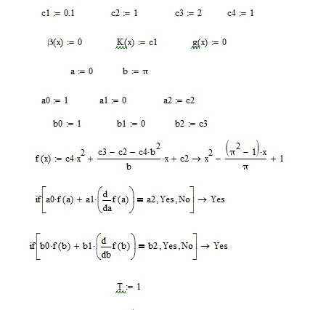

Fig.3.1. – Input data

Let's calculate the coefficients *Аk* and plot the exact solution  (see Fig. 3.2).

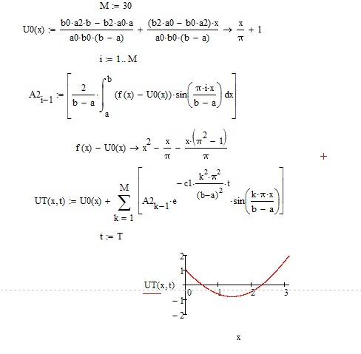

Fig.3.2. – Exact solution

### 3.3.2 Galerkin's method

Let us introduce a system of trial functions for $n = 5.$ Let us normalize them (see Fig. 3.3). To do this, let us calculate the normalized coefficients and obtain the normalized trial functions.

Let us introduce a system of checking functions. For our example, we will take trial functions as checkers. Let us find the coefficients of the system of differential equations  to find the functions *Hk(t)* with initial conditions (see Fig. 3.4).

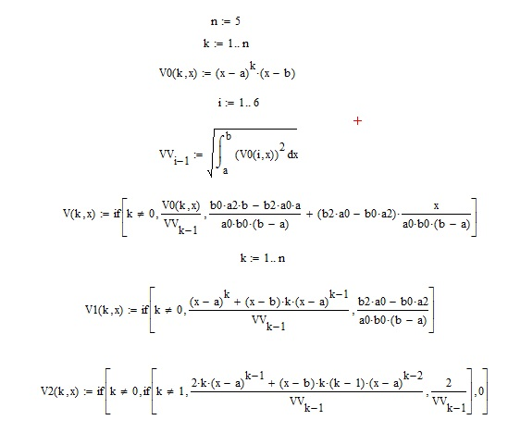

Fig.3.3. – Trial function system

Let us reduce the system to the form  with initial conditions $H(0) = D2$ (see Fig. 3.5). Let us find the solution of the resulting system of differential equations using a special function for solving general differential equations by the Runge-Kutta method of the fourth order with a constant step – *rkfixed* (see Fig. 3.6).

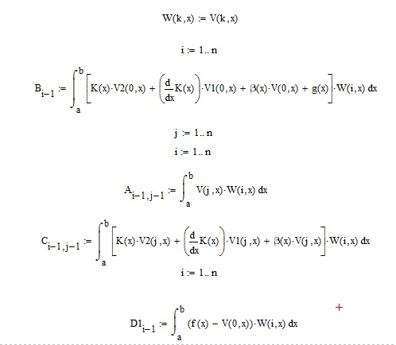

Fig.3.4. – System of checking functions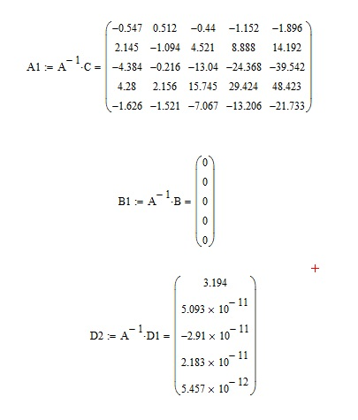

Fig.3.5. – Initial conditions

Substituting the obtained coefficients *Y100,k* (see Fig. 3.7), we obtain a trial solution in the form

.

The preliminary trial solution  for $n = 5$ will look like shown in Fig. 3.8.

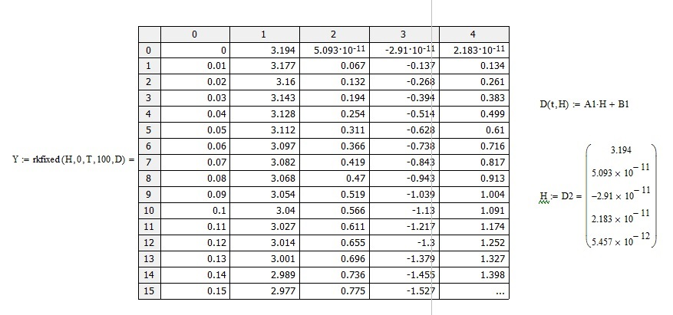

Fig.3.6. – Solution of a system of differential equations

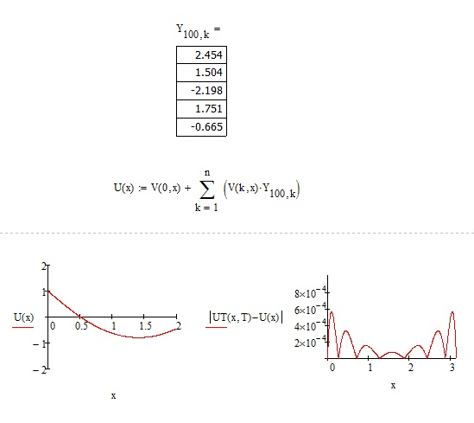

Fig.3.7. – Coefficients

We compare the solutions obtained by the Galerkin and Fourie methods at $t = T$ and plot the following graphs. The result can be seen in Fig. 3.8. By analyzing the graph of the function , we will obtain the corresponding measures of accuracy.

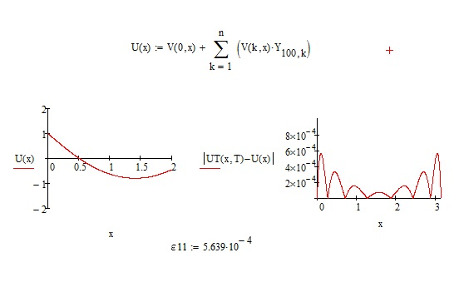

Fig. 3.8. – Trial solution

Next, we calculate the matrix of the previous (for $n = 4$) trial solution (see Fig. 3.9).

Therefore, the preliminary trial solution for $n = 5$ will look like shown in Fig. 3.10.

Let us find the residuals for constructing an approximate solution to the initial problem using the Galerkin method at $t = T$ and $t = 0$ (see Fig. 3.11 – 3.12).

Analyzing the graph of the function , we will determine the accuracy measures

.

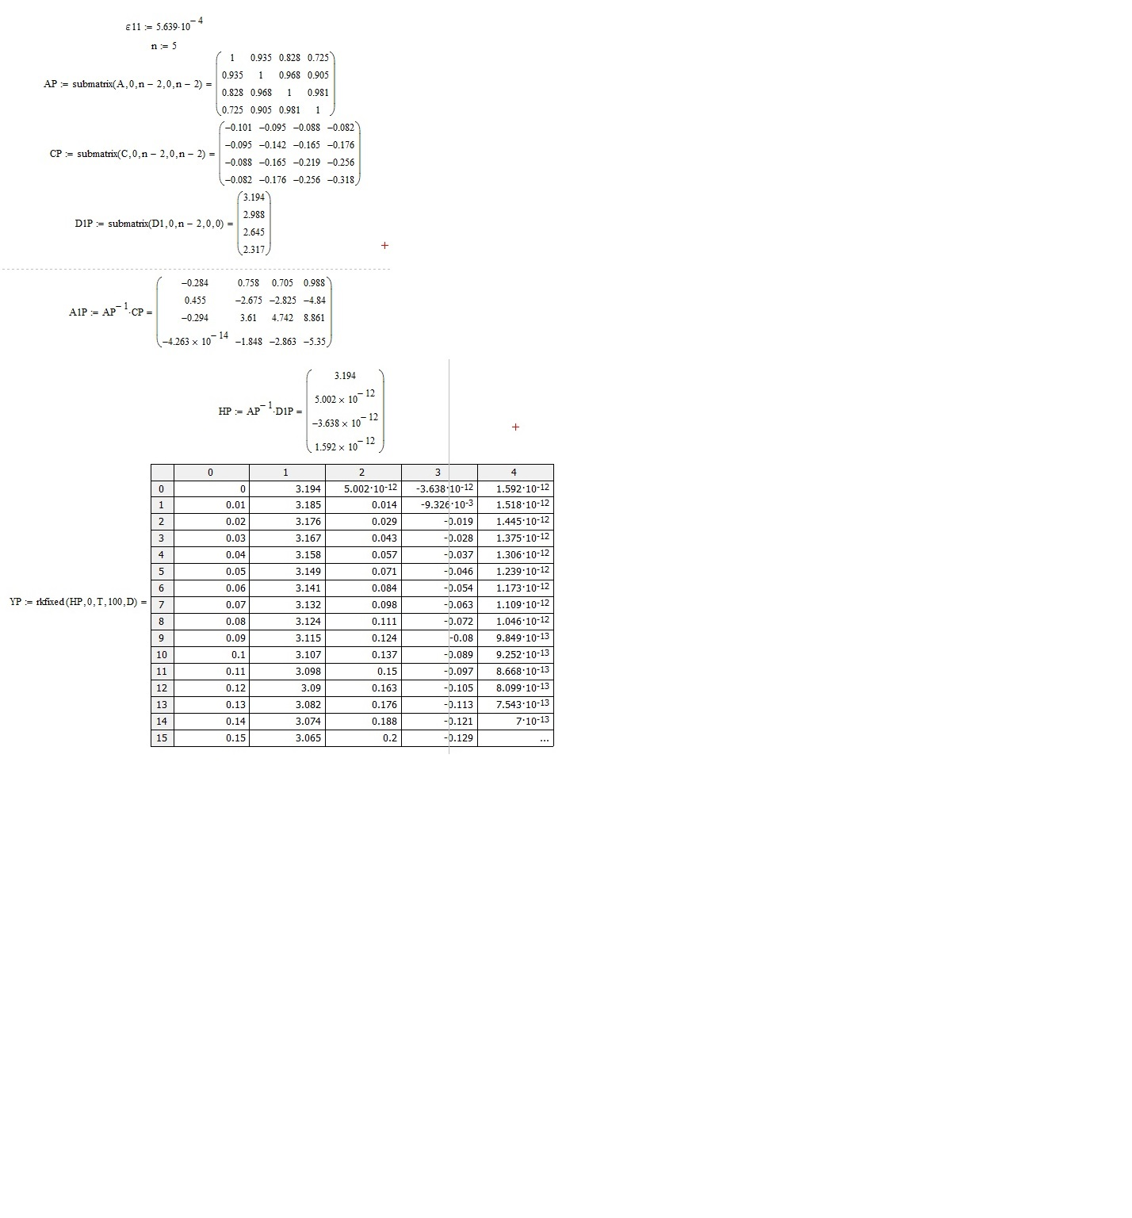

Fig .3.9. – Trial solution matrix

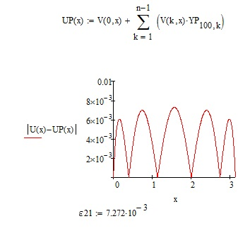

Fig.3.10. – Trial solution for $n = 5$

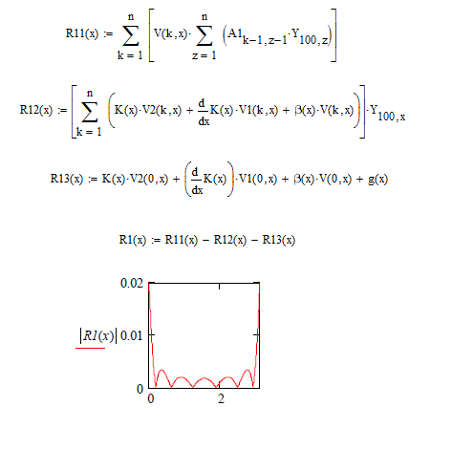

Fig.3.11. – Residual R1 at $t = T$

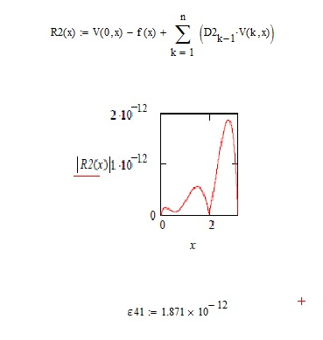

Fig.3.12. – Residual at $t = 0$

Analyzing the graph of the function , we will determine the accuracy measures

.

Analyzing the graph of the solution's residual , we determine the accuracy measures

.

Analyzing the graph of the function  for solution , we determine the accuracy measures

.

# CONCLUSIONS

This qualification work describes the modeling of the heat transfer problem using the Bubnov-Galyorkin method. The work consists of three sections.

The first section is devoted to the modeling of the heat transfer process. It considers the basic concepts of mathematical modeling and heat transfer mechanisms – heat conduction, convection and radiation.

The second section presents numerical methods for solving the heat transfer problem, namely the general formulation of the Bubnov-Galerkin method. The exploration of the Bubnov-Galyorkin method within this study has yielded a wealth of insights into its application, effectiveness, and potential within the field of heat transfer and beyond.

The third section of this work contains a software implementation of the Bubnov-Galerkin method using the example of the problem of non-stationary heat conduction. The mathematical package MathCAD was chosen to implement this method. The section consists of subsections that consider the problem statement and the algorithm of the method and the modeling of the problem itself, which includes a comparison of two methods – the Fourier and Galerkin methods.

One of the key findings of this study is the Bubnov-Galyorkin method's ability to handle intricate boundary conditions and variable material properties, which are prevalent in real-world engineering problems.

The method's variational nature allows it to provide approximate solutions that converge to the exact solution under appropriate conditions, offering a high degree of accuracy and reliability.

# REFERENCES

1. Bender E. A. An introduction to mathematical modeling. Courier Corporation. 2000. 272 p.
2. Leuschner D. A. Mathematical model for classification and identification. Journal of classification, Vol. 8(1), 1991. 99-113 pp.
3. Levenspiel O. The Three Mechanisms of Heat Transfer: Conduction, Convection, and Radiation. Engineering Flow and Heat Exchange. 1984. P. 161-188
4. Marín E. Linear relationships in heat transfer. Lat. Am. J. Phys. Educ. Vol. 3, No. 2, May 2009. P. 243-245.
5. Murthy Ja. Y. Numerical Methods in Heat, Mass, and Momentum Transfer. School of Mechanical Engineering Purdue University Spring 2002. URL: <https://engineering.purdue.edu/~scalo/menu/teaching/me608/ME608_Notes_Murthy.pdf>
6. Chapter 5 The Bubnov-Galerkin Method. *Methods of Nonlinear Analysis Mathematics in Science and Engineering*, 1970. P. 187-224.
7. MathCAD. – URL: <https://mathcad.com>