Enhancing Grammatical Competence in English as a Foreign Language Through Online Educational Games in High School

by

Veronika Dvornyk

A Master's Thesis
Submitted to the Department of Germanic Philology and Foreign Language Teaching Methodology
Nizhyn Mykola Gogol State University

In Partial Fulfillment of the Requirements
For the Degree of Master of Secondary Education
December 2024

Supervised by associate professor Viktoriia Smelianska

Ніжинський державний університет імені Миколи Гоголя
Факультет філології, історії та політико-юридичних наук
Кафедра германської філології та методики викладання іноземних мов

ОПП «Середня освіта. Англійська мова та зарубіжна література»
014.02 Середня освіта (Мова та зарубіжна література (англійська))

КВАЛІФІКАЦІЙНА РОБОТА
на здобуття освітнього ступеня магістр

«Розвиток граматичної компетентності з англійської мови як іноземної за допомогою навчальних онлайн-ігор у старшій школі»

Студентки
Дворник Вероніки Геннадіївни

Науковий керівник
Смелянська В. В., к. пед. наук, доцент кафедри германської філології та методики викладання іноземних мов
Рецензенти:
Таран О. М. к. пед. наук, доцент кафедри германської філології та методики викладання іноземних мов
Афанасова С.І. учитель англійської мови Ніжинського ліцею Ніжинської міської ради при НДУ імені Миколи Гоголя спеціаліст вищої категорії учитель- методист

Допущено до захисту

Завідувач кафедри к. пед. наук, доцент Давиденко О. В.
__________ (підпис)
____________ (дата)

Ніжин- 2024

Abstract

Modern education by English teachers always requires up-to-date ways of teaching students, especially English grammar for those whose English is a Foreign Language(EFL). Developing grammatical competence is crucial because students can express themselves only with the proper knowledge of grammar. However, making progress in grammar can take time and involves new solutions. For this reason, teachers are integrating modern tools such as online educational games into their teaching. Online educational games provide students with opportunities to express themselves and develop their grammatical competence.

This master's thesis aims to discover how online educational games affect EFL students' learning and development of grammatical competence and investigate whether different online educational games help develop students' grammatical competence. The master's thesis will discuss those research questions in six parts.

The thesis involves observation, tests (pre-and post-test), and questionnaires( before and after using online educational games) as methods of collecting data. The action research involved ten high school students who learnt English as a foreign language. The set of activities (games) was designed and implemented throughout the research to reach the aim of the thesis.

The data was analyzed and presented in detail in the thesis. The results of the post-test show that student's grammatical competence developed significantly. The comparison of questionnaires displays that students in high school liked to use online educational games while learning grammar. Still, sometimes, they desire to blend online educational games with traditional methods.

In conclusion, developing EFL grammatical competence with online educational games was successful in high school, but some additional actions and recommendations need consideration.
Keywords: grammatical competence, educational online games, English as a foreign language lesson, high school.

Анотація
Сучасна освіта від викладачів англійської мови завжди вимагає сучасних підходів до навчання студентів, особливо це стосується граматики англійської мови для тих, хто вивчає англійську як іноземну (EFL). Розвиток граматичної компетенції має вирішальне значення, оскільки студенти можуть виражати свої думки лише за умови належного знання граматики. Однак, досягнення прогресу в граматиці може зайняти певний час і вимагає нових рішень. Тому для цього викладачі інтегрують в навчання сучасні інсрументи такі як навчальні онлай-ігри. Навчальні онлайн-ігри надають учням можливості для проявлення себе та звичайно розвивати граматичні навички.
Ця магістерська робота має на меті з'ясувати, як навчальні онлайн-ігри впливають на навчання та розвиток граматичної компетенції студентів, які вивчають англійську мову як іноземну, а також дослідити, чи допомагають різні навчальні онлайн-ігри розвивати граматичну компетенцію студентів. Ці дослідницькі питання будуть розгорнуто висвітлені в шести частинах роботи, а саме: вступ, огляд літератури, методологія та процедура, результати,обговорення та висновок. У вступі буде поставлена ціль, дослідницькі питання, гіпотеза даного дослідження. В огляді літератури буде подано різні погляди різних дослідників, які намагалися розкрити цю тему,або теми ,які наближені до магістерської. Методологія та процедура має на меті розкрити методи дослідження, які будуть використовуватися; навчальні онлайн- ігри та їх опис , і, звичайно, комплекс вправ. У частині результати будуть подані саме результати даного дослідження, які будуть репрезентовані в таблицях. Це буде саме показано через граматичні тести до та після, а також опитувальники: перший, який був проведений до того, як навчальні онлайн ігри були застосовані для розвитку граматичної компетенції, та другий для того, щоб побачити розвиток граматичної компетентності після залучення навчальних онлайн- ігор. У розділі дискусія буде критичний аналіз дослідження; рекомендації та сфери ,які мають бути досліджені в майбутньому. У розділі висновок будуть подані основні результати.
Методами збору даних є спостереження, тестування (до і після тестування) та опитування (до і після використання навчальних онлайн-ігор). Дослідження буде проводитися з десятьма старшокласниками, які вивчають англійську мову як іноземну. Для досягнення мети дослідження було розроблено та впроваджено комплекс з десяти вправ, спрямованих на досягнення поставленої мети. Ці вправи були створені на таких сайтах як WordWall, Quizlet, Baamboozle, LearningApps, Educaplay, British Council. Дослідження проводилося онлайн.
Отримані дані були проаналізовані та детально представлені в магістерскій роботі. Результати пост-тесту показали, що граматична компетенція учнів значно покращилася. Це можна підтвердити тим,що перед використанням онлайн-ігор для розвитку граматичної компетенції в чотирьох учнів був низький рівень граматики ,але вже після застосування онлайн-ігор на цьому рівні залишився лише один учень. Середній рівень піднявся з 40 % до 50%. А високий рівень з 20% це двоє учнів до 40 % це 4 учнів. Порівняння опитувань показує, що учням старших класів подобалося використовувати навчальні онлайн-ігри під час вивчення граматики. Проте, іноді вони хотіли б поєднувати навчальні онлайн-ігри з традиційними методами. Також деякі учні зазначили,що навчальні онлайн-ігри дуже їм подобалися при вивченні граматики,але на їхню думку,вони не повинні застосовуватися кожен урок ,бо це призводить до повторення, відволікання та до того,що учні можуть мати складнощі чи труднощі в навігації.
Підсумовуючи, можна сказати, що розвиток граматичної компетенції з англійської мови професійного спрямування за допомогою навчальних онлайн-ігор у старших класах був успішним, незважаючи на те,що менша половина учнів вважає ,що навчальні онлайн-ігри можуть мати деякі фактори ,які сповільнують їхнє навчання. Тому ,це слід врахувати як рекомендації та для подальшого дослідження.
Ключові слова: граматична компетентність, навчальні онлайн-ігри, англійська як іноземна, старша школа.

Table of Contents

Introduction 7
Literature Review 8
Methodology and Procedure 15
Results 19
Discussion 30
Conclusion 32
References 34
Appendices 38
Appendix A 38
Appendix B 57
Appendix C 59
Appendix D 60

Introduction

Learning foreign languages includes many aspects. One of the critical aspects is the study of the grammatical rules of the language since the process of learning and learning the grammatical rules is complex, given the fact that terms and rules, exceptions, and other things complicate it. Grammatical aspects of the English language are the most difficult to learn and master, knowing that English and Ukrainian grammar differ significantly. The current level of social development shows that outdated methods of learning grammar rules are ineffective, as students cannot effectively apply the acquired knowledge. There is a large number of information and communication technologies that can be used in the course of teaching grammatical structures of the English language to students.
Adolescence is a period of formation of worldview, character and life self-determination, self-affirmation, and active understanding of the future. High school students are on the threshold of choosing a profession; they vary in differentiation by interests and intentions but coincide in the main thing: the problem of finding themselves. In this challenging situation, they should be helped by a competent teacher. In this regard, teaching methods are of great importance. Thus, for teaching English as an English Foreign Language (EFL) to be effective, it is essential to give attention to each skill and make sure that students are developing their communicative competence and reaching the desired outcomes (DeKeyser, 2007).
Recently, the issue of using online educational games in schools has been raised more often. These are new technical means, innovative teaching methods, and modern approaches to the learning process. The task of a contemporary teacher is to create conditions for practical mastery of the language for learners, to know different methods and how to apply them so that learners will be comfortable with them to show their activity and progress. Using online educational games helps develop students' grammatical competence and does it according to their needs, interests, and the aim of the lessons.
All in all, this topic is relevant. Today, among such various methods and forms of teaching a foreign language, it is essential for teachers to choose the most suitable one to meet the requirements stated in the national curriculum. The use of information and communication technologies, characterized by high communicative capabilities and active involvement of students in educational activities, contributes to adaptation to modern social conditions since society needs people who quickly navigate the modern world and are proactive and independent (Gilakjani, 2012).
The aim of the study is to investigate the possibility of using online educational tools as an effective way of improving grammatical skills in English language classes in high school.
To reach the aim, the following tasks involve:
- To determine such terms as grammar, grammatical competence, and online educational games and how researchers describe them from their perspectives;
- To choose online educational games that are usable now in the educational sphere;
- To apply the chosen online educational games to develop grammatical competence;
- To conduct grammar tests at the beginning and the end of the research and do questionnaires to compare the attitude towards online educational games in the context of developing grammatical competence;
- To analyze the data together with literature in the field of the research.
- To state conclusions and point out which further areas need to be researched.
The research questions underlying this request are formulated as follows:
- How do online educational games affect EFL student's learning and development of grammatical competence?
- Do different online educational games help develop students' grammatical competence?
This study hypothesizes that online educational games significantly improve EFL learners' grammatical competence by creating engaging games that will be fun for students and educational.
The study systematically examines various technological tools, namely online educational games, which will be done on platforms such as WordWall, Quizlet, Baamboozle, LearningApps, Educaplay, and British Council, and their impact on learner engagement, motivation, and grammar learning. Using observation, questionnaires, and pre-and post-intervention grammar test results, the study shows how different technologies can help students develop their grammatical competence.

Literature Review
The urge for gamification and digital games in English as a Foreign Language learning is not only about student engagement but also about providing instant feedback, a vital element of the learning process. Quite a lot of researchers have explored this topic in their way.
Firstly, it is worth mentioning what grammar is, and S. Thornbury defines it the following way: 'Grammar is the way that, in the absence of context, we sequence and modify words in order to achieve greater clarity and precision. Grammar is a toolbox for making meaning.' (NSW Federation of Community Language Schools INC, 2020).
Such researchers as York, Poole, & deHaan (2021) note that grammatical competence is extremely important for understanding the speech of speakers of a foreign language: the speaker can construct his own utterance grammatically correctly, using a limited set of lexical units and knowledge about the grammatical phenomena of the language being studied. However, other communicators can use complex constructions, which will become an obstacle to understanding the entire statement. Thus, the implementation of a full-fledged two-way communication process is possible only if the interlocutors understand each other. Kotenko and Solomakha (2015, p. 139) note that grammatical competence can be defined as "the ability to recognize and produce certain grammatical structures of the language and to use them effectively in the process of communication".
According to Kolomiyets (2015), grammatical competence can be defined as a person's ability to effectively and correctly use the acquired grammatical knowledge and skills in each individual situation to adequately carry out language activities in the process of EFL communication.
Thus, grammatical competence includes the skills of effective use of grammatical means of language, namely:
- The ability to construct grammatically correct statements of various levels of complexity;
- The ability to recognize and understand various grammatical structures in the speech of others;
- The ability to use grammatically correct phrases and sentences.
Grammatical skill, like any other, is formed in stages. York et al. (2021) distinguish the following stages of the formation of grammatical skills:
- perception (presentation of a grammatical phenomenon in the speech of the teacher takes place);
- imitation (training of grammatical phenomena in expressions based on repetition after the teacher, on pronouncing expressions identical to those previously pronounced);
- substitution (substitution of equivalent meanings in English);
- transformation (change of language forms);
- reproduction (independent reproduction of acquired knowledge).
The formation of grammatical skills plays an essential role in teaching English. Grammar training is necessary for students since it is the basis of the rest of the linguistics sections, and learning English is impossible without forming grammatical skills. Since grammar skills are formed one stage at a time, specific difficulties may arise in mastering this skill, which are resolved individually. This includes applying the rules and structures of language to achieve effective communication. As Saville-Troike (2006) points out, grammatical competence encompasses knowledge of lexical items, morphology, syntax, grammatical semantics, and phonology (p. 29) and is an important component of communicative competence.
Having defined grammatical competence, it can be mentioned that it covers understanding grammar rules, correct pronunciation, using the correct verb form, parts of speech, and sentences in the correct order. Knowing grammar rules helps students understand language and develop their grammar. Studying the grammar of a language also helps students expand their vocabulary and develop skills in analyzing and understanding language constructions.
Ringelová (2017) notes that language learning has changed completely: "There is a difference between the contemporary generation of students and the previous ones; that contemporary students are believed to be digital natives who are used to technology from early childhood, who use it all the time, and for whom technology is an indivisible part of their lives. The field of education should accept this fact and work with these students in new ways, using new learning tools." In such a situation, the problem of using effective methods of teaching foreign languages in schools seems extremely important. It is necessary to instill interest in the subject.
Based on the types of speech activity, Rahmani (2020) identifies two types of grammar skills: receptive and productive. Productive grammatical skills mean the ability of the speaker to choose a mode adequate to the speech task and to design it in accordance with the norms of the given language. In turn, receptive skills are the ability of the reader and speaker to recognize grammatical forms of the studied language and correlate them with their meaning. Those grammatical skills that students actively use are called active grammatical skills, and those that students learn in the course of learning a foreign language are called passive. They are most commonly used in written speech, tasks that students must master in speech and reading (there are more passive grammar skills than active ones).
Janna et al. (2023) explore that the role of grammar skills in teaching English is extremely important since by teaching students to read, speak, and write in a foreign language, the school simultaneously provides them with direct access to other national cultures and, thereby, to world culture. All of the above-mentioned skills cannot be formed without grammar skills. The authors conclude that gamification can improve the learning process and make it more enjoyable for students.
Castillo-Cuesta (2020) defines that at the present stage of development of human society, information and communication technologies are an integral part of an individual's life. The high level of development of technology and the growth of computerization in all areas of life allows a person to be in a constant information and communication space. The global Internet network is becoming the main and most important source of knowledge and information for the younger generation. The abundance and colorfulness of information in the media make schoolchildren less receptive to traditional teaching methods.
Besides, several grammar activities must be highlighted as they will be included in the next part of the master thesis.
Awareness type activities aim to make learners more aware of language and improve their understanding but do not involve learners in using the language themselves. As such, awareness-raising activities are often the first stage of learning a new language (Awareness-raising, n.d.).
Matching is another grammar activity where students must match or translate parts of sentences to English variants. Matching is a universal activity as it can be used to teach grammar and other aspects of language.
The next one is controlled drills. What is drilling? Drilling is a process of listening to a teacher, a video, or an audio and repeating the material that has been heard (Kravchenko, 2023). Controlled drills are manipulative drills with the aim of developing accuracy. They come directly after presenting the new grammar point (Ramadan, 2022). Drills are usually used at the controlled practice stage of language learning so that students have the opportunity to accurately try out what they have learned. Drills help students to develop quick, automatic responses using a specific formulaic expression or structure, such as a tag ending, verb form, or transformation (Alem, 2021).
It is worth mentioning controlled practice. Controlled practice activities refer to restricted activities where the focus is on developing accuracy rather than fluency. They usually include: repetition, scaffolding, specific target language focus (LearnTeachTravel, 2020).
The last one that needs to be discussed is guided, meaningful practice. According to Ramadan (2021), teachers want students to think about and use specific language item(s) accurately as often as possible. Guided practice activities can help them achieve this goal. Guided practice activities require students to use the target grammar structure while allowing them to personalize the language somewhat and contribute their own ideas. If relevant and engaging, guided practice tasks can motivate learners by:
- Giving them confidence that what they are saying is right;
- Preparing them for meaningful communication.
Those types of grammar activities can be used in online educational games. This term needs to be defined. Educational games are designed around a particular learning experience or outcome. Many games […] have some type of educational content, although sometimes players might not realize they are practicing a skill or using their knowledge while playing(What Are Educational Games? - Twinkl, n.d.).
Besides, Melati et al. (2022) say that online educational games help students learn English because they make them feel happy, so it can be said that these games are very effective in teaching English, especially for young people who prefer learning and playing.
The goal of educational games is to allow players to learn unconsciously while playing. The more a player plays an educational game, the more their learning and their skills can increase (Seaton et al., 2019).
Especially when it comes to teaching students grammar in EFL (English as a foreign language) lessons because using traditional methods can lead to some challenges, so educational online games may become useful and will not only captivate learners but also facilitate the development of grammatical competence (Dvornyk, 2024).
A study by Idris et al. (2020) points out the need to involve students in educational activities to develop grammatical skills. This is explained by the fact that the goal of mastering the grammar of a foreign language is not simply mastering a set of grammatical constructions at the level of imitation but, first of all, developing the ability to convey the desired content employing the studied language. That is, the student's activity in the process of assimilation ends not in his passive attitude to the material being assimilated but in active mastering of grammatical structures and their transformation. Accordingly, in the process of mastering grammatical structures, a large place should be given to analytical work with language material, and this work should be balanced. Control of grammatical skills is one of the most critical stages of learning a foreign language.
According to Idris et al. (2020), the role of language or training exercises is undeniable because they help students consolidate in memory the lexical and grammatical material necessary for use in speech. The advantage of such tasks is that they are aimed at voluntary memorization, i.e., the student's attention is focused on the skill being trained. Such a conscious approach to learning leads to further automation of skills. If you immediately direct the students' attention not to the grammatical form but to the purpose of the utterance, then there is a possibility that the students will not concentrate on the form itself and will subsequently make mistakes. The main thing during such exercises is to show the students the practical value of the skill being trained and to give situations of its actual use in speech. It is also necessary to vary the exercises so that the grammatical skills just trained by the students are consolidated in speech tasks aimed at speaking itself.
Rejeki and Muhajir (2020) consider the broader implications of gamification and digital games for supporting EFL teaching and learning in 21st-century education. Gamification is a game element used in non-game contexts to persuade people and solve problems. In the 21st century, gamification can be used as an educational means to improve learning outcomes as it represents an innovative, productive, and interesting learning activity. The studies on gamification show that it can make students more excited and motivated in improving their English.
Thanks to Internet technologies, providing educational training in learning foreign languages becomes a requirement of the time, so course developers and teachers must consider the factor of accessibility when developing educational programs. Mobile devices have been found to be tools that provide greater access to information and people than other mediums, such as computers. Thus, teachers should be able to apply this approach to traditional and electronic ways of learning a foreign language since the mobile phone is the most accessible device among learners.
Games are said to be beneficial in education. The main reason for a game to be a successful tool in aiding learning is due to the fact that games provide a competitive platform for learners to fully engage in the game (Hashim et al., 2019).
Pratama (2020) states that the use of information technology achievements in foreign language lessons increases the motivation and cognitive activity of students of all ages and broadens their horizons. An effective means of implementing a multi-level approach and individualizing foreign language teaching is using electronic teaching aids.
According to Khan et al. (2024), using games to teach and explain grammatical structures or formations is highly effective, as it both teaches them and entertains them simultaneously. Students are encouraged and under minimal stress while using games for learning.
Earlier, online educational platforms were mentioned to create online educational games, such as WordWall, Quizlet, Baamboozle, LearningApps, Educaplay, and British Council. It is very vague to mention their advantages while developing grammatical competence. Nowadays, the usage of online educational platforms has arisen since English as a Foreign Language developed and changed the outlook of the traditional classroom. These interactive platforms make learning not only enjoyable but also help diverse learning styles, enhancing understanding. As educators want to adapt to the needs of their students, integrating […] innovative tools offers a deeper understanding of grammar concepts (Dvornyk, 2024).
According to Rosydiyah et al. (2022), there is a significant difference on the use of WordWall online games on students' grammar quality between experimental and control groups.
Adopting Quizlet in the learning process will create a better ambiance in the classroom, which supports the learning process. Not only that, the interactive interface of Quizlet will also urge the students to think of grammar as an easy subject to learn and enjoyable one. Previously, the teacher could only use textbooks and boards to teach grammar, which was monotonous. However, the way teachers teach and the students learn will be more varied when using Quizlet. The teacher can use grammar features to create an engaging explanation by creating flip-flop games, matching tests, and many more. Those ways of teaching grammar will create a good classroom ambiance and make learning grammar more accessible. The use of Quizlet will allow students to learn grammar not only in the classroom but also outside the classroom. By doing so, the students can exchange understanding about the explanation and learn together along with their peers (Yuliyanto & Fitriyati, 2019).
Baamboozle is another online educational platform where educators can create and employ different grammar activities according to the grammar focus. The research conducted by Sakdiyah et al. (2024) aimed to discover how students develop their grammar mastery using game-based learning Baamboozle and investigate the students' responses toward using Baamboozle in developing their grammar mastery. They found out that the questionnaire result showed that the students gave positive responses regarding developing their grammar mastery by using Baamboozle game-based learning. The students admitted that the game-based learning method, with the help of Baamboozle media, is very suitable and helpful in developing their understanding of grammar materials. The questionnaire results also showed that the game-based learning method could develop their focus and understanding of the grammar material, as students reported that they experienced improvements in terms of focus, reasoning, decision-making ability, escape, attention-getting activities, and decreased stress levels. The students found the game-based learning method fun, challenging, enthusiastic, and engaging, supported by the game features and activities with a spirit of competition.
So far, it can be seen that these online educational games provide good results, feedback, and developing grammar. However, some educational platforms have not yet been discussed. For example, LearningApps.org can guide teachers with already created grammar activities that suit the grammar that is being taught now: educators have to write the keywords in the box 'search in apps' and find the app they think will suit their learners. One of the advantages of this online educational platform is that teachers can find activities in more than 20 languages and either customize them or create their own.
In Argentina, Cad and Carrera (2021) used Educaplay tool to teach grammar and foster collaborative learning. Their descriptive study shows that Educaplay has great potential in these areas. Besides, the findings of the Torres Celi et al.(2023) study explained that the most favorite gamified strategies for students were Educaplay and Wordwall. Since they ensure motivational and active learning, they make students feel more confident working in groups rather than alone to develop the grammar activities; thus, they motivate students' positive participation in competitions.
Lastly, Puspitasari et al. (2023) research findings showed that the British Council website, as a medium for teaching grammar was an effective medium for teaching grammar. It was clear from the comparison obtained score between the pre-test and post-test, after giving treatment by using the British Council website, that the mean score of EFL students' achievement on the pre-test was 44.8, and the mean score of their achievement on the post-test was 70.24. Implementing the British Council website on EFL students' grammar mastery was an effective alternative media for teaching grammar. It increases students' grammar mastery, as seen in pre-test and post-test scores.

Methodology and Procedure
The study, aimed at improving the grammatical competence of EFL students, is implemented in online learning and includes students aged 16-17 years from different levels of English proficiency. All ethical issues have been considered, and the privacy of respondents remains anonymous.
The research consisted of three stages: initial, main, and evaluation. Each stage had its tasks.
In the initial phase, the students were given a pre-test to see their grammar knowledge before using online educational games and one questionnaire to see the opinions of students before using online educational games. In the main phase, the set of activities(games) was created and applied in lessons while teaching grammar through educational online games. Finally, for the evaluation phase, the post-test was done by learners, where it was possible to see changes, improvements, or problems after implementing activities with e-games. The questionnaire was designed to assess their opinions after using online educational games.
In addition, the analysis of the research results will reveal the strengths and weaknesses of using online educational games in the educational process and determine how online educational games will help develop grammar skills. This knowledge can become the basis for further improvements in educational programs and the introduction of new methods that will meet the needs and interests of students.
This study has the potential not only to improve students' grammatical competence but also to create a more interactive, motivating, and effective learning environment. It can serve as a valuable resource for educators seeking to incorporate innovative approaches into their practice, adapting them to specific classroom conditions and individual student needs.
Empirical research methods are techniques, procedures, and operations of empirical knowledge and study of phenomena of reality; methods of solving scientific research problems provide direct perception (collection) of information, accumulation, classification, and generalization of the source material on the problem under study. Various methods were employed to gather data and insights into developing grammatical competence using educational online games.
Observation. Observation is a data collection tool used by the researcher to collect live data with the help of his/her senses of observation in controlled or naturalistic situations of events. A researcher collects lively and rich information/evidences from the available sources by making use of his/her senses of observation (Satapathy, 2023). Recording the observation results in the form of notes or videos helps in further reflection and correction of the curriculum, providing qualitative feedback on how students learn grammar concepts through interactive game methods. (Kolomiiets, 2015). Employing the observation method was crucial in analyzing grammatical competence among students in the 11th grade using online games. With the help of this data collection tool, in the research, it is possible to compare the real influence of educational online games on the initial stage and control stage. This tool was used to observe learner's emotions, feelings of happiness, struggles, or motivation to develop their grammatical competence.
Questionnaire is a research tool featuring a series of questions used to collect useful information from respondents (Petrat, 2024). The use of this method helps to increase the objectivity of information on pedagogical facts, phenomena, processes, and their typicality since it involves obtaining information from a more significant number of respondents. Questionnaires in psychology are used to obtain psychological information, and sociological and demographic data play only a supporting role. Contact between the researcher and the respondent is reduced to a minimum here. A feature of this method is its anonymity, since the respondent's identity is not recorded, only his answers are recorded. Questionnaires are mainly conducted in cases where it is necessary to find out people's opinions on some issues and cover a large number of people in a short time (Kotenko, Solomakha, 2015).
Two questionnaires were created in Google Forms to understand how their grammar developed before using online educational games and after (see Appendix D). 10 students participated in it.
A test is a general scientific empirical research method consisting of the application of a system of specially selected procedures (formalization, algorithmization, instruction, recording, measurement, analysis, and interpretation) to measure the qualities and properties of a person, academic achievements, the change of which is possible in the process of systematic training (see Appendix B, C). Two tests were used: one at the initial stage and the second at the evaluation stage.
In this study, educational online games are meant for grammar activities created or borrowed using different online educational games. It differs from traditional grammar activities because they have a game interface, rewards, and immediate feedback, and they are not done just to practice, practice, and practice grammar but to increase students' motivation and develop their grammatical competence through them.
In an effort to enhance the EFL grammatical competence of high school students, educators can specifically utilize online games available on the provided websites:
www.britishcouncil.org belongs to the British Council (an international organization representing Great Britain in education and culture). It consists of LearnEnglish Teens and LeanEnglish Kids. It is possible to practice all four skills there. If to talk precisely about grammar, different levels of English can be used to improve it. Numerous articles on the website can be found on how to improve grammar. Besides, it includes explanations of grammar, lessons, tests, and activities. These things can be used to create online educational games.
https://www.educaplay.com/learning-resources/2923038-grammar_games.html is an interactive platform for students to test and enhance their grammar knowledge through various tasks that can be created or found. Feedback is provided immediately after each question, indicating whether the choice was correct and explaining the correct answers.
https://learningapps.org/ is a website that was created to make educational online games. Numerous templates can be found there for creating games. This research used this platform to recycle grammar interestingly.
https://wordwall.net/ is an excellent online platform for creating educational games in different forms (templates). For instance, a game to complete sentences helps learners remember their grammar knowledge and recycle it interactively. This platform was used constantly, as was the others that have been presented.
https://www.baamboozle.com/ is an excellent educational online platform that helps create games for anything educators want. However, this platform was used in the research to practice grammar. While using online educational games on this platform, it was important to observe how learners use their knowledge of grammar and how they have to compete with each other. Another goal was to explore how students felt about this learning platform and their feedback.
https://quizlet.com/ can sometimes be seen as a tool for exam preparation, but this research wanted to dispel these rumors. This website can be called another educational online platform where teachers can create games for their lessons or courses. This master thesis aimed to reveal how possible it is to use it, for instance, to practice grammar through speaking.
As mentioned before, here is a set of activities used during the main phase and created on online education platforms. Some are presented here, and others are in the master's thesis (see Appendix A).
Sample activity (game)
Topic: Prepare for exams
Grammar focus: The second conditional
The aim: to teach the usage of the second conditional and its form.
The outcome: Students will be able to talk about imaginary situations and the consequences of preparing for exams.
Type of grammar activity: controlled drill, matching.
Instruction: Match the first part of the sentence to the second part so it will be grammatically correct to the rules of the second conditional.
Model:
1. If I took responsibility more seriously | A) I would use more words in the exam
2. If I read my vocabulary every day | B) I would do better at the exam
Keys: 1-B; 2-A
Procedure: The teacher explains to students what they need to do (previously, they had a link to the game and opened it) and points out that in the game, the time to complete the game is 2 minutes. Besides, the teacher says their names will be on the leaderboard, and the time countdown will be in the game.
The teacher asks concept checking questions if the students know what to do and how to play this game.
When students play this game, they can see how many scores they have at the moment of playing. Furthermore, when they finish the game, the total score will be written on the screen, and if one student has earned the most scores, he/she will have feedback on the screen: "You won! Congratulations".
After, when the time is up, students can see their place on the leaderboard (top 10 results) and understand who performs well and who does not in this game. Those who have the highest scores will get an excellent mark. Nevertheless, the teacher asks students if they have some questions about the sentences where they have mistakes.
Assessment and feedback: Immediate online
Online website: Educaplay

Sample activity (game)
Topic: Family. Relationship with parents; The third conditional.
The aim: to continue practicing using the third conditional.
The outcome: Learners will be to make dialogues and discuss them in the context of the topic "Family. Relationship with parents" using the third conditional
Type of grammar activity: guided, meaningful practice.
Instruction: Read the dialogues in Ukrainian and find the translation within three variants.
Model: Якщо її батьки б не били її, вона не втекла б з дому.-If her parents hadn't beaten her, she would not have escaped from home.
Procedure: Students have the link to the game. The teacher gives the instruction and says they only have 50 seconds for each question. The student who is the first to finish the game will receive an excellent mark.
They can hear the ticking sound of time when they play this game. Besides, they have some boosts in the game: x2 score, 50:50, or extra time. These boosts can help students if they struggle with the answers. Also, if the answer is wrong, they will see a big red cross. Moreover, when they finish the game, they will see the total score, and there will be applause for them in the game.

This activity is done by the whole class.
Assessment and feedback: Immediate online
Online website: WordWall.

Results
For this master's thesis to observe how students' EFL grammatical competence develops using educational online games, the experimental work took place in three stages: the initial, the main, and the evaluation. Throughout the research, games played a central role in the students' learning process, helping them develop their grammar skills. To establish the initial level of students' grammatical competence, a test was conducted (see Appendix B).

Table 1
Table of levels of development of English as a Foreign Language grammatical competence, the initial phase
Level | Score Range | Description
High | 28-30 | Students who have high grammatical competence have excellent command of English grammar. They can easily use grammatical constructions in language. These students accurately use different tenses and conditionals.
Medium | 15-20 | Students with a medium level have a little less understanding of basic grammar concepts. They confidently use simple to moderately complex grammatical structures but occasionally make minor mistakes, especially in more complex sentences. These students know how to work with different tenses, understand simple conditional constructions, and sometimes correctly use verbs in tenses and conditionals.
Low | 0-15 | Students scoring below average are beginning to learn English grammar and its rules. They use a few grammatical structures correctly but make mistakes almost always due to complex rules. The words and sentences they use are usually incorrect or oversimplified because they cannot clearly express the variety of ideas that they would like to. For these students, it is hard to understand something or express themselves unless it involves a simple sentence or primary conversation.

Table 1 presents the criteria for assessing the level of development of grammatical competence of high school students. This tool is helpful in measuring how well students understand and develop different grammatical concepts. It allows tracking students' progress, seeing things that need improvement, and giving feedback to improve their grammar skills.
Students who receive average scores (medium level) face particular difficulties in understanding and applying grammar rules. Although they sometimes manage to form grammatical constructions and use them in context, their explanations often reveal gaps in knowledge, and their use of grammar is accompanied by errors. This suggests a need for specialized educational support to help address these gaps in understanding and practice (Hussain, 2017).
In contrast, students with lower scores (low level) face severe difficulties in almost all aspects of grammatical competence. They misunderstand grammatical rules, have difficulties making grammatical sentences, and find identifying or applying grammatical forms challenging.
For the initial stage, a pre-intervention grammar test was used to help students cope with grammar learnt during practice time. The results of students were analyzed. It was found that students can read and translate texts adapted to their level, but at the same time, they experience difficulties in expressing their thoughts in English since they have a small vocabulary and abysmal knowledge of English grammar. The level of development of speech skills and abilities is not very high. The general results are shown in Table 2.

Table 2
Level of development of grammatical competence in the initial stage
 | Low |  | Medium |  | High
Students | 4 | 40% | 4 | 40% | 2 | 20%

The results of the initial stage showed that students have a good command of grammatical structures but poor knowledge of the form of a grammatical phenomenon and literacy.

Figure 1
Level of development of grammatical competence in the initial stage

In addition, the questionnaire was created and done by students to see how they feel about developing grammatical competence before using online educational games created on Baamboozle, WordWall, Educaplay, and other platforms. Ten students participated and had to answer six questions with 5 questions with given variants and 1 question requiring their response (see Appendix D).

Figure 2
The students' answers to the question: How did you feel about using online educational games for learning grammar?
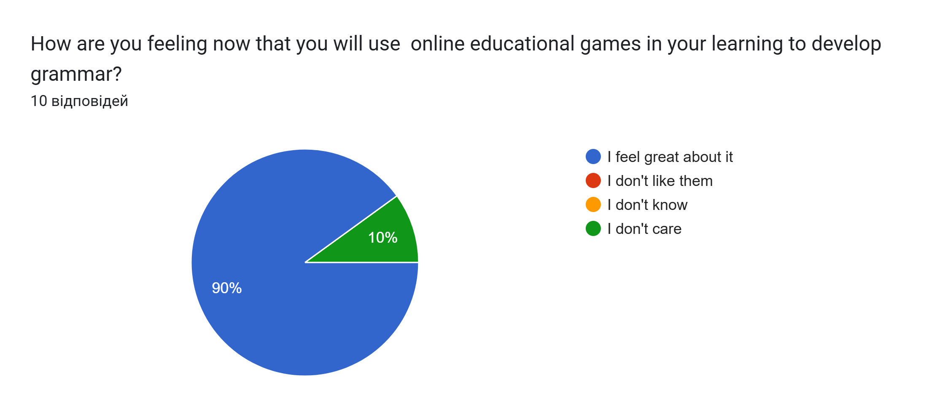
Figure 3
The students' answers to the question: Do you think that you will make progress in grammar when we use online educational games on WordWall, Baamboozle, and other platforms?
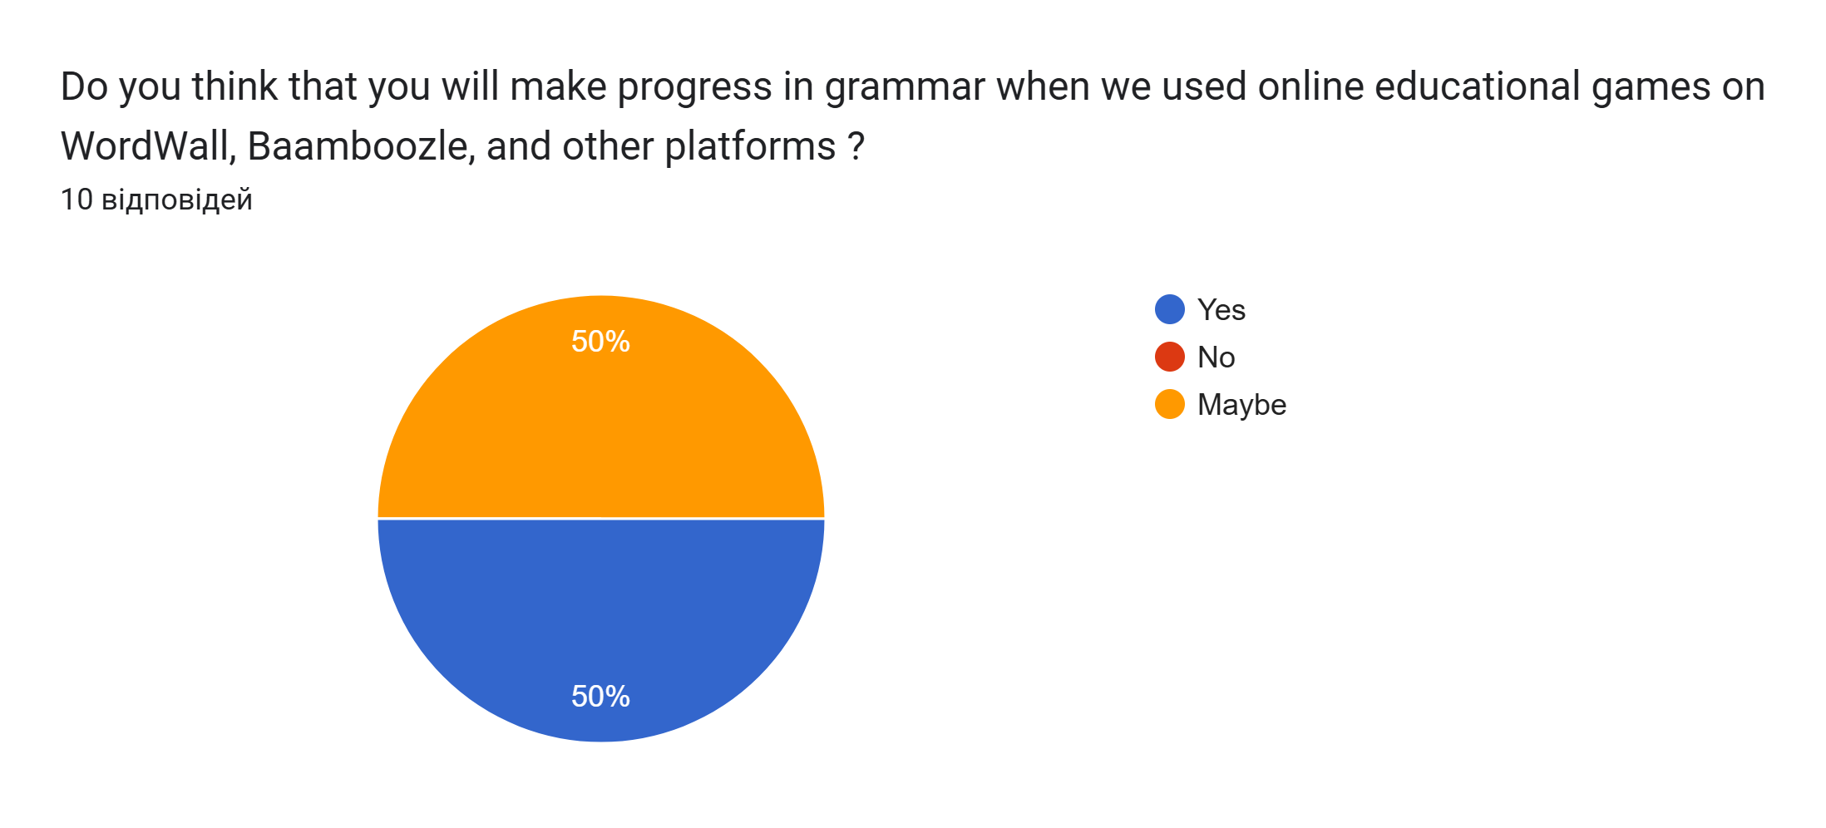
Figure 4
The students' answers to the question: What do you like when you are learning grammar and using online educational games?
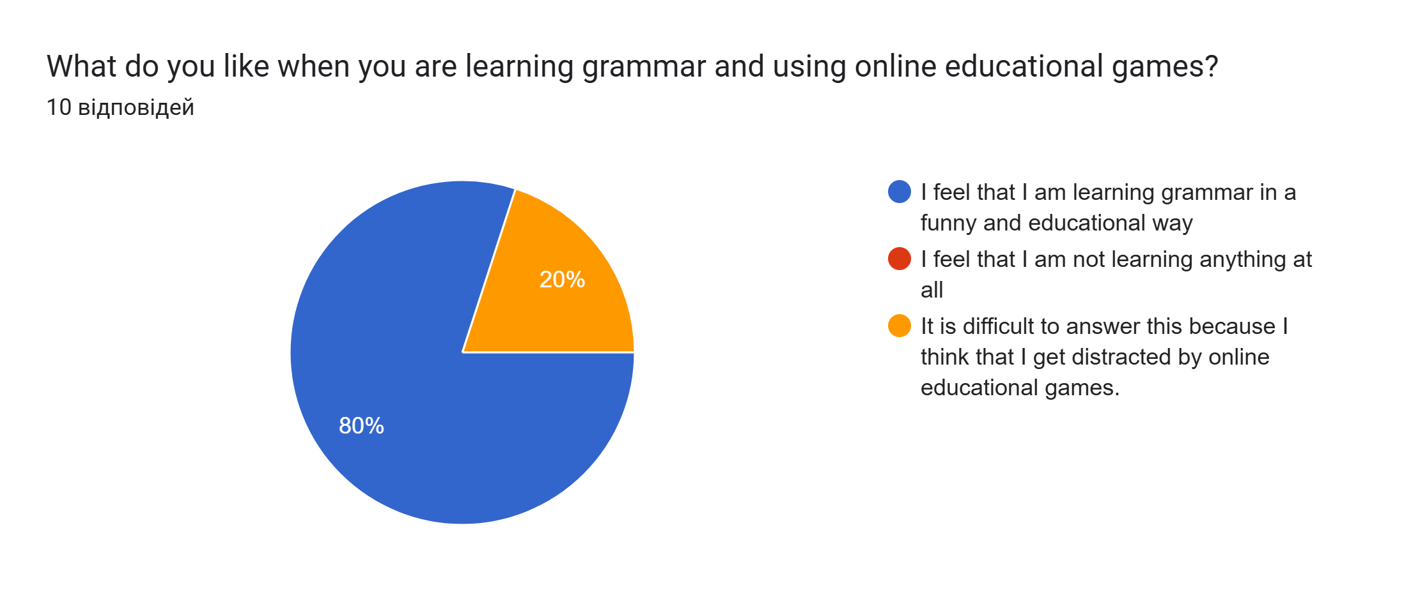
Figure 5
The students' answers to the question: What is it that you don't like when you are learning grammar and using online educational games?
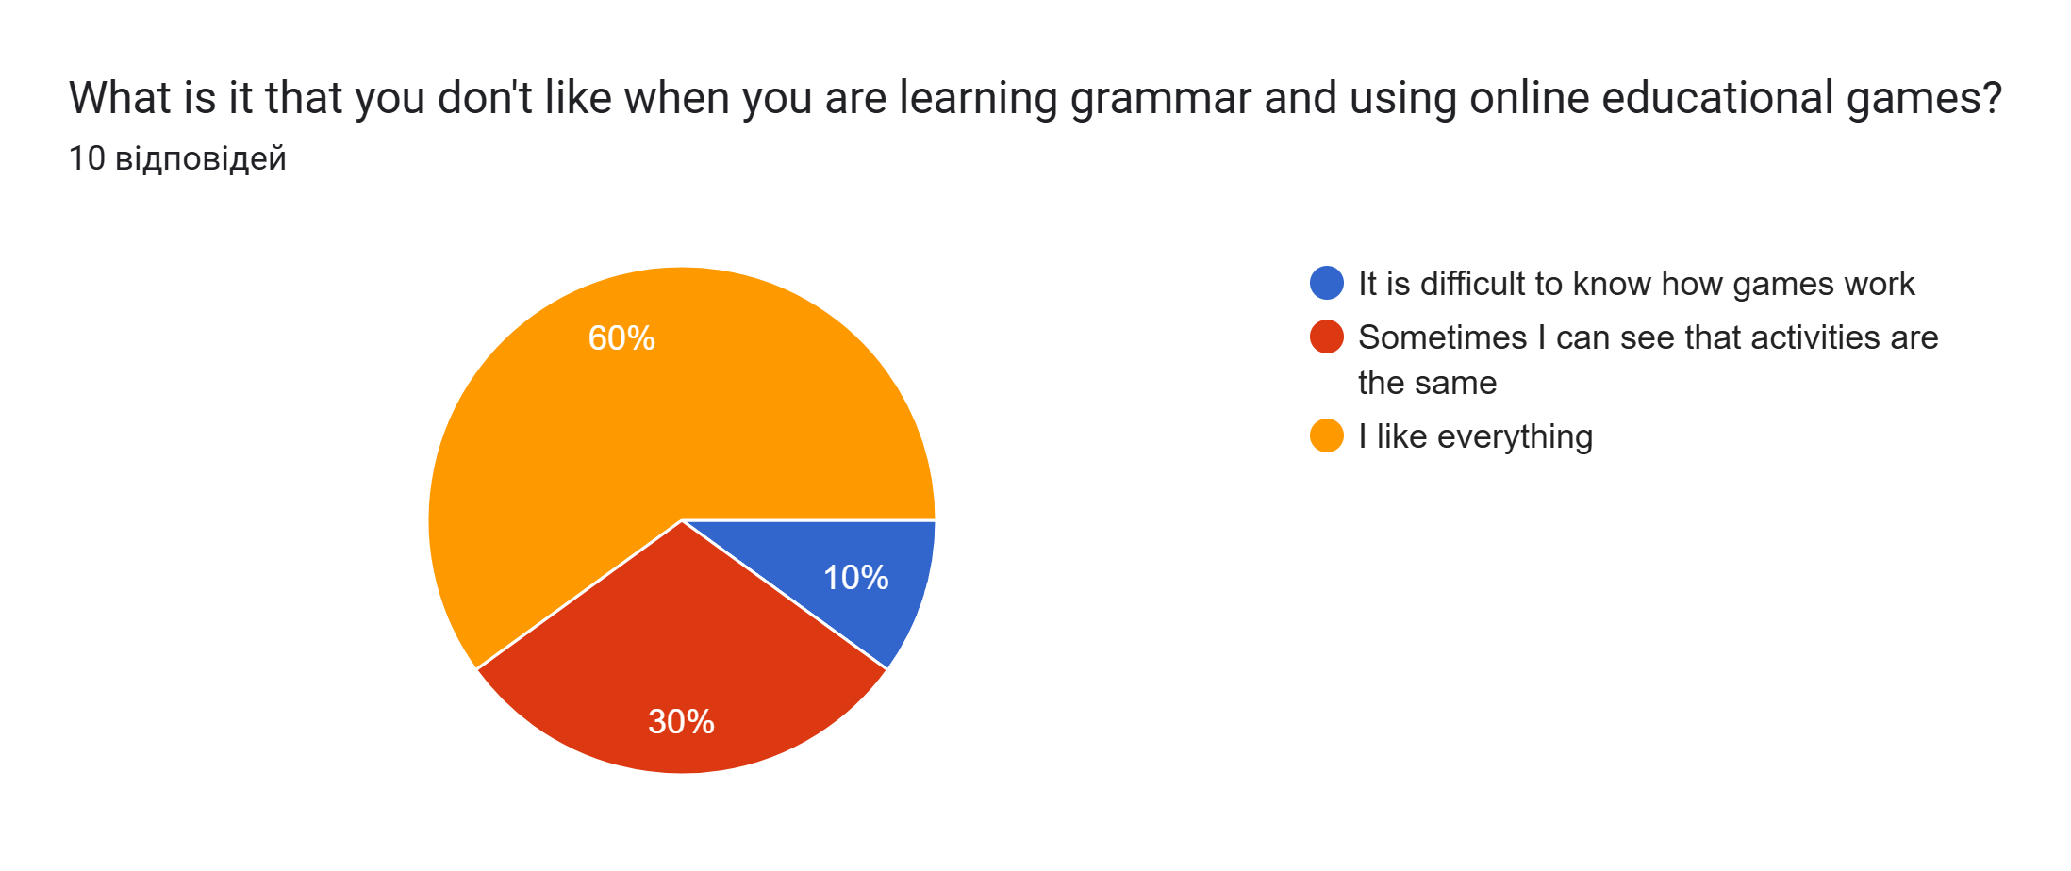
Figure 6
The students' answers to the question: Do you think that grammar should be taught with online educational games? Why?
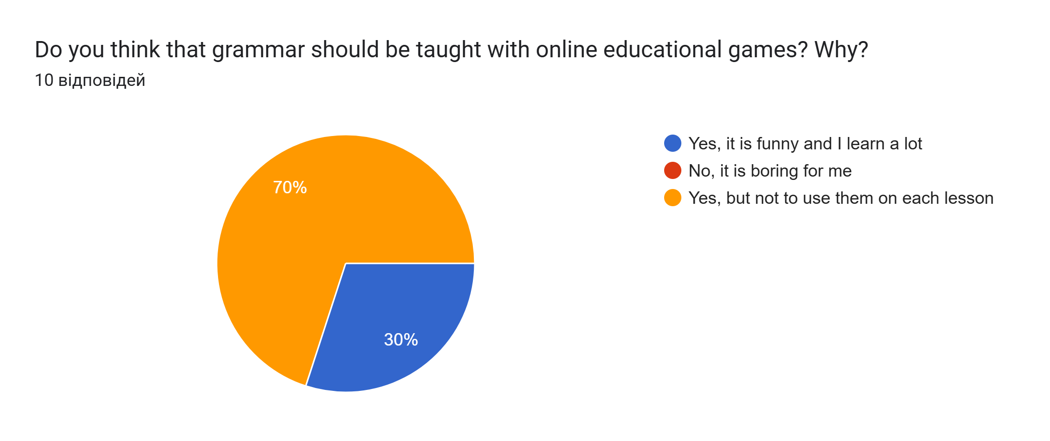
Answers
The students' answers to the question: Is there anything that you want to say before your teacher uses online educational games to see if your grammatical competence has developed?
Student 1: Online educational games are great tools in the process of learning grammar. It would be great to have more such activities during the class.
Student 2: I am ready to learn grammar with online educational games to see how my grammar will develop.
Student 3: I want to say that our teacher has used some educational online games, but it will be interesting to see how much I will learn to develop my grammar.
Student 4: I feel okay with it, but do not overdo it with these activities in every lesson.
Student 5: No.
Student 6: I have learned many things. Those grammar games are great.
Student 7: This is an excellent way of learning, and it should be used more.
Student 8: Yes, I am m eager to see if my grammar has improved, and I think this will be a fun way to test my progress.
Student 9: Not to make it too flashy and flowery because it can distract me from tasks.
Student 10: I am looking forward to learning new grammar because it is crucial to me. I think it will be even better to learn it with games.
The answers to this questionnaire will be compared with the next one after the evaluation stage.
During the main phase of our research, the focus was on developing grammatical competence that can be improved by using online platforms during the learning. A set of activities (games) was used for this, as shown in the Appendices section. Those activities were used alongside online educational games. Besides, during this stage, the observation took place. This tool was significant here, as it was vital to see how it affected students' learning of grammar, its development, and their feedback. At the beginning of employing online educational games, learners looked at them skeptically and did not know some. However, then using the observation, it was seen that students adored them, and their grammatical competence improved.
After finalizing this stage, a review of changes in the level of grammatical competence development among students was performed using a post-intervention test ( see Appendix C). The results of the post-test are presented in Table 3.
Table 3
Level of development of grammatical competence in the evaluation stage.
 | Low |  | Medium |  | High
Students | 1 | 10% | 5 | 50% | 4 | 40%

The comparison of the results of the pre-intervention and post-intervention tests is shown in Figure 7.
Figure 7
Level of development of grammatical competence in the evaluation stage (pre-and post-tests).

Overall, the analysis demonstrates some enhancement in students' grammatical competence from the initial to the control stages, with notable reductions in the proportion of students at the low proficiency level and substantial increases in those at the medium and high levels. As can be seen, firstly, four students had low levels, but after taking the post-test, there was only one student. Besides, it arose to 1 student who had a medium level, as there were four students in the beginning, but after the post-test, it was revealed to be 5. Moreover, it can be noticed that there are two more students who have a high level of proficiency.
Moreover, for the evaluation phase, to see the general image and how students felt about the meaning of using online educational games, students completed the questionnaire again. Ten students participated in it and answered questions in the questionnaire based on this experience. The questionnaire has six questions that consist of questions with given variants and 1 question that requires their response. (see Appendix E).

Figure 8
The students' answers to the question: How did you feel about using online educational games for learning grammar?
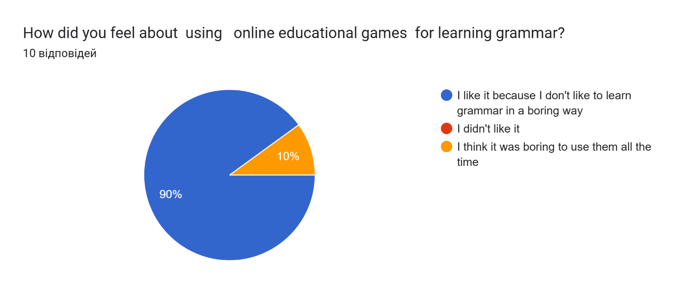
Figure 9
The students' answers to the question: Did you feel progress in grammar when we used online educational games on WordWall, Baamboozle, and other platforms?
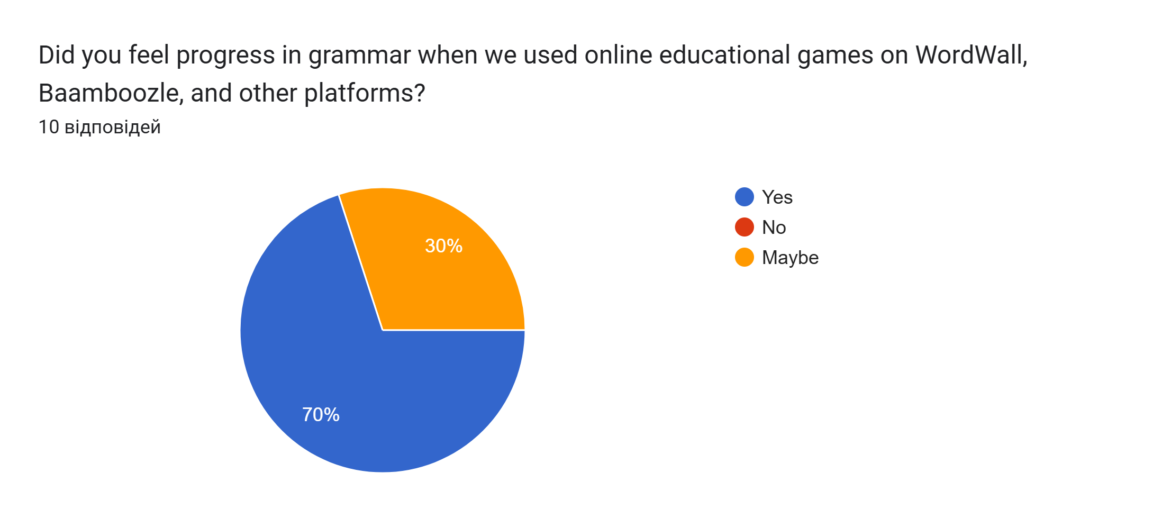
Figure 10
The students' answers to the question: What did you like when you were learning grammar and using online educational games?
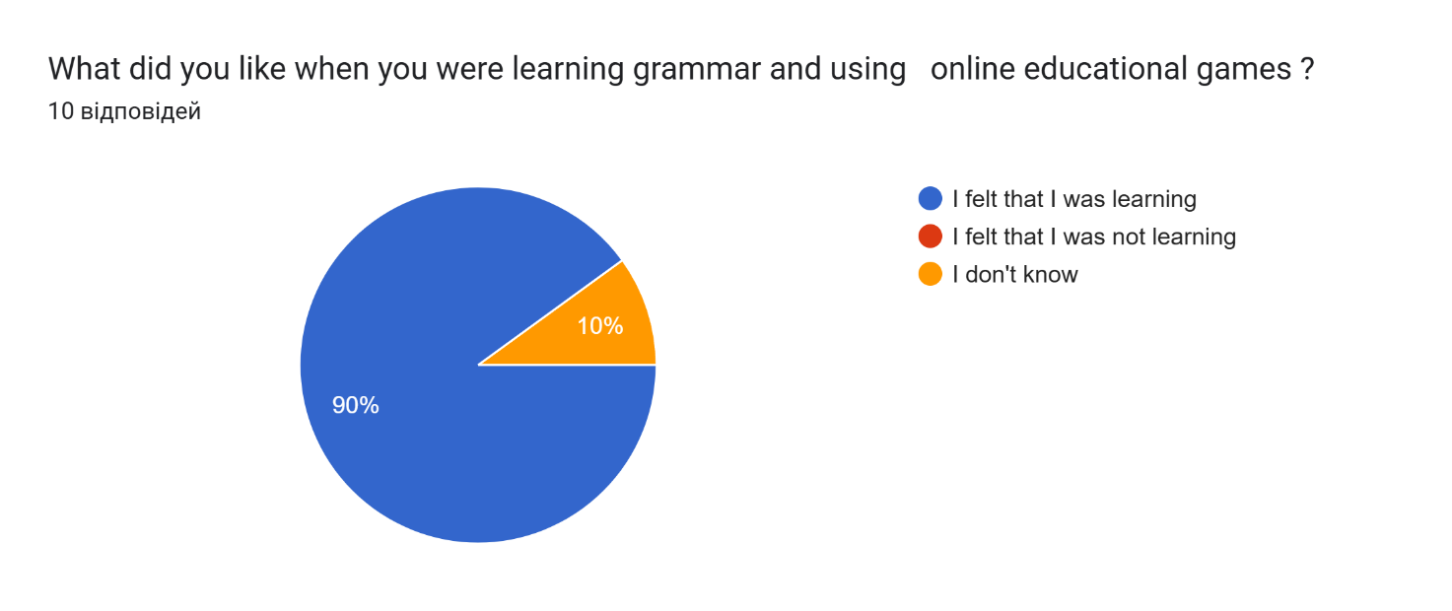
Figure 11
The students' answers to the question: What did you not like when you were learning grammar and using online educational games?
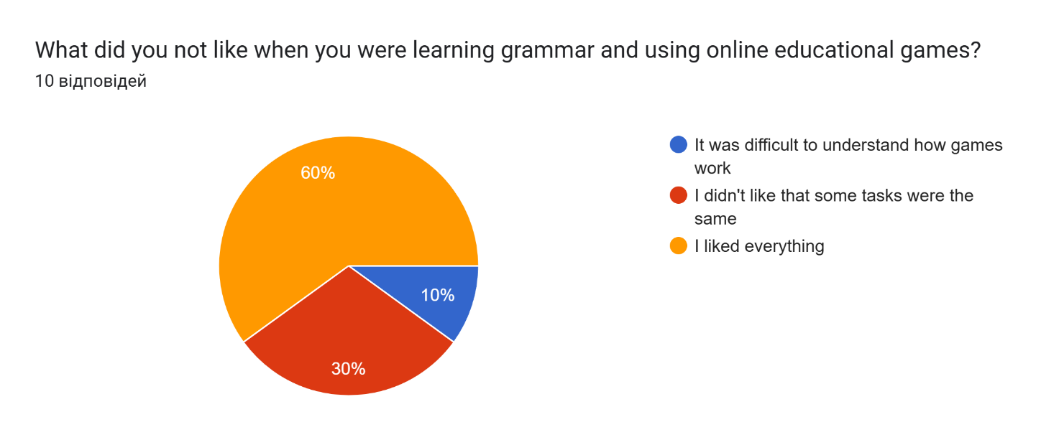

Figure 12
The students' answers to the question: Do you think that grammar should be taught with online educational games? Why?
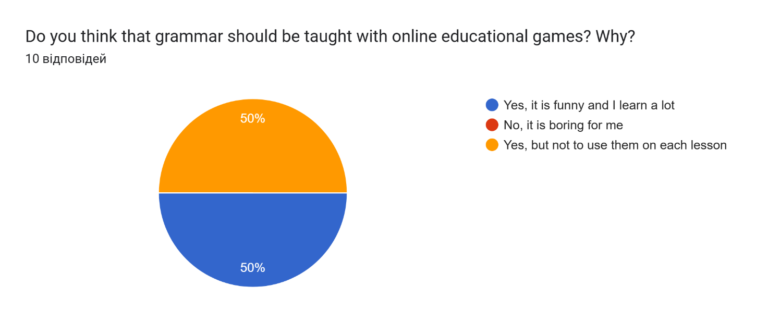
Answers
The students' answers to the question: Is there anything you want to say about how grammar was taught with educational online games?
Student 1: I liked to learn grammar with games. I find it interesting. I want our teachers to use them more when we have grammar lessons.
Student 2: It is fun, and I learned faster.
Student 3: It is not easy for me to learn grammar. However, with educational online games, I felt that it was easier. My grammar become much better.
Student 4: Educational online games are very effective in learning and teaching grammar. Using these educational tools has made the lesson very interesting and not dull.
Student 5: Nothing to say.
Student 6: I liked it a lot. It was really fun and useful to learn grammar in such a way.
Student 7: My thought is that I do not like when teachers use these online educational games because, simply, I do not like them. Nevertheless, of course, it is good to use them occasionally. I can say that maybe my grammar did not change much, but it was cool and fun to learn it in that way.
Student 8: It was interesting.
Student 9: When a teacher uses game tasks, it is always interesting.
Student 10: It is a good way for me to understand grammar.
In general, it can be said that participants had different responses to each question, but what can be seen is that they really enjoyed learning grammar with the help of online educational games because they preferred it more than learning it monotonously. On the other hand, it can be noticed that their responses were given in half when it came to the question, "Do you think that grammar should be taught with online educational games? Why?" because 50% think it should as it is interesting and they learn a lot and other 50% think that it should but not to use them on each lesson.
The comparison of two questionnaires done in different stages is presented in the following table.

Table 4
The analysis of two questionnaires based on the student's answers before and after online educational games was used to develop grammatical competence.
Category | Response | Before Using Games | After Using Games | Change (%)
Feelings About Using Games | Positive (e.g., 'I like it') | 8 (80%) | 8 (80%) | No Change
Feelings About Using Games | Neutral/Mixed (e.g., 'I do not care') | 0 | 1 (10%) | +10%
Feelings About Using Games | Negative | 2 (20%) | 1 (10%) | -10%
Perceived Progress in Grammatical competence | Yes | 7 (70%) | 6 (60%) | -10%
Perceived Progress in Grammatical competence | Maybe | 3 (30%) | 4 (40%) | +10%
Perceived Progress in Grammatical competence | No | 0 | 0 | No Change
Liked Aspects | Engaging and enjoyable | 10 (100%) | 10 (100%) | No Change
Liked Aspects | Easy to understand and user-friendly | 8 (80%) | 7 (70%) | -10%
Liked Aspects | Fast learning/perceived effectiveness | 6 (60%) | 6 (60%) | No Change
Disliked Aspects | Repetitiveness | 3 (30%) | 4 (40%) | +10%
Disliked Aspects | Complexity or difficulty in navigation | 2 (20%) | 3 (30%) | +10%
Disliked Aspects | Distracting elements | 0 | 2 (20%) | +20%
Opinions on the Future Use of Games | Yes, regularly | 6 (60%) | 5 (50%) | -10%
Opinions on the Future Use of Games | Yes, but not every lesson | 4 (40%) | 5 (50%) | +10%
Opinions on the Future Use of Games | No | 0 | 0 | No Change
Additional Comments | Positive (e.g., 'I want more games') | 8 (80%) | 7 (70%) | -10%
Additional Comments | Balanced (e.g., 'Games are good, but not too much') | 2 (20%) | 3 (30%) | +10%

Discussion
Conventional methods of grammar instruction have dominated for a long time. However, there is a growing shift in grammar learning and teaching methods due to various elements. Creative solutions for efficacious language teaching are developed, evaluated, and proposed as learning and teaching shifts from the instructor to the student. Integrating games in grammar instruction has become a popular method that many academics use in schools, and experts suggest efficacious grammar teaching, particularly in language teaching. This is due to the numerous benefits and implications of using games with EFL students (Khan et al., 2024).
Online educational games contribute to the optimization of the learning process, and this is due to the fact that technical support for lessons transforms into comfortable psychological conditions, where psychological barriers disappear through this, which has a positive effect on the pace of studying various topics taught in a foreign language and also improves the quality of education due to the provision to teaching.
In order to form the grammatical competence of high school students, various methods based on modern platforms for learning foreign languages can be used. In particular, it is crucial to use interactive technologies that allow students to actively engage in independent work and interact with other students and the teacher.
Using online educational games activates the educational process and is an effective means of developing grammatical competence. During all stages of work, it was found that any student is unconsciously or consciously ready to play, to express themselves, and, therefore, to learn grammar in a foreign language, mainly when pre-and post-tests were conducted. It must be said that there was a notable reduction of students with a low level of grammatical competence; this was 40%, which dropped to 10%. From this, it leads that online educational games were influential in developing grammatical competence for those students who struggled with it. Furthermore, in Hashim et al.(2019), eight participants scored from 40-49% for their pre-tests(where the highest one is 80-100%), but none of the participants received the post-test. The same goes for the range scores from 0-39%, where one participant scored it for the pre-test, but none scored the same for the post-test. The results proved that gamified learning can improve learners' ESL grammar. Most of the participants received better grades and were able to improve their grammar learning. Using online language games, which is also a technology-based learning tool, participants benefit more from it.
Besides, it was found from the questionnaires that were done before and after using online educational games to develop grammatical competence that a positive attitude towards them was maintained at 80% even though there was a slight increase in students who had mixed or neutral feelings. It is also important to state that they desire to use online educational games, but not every lesson has grown from 40% to 50%. Chen et al. (2019) consistently suggest that not all students find educational gamification fun and motivating. Some students may prefer to use traditional learning and teaching methods because, perhaps, it is a habitual behavior (Cheung & Ng, 2021).
When using modern platforms for learning foreign languages, such as WordWall, Educaplay, Baamboozle, and others, it is possible to ensure learning and assimilation of the material as efficiently as possible. It is also important to constantly monitor and control the learning process using them.
It was found that games in teaching help students' learning and increase their general interest in learning a foreign language. Online educational games in teaching are the key to achieving high results in learning and further development of the knowledge gained by students. The advantages and disadvantages of developing grammatical competence using educational online games were identified based on the observation and the questionnaire.
There are the following advantages:
- The efficiency of teaching;
- Increased motivation for learning;
- It is fun, and learners learn faster;
- Increased interest in the subject being taught;
- Activation of students' cognitive activity;
- Visibility in the presentation of educational material;
- It is a good way to understand grammar.
There are the following disadvantages:
- In addition to the mistakes made by the student in traditional lessons, technological errors associated with working in games appear;
- Teachers in schools do not apply them to lessons as students want to;
- Not all students like to learn grammar or other skills in this way;
- The teacher must have special knowledge;
- The use of games is devoid of emotionality.
The advantages of online educational games in education were looked at in more detail, which helped us understand that their use at a professional level contributes to increasing the effectiveness of the overall educational process, which entails the high quality of the material taught. Nevertheless, some disadvantages cannot be avoided, and teachers must challenge them.
After conducting research, the conclusion was made that the role of online educational games in studying foreign languages is to ensure a high-quality educational process and make education more exciting. The use of online educational platforms in the process of learning foreign languages and in the aspect of individualization of learning can become the very pedagogical tool that contributes to the improvement of the quality of knowledge acquisition by tracing the individual educational path of the learner, as well as, identifying cause-and-effect relationships between online activity educational platforms and educational success. The implementation of online education makes the student an active participant in education who consciously carries out the process of learning and learning a foreign language.
However, since the questionnaires showed that online educational games can lead to repetitiveness, this might need further research. Besides, as it was stated, there is a preference not to use games in every grammar lesson, so the recommendation for further action might be to balance the traditional teaching approach with educational online games.

Conclusion
The research aimed to discover how online educational games affect EFL students' learning and development of grammatical competence and whether different online educational games help to develop students' grammatical competence. Furthermore, it can be said that:
- The study investigated the development of EFL grammatical competence using educational online games in high school, and this term was defined. The importance of online educational games was presented. Other important terms, such as types of grammar activities, awareness, matching, controlled drills, controlled practice, and guided and meaningful practice, were described.
- Tests, questionnaires, and observation were chosen as data collection tools to gather information and reach the research aim. Pre- and post-tests, two questionnaires, and observation were used to observe students' feelings and feedback towards online educational games regarding developing grammatical competence.
- During the observation, it was found that students were doubtful about how their grammar would improve by using online educational games, but for that, this research was done, and a set of activities was created.
- The set of activities was done and tested with ten students from the eleventh grade of Talalayivka lyceum of Talalayivka village council, Nizhyn district, Chernihiv region. Games (activities) were built on educational online platforms and used during the main phase of the research.
- A comparison of pre-and post-tests can demonstrate that students' grammatical competence has increased exponentially: before using online educational games, a low level of grammatical competence was 40% in 4 students, but after using them, only one student had a low level. Moreover, other levels, such as medium and high, were also improved. That shows that students' grammatical competence has developed well through the use of online educational games.
- The findings reveal that online educational games used and created on various online platforms (Baamboozle, WordWall, LearningApps.org, and others) mainly had a positive impact, while some students, according to the questionnaires, preferred traditional teaching and expressed the need for a balanced usage of educational online games.
- Giving the answers to the research questions, it should be said that online educational games affected EFL student's learning and development of grammatical competence in a way that students' grammatical competence has been enhanced, looking at the results from the pre-and post-tests. However, it can be seen that it is good to use them but not in every lesson. In addition, it can be stated that different online educational games help to enhance grammatical competence as long as they are educational and educators use them to develop grammatical competence.
- Based on the research, it is worth emphasizing the recommendations. Firstly, to balance traditional teaching (using student's books, classroom whiteboards, and other things) with educational online games. Secondly, do not use complex or challenging games that can lead to negative results. It is also essential to consider that games must be conducted only in the context of teaching, as was done in the research on developing grammatical competence.
So, based on the work done, online educational games can effectively develop EFL grammatical competence in high school students.

References
- Дворник В. (2024) Development of EFL grammatical competence using educational online games. Всеукраїнська Науково-Практична Конференція Молодих Науковців Та Студентів ФІЛОСОФІЯ, ФІЛОЛОГІЯ, КУЛЬТУРА, ОСВІТА: СЛОВО МОЛОДІ (26 Березня 2024 р., м. Чернігів), 59–60.
- Дворник , В. (2024). Bridging the gap in English grammar proficiency with online educational games in high school. ВІСНИК Студентського Наукового Товариства , (30), 108–112. https://doi.org/373.5.016:811.111' 36]:373.091.3:004
- Котенко, О. В., Соломаха, А. В. (2013). Методика навчання іноземних мов у початковій школі: навч.посіб. для студ. вищ. навч. Закл. Київ: Київ. ун-т ім. Б.Грінченка.
- Коломієць, А. (2015). Використання інтернет-сайтів на заняттях з іноземної мови. Наука і освіта. 9. 102–107.
- Alem, D. D. (2021). Teaching grammar: in the view of conventional VS contemporary approach. NEW ACADEMIA: An International Journal of English Language, Literature and Literary Theory, X(II). https://doi.org/https://interactionsforum.com/2021/new-academia-vol-x-issue-ii-april 2021#:~:text=TEACHING%20GRAMMAR%3A%20IN%20THE%20VIEW%20OF%20CONVENTIONAL%20VS%20CONTEMPORARY%20APPROACH
- Awareness-raising. TeachingEnglish. (n.d.). https://www.teachingenglish.org.uk/professional-development/teachers/knowing-subject/c/awareness-raising
- Belyh, L. (2019, September 8). Solutions pre intermediate. student's book 2017, 3rd 142 P. Academia.edu. https://www.academia.edu/40289242/Solutions_Pre_Intermediate_Students_Book_2017_3rd_142p
- Cad, A.C., Spataro, C.A., Carrera, P.A. (2021). Fostering Interaction and Motivation in EFL Live Virtual Classes at University. In: Chen, J. (eds) Emergency Remote Teaching and Beyond. Springer, Cham. https://doi.org/10.1007/978-3-030-84067-9_12
- Castillo-Cuesta, L. (2020). Using digital games for enhancing EFL grammar and vocabulary in higher education. International Journal of Emerging Technologies in Learning (iJET), 15(20), 116-129.
- Cheung, S. Y., & Ng, K. Y. (2021). Application of the educational game to enhance student learning. Frontiers in Education, 6, 1–10. https://doi.org/10.3389/feduc.2021.623793
- DeKeyser, R. (2007). Practice in a Second Language: Perspectives from Applied Linguistics and Cognitive Psychology. Cambridge: Cambridge University Press.
- George, T. (2023, June 22). Types of interviews in research | Guide & Examples. Scribbr. https://www.scribbr.com/methodology/interviews-research/
- Gilakjani, A. (2012). Visual, Auditory, Kinesthetic Learning Styles and Their Impacts on English Language Teaching. Journal of Studies in Education. 1. 104–113.
- Hashim, H., Rafiqah M. Rafiq, K., & Md. Yunus, M. (2019). Improving ESL learners' grammar with gamified-learning. Arab World English Journal, (5), 41–50. https://doi.org/10.24093/awej/call5.4
- Hussain, I. (2017). Pedagogical Implications of VARK Model of Learning. Journal of Literature, Languages and Linguistics. 38. 33–37.
- Idris, M. I., Said, N. E. M., & Tan, K. H. (2020). Game-based learning platform and its effects on present tense mastery: Evidence from an ESL classroom. International Journal of Learning, Teaching and Educational Research, 19(5), 13-26.
- Jannah, R., Nor, H., & Asfihana, R. (2023). The implementation of gamification to teach grammar in higher education. ELT Forum (Semarang, Indonesia), 12(2), 122-133. https://doi.org/10.15294/elt.v12i2.64683
- Khan, R., Alahmadi, A., & Kumar, T. (2024). Evaluating the Impact of Digital Interactive Games in Developing EFL Grammar Skills. World Journal of English Language, 14(3), p463. doi:http://dx.doi.org/10.5430/wjel.v14n3p463
- Kravchenko, A. (2023, September 11). Types of drilling. The classification of drilling in ELT and when to use it. https://grade-university.com/blog/types-of-drilling
- LearnTeachTravel. (2020, June 2). Controlled practice activities. Learn. Teach. Travel. https://learnteachtravel.com/controlled-practice-activities/
- Melati, E., Malabar, F., Hardiansyah, A., Husen, N., & Adi Cakranegara, P. (2022a). Identification of online educational game applications in teaching English for madrasah students. Nazhruna: Jurnal Pendidikan Islam, 5(3), 994–1012. https://doi.org/10.31538/nzh.v5i3.2502
- NSW Federation of Community Language Schools INC. (2020, May 29). "Grammaring" activities by SCOTT THORNBURY video master class [Video]. YouTube. https://www.youtube.com/watch?v=HWWE1Jt4OGE
- Petrat, P. (2024, October 21). What is a questionnaire and how is it used in research? CintTM | Digital Insights Gathering Platform. https://www.cint.com/blog/what-is-a-questionnaire-and-how-is-it-used-in-research/
- Pratama, G. A. (2020). Students' perception of gamification to promote classroom engagement and motivation in senior high school. Language Research Society, 1(1).
- Puspitasari, I., Pureka, M. N. Y., & Azizah, N. (2023). Integrating ICT: EFL Students' Challenge in Learning Grammar. Proceeding of Conference on English Language Teaching (CELTI) English Education Department, Faculty of Tarbiya and Teacher Training State Islamic University of Prof. K.H. Saifuddin Zuhri Purwokerto, 3, 433–441.
- Rahmani, E. F. (2020). The benefits of gamification in the English learning context. IJEE (Indonesian Journal of English Education), 7(1), 32-47. https://doi.org/10.15408/ijee.v7i1.17054
- Ramadan, M. (2020, October 24). The 3 main kinds of drills to practice grammar. elttguide.com. https://elttguide.com/the-3-main-kinds-of-drills-to-practice-grammar/
- Ramadan , M. (2021, December 13). The 3 main types of grammar practice activities. English Language Teaching & Testing Guide. https://elttguide.com/wp-content/uploads/2021/12/The-3-Main-Types-Of-Grammar-Practice-Activities.pdf
- Redjeki, I. S., & Muhajir, R. (2021). Gamification in EFL classroom to support teaching and learning in 21st century. JEES (Journal of English Educators Society) (Sidoarjo), 6(1), 68-78. https://doi.org/10.21070/jees.v6i1.882
- Ringelová, J. (2017). Analysis of Potential benefits of using gamification in English learning in a high-school educational context. https://is.muni.cz/th/x4cdk/?lang=en
- Rosydiyah, A., Asari, S., & Maruf, N. (2022). The effectiveness of Wordwall online games as technology-based learning on grammar quality among junior high students |Budapest International Research and Critics Institute-Journal (BIRCI-Journal). https://www.bircu-journal.com/index.php/birci/article/view/6818
- Sakdiyah, I. H., Maolida, E. H., & Nurviyani, V. (2024). Utilizing game-based learning baamboozle in developing students' English grammar mastery. JALL (Journal of Applied Linguistics and Literacy), 8(1), 132–142. https://doi.org/10.25157/jall.v8i1.12755
- Satapathy, S. (2019). Observation as a tool for collecting data. International Journal Of Multidisciplinary Educational Research, 8(5), 152–164.
- Saville-Troike, M. (2006). Introducing Second Language Acquisition. New York: Cambridge University Press.
- Seaton, J. X., Chang, M., & Graf, S. (2019). Integrating a learning analytics dashboard in an online educational game. Smart Computing and Intelligence, 127–138. https://doi.org/10.1007/978-981-32-9335-9_7
- Torres Celi, Y. A., Ramón Rodríguez, B. L., & Criollo Vargas, M. I. (2023). Gamification on learning English grammar by using technology. Investigación Contemporánea Desde Una Visión Multidisciplinar. Libro 2. Ciencias Sociales, VI, 123–140. https://doi.org/10.58995/lb.redlic.9.111
- What are Educational Games? - Twinkl. (n.d.). Twinkl https://www.twinkl.com.se/parenting-wiki/educational-games
- York, J., Poole, F. J., & deHaan, J. W. (2021). Playing a new game - An argument for a teacher‐focused field around games and play in language education. Foreign Language Annals , 54 (4), 1164-1188.
- Yuliyanto, Y., & Fitriyati, N. R. (2019, July 24). Boosting students' interest in learning grammar by using Quizlet. Portal Publikasi Ilmiah UMS. https://publikasiilmiah.ums.ac.id/bitstream/handle/11617/11145/14. BOOSTING STUDENTS' INTEREST IN LEARNING GRAMMAR BY USING QUIZLET.pdf?sequence=1&isAllowed=y

Appendices

Appendix A

The set of activities (educational online games)
Activity (game) 1
Topic: Future plans of school-leavers.
Grammar focus: The Present Perfect Continuous, The Past Perfect Continuous, and The Future Perfect Continuous.
The aim: to raise awareness of forming The Present Perfect Continuous, The Past Perfect Continuous, and The Future Perfect Continuous, to translate the sentences from English into Ukrainian.
The outcome: learners will be able to differentiate sentences in Present Perfect Continuous, Past Perfect Continuous, and Future Perfect Continuous.
Type of grammar activity: awareness, matching.
Instruction: Match sentences to their translation online. Name the grammar tense used.
Model: She has been thinking of taking a gap year after school for a long time. Matches to sentence: Вона думає взяти рік без навчання після школи вже довгий час. Grammar tense: The Present Perfect Continous.
Procedure: The students receive the game link in the Zoom conference and follow it. When they open it, the teacher provides model of the game. After the teacher asks CCQ to see if the students understand what they are to do. Besides, in the upper left corner, they can press on the question mark where the task explanation is.
The students did the activity online individually—the student who was the first to do it and had the highest score got an excellent mark. Students can see immediately in the game if they are doing the right things or making mistakes because the game will show them their mistakes colored in red after they press the button finish.
Assessment and feedback: Immediate online, immediate by the teacher
Online platform: LearningApps.com

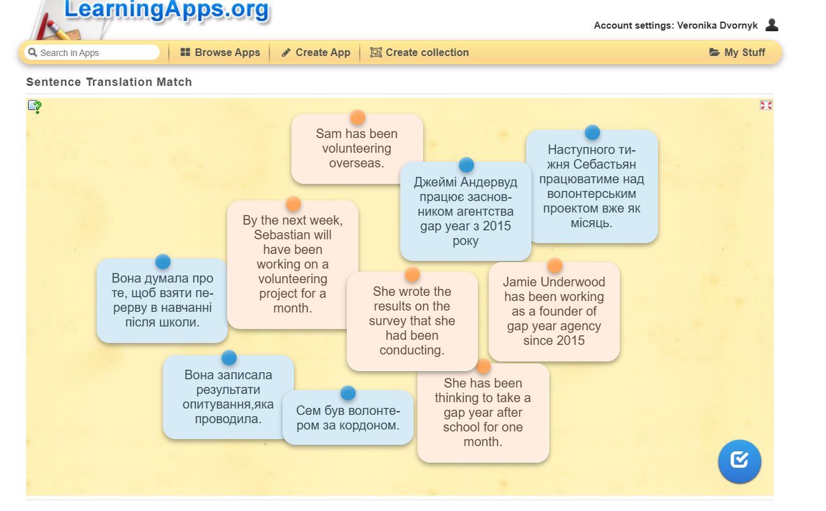
Activity (game) 2
Topic: Professional skills and abilities of a person.
Grammar focus: Reported Speech.
The aim: to raise the learner's understanding of reported speech in sentences within the topic.
The outcome: by the end of this activity, students will be able to change sentences from Direct Speech to Reported Speech by choosing the correct verb forms.
Type of grammar activity: controlled drill.
Instruction: Read the sentence that is written in the Direct Speech and put the verbs in the form that has Reported speech.
Model: She is not punctual at work.=> She said that she ____ punctual at work. What is the missing form of the verb there? (The correct answer: She said that she was not punctual at work).
Procedure: The students receive the game link in the Zoom conference and follow it. When they open it, the teacher announces the instruction and gives the model. The teacher asks CCQ to see if students really know what to do. The teacher points out that they will write their names when they are finished with the game to see themselves on the leaderboard. In that way, students compete with each other, knowing that they will receive ten points in this game if they have the highest score.
Students have 5-7 minutes to do this task. If they have questions, they can ask the teacher directly. After, when the time is up, the teacher looks at the leaderboard and can understand who prevails and who does not by this game. Nevertheless, the teacher asks students if they have some questions about the sentences where they have mistakes.
Assessment and feedback: Immediate online in the game by showing the score and correct/incorrect answer.
Online website: WordWall.
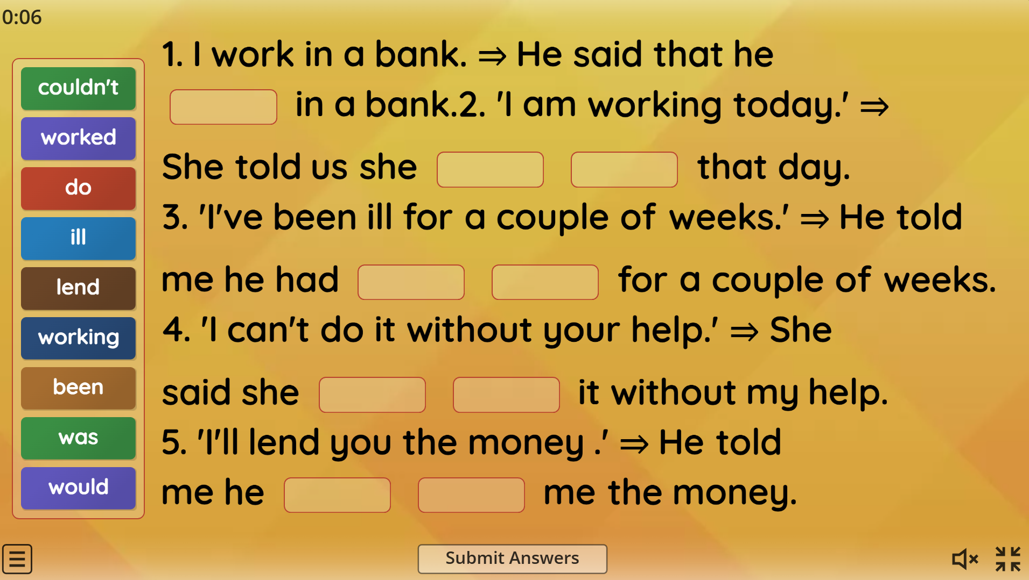
Activity (game) 3
Topic: The choice of future profession.
Grammar focus: Present Perfect Continuous and Present Perfect tenses.
The aim: to identify and differentiate between Present Perfect Continuous and Present Perfect tenses in dialogues about choosing a future profession.
The outcome: students will be able to recognize Present Perfect Continuous and Present Perfect tenses in dialogues by reading them and identifying the tense.
Type of grammar activity: awareness.
Instruction: Read the following dialogues and decide which cards you must match by grammar tense, either Present Perfect Continuous or Present Perfect, used in the dialogues.
Model: John, how long have you been looking for your career path? - It is the Present Perfect Continuous.
Procedure: The students receive the game link in the Zoom conference and follow it. When they open it, the teacher says what they need to do. Moreover, students have been acquainted with these dialogues before because this game is a part of the story, and when they are done playing it, they will read on other cards what happens with each character from this game. The teacher sets a time for them as 3 minutes.
Besides, the teacher makes a mark on this: if students combine the two parts that are not correct, the game will not let them finish it until they match it to the correct answer.
After the students are done, the teacher and students look at these dialogues together to ensure they understand the usage of different tenses.
Assessment and feedback: Immediate online
Online website: Quizlet
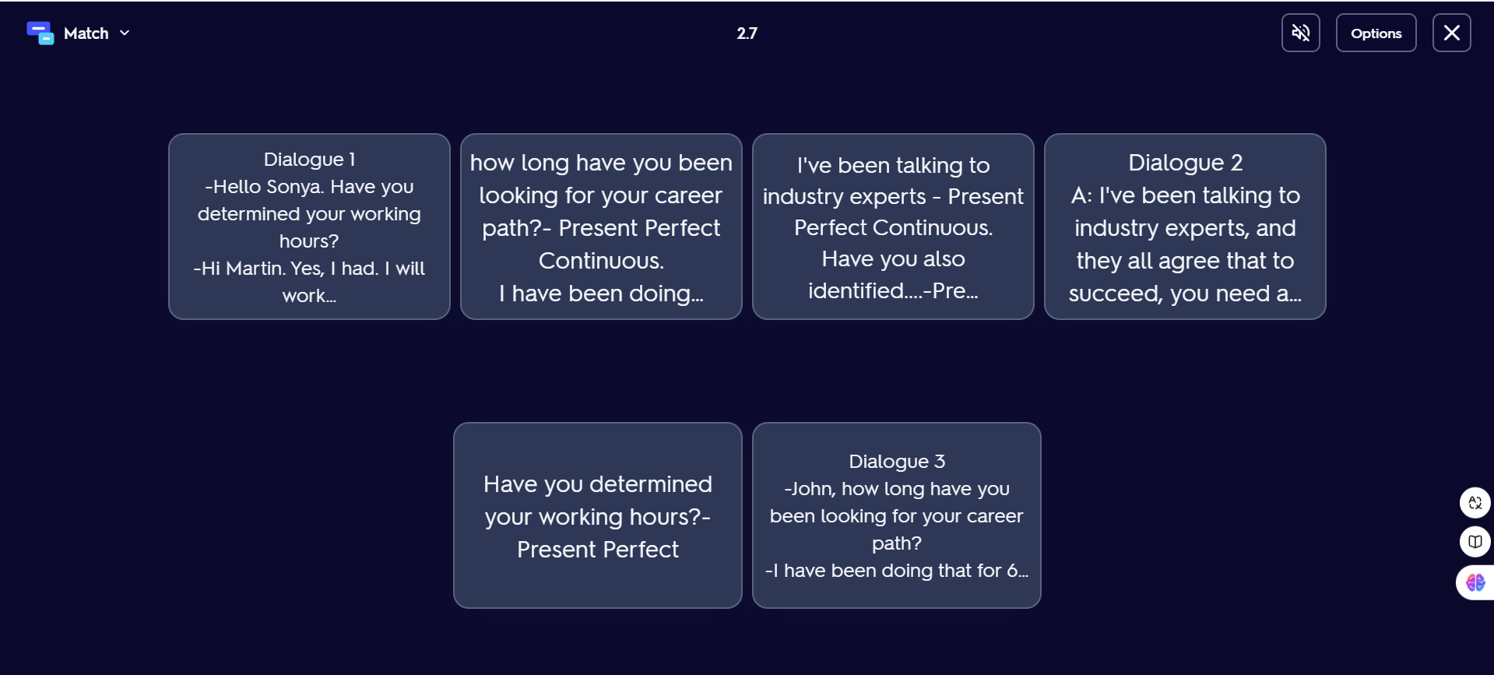


Activity (game) 4
Topic: Gender stereotypes in education, The first conditional.
The aim: to develop the learner's ability to use the first conditional.
The outcome: Learners will be able to use sentences with the first conditional in the context of gender stereotypes in education.
Type of grammar activity: controlled drill.
Instruction: Complete sentences with the verbs in the first conditional (if +present simple, will+ infinitive)
Model: If girls… the same jobs as boys, it … be a gender stereotype. (do, won't) > If girls do the same jobs as boys, it won't be a gender stereotype.
Procedure: The teacher announces the instruction about the game in WordWall and gives the model. The teacher says that in this game, they will play as two groups competing. Students say with whom they want to play this game in a group.
The teacher also says that a red cross will appear towards the incorrect answer when they make mistakes in the game. Students can also use three hints that the teacher has created: help from a classmate from your group, help from the teacher, and help from the opponent group. All of this will create a spirit of competition, and the group with the most correct answers will also receive an excellent mark.
Each student from the two groups read one sentence at a time, try to open the gaps and complete the sentence grammatically and logically while others are listening.
Assessment and feedback: Immediate online
Online website: WordWall.

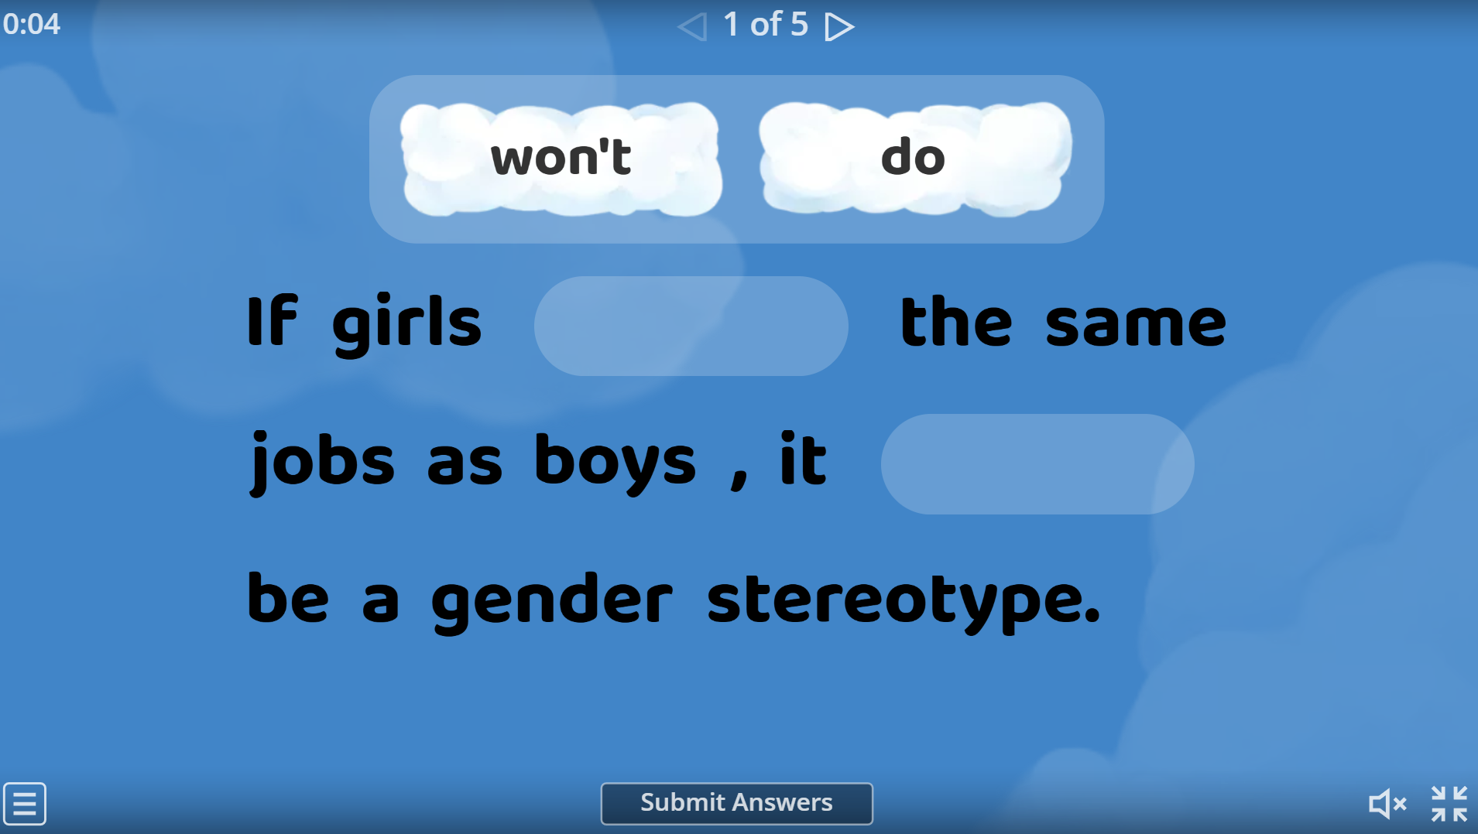

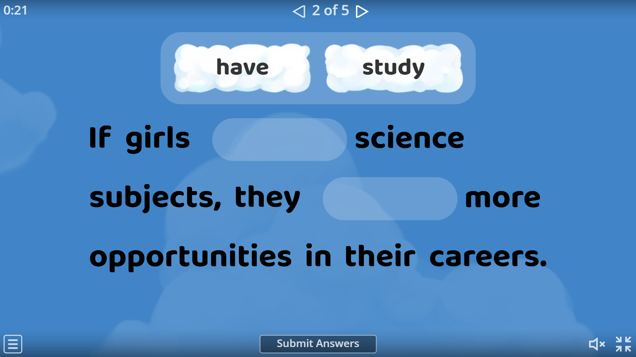
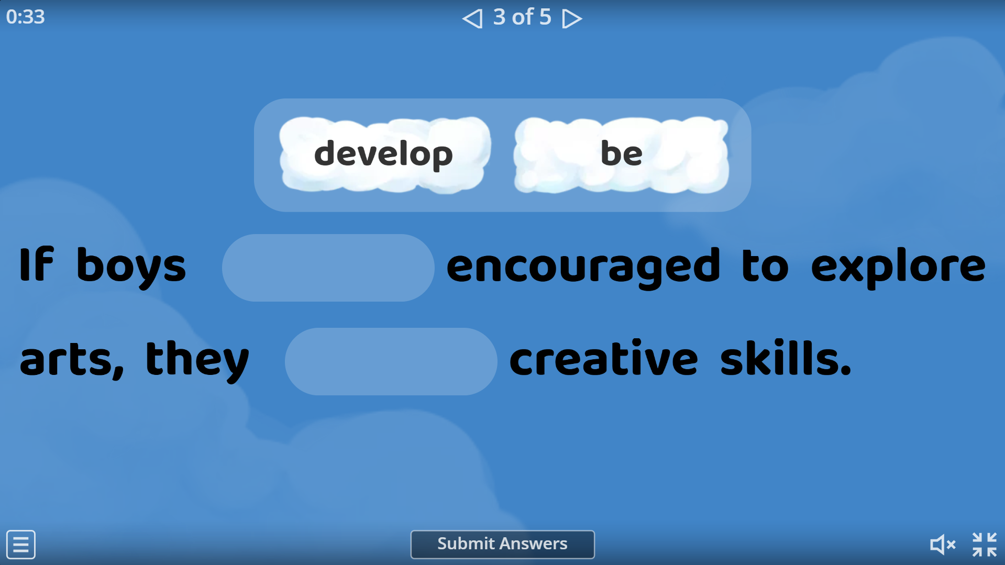

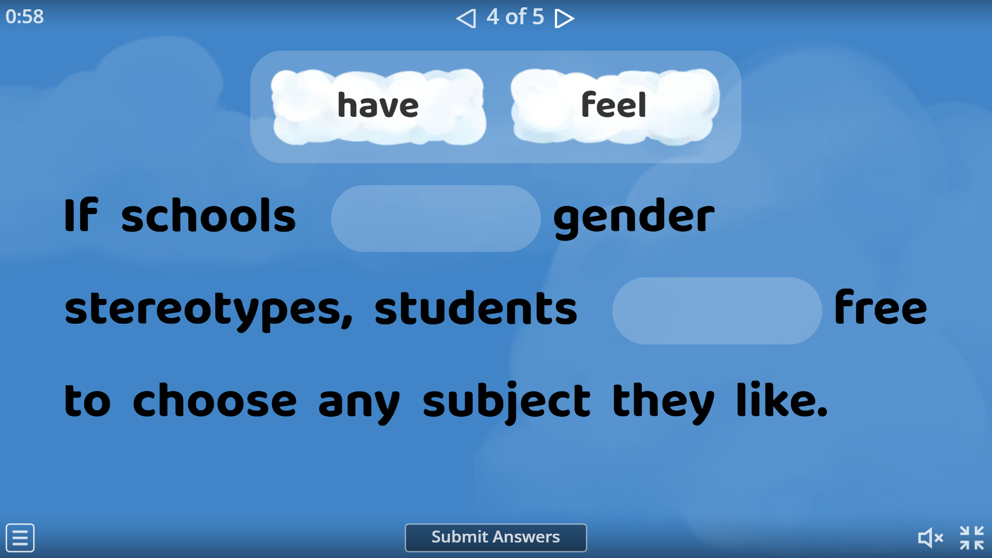

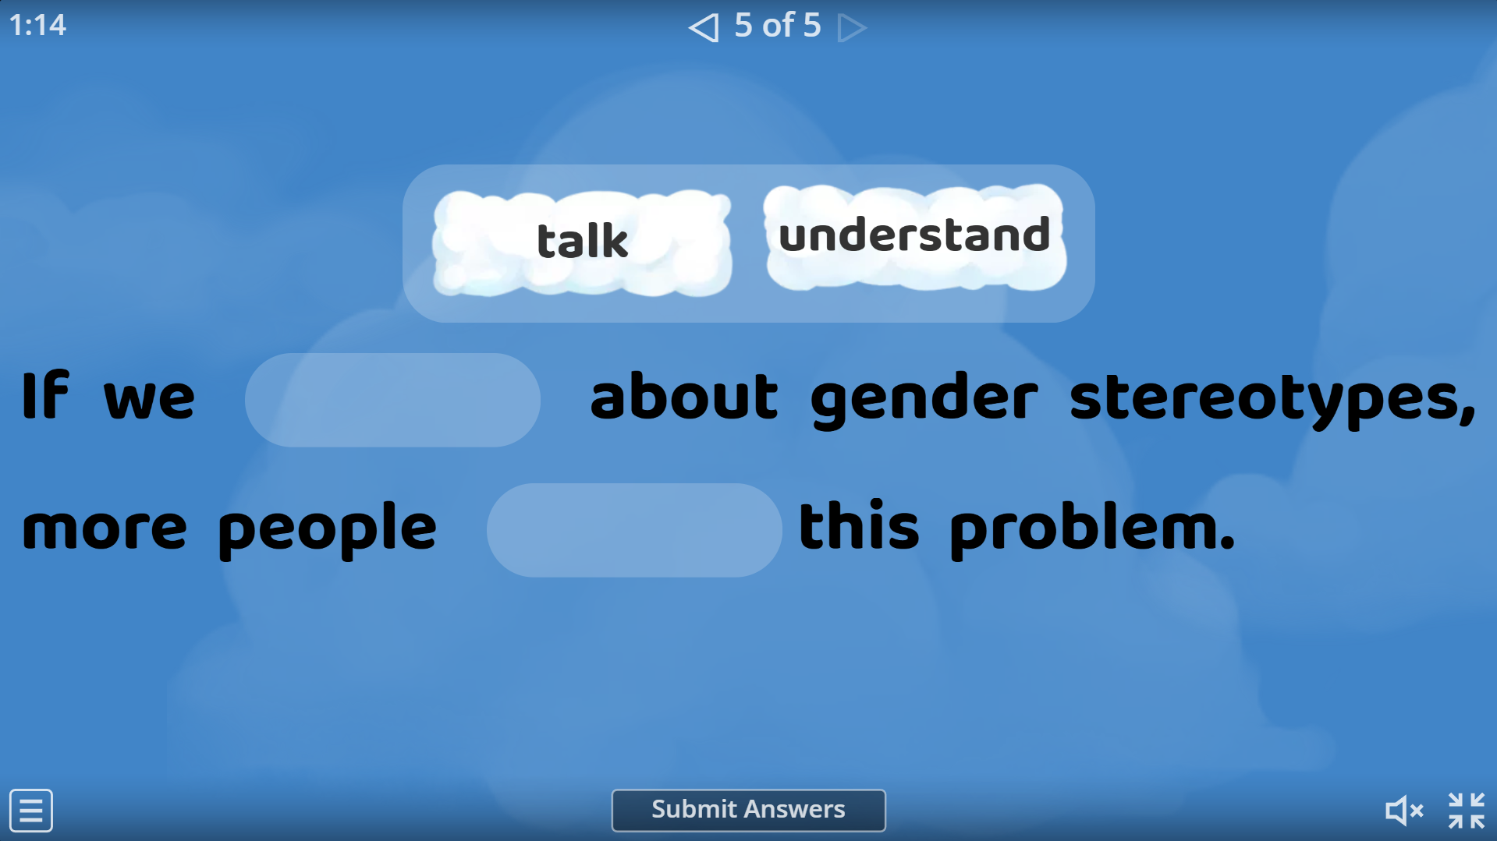

Activity (game) 5
Topic: Gender stereotypes in education
Grammar focus: The first conditional.
The aim: to continue practicing using the first conditional.
The outcome: students will be able to use and identify the first conditional in emails in the context of gender stereotypes in education.
Type of grammar activity: controlled practice.
Instruction: Complete the email in pairs. Use the correct form of the verbs in brackets.
Model: I’m sure I ____(pass), if I ____(work) hard.
Procedure: The teacher points out pairs of students and assigns them to breakout rooms.
Before opening them, the teacher says that they have the link in the chat to the game, and they need, together in pairs, to complete the email by putting verbs into the correct form of the first conditional. Besides, the teacher says that the correct answers will be colored green and the wrong ones - red.
Students have 7 minutes to play this game. The teacher visits breakout rooms to observe if students understand their assignment and if they do something. After the time is up, the teacher asks one student from each pair to read the sentence, and if they make a mistake, they will lose a point and get 10 points.
Assessment and feedback: Immediate online
Online website: LearningApps.com
Student's book Solutions Pre-Intermediate, page 56 (Belyh, 2019)

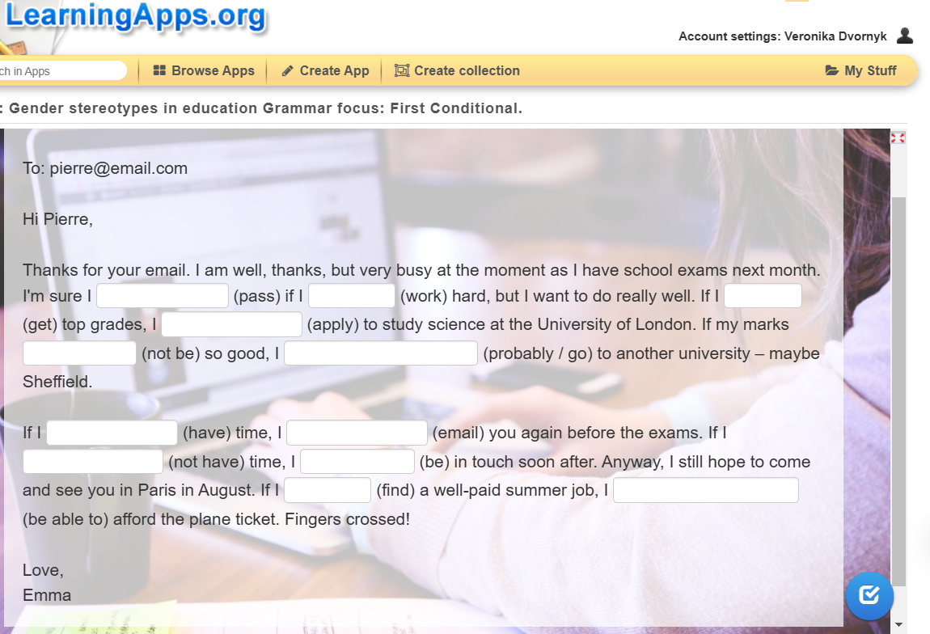

Activity (game) 6
Topic: Prepare for exams.
Grammar focus: The second conditional.
The aim: to teach the usage of the second conditional and its form.
The outcome: Students will be able to talk about imaginary situations and the consequences of preparing for exams.
Type of grammar activity: controlled drill, matching.
Instruction: Match the first part of the sentence to the second part so it will be grammatically correct to the rules of the second conditional.
Model:
1. If I took responsibility more seriously | A)I would use more words in the exam
2. If I read my vocabulary every day | B) I would do better at the exam

Keys: 1-B; 2-A
Procedure: The teacher explains to students what they need to do (previously, they had a link to the game and opened it) and points out that in the game, the time to complete the game is 2 minutes. Besides, the teacher says their names will be written on the leaderboard, and the countdown of time will also be written in the game.
The teacher asks CCQ if the students know what to do and how to play this game.
When students play this game, they can see how many scores they have at the moment of playing. Moreover, when they are finished with the game, the total score will be written, and if one student has earned the most scores, he/she will have feedback on the screen: "You won! Congratulations".
After, when the time is up, students can see their place on the leaderboard (top 10 results) and understand who prevails and who does not by this game. Those who have the highest scores will get an excellent mark. Nevertheless, the teacher asks students if they have some questions about the sentences where they have mistakes.
Assessment and feedback: Immediate online
Online website: Educaplay

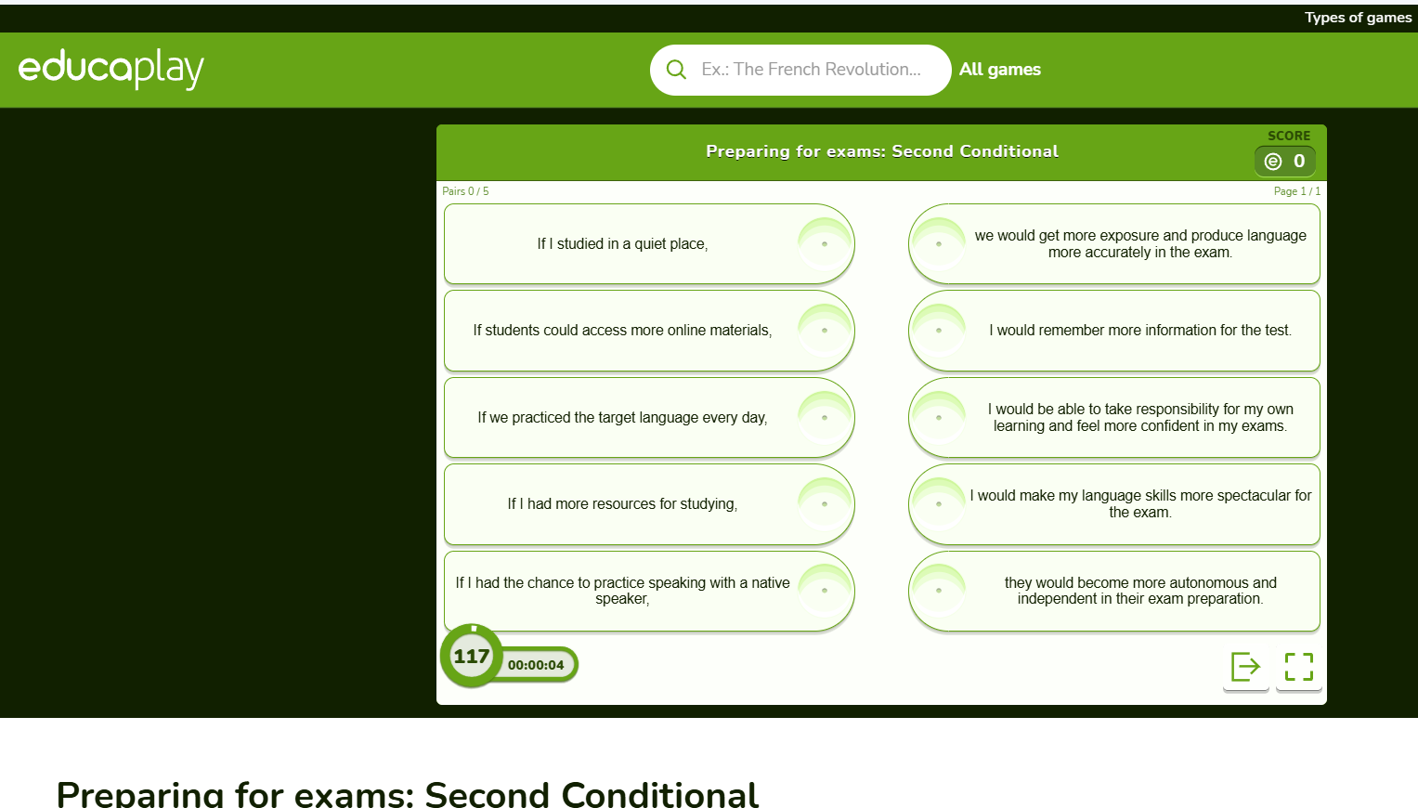

Activity (game) 7
Topic: Prepare for exams.
Grammar focus: The first and the second conditionals.
The aim: to wrap up the knowledge of the first and the second conditionals.
The outcome: learners will be prepared to use the first and the second conditionals not only in the context of preparing for exams but also for using these grammar structures in other spheres.
Type of grammar activity: guided, meaningful practice.
Instruction: In each sentence, you have missing parts. Put them into the sentences, but remember the usage of the first and the second conditionals.
Model: If you _____ every day, your results ______( will be more spectacular, practice)
Procedure: The teacher announces the instruction and gives the model of the game in WordWall. The teacher says that they will write their names before playing this game to see their rank, score, and time spent on the game. The teacher also says that a red cross will appear towards the incorrect answer when they make mistakes in the game.
Students play this game online, individually. They read one sentence and tried to put missing parts into the sentence. Those students who are the first, the second, and the third in rank will receive an excellent mark.
Assessment and feedback: Immediate online
Online website: WordWall.

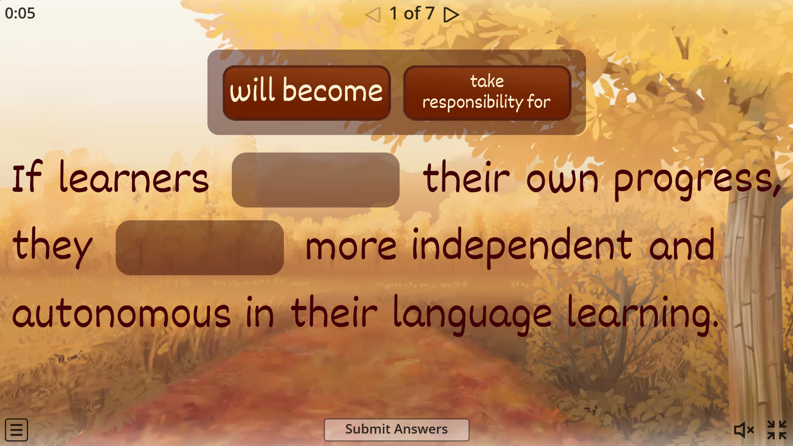

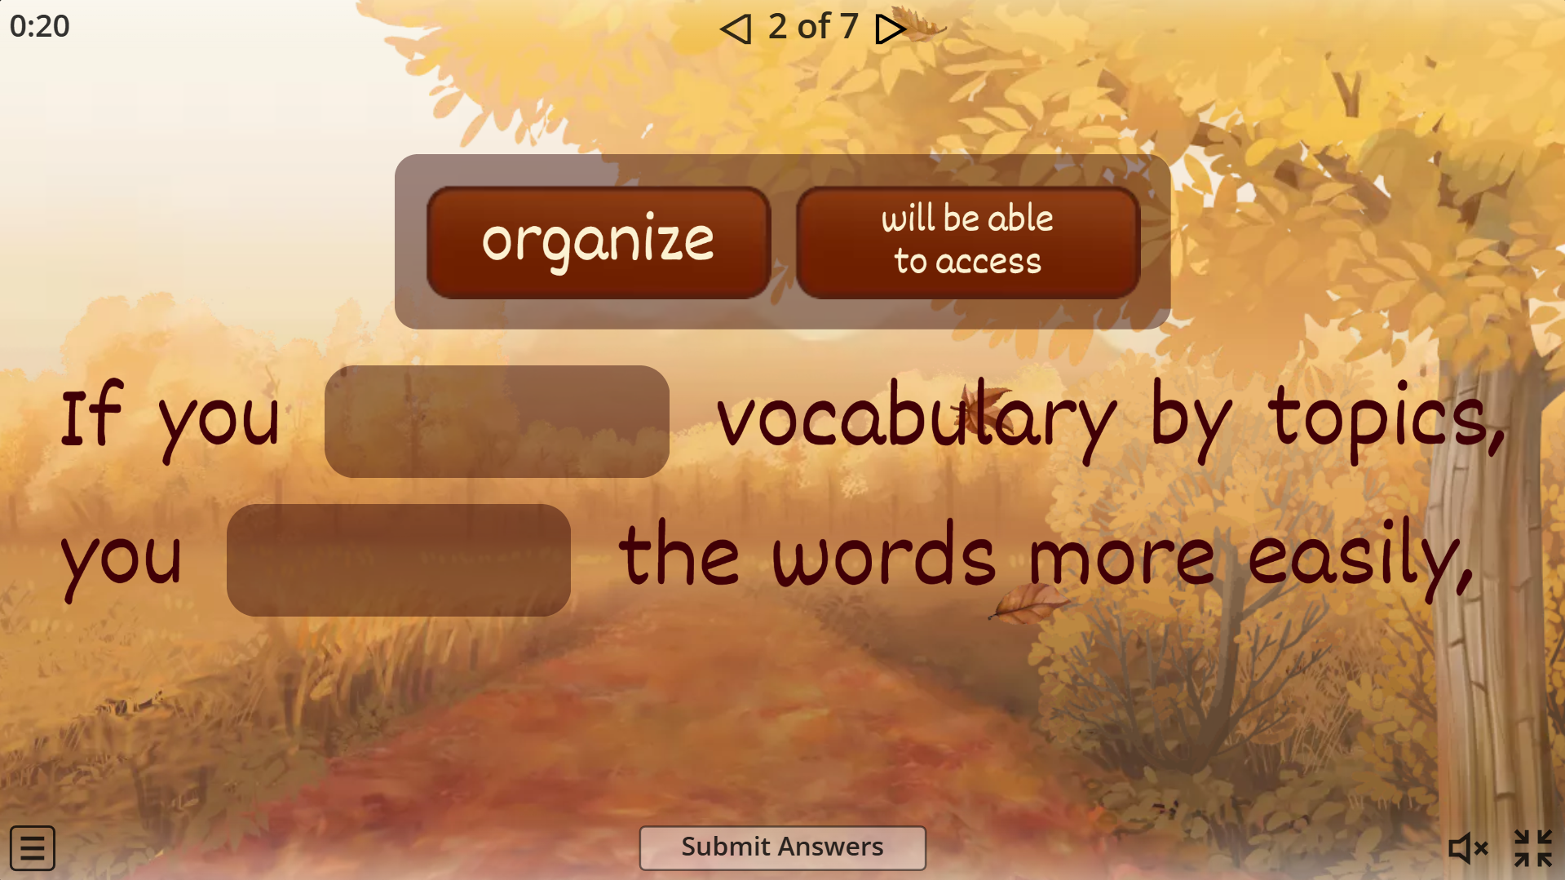

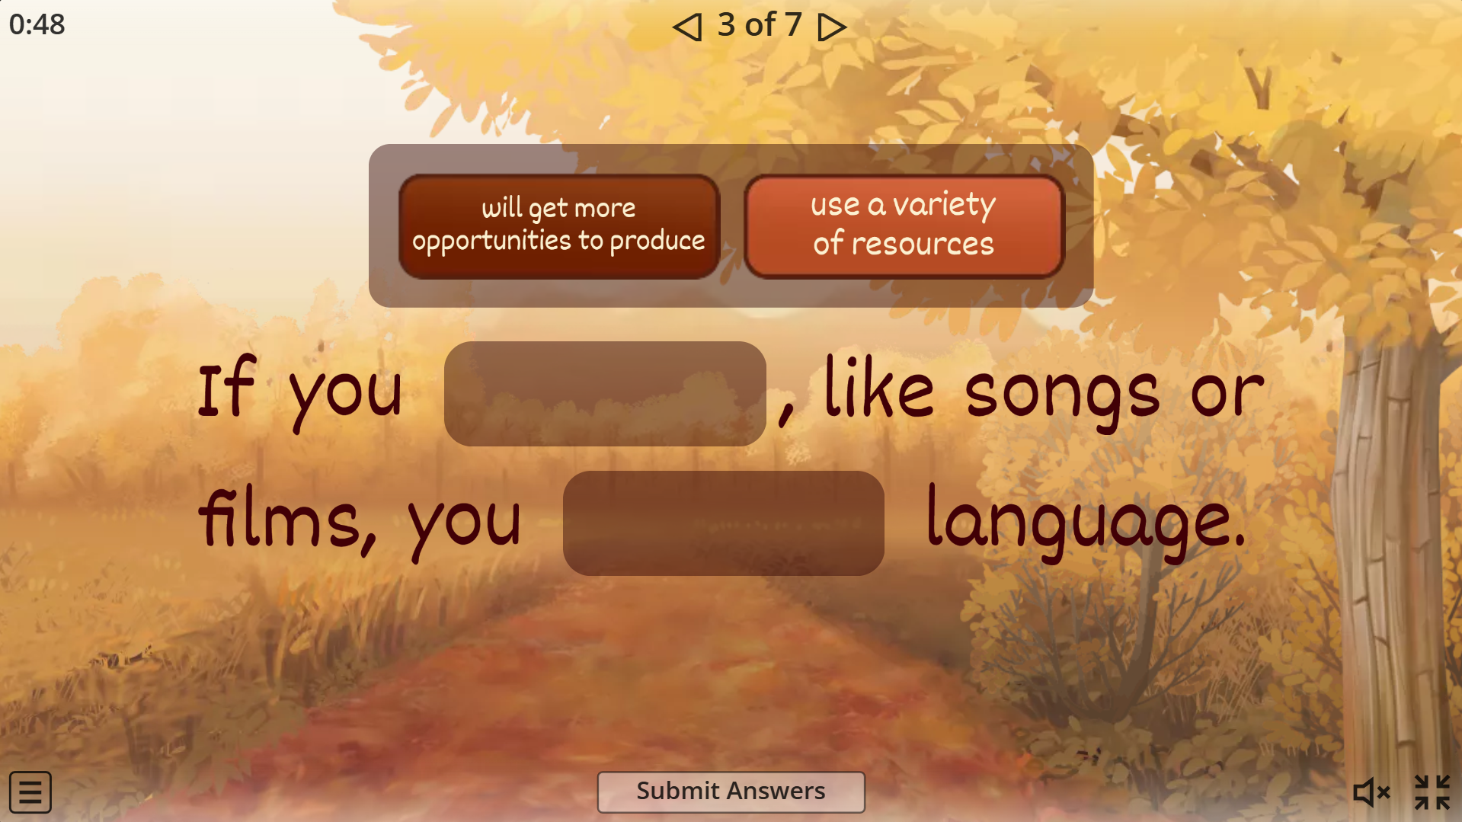

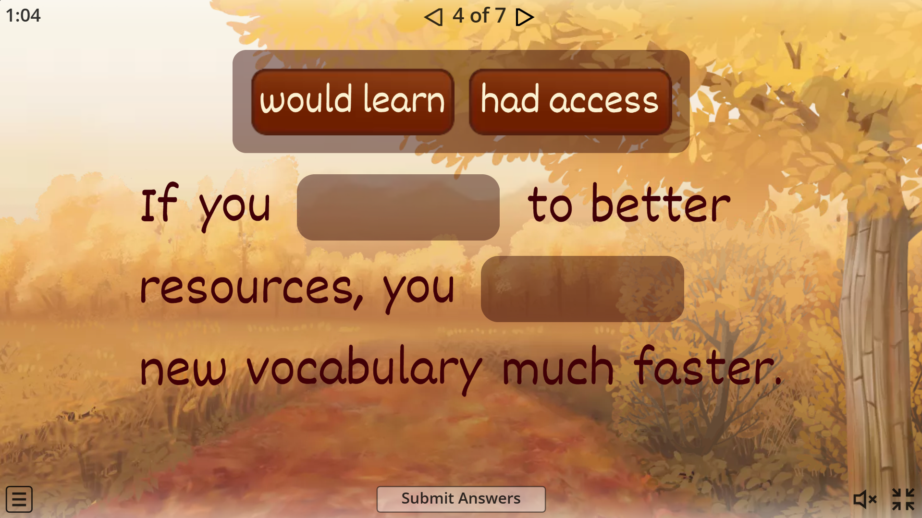

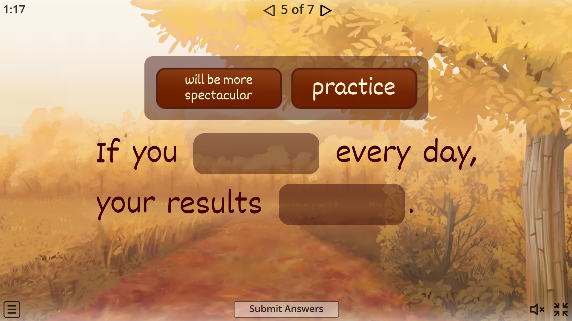

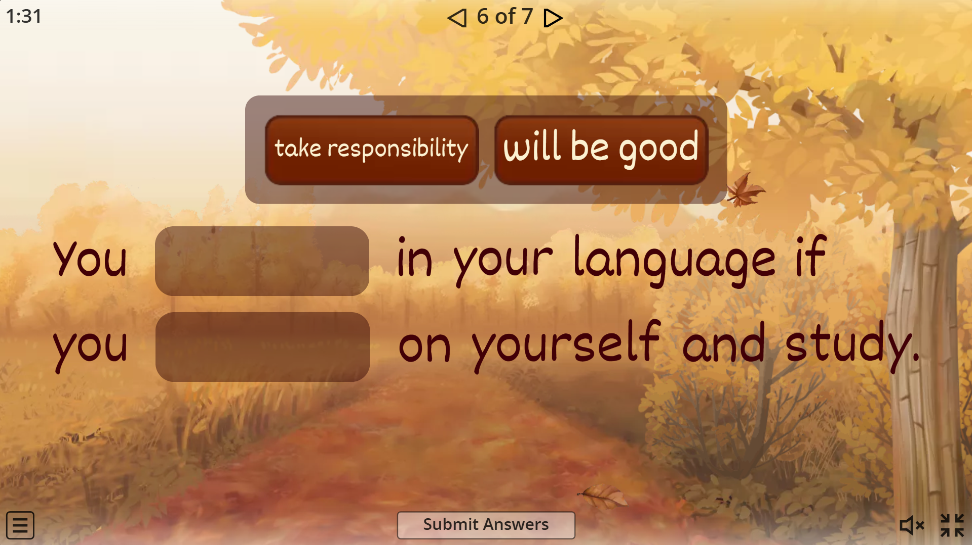

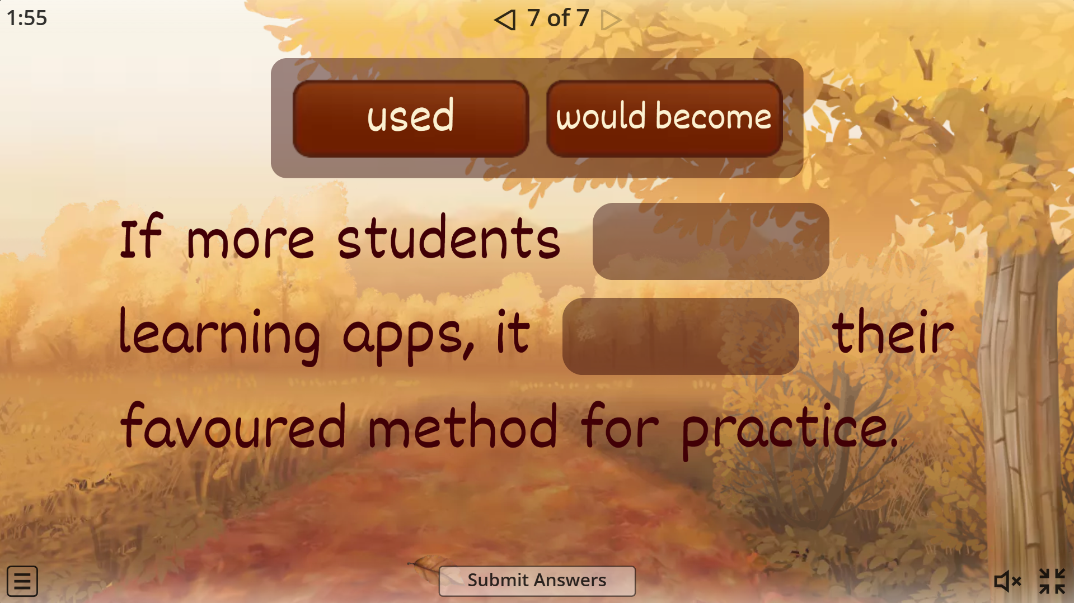

Activity (game) 8
Topic: Family. Relationship with parents.
Grammar focus: The third conditional.
The aim: to develop students understanding of using the third conditional and its form.
The outcome: students will be able to make sentences in the third conditional within the topic "Family. Relationship with parents",
Type of grammar activity: awareness and guided, meaningful practice.
Instruction for the matching activity: Look at the sentences and match the two parts of the sentences. Those parts that are in the boxes you have to match.
A model: You could have been a doctor if you had studied medicine.
Instruction for the reording activity: Put the words in the correct order to make sentences.
A model: if I remembered you had called me would have=> I would have remembered if you had called me.
Procedure: firstly, students will be presented with tasks on the website British Counsil.org, where they will be aware of the usage of the third conditional. There, they will do two activities: matching and reordering. Students who have the highest scores are the winners and will receive ten points, as there after the game, they can see their scores immediately.
Instruction (for the game in Baamboozle): You are two teams now. You will have five questions in this exercise. The group that reorders sentences in the correct order correctly will get 15 points. So, the team that has the most points will be the winner.
A model: she would have had not run out of battery, If her phone called her parents.=> If her phone had not run out of battery, she would have called her parents.
Procedure: secondly, in the following activity, students will be divided into two teams and will reorder sentences in the correct order. The team with the highest score in the game will receive 15 points and will be the winner.
Assessment and feedback: Immediate online
Online website: Baamboozle
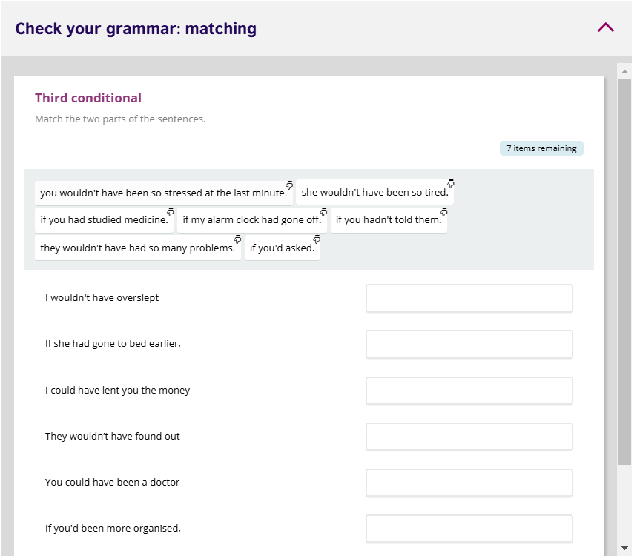

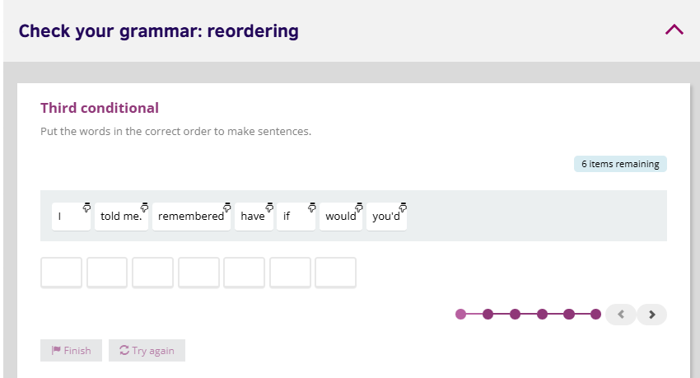

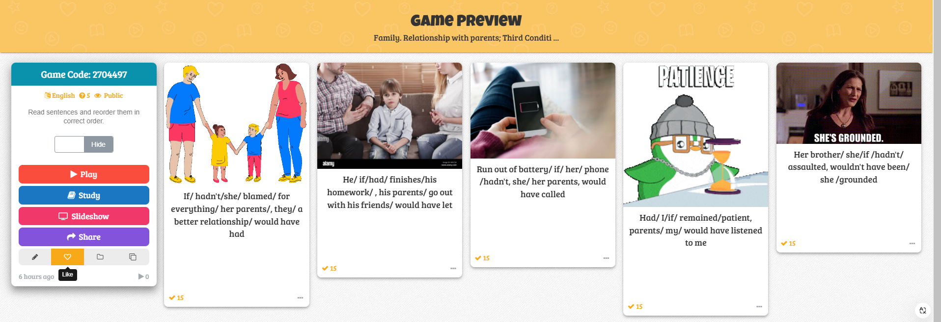

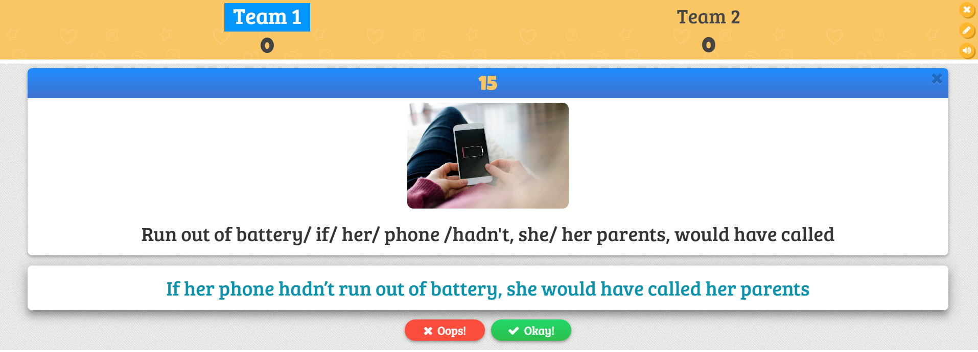

Activity (game) 9
Topic: Family. Relationship with parents; The third conditional.
The aim: to continue practicing using the third conditional.
The outcome: Learners will be to make dialogues and discuss them in the context of the topic "Family. Relationship with parents" using the third conditional.
Type of grammar activity: guided, meaningful practice.
Instruction: Read the dialogues in Ukrainian and find the translation within three variants.
Model: Якщо її батьки б не били її, вона не втекла б з дому.-If her parents hadn't beaten her, she would not have escaped from home.
Procedure: Students have the link to the game. The teacher gives the instruction and says they only have 50 seconds for each question. The student who is the first to finish the game will receive an excellent mark.
They can hear the ticking sound of time when they play this game. Besides, they have some boosts in the game: x2 score, 50:50, or extra time. These boosts can help students if they struggle with the answers. Also, if the answer is wrong, they will see a big red cross. Moreover, when they finish the game, they will see the total score, and there will be applause for them in the game.
This activity is done by the whole class.
Assessment and feedback: Immediate online
Online website: WordWall.


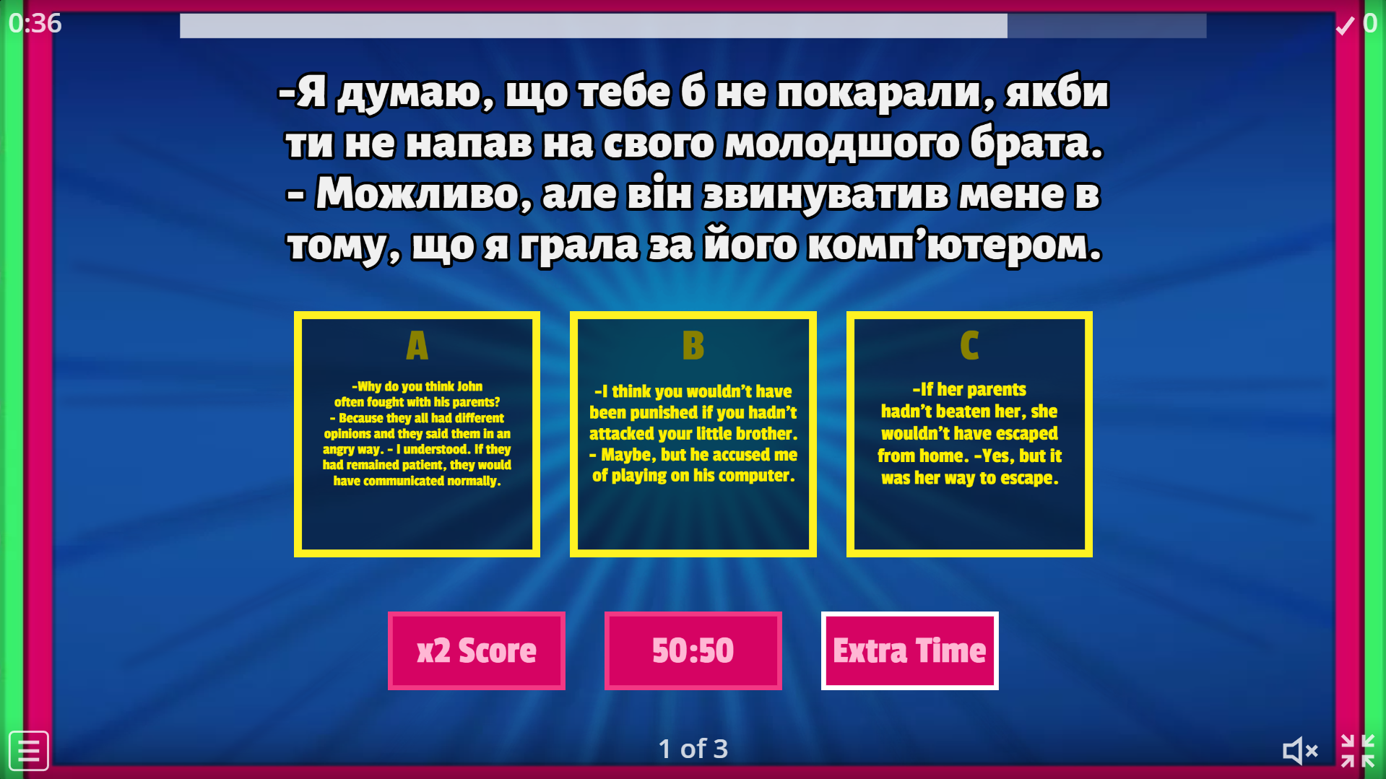

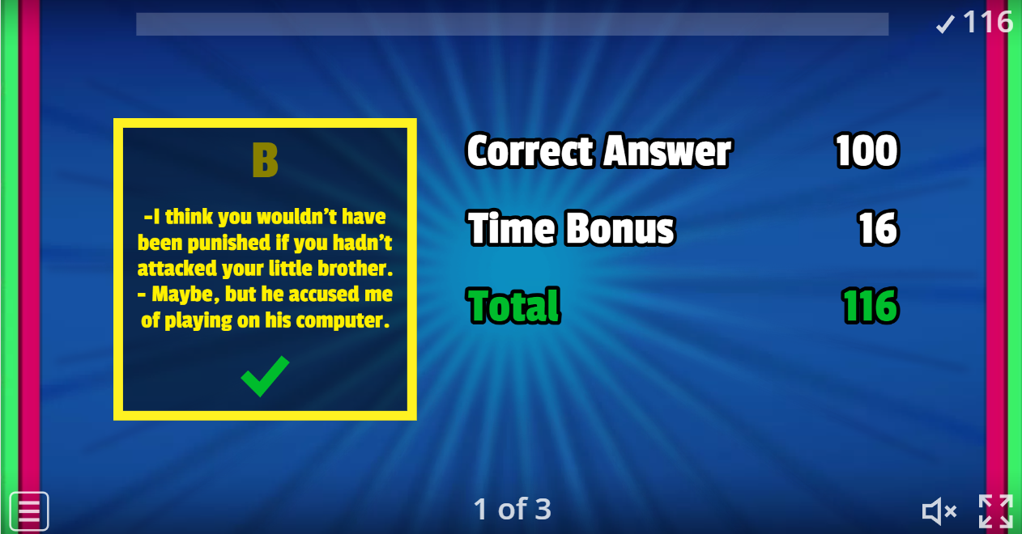

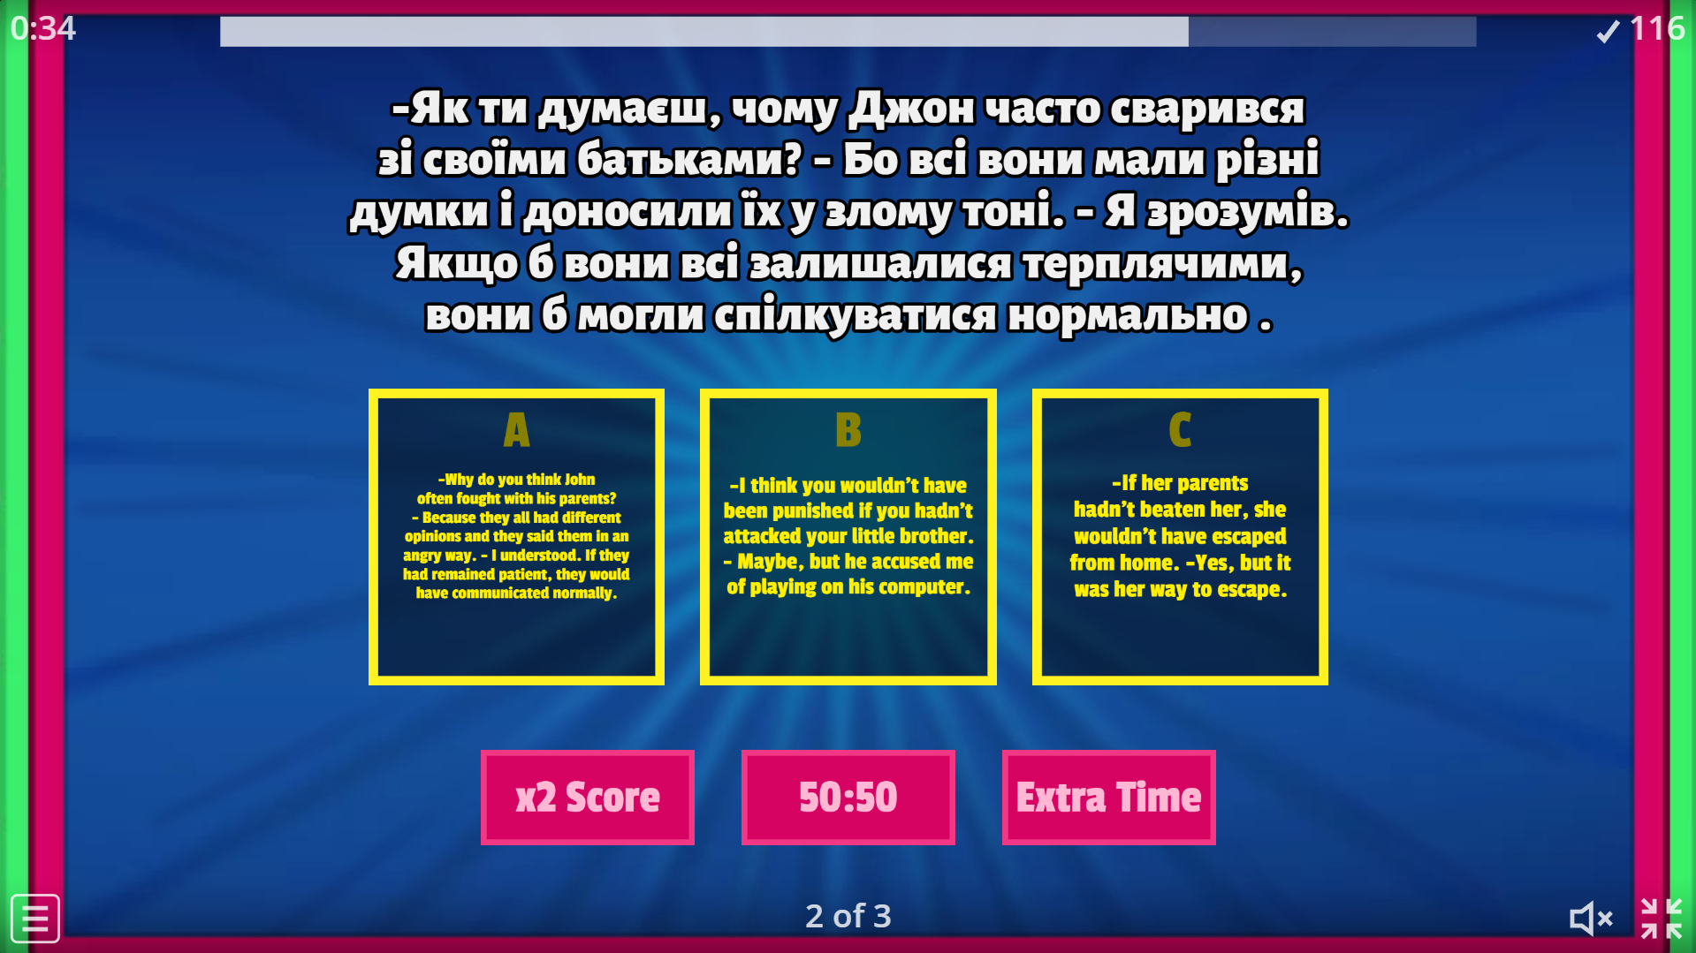

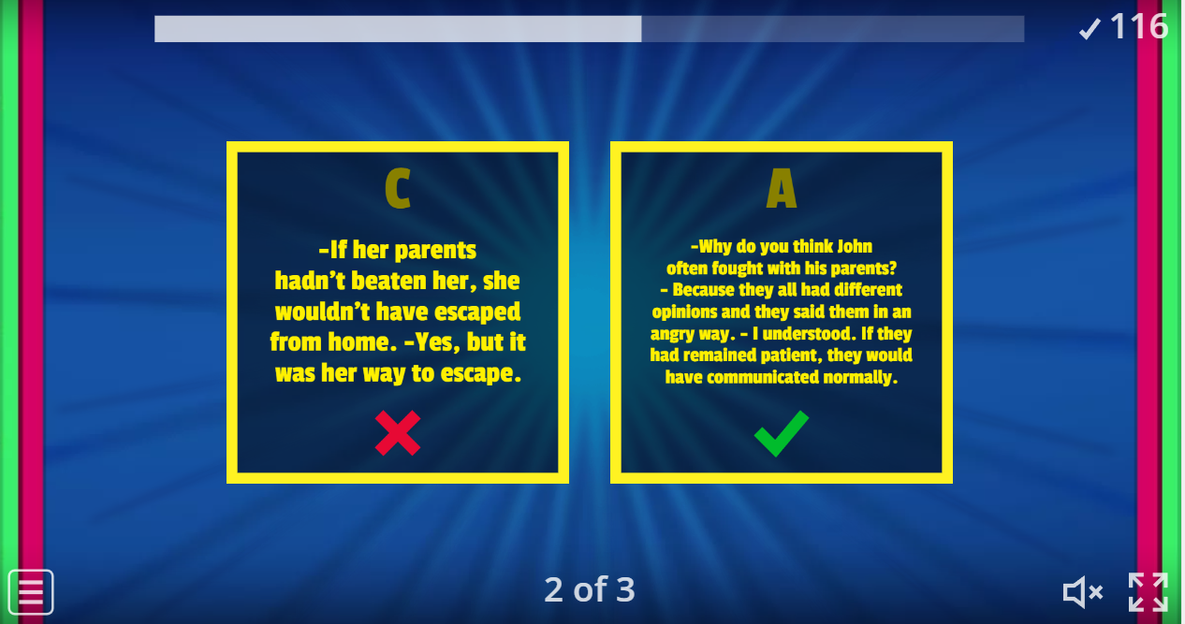

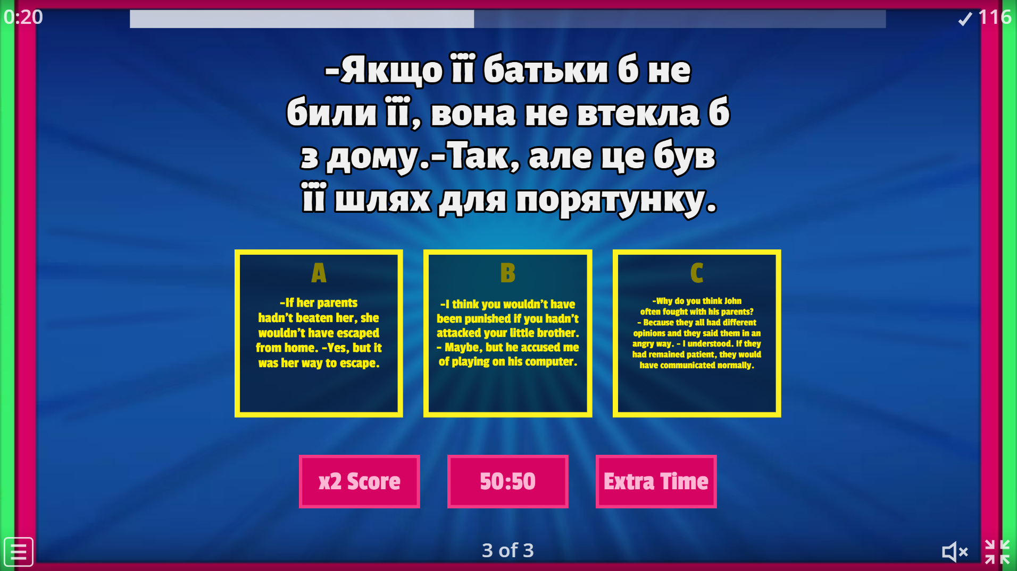

Activity (game) 10
Topic: Revision of the first, the second, and the third conditionals.
Grammar focus: The first, the second, and the third conditionals.
The aim: to distinguish the usage of the first, the second, and the third conditionals and use them correctly in sentences.
The outcome: Learners will separate these grammar structures from one another and make sentences with them.
Type of grammar activity: awareness and controlled practice.
Instructions: Read the sentence and decide if it is correct or wrong. If it is wrong, you must transform it to make it right. Also, you need to say if the sentence has the first, the second, and the third conditional.
Procedure: The teacher explains to students what they need to do( previously, they had a link to the game and opened it) and points out that in the game, the time to answer on each card is 40 seconds. Learners read each sentence and decide if it is correct or wrong by clicking 'Yes' or 'No.' If they do not cope with this given time, the flashcard will disappear, and the next one will appear(meaning they lose 1 point).
After the game, their names will appear on the leaderboard. The teacher asks those with the most significant struggles and those who ask questions.
Assessment and feedback: Immediate online
Online website: Educaplay
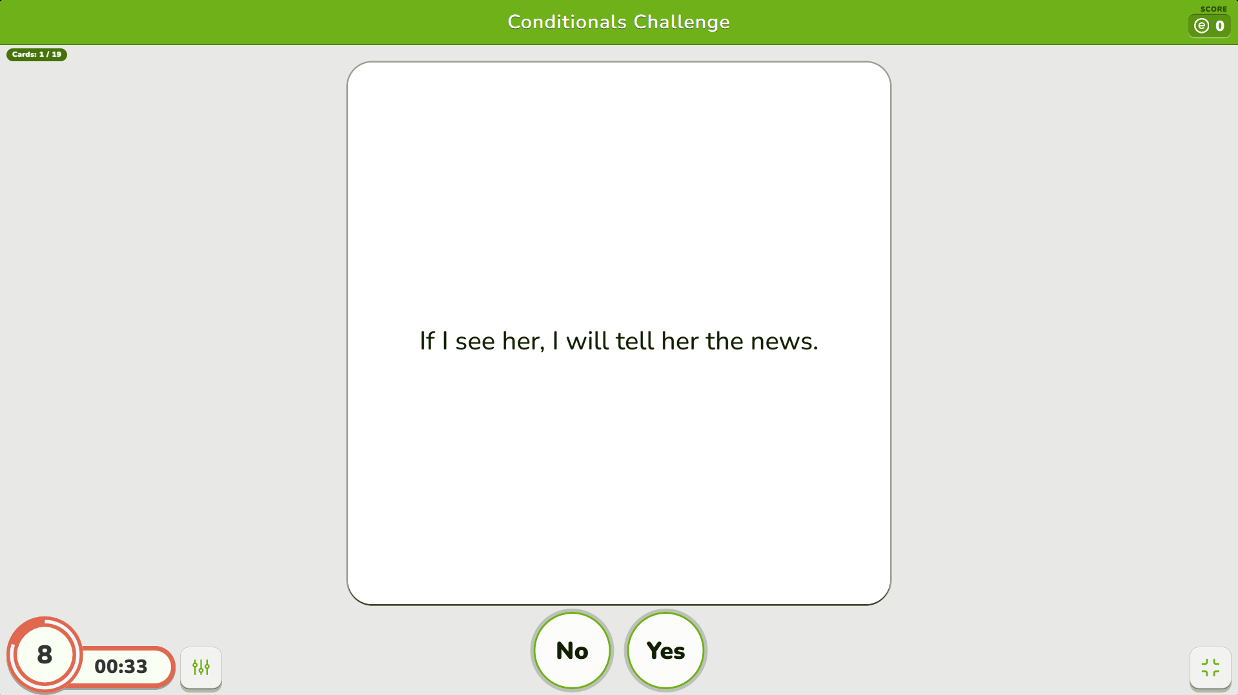

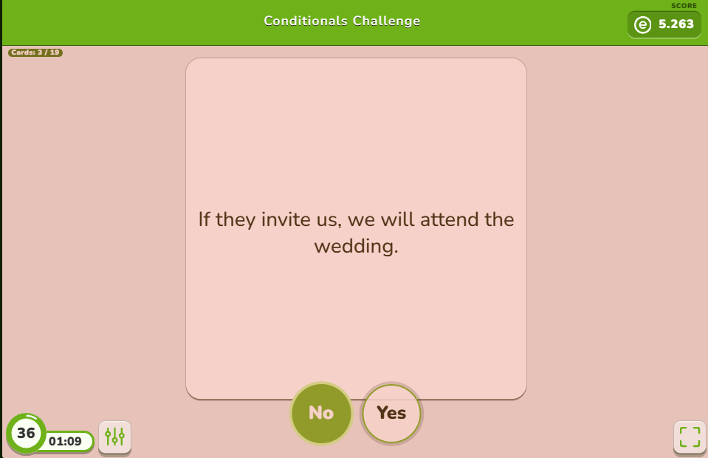

Appendix B
Pre-intervention Grammar test (initial stage)
Aim: to access student's knowledge of grammar before applying educational online games.
Assessment: 2 points per correct answer.
Instruction: Read the instructions for each part and choose the correct answer. There is only one answer in each part.
Part 1. Choose the correct answer.
1. We ____ never been to Paris.
- did
- have
- has
2. She _____ studying in university for 2 years
- have been
- were
- has been
3. I ______ vacuuming for two hours when I noticed a robot vacuum cleaner
- was doing
- had been
- was

4. At six o'clock, I _____ drinking tea for an hour
- will have
- will have been
- will
5. He said that he ____ tired
- had
- was being
- was
Part 2. Make the correct sentence.
1. never / I / been / to / Canada / have
2. if/ study/you/ hard, you/ pass/will/exam
Part 3. Correct the mistake in each sentence. 1. She will be work as a volunteer for one year next month.
2. The teacher said we are quiet.
Part 4: Fill in the blanks with the correct forms of the verbs.
1. Have you ____ (find) out your future profession?
2. They have been_____ (play) basketball for one hour.
Part 5: Complete the sentences.
1. If it rains, I ________________.
2. She has been studying English ________________.
3. He said that ________________.
4. If I won a lottery, ________________.

Appendix C
Post-intervention Grammar test (control stage)
Aim: to observe the results of using online educational games to improve grammatical competence.
Assessment: 2 points per correct answer.
Instruction: Read the instructions for each part and choose the correct answer. There is only one answer in each part.
Part 1. Multiple Choice
1. If I _____ you, I wouldn't trust him.
a) am
b) were
c) would be
2. By the time we arrive, the meeting _____.
a) will have finished
b) would have finished
c) finishes
3. You ____ cleaned your room. Now, it is not messy!
- done
- have been
- have
4. She ____ reading emails all day.
- was
- were
- has been
Part 2. Sentence Correction
1. Each of the students have finished their project.
2. If she had taken a taxi, she won't have missed a plane.
Part 3. Fill in the blanks with the correct form of the verb
1. By this time next year, I _____ (finish) my studies.
2. When I arrived at the party, Jane _____ (already, leave).
Part 4. Error Identification
Identify the error in the following sentence:
« I had been waiting for you with an hour.»
Part 5. Rewriting Sentences
Rewrite the sentence using the reported speech:
«The teacher will announce the results tomorrow.»
Part 6: Sentence Completion
1. They ____ (will) stay in the library longer, if they had time.
2. I would have _____(come) in time, if I had left house earlier.
Part 7. Match the sentence halves
a) As soon as he had finished his work, _____
he would have gone home.
he went home.
b) If he were more ambitious, _____
he has achieved a lot more.
he would have achieved a lot more.

Appendix D
Questionnaire № 1
Questionnaire for students of the 11th grade before using online educational games (such as WordWall, Educaplay, Baamboozle, etc.) for developing grammatical competence.
Aim: to see how students' opinions are now of online educational games to develop their grammatical competence and to compare with answers to the questionnaire that will be done after.
- How are you feeling now that you will use online educational games in your learning to develop grammar?
I feel great about them
I don't like them
I don't know
I don't care
- Do you think that you will make progress in grammar when we used WordWall, Baamboozle, and other online educational games?
Yes
No
Maybe
- What do you like when you are learning grammar and using online educational games?
I feel that I am learning grammar in a funny and educational way
I feel that I am not learning anything at all
It is difficult to answer this because I think that I get distracted by online educational games.

- What is it that you don't like when you are learning grammar and using online educational games?
It is difficult to know how games work
Sometimes, I can see that activities are the same
I like everything

- Do you think that grammar should be taught with online educational games? Why?
Yes, it is funny, and I learn a lot
No, it is boring for me
Yes, but do not use them in each lesson

- Is there anything that you want to say before your teacher uses online educational games to see if your grammatical competence has developed?
Questionnaire № 2
Questionnaire for students of the 11th grade for developing grammatical competence after using online educational games (such as WordWall, Educaplay, Baamboozle, etc.)
Aim: to gather student's opinions of their experience on how they developed their grammar using online educational games.
Instruction: Answer the questions in the questionnaire. Be honest with your answers.
- How did you feel about using online educational games for learning grammar?
I like it because I don't like to learn grammar in a boring way
I didn't like it
I think it was boring to use them all the time
- Did you feel progress in grammar when we used WordWall, Baamboozle and other online educational games?
Yes
No
Maybe
- What did you like when you were learning grammar and using online educational games?
I felt that I was learning
I felt that I was not learning
I don't know
- What did you not like when you were learning grammar and using online educational games?
It was difficult to understand how games work
I didn't like that some tasks were the same
I liked everything.
- Do you think that grammar should be taught with online educational games? Why?
Yes, it is funny, and I learn a lot
Yes, but do not use them in each lesson
No, it is boring for me
- Is there anything you want to say about how grammar was taught with educational online games?

