Міністерство освіти і науки України

Ніжинський державний університет імені Миколи Гоголя

Навчально-науковий інститут природничо-математичних,

медико- біологічних наук та інформаційних технологій

Кафедра інформаційних технологій, фізико-математичних та

економічних наук

Освітня програма: Комп’ютерні науки

Спеціальність:122 Компʼютерні науки

**КВАЛІФІКАЦІЙНА РОБОТА**

на здобуття освітнього ступеня *магістр*

**Система управління клієнтами на Java**

**з прикладами застосування в інноваційному бізнесі** (англійською мовою)

студента магістранта Яо Біня

**Науковий керівник:**

Казачков Іван Васильович,

доктор технічних наук, професор

**Допущено до захисту:**  2024 р. Завідувач кафедри

професор Казачков І.В.

Ніжин − 2024

Ministry of Education and Science of Ukraine

Mykola Gogol Nizhyn State University

Educational and Scientific Institute of Natural and Mathematical Sciences,

medical and biological sciences and information technologies

Department of information technologies, physical and mathematical and

economic sciences

Educational program: Computer science

Specialty: 122 Computer science

**QUALIFICATION WORK**

to obtain a *master*'s degree

Customer management system on Java

with examples of application in innovation business

By the magister student Byng Yao

**Supervisor:**

Kazachkov Ivan Vasyliovych,

doctor of technical sciences, professor

**Admitted to the defense: :**  2024

Head of the department

Prof. Kazachkov I.V.

Nizhyn − 2024

**Content**

**Abstact.** The core of competition in the market of telecommunication operators' services is the maintenance and expansion of customer relationship, improving service quality and customer satisfaction is the goal of all operators, and the connotation of market competition determines the importance of customer relationship management for telecommunication operators. The design of CRM in telecommunication industry must fully consider the characteristics of the telecommunication industry with massive customer data and many business systems, for which enterprises need to establish a customer relationship management system that suits the competitive needs and business characteristics of the enterprise, and helps enterprises to improve the profit level and enhance customer value.

This paper discusses the design and implementation of the customer management system of a provincial branch of China United Network Communications Co., Ltd. against the background of the project and the current status of research at home and abroad. On the basis of the requirement analysis, the system architecture and each functional module of the system are designed based on the C/S hybrid mode, and the database design scheme of the customer management system is given at the same time; then in the process of system implementation, JAVA language is used, and under the MVC design mode, the functions of four modules of the system, namely, the customer information management, the market management, the after-sales service management, and the system management, are implemented; finally, the functionality of the system is completed through the design of test cases, which is the main work of this paper. Finally, the functionality and performance testing of the system is completed by designing test cases.

The successful operation of the system is the basis of customer management work, is the enterprise development of potential customers, retain the stock of customers information processing platform, is to analyse customer consumption psychology and consumption trends, improve customer loyalty, find the most profitable customers an important means, can greatly improve the core competitiveness of enterprises.

**1. Introduction**

* Project Background.
* Current status of domestic and international research.
* The main research work of the diploma work.
* Structure of the thesis.

**2. System requirements analysis**

* Feasibility requirements analysis.
* Analysis of business requirements.
* Role Requirements Analysis.
* Functional requirements analysis.
* Non-functional requirements analysis.

**3. System design**

* System architecture design.
* System Function Module Design.
* Database design.

**4. System implementation and key technologies**

* Development environment setup.
* Key technology realisation.
* Customer information management module implementation.
* Market management module implementation.
* After-sales service management module implementation.
* Implementation of the system management module.

**5. System testing**

* System test environment.
* Functional Testing.
* Functional Performance Testing.

**6. Conclusion**

* Summary.
* Outlook.

**References**

**Appendices**

**1. Introduction**

On 6 June 2019, China's Ministry of Industry and Information Technology (MIIT) officially issued 5G commercial licences to four operators, namely China Telecom, China Mobile, China Unicom and China Radio and Television, marking China's official entry into the 5G commercial era. This milestone event means that China's mobile communications industry has ushered in a brand new stage of development. China Unicom needs to create competitive products and innovative sharing mechanisms to attract more customers. This is undoubtedly a great challenge for the employees of communication operators, requiring them to constantly innovate and improve their service quality to meet the needs of customers in the 5G era.The issuance of 5G commercial licences is an important milestone in the development of China's communication industry. Major carriers need to seize this opportunity to accelerate 5G network construction and application promotion, and promote the high-quality development of the communications industry.

1.1 Project Background

As competition in the domestic telecoms industry is in full swing, and with foreign telecoms giants looking on, it is especially important to face the threat of Internet companies such as Tencent, for example, WeChat. The traditional business model has encountered unprecedented difficulties in keeping pace with the rapid development of today's telecoms market, where the focus of competition between telecoms operators is no longer on technology, products and prices, but on customer satisfaction and loyalty. Based on this background, the marketing strategy of telecom operators has gradually shifted to a market demand-oriented, end-customer-centred objective. This requires the relevant practitioners to collect customer information through various ways and channels, and through analysis and research of customer needs, customer consumption psychology and consumption trends, to tailor different marketing programmes in a targeted manner, to improve customer loyalty and to win customers' trust, so that the purpose of doing so can satisfy the two-way demand, and can increase the market share and the company's operating income under the prerequisite of meeting the market demand. This new marketing concept - customer relationship management came into being.

Customer relationship management system not only collects, processes, stores and manages customer information, but also provides useful information to relevant personnel when necessary. It is the information processing platform for the company to explore potential customers and retain old customers, and is the foundation of customer management work, which provides a powerful support for analysing customers' consumption demand and consumption pattern, improving customer satisfaction, and laying a foundation for creating a good and strong cooperative relationship with customers, which can greatly improve the core competitiveness of the enterprise. However, the customer management system of a provincial branch of China Unicom is not mature enough, and the defects in the use of the system mainly cover the following aspects:

(1) The work of customer relationship management is relatively chaotic, there are no rules and regulations and a set of mature customer management management system to carry out unified management, the ins and outs of business development is only clear to the person in charge of the business, and once a change in the work position of the staff or sick leave or leave of absence, the new staff can not be replaced by the old staff in a short period of time.

(2) Information cannot be shared between departments in a timely manner, account managers and maintenance personnel know the information they need to know in their own duties, but there is no platform for customer information and technical exchanges between the two sides, front-end salespersons or account managers often complain that the back-end maintenance personnel are not in place to repair the obstacles, while the back-end maintenance personnel often complain that the account manager does not take into account the normal wear and tear of the business in actual use and network coverage, only relying on theoretical values to randomly promise customers bandwidth and other indicators, resulting in complaints from users. The back-end maintenance personnel often complain that the customer manager does not consider the normal loss of business in actual use and the coverage of the network, relying only on the theoretical value to casually commit customers to high bandwidth and other indicators, resulting in user complaints.

(3) The system maintenance process is cumbersome, the interface of the system is rather dull, and the division of roles and rights to access the system is rather confusing, which results in the inaccuracy of customer information, both in terms of human input errors and errors generated by the system in the process of extracting data, leading to low efficiency.

Based on the above problems, there is an urgent need to develop a set of effective and easy-to-use customer management system to complete the daily work, and better provide customer management services, which has far-reaching significance for the future development and business management of enterprises:

(1) Standardise the management of enterprises. By re-planning and optimising the business process, the business and personal work of the enterprise will be closely linked through the business information processing platform provided by the customer management system, so that customer relations can be effectively managed, which is to reduce the cost of the enterprise.

(2) Meet the diversity of customer needs. The customer management system can assist enterprises to dig deeper into the user needs, so that the company or enterprise "more than the customer himself or herself to understand what he or she needs, what is suitable for", based on marketing and service records for the customer to provide targeted service content, so as to bring the user a more relevant use of the experience.

(3) Helping enterprises improve operational effectiveness. Customer management system can effectively integrate the enterprise's business links and resource system, can be extended to other directions through the business channels, the enterprise through the customer management system of marketing module and enterprise resource planning (back-end ERP) integration, comprehensive coordination of other business factors within the enterprise, thus gradually improve the operating results of the enterprise to achieve the sharing of information within the enterprise to increase the share of marketing.

Therefore, the development of a customer management system that meets the needs of telecom operators is a particularly important part of the company.

1.2 Current status of domestic and international research

The concept of Customer Relationship Management (CRM) was first proposed by the Gartnet Group in the United States, who believed that CRM is a method that can provide companies with a more scientific management model, and can also provide a more robust customer relationship communication skills, in order to maximise customer revenue. The development of customer relationship has gone through three changes, from sales theory automation system (SFA) into customer service system (CSS), and finally evolved into a call centre (CALL CENTER), gradually developed into a complete set of management ideas and management system for the development of the enterprise to provide a new vision, to provide a platform for enterprises and customers to communicate with each other, so that the marketing and field service The process of marketing and field service is effectively combined with the four

For the telecom operator industry, after the operators in all developed countries in the world have reached a certain stage of development, the focus of competition will shift from product, network and price competition to the competition of superior brand and quality service. Operators in developed countries such as the US, France, UK, etc. are already deploying CRM systems. the global CRM market was $3.2bn in 1999, $12.1bn in 2004, and $52.28bn in 2023. the market is growing rapidly, with telecoms operators contributing half of the total, and telecoms companies that have purchased their CRMs include Telecom Italia, Telecom operators are contributing half of the market, with telecom companies such as Telecom Italia, Cable and Wireless, and BT purchasing their CRM.

E-commerce and the Internet gradually get after the development of customer management systems are also stationed in China, from the end of the world to 2002, is the CRM of the embryonic period, from 2002 onwards, China's CRM market began to grow dramatically products, vendors are gradually moving towards maturity. The characteristics of the domestic customer relationship management system are as follows.

(1) Domestic CRM started late, whether it is the product structure or from the sales channel to test, customer management system is not sound enough, there is a larger market development space and development opportunities.

(2) Fewer suppliers of CRM products. Due to the huge implementation cost of CRM and the long implementation cycle, coupled with the relatively short period of time since CRM entered China, most of the CRM products on the market at present are mainly focused on operational CRM products, and there are fewer suppliers who can provide high-quality CRM products.

(3) Software technology needs to be further improved, software is the core of the whole system, developed countries in the software design process with advanced concepts combined with a high degree of resource sharing. While the domestic although rapid development in software, but due to the processing software is not standardised enough, resulting in software product quality and control technology is not high enough. Telecom operator industry due to its own characteristics, in the customer relationship management system investment has been far ahead of other industries, China Mobile in 2005 began large-scale construction and deployment of CRM systems, China Telecom in 2005 at the end of the deployment of CRM systems, and China Unicom as early as 2002 began to systematically and comprehensively build and deploy CRM systems. On these bases, China's telecom operators have put forward their respective service concepts: China Unicom's service concept is "customer-centred, providing excellent communication services"; China Telecom's service concept is "user first, service with heart"; China Mobile's service concept is "communication from the heart"; China Radio and Television's service concept is "people-centred, providing quality media services", from these service concepts can be seen in the telecom operators have shifted to a customer-centred service mindset.

1.3 The main research work of this paper

The design and development of the customer relationship management system of a provincial Unicom is "demand-oriented, using the development mechanism as a guiding direction, to provide a set of decision support, sound and effective system. The main research work includes the following.

(1) system requirements survey, listen carefully to the views of marketers, salespeople, technical staff, to understand their requirements for customer management system, what are the requirements in terms of system operation and other information, a detailed analysis and study of the company's current existing application systems.

(2) Research on theories and technologies related to system development. Through reading a large number of references, we understand the current development status of customer management system of telecom operators' industry at home and abroad and what are the characteristics of CRM in actual operation; through sincere and effective communication with technical staff, from the technical point of view, we learn about the B/S three-tier architecture used to complete the system, JAVA , SQLserver2008 database technology, and the algorithms of customer segmentation and clustering analysis. We have learnt systematically.

(3) On the basis of user functional requirements analysis, complete the design, system implementation and system testing of the customer management system of a provincial Unicom company.

The key technologies of this system are.

1. B/S and C/S hybrid service model: C/S, client/server, is a LAN-based service mode, through the terminal in the LAN to get and the system's server to interact with the required content, the shortcomings of the high development costs and complex maintenance; B/S, browser/server, only need to install a browser with common functions in the client, which simplifies the development of the client and the system as well as the maintenance. This simplifies the development and maintenance of the client and the system. This thesis applies C/S and B/S hybrid mode, adopting different implementation methods for different applications. For the salesman or account manager who enters user information, it is more convenient and safe to choose C/S mode; while for the query and release of information, it is more suitable to choose B/S mode. The use of the two modes of cross-combination has achieved good results.

(2) Customer Segmentation: Unicom of a certain province implements precision marketing, first of all, we should do a good job of market segmentation, through the study of the characteristics of customer demand and the law of consumer behaviour, for each user of the enterprise to locate the category to which it belongs to, to help the company's managers in a variety of marketing activities to accurately determine the typical characteristics of each user, thus laying the foundation for product positioning and marketing strategy.

1.4 Organisation of the thesis

The chapters of this thesis totalled six chapters, each of which is specified as follows.

Chapter 1 is the introduction, firstly describes the background of the project and the main problems of the system in the process of using, which leads to the significance of the subject research; then introduces the current status of research and development of customer management system at home and abroad, and finally gives a short description of the research work and organisational structure of the subject.

Chapter 2 is the system requirements analysis, according to the typical process of software system development, the demand analysis of this topic, specifically from the feasibility analysis, business requirements analysis, role requirements analysis, functional requirements analysis of non-functional requirements analysis of five aspects.

Chapter 3 is the system design, firstly, describes the overall architecture of the system, then on the basis of the previous chapter of the requirements analysis, the design of each functional module is elaborated in detail, and then the detailed design of the system database, the design of the database table is strictly in accordance with the specification

Chapter 4 is the system implementation, mainly describes the implementation process of the functional modules of the customer management system, specifically including the implementation of the program code and the main functions of the page display and so on.

Chapter 5 is the system testing, which introduces the testing environment of the system, and analyses and summarises the testing results of the system through functional test cases and performance test cases using typical testing methods, and then verifies the integrity of the system.

Finally, there is a summary and outlook, which is the conclusion of this article. It summarizes all the work of this article, looks forward to possible development directions in related areas, and proposes improvement suggestions based on actual situations.

**2. System requirements analysis**

Application-based management software in the design and development of the beginning will strive to meet the needs of the enterprise, requirements analysis is the starting point of the software system, belongs to the bridge between the system analysis and software analysis phase, helps to avoid early errors, thus improving the speed of system development and reducing development costs. This chapter describes the requirements analysis of China Telecom's customer management system, including the analysis of feasibility requirements, business requirements, functional requirements, role requirements and non-functional requirements.

2.1 Feasibility needs analysis

Through an in-depth understanding of the relevant cutting-edge technology, and combined with the market practice needs, the system adopts the B/S three-tier architecture, only need to install a browser with general functions on the client side, maintenance and upgrading of the work can be completed on the server side, to a certain extent, can be reduced to the client equipment requirements, and can reduce the maintenance workload of the system, significantly improve system stability and security. The use of browser technology, the use of popular ASP.net technology, in the construction of the system on the basic requirements of the system is relatively low, can effectively reduce the threshold of the system to achieve, thereby reducing the system to achieve the link in the loss of human costs. To sum up, for the demand of the system, the technical means adopted by this system is feasible both in the technical level and in the economic level.

2.2 Analysis of business requirements

Telecommunications services refer to the services provided by telecommunications to users. It can be divided into basic telecommunication services and value-added services according to the type of service, and into wired telecommunication services and wireless telecommunication services according to the network used to provide the service.

Business needs are not immutable, we need to use technology to achieve changing business needs in the business and technical means between the existence of many concepts, these concepts can organically connect the two together. For example, services, general business is achieved by programming technology, is tightly coupled, while the service is in the object and component on top of the loosely coupled; for example, the process: business can not be separated from the process, the process of superposition and iteration is the specific implementation of complex business logic, and the process is service-oriented, that is, the carrier of the business - services in the application system is organised through the process.

Details of the business process can be found in Figure 2.1 below.

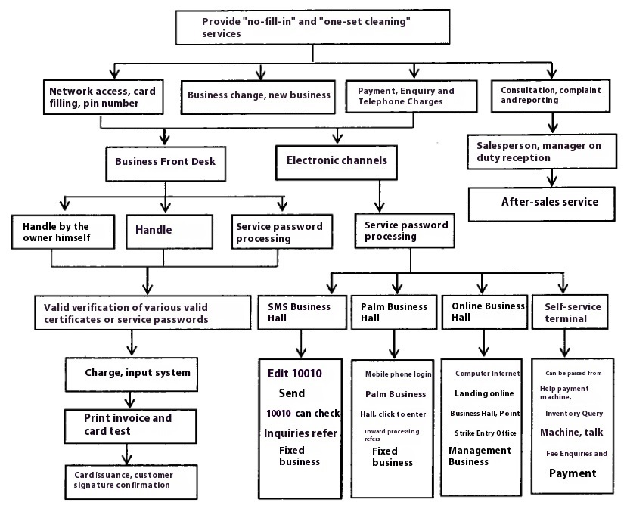

Figure 2.1 Business Process

2.3 Role Requirements Analysis

According to the main source of information and the main users of customer relationship management system, they are the system put forward different functional requirements, this paper on the role of the system users are divided into customers, account managers (or receptionist), market management personnel, after-sales service personnel and system administrators.

(1) Clients

Customers are those who have applied for telecommunication services and are the main source of information for this system, providing the system with the most basic identity information, contact information and consumption information, which constitutes the main body of information in this system. In addition, customers can also use the system to enquire about their package status, cost information, and modify their personal information, etc. At the same time, they can also make complaints and obstacle declarations through the system.

(2) Account Manager (or Front Desk Salesperson)

Customer manager (or front desk salesman is responsible for the sales of products, in the customer for business, access to the user's basic information, and for the user to establish a basic file, at the same time, through the customer management system to view and modify their own authority within the scope of the customer's basic information, contact information, consumer information, etc., to submit and modify their own mastery of the new customer information provided to the back-end management personnel for reference.

(3) Marketing managers

Market management personnel can view the customer's basic information through the customer management system as well as for all kinds of products and services and other consumer information, after the customer's consumer behaviour and consumption habits of statistical analysis, as well as reference to the competitors' data management, in order to formulate the next step of the business guidance strategy, the design and creation of personalized service content and products, through a variety of channels and ways of accurate marketing to the user.

(4) After-sales service personnel

After-sales service personnel are the personnel who manage and respond to customer complaints and faults, and when they solve customer complaints and faults, they need to query the customer information and package information in the system, as well as do a good job of service tracking, fault repair records, and return visits to the user, and at the same time, also be able to formulate appropriate service content for the user based on the user's information and the user's potential needs to cultivate the consumer's preference and loyalty to the enterprise. and loyalty.

(5) System Administrator

System administrator is the whole customer management system for maintenance and management of personnel, its authority is the highest, the most important functional requirements of the system for different roles of different levels of user rights management, but also responsible for the system's basic information to set up the management of employee information, maintenance of the system.

2.4 Functional Requirements Score

According to the functions desired by the customer for this system and the working needs between the customer manager, market management personnel, after-sales service personnel and system administrators, the functional requirements of this system are divided into four major modules, which are customer management, market management, after-sales service management and system management. These functional requirements are described in detail below.

2.4.1 Customer information management

The functional modules in Customer Information Management cover the following main sections.

(1) Management of basic customer information

Customers go to the business hall for business acceptance, or contact with Unicom by dialling the number 10010, or new customers developed in marketing activities, all these cases are subject to account opening work, and the main participants in the business process are the customers and the service staff of the business hall. For each legitimate user, you need to provide valid documents (account book, ID card, etc.) to open an account, the staff through the information provided by the user to verify, if the verification of the user's identity information is legitimate, the customer management system will call the customer management system of the customer management function, enter the customer's basic information, including the customer name, document information, customer address, contact person, contact information, etc., to open an account for the operation. In addition, you can manage the basic information of the customer, providing the function of adding, reviewing, inquiring, modifying and deleting the customer information.

(2) Consumer information management

The management work mainly manages customer consumption information, facilitates users to query their personal consumption history, provides data support for the leaders of telecommunication companies to understand the overall sales and income of various services, and provides a basis for enterprise management and decision-making.

(3) Contact information management

The management of contacts is an important part of customer management. In the customer service management system, the contacts can be the company's employees, individual users, or those who are related to the business of Unicom, and the contact corresponding to each customer is more than one, so that the contact information of the customer can be changed into the contact relationship between the customers.

(4) Lost customer management

This management refers to the fact that subscribers do not continue to purchase the services they have previously used. In the context of the current increasingly fierce market competition, all telecom operators are thinking about how to provide targeted services and packages to attract more new subscribers, and how to establish long-term relationships with their customers, so as to reduce the rate of customer churn.

2.4.2 Market management

The functional modules in Market Management cover the following main sections

(1) Customer statistics and analysis

Customer statistics in marketing and customer retention has a pivotal role, through a variety of ways and channels to collect customer consumption information, consumption ability, preference tendency, through the analysis of data to understand the needs of various types of users, through certain data mining means of customer clustering, customer demand analysis and the development of marketing strategies to provide strong support.

(2) Product management

Sales support and management requires the selection of specific products based on customer needs. Built on the results of customer statistics, the categorisation of customer needs can guide new product development, as well as the design of responsible product packages that can be pushed through consumer habits.

(3) Precision marketing

The only way to fully satisfy the market needs of all types of consumers is to explore the different potential needs of different consumers and provide corresponding service content and products. The marketing model pays great attention to the creation and maintenance of service value, and strives to provide users with sound and mature service content, and enterprises can also rely on this marketing model to establish brand image, improve user satisfaction and loyalty.

2.4.3 After-sales service management

After-sales service management for telecoms operators is an important part of the customer management system and can help companies to be more efficient in meeting customer needs. As competition in the market continues to intensify, the creation of a sound after-sales service system and the gradual improvement of the relationship with the customer is the key to market share. Often, the way to maintain the customer is to provide services that meet the needs of the user, so that the customer only needs to log on to the web site or dial a telephone number to switch to another operator, maximise customer value, win back preconceived ideas, and develop new customers, thus achieving the strategic goal of customer centricity. The strategic goal of customer centricity can be achieved.

2.4.4 Systems management

Specific functional descriptions of the 3 parts of the system management module are as follows

(1) Account management

Account management is mainly to provide a system of different roles in the user's account of some of the operations, such as when a new employee onboarding, the system administrator can be a new employee; when the employee mobilisation information changes, you can make timely and appropriate changes: when the employee transfer or resignation, you can log out of their accounts.

(2) Rights management

When setting up the system, the system administrator will assign each role with relevant permissions according to the differences in the scope of work of each user as well as the differences in roles, and only users with permissions can see and use the corresponding functions. One of the management principles of rights management is level-by-level control, not to exceed the level of operation than the current level of the role of higher information, so as to ensure the confidentiality and security of customer management system data.

(3) System maintenance

The system also requires certain maintenance functions, because there are unpredictable factors, such as hardware problems, software problems and human factors, etc., will lead to system collapse, in order to ensure that the system failure can be quickly recovered after the system needs to have a backup and recovery of data, so that even if a catastrophic accident occurs, but also through the one-button recovery of the customer's system to restore the maximum extent of the data.

2.5 Non-functional requirements analysis

The non-functional requirements analysis of a customer management system takes into account the following points.

(1) Reliability

Reliability is essential for a stable system, and the frequency of occurrence of faults, recoverability and maintainability are specific manifestations of system reliability. This requires the system to have a relatively mature error-handling mechanism, with the frequency of failures not to exceed one per month, while at the same time adopting a convenient system backup and recovery tool to back up the system on a regular basis and to be able to restore the system in time in the event of a failure, so as to ensure the orderly and reliable operation of the system.

(2) Scalability

With the continuous development of telecommunications services, all kinds of customer relationship management functions will be constantly expanded and upgraded, so, in this case, the system must be able to meet the expansion and upgrading needs of the system functions, when the user's needs change, the ability to flexibly expand the functional modules of the system.

(3) Ease of use

The system should have a good man-machine interface, the operation is simple and clear, user-friendly, even without special training, but also in the shortest possible time to master the basic use of methods.

(4) Maintainability

The system design needs to fully consider its maintainability, its various key parameters can be maintained through the programme and can be based on the integrated network of the system for upgrading and maintenance, troubleshooting, fault isolation, etc., so as to reduce the maintenance cost.

2.5.1 Performance requirements

The maximum number of users required by the system is 1000 people online at the same time, the maximum number of concurrent users is 500 people The average response time of the system should be controlled within 2 seconds, and the average CPU usage rate should be controlled within 40%.

2.5.2 Interface requirements

The interface is the bridge between the user and the application system. The user realises the information exchange between the user and the application system through the interface. The interface design is good or bad, can directly affect the function of the application system, and whether the consumer can work accurately, effectively and happily, so the interface is friendly and easy to use for customer management system is very important.

Because the use of customer management systems are mostly front desk salespersons or account managers, and does not have very professional IT knowledge, in order to ensure that these users after a short period of training will be able to easily and skilfully use the various functional modules of the system, which requires that the interface should be as simple as possible, easy to use, on each page, there should be intuitive, generous navigation bar and its functional description, the list of information is clearly classified, font colour, font size clear and recognisable, but also to provide some auxiliary functions, such as adding text help to certain pages can improve the efficiency of the user. Colour, font size clear and recognizable, can quickly search for the information you need, but also to provide some auxiliary functions, such as adding text help in some pages, can improve the efficiency of the user's work, in addition, all the error messages and tips to pop-up boxes or go to the error page of the display of the way to prompt.

2.5.3 Security requirements

With the booming development of the network, the solution to the security problem has been imminent, must take the appropriate means of protection and implementation to ensure that the customer management system for the good implementation and operation of the system. Specific measures are as follows

(1) identity authentication mechanism: the system land using a strict identity authentication mechanism, the system will assign a unique user identifier for each registered user, the user logs on, the server first verifies its identity identifier is legal to determine whether to accept access to ensure that only registered valid users can log on to prevent the invasion of illegal users.

(2 Permission control mechanism: the system should use advanced permission control technology, administrators can formulate user authorisation policies to determine which servers or applications can be accessed by users, to avoid the misuse of one user's data on other users.

(3) Log management and monitoring system: Used to record user logins and operation records.

(4) Data encryption: As the customer management system involves a certain amount of user safety data and sensitive data, so effective data encryption for customer information management is very important, based on the data encryption means to maintain the independence of the data transmission process, to achieve end-to-end secure transmission, always maintain the integrity of the data, correctness, and confidentiality to ensure that the data access and exchange process of security. security in the process of data access and exchange.

2.5.4 Database requirements

Database is the core of the system, the role of the customer information management system in the role of the whole body, can be related to the collection of data storage together. An excellent design quality, perfect data structure of the database, can greatly improve the system operation rate, in the design of the database, to consider the following factors.

(1) in line with the various specifications of this system involves a variety of according to the type, respectively, the character data type, date data type and digital data type.

(2) Ensure data completeness and accuracy;

(3) Reduce redundancy and reduce the storage space for data;

(4)The data structure is reasonable and the database involves normalisation and standardisation;

(5) Adopt the security mechanism that meets the requirements of the database: encryption is required for the transaction data during the entire data transmission process, and the encryption equipment is responsible for encrypting the data source when acquiring data with other business systems.

2.6 Summary of the chapter

Requirement analysis is the basis for system design and implementation. The system requirement analysis in this chapter starts from the feasibility study of the system, followed by business requirement analysis and role requirement analysis, then functional requirement analysis covering four parts: market management, customer information management, system management and after-sales service management, and finally non-functional requirement introduction of the system including four parts: performance requirement, interface requirement, security requirement, and database requirement. and database requirements. These functional requirements are closely integrated with the market and meet the requirements of the enterprise for customer management system.

**3. System design**

The overall design of the system is to design the architecture, functionality and database of the system, which are described in detail in this chapter.

3.1 System architecture design

The network platform of the telecom customer management system adopts multi-layer B/S structure. As the B/S structure has cross-platform and universality, the client side only needs to install a browser, and the user will be able to send requests to the server in any place where there is a network, and the system maintenance and upgrading can be completed at the server side, and the client side doesn't need to do any maintenance and upgrading work, which can reduce the overall maintenance cost of the target system significantly.

The system architecture adopts B/S three-layer architecture, the first is the representation layer, the second is the logical layer, the third is the data layer, and logically divided into three relatively independent units, in which the change of any one layer will not affect the function of other layers. The client does not have to deal with data access and other key transactions, only need to submit the transaction logic to the web server, in the web server returns the results, the client is responsible for displaying the results. The specific system architecture can be understood in the following figure in 3.1:

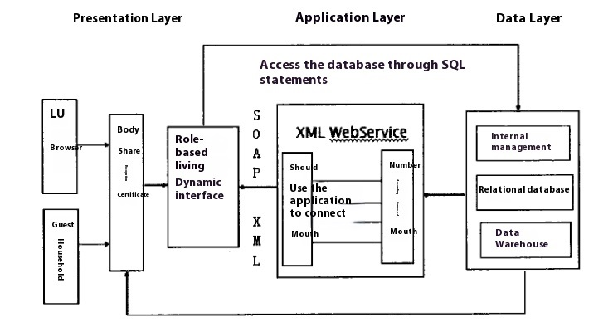

Figure 3.1 System Architecture

(1) Representation layer: located in the client, is to show the user information system interface, the interface for the user to provide the required data information and functional links, the user based on the web browser to the web server to send a service request, the web server receives a service request, the user's identity will be verified to confirm the legitimacy of the user's request according to the http protocol in the form of web pages transmitted to the client.

(2) Application layer: located on the server side, is the key to the entire customer management system architecture. The application layer is responsible for realising the logical operation of each function of the system, and a unified calling interface is set up in both the representation layer and the data layer to realise the data transmission between the representation layer and the data layer.

(3) Data layer: Located on the data server side, it is the core of the whole system architecture. The data layer is responsible for saving all customer data information, and has the functions of managing, storing and conveniently providing data services for large-volume data. The data layer provides the database for the system, the application layer and the data layer communicate with each other, the application layer sends data operation request to the data layer, the data continues to execute the operation request and transmits the execution result to the application layer, and the application layer then displays it to the representation layer.

3.2 System Functional Module Design

This system is able to complete the various functions of the management of the telecom operator's customers, according to the results of the demand analysis in Chapter 2, the functional modules mainly include four parts: (1) customer information management: (2) market management: (3) after-sales service management; (4) system management, while there are some general modules in the system, the more typical is the system login operation module, therefore, the design of the functional modules a total of Including 5 aspects.

The overall functional module division of the system can be seen in detail in Figure 3.2 below:

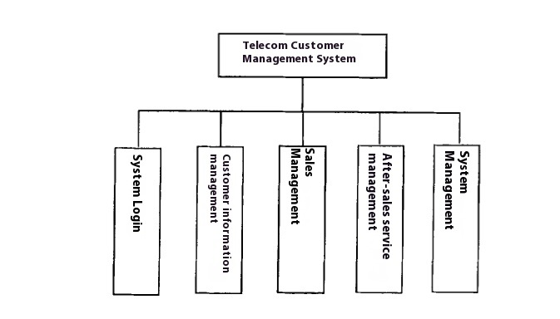

Figure 3.2 System overall function module division

3.2.1 System login module

The login module is a general module that can enter different function modes according to the privilege level selected when logging in. The login module can verify whether the user name and password entered by the user are matched by the privilege level selected by the user, and if they are matched, it will jump to the corresponding interface of the corresponding privilege; if they are not matched, it will send out a friendly reminder and return. The detailed flowchart of the login module can be found in Figure 3.3 below:

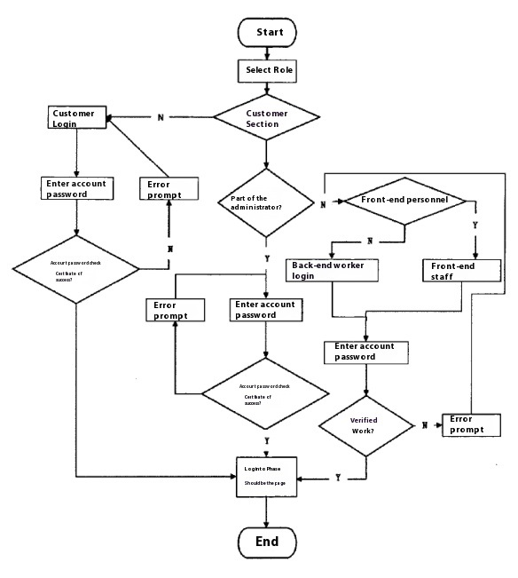

Figure 3.3 System login module flow

Through the flow chart can be seen, the user first according to their own permission level to enter the user name and password to log in, if the server can not find the account then return the error message, if you find the account, take out the password and the password entered by the user to match the password is inconsistent, then return the error message, the password is consistent, then go to the appropriate page number, and then the system will be loaded on the user permissions of a global variable that can be used in the The system will load a global variable about the user's authority, which can be used in the later information display and authority judgement.

3.2.2 Customer information management module

According to the analysis of the functional requirements of customer information management in the system, the design of the customer information management module is mainly divided into four parts: basic customer information management, consumption information management, contact information management, and lost customer management. Detailed functions of the customer information management module can be understood in Figure 3.4 below:

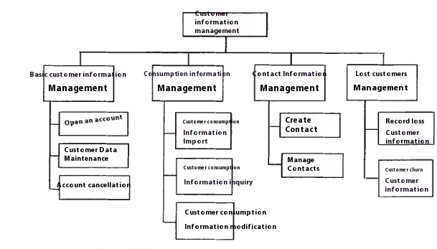

Figure 3.4 Customer information management module function

3.2.2.1 Management of basic customer information

The basic customer information mainly covers customer's name, gender, age, ID number, home address, contact phone number, education level, etc. It provides the system with functions such as deletion and enquiry of customer data information.

The basic customer information management has three main business applications: account opening management, maintenance of customer information, and account cancellation. Specific basic customer information management process can be understood in the following figure 3.5.

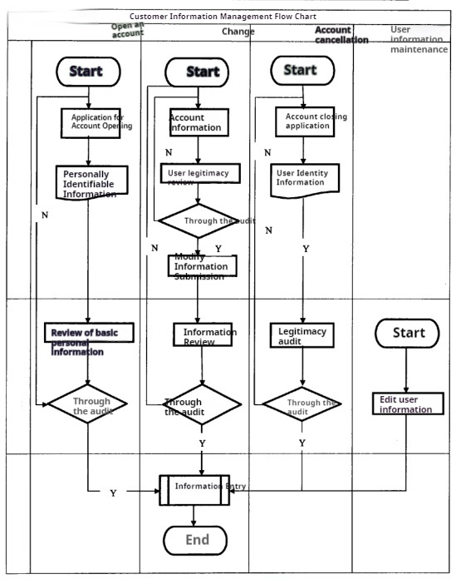

Figure 3.5 Basic customer information management process

(1) Account opening management

The first step for every user to reach out to the telecom is to apply for the business, the account opening function process is as follows.

①The user provides relevant customer information and his/her valid documents as required by the telecommunication company;

②The salesperson manually verifies that the information provided by the user is complete and that the documents are genuine;

③The salesperson logs into the CRM system and has access to the customer management interface to add customer information.

④The system makes a judgement on the user information, if it is correct, the system updates the database and prompts the user to add successfully.

(2) Maintenance of customer information

Customer data maintenance can manage the basic information of all customers, salespersons or account managers can find and identify customers in the system, and at the same time in the corresponding customer data management interface in the system according to the scope of permissions allowed to modify the customer data: such as modifying the user's address and the customer's password, and so on, in addition to being able to delete or delete the customer data operation.

(3) Account cancellation management

Account cancellation management is relatively more information needed to check, for account cancellation need to provide personal identity information, but also need to clear the user's account charges, if not cancelled resulting in arrears, will affect the future use of other telecommunications products, only the first arrears and late fees to pay off the telecommunications other services and modify the package and other operations

3.2.2.2 Consumer information management

The functions of the consumption information module include batch import, query, modification and other operations of customer consumption information. For customers, the core operation of consumption information management is to facilitate their own enquiry on consumption, which can be obtained through the Internet or mobile phone terminals. The consumption information module obtains business information from the business system, business consumption information from the billing system, and payment information from the billing system.

3.2.2.3 Contact information management

When the business hall for business acceptance or each channel account manager according to the need to create and manage contact information, you can record the customer's contact name, contact phone number, contact address and other contact information in the customer management system, in the order management, customer management, business opportunity management, contact management, contact information is needed, so this part of the information is the most important information that the sales staff want to get. The relationship between customers and contacts in the customer management system is a many-to-many relationship, which means that a single customer can be associated with multiple contacts at the same time, and vice versa, a single contact can also correspond to multiple customers.

The functional structure of contact management is shown in Figure 3.6.

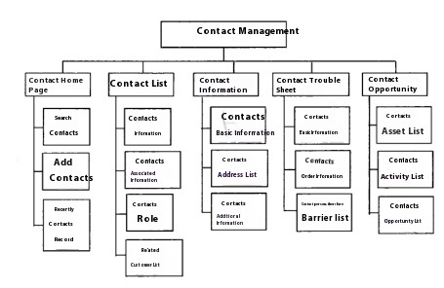

Figure 3.6 Structure of contact management function

3.2.2.4 Churn management

Churn customer management module is used to record, manage and analyse the information of churn customers, provide targeted personalized service or retention plan, and implement the plan to retain or win back customers. Lost customer management module provides batch import, modification, query and statistics of lost customer information.

The detailed churn management process can be understood in Figure 3.7 below:

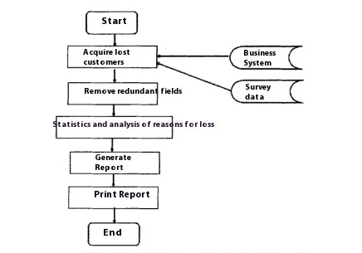

Figure 3.7 Churn Customer Management Process

Lost customer data is partly generated from the business system and partly obtained through market research and customer service staff input. By analysing the reasons for customer loss, we make and print reports and provide them to the leaders and the marketing department for reference, so as to provide the products and services that are most suitable for the needs of the customers, and to reduce the rate of customer loss.

3.2.3 Market Management Module

According to the analysis of the functional requirements of market management in the system, the design of the market management module is mainly divided into three parts: customer statistics and analysis, product management, and precision marketing, and its functional diagram is shown in Figure 3.8:

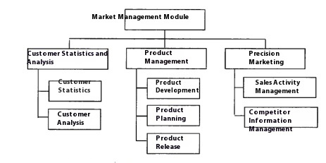

Figure 3.8 Market Management Module Functions

3.2.3.1

For the telecom operator industry, starting to understand customers is a good start. By analysing customer call patterns, operators can learn some basic characteristics of their customers, through which telecom companies can better analyse the differences in their customers, and the results of their analysis are the basis for telecom operators to carry out marketing activities. Data mining technology can be used, first of all, to convert complex business problems into problems that can be handled by data mining, and then with the help of data mining tool software to obtain the results of the data mining problem, and then the business personnel through the statistical analysis of the collected data set, summarise the characteristics of customer demand and the development of the customer base law and other series of valuable information for the self-existing.

The detailed process of CRM data mining can be understood in Figure 3.9 below:

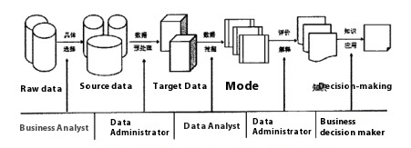

Figure 3.9The general process of CRM data mining.

These phases may need to be repeated more than once in the course of a specific implementation, and different professionals need to be involved in order to fulfil the tasks of these phases, notably business analysts, data managers, data analysts, data administrators and business decision makers.

In data mining, it is usually necessary to complete the segmentation based on the cluster analysis method, due to the fast clustering method in dealing with large-scale data clustering analysis has a very good adaptability as well as the advantages of fast computing speed, this thesis uses the fast clustering method, also known as K-Means. the fast clustering method of the clustering process is as follows.

(1) Divide the data into K clustering methods in order to automate the location of this cluster centre;

(2) The mean value of all objects within each cluster is used as its centre, and then the distance of each record to these K centre positions is calculated line by line, followed by adding each record to these K clusters using the proximity principle;

(3) Repeat step 2 to recalculate the minimum distance grouping for each sample and assign each object to the class whose cohesion point is closest to it, and so on, until all the objects can no longer be assigned, ending the above steps.

Wide table design is the first work to establish the customer segmentation model. Wide table is the model used to achieve a unified customer view in the enterprise user database, which contains a large number of customer data variables, and effective segmentation variables are determined by analysing the customer demand and segmentation purpose. On the basis of a certain understanding of the calling behaviour and consumption behaviour of Unicom's customers in a certain province, as well as the natural data aspects of the customers, and taking into account that this system is a segmentation based on the analysis of packages, it is also necessary to take into account the relevant attributes of certain packages, so as to provide a comprehensive analytical basis for the design of the packages and the evaluation of the packages. By identifying segmentation variables (variables used to segment users into customers) and descriptive variables (basic characteristics of each group after subdividing customers into groups), we selected and designed 15 groups as segmentation variables on the basis of customer needs, as shown in Table 3.1:

|  |  |
| --- | --- |
| 3.1 Subdivision Variables | |
| Attribute Number | Segmentation Variables |
| 1 | Basic monthly cost |
| 2 | Monthly Voice Consumption |
| 3 | local call charge |
| 4 | Long distance call charges |
| 5 | Roaming call charge |
| 6 | Local airtime |
| 7 | Provincial Long Distance Call Duration |
| 8 | Domestic Long Distance Calls |
| 9 | International airtime |
| 10 | Provincial roaming airtime |
| 11 | Domestic roaming airtime |
| 12 | international roaming call time |
| 13 | Internet access charges |
| 14 | Busy-time Internet traffic |
| 15 | Idle Internet traffic |

3.2.3.2 Product management

The product in the precision marketing belongs to the key, is to increase the sales of the foundation, if the lack of good products, no matter what form of marketing programmes and promotional tools can only be built on the basis of a "mirage". Based on the formation of services available for customers to use the combination is called a single product, services often can not be used by the customer, some services must be tied to some basic services can be used, such as caller ID must be tied to basic voice services can be used after

Product design should first be built on the current existing potential customer base on the basis of refinement, how to carry out targeted business recommendations based on customer demand, the only way to tap the different potential needs of different consumers, and provide the corresponding service content and products, in order to fully meet the market needs of all types of consumers, improve the adaptability of the product value, so as to maximise the value of the product. For example, for the weekend consumption is much higher than the usual customer groups, can be targeted to reduce the weekend time period call costs or exempt part of the airtime and other preferential tariffs.

Product planning is to manage the life cycle of a product. The product needs to determine the price, applicable region, applicable customer group, etc. before it is introduced to the market. Functions include product testing, product performance analysis, determination of tariff packages, and bundling of products and services.

A product release is the provision of a product service to all other systems that use the product. The specific product/service development process can be understood in Figure 3.10 below:

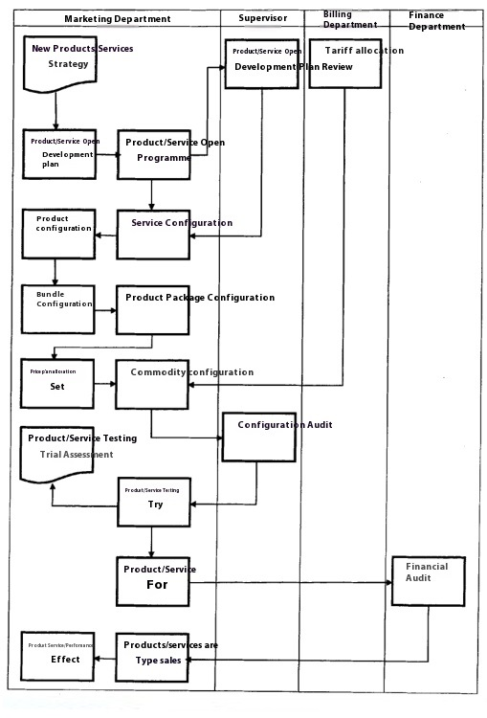

Figure 3.10 Product/Service Development Process

3.2.3.3 Precision marketing

With the arrival of 5G communications, a new pattern of competition in the telecommunications market has basically been formed, a detailed understanding of the development of different customer groups and competitors' customer groups is an urgent matter, competitors' data mainly comes from the detailed list, i.e., the detailed list of calls generated by the exchange of information between telecommunication users and users of other carriers, with a focus on the new subscribers, large customers and packages of the three data, and a detailed collection of the competitive pairs of packages of services and operations can be used for the overall planning and strategic planning of enterprises to bring positive and active promotion. The collection of the operation status of the competitors can bring active and positive impetus to the overall planning and strategic deployment of the enterprise.

As customers' needs become more and more diverse and personalised, mass marketing has clearly lost its edge. Precision marketing is based on an in-depth analysis of customer value and customer needs, a concept that is increasingly favoured by the three major telecom operators. Precision marketing advocates the development of products that are superior to those of competitors. Precision sales realises "one-to-one" marketing, enhances communication effect, shortens communication distance, and truly realises the recommendation of services corresponding to users' needs to users at the right time and through channels. Telecommunications companies to achieve precision sales is a closed-loop process, which includes five links: (1) customer insight (2) customer segmentation (3) product development (4) marketing (5) marketing results assessment: the only way to achieve the true meaning of precision marketing mode is to operate the above links in a precise manner. At the same time, precision sales through a series of product promotion activities and promotional tools to significantly enhance the corporate brand image and cultivate consumer loyalty.

The process of handling a specific marketing campaign can be seen in Figure 3.11 below.

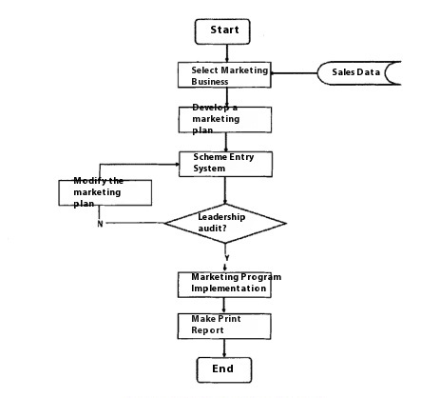

Figure 3.11 Processing Flow of Marketing Activities

3.2.4 After-sales service management module

The establishment of a perfect customer after-sales service system can greatly promote the satisfaction of the company's customer service and gradually improve the comprehensive management level and service level of enterprise service information technology. According to the functional requirements analysis of after-sales service management in Chapter 2, the design of after-sales service management module is mainly divided into four parts: customer consultation and enquiry content management, customer complaints and fault repair, care management and technical support, and the detailed functions of the after-sales service management module can be understood in the following figure in 3.12.

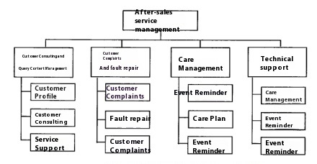

Figure 3.12 Function diagram of after-sales service management module

3.2.4.1 Content management of customer enquiries and queries

This module is mainly to standardise the management of customer's consultation or query information, record the business of customer inquiries, and can also be based on the user profile and the potential needs of the user, to develop appropriate services for the user, in order to consolidate the loyalty of the user. This module mainly includes three parts: customer profile, customer enquiry and service support.

(1) The customer file mainly covers the contract order, contact record, package type and billing situation related to the customer. Only service personnel are entitled to use the customer file, and customer classification rights can also be set to facilitate the use of branch regional customer service system, and can also ensure the security of the customer file.

(2) Customer counselling

Customer inquiries include: package status, consumption information, balance, traffic usage, etc.

(3) Service support

The answers to common questions and answers to customer enquiries are stored in a standard question bank, so that when a customer enquires, the keyword search function can be used to quickly find the answer from the bank and respond to the customer's question.

3.2.4.2 Customer complaints and fault warranties

(1) Customer complaints and fault warranty

Service personnel in the face of customer complaints, you need to note down the status of customer complaints, including the customer's name, the object of the complaint, the reason for the complaint, etc.; if it is a customer obstacle (broadband and IPTV failures, mobile phone to answer the phone faults, etc.) to report repairs, you need to record the user's name, type of business, account information, contact information, etc., will be declared by the customer to organise the content of the immediately after the generation of the work order link.

The customer complaint or repair handling process is shown in Figure 3.13:

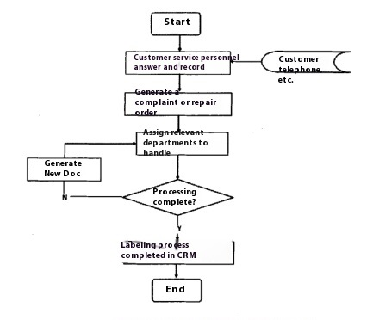

Figure 3.13 Handling Process of Customer Complaint or Repair Report

As can be seen from the process, the beginning and end of the work order is completed by the service personnel, when other departments after the completion of the work order processing, the single will flow back to the acceptance of the person's workstation, after the return visit to the customer, if it is confirmed to have been restored, then the work order will be archived, if the customer is not satisfied, then the work order will be returned to the relevant departments of the handling of the inappropriate.

(2) Distribution of tasks

After the complaint or trouble ticket is completed, the work order needs to be transferred, the transfer steps are as follows.

The first step is to determine the region, and the regional division can be determined from the content of the work order or through a user account query to determine whether it belongs to the city or another county;

Secondly, it is the departmental judgment, according to the fault acceptance content to determine which type of business, if it is a broadband or fixed-line complaints or fault repair, then assigned to the access network maintenance centre to deal with, if it is a mobile user signal problem complaints or repair, then assigned to the wireless access maintenance centre: if it is a large customer's fibre optic broadband or digital circuits repair, then assigned to the government and enterprise customer support centre to deal with: if it is a cable failure, then assigned to the optical fiber maintenance centre. If it is optical cable fault, it will be assigned to optical cable maintenance centre.

Finally, after checking the contents of the business, the receiving service staff will sort and dispatch it to the various technical departments.

3.2.4.3 Technical support

Technical support includes FAQ aggregation and sharing, email blasts and SMS services.

(1) Frequently asked questions sharing, the service personnel in the process of dealing with the industry encountered in the difficult questions to create a theme for everyone to reply, select the best answer, so that the next time you encounter the same problem can be directly in the library to retrieve the answer, can quickly and accurately reply to the user, so that after-sales service personnel can quickly learn professional knowledge to improve the efficiency of the work and customer service: At the same time, you can also be the day-to-day work to precipitate the experience, service answers and product knowledge to gather and share. At the same time, it can also gather and share the experience, service answers and product knowledge precipitated in daily work, establish a channel to obtain knowledge at any time, and enhance the professionalism and efficiency of the service.

(2) Mail service: Through the mailbox set up by the system, it is possible to carry out mass mail service for users within the scope of authorisation, such as notification of new meal releases and advertising services.

(3) SMS

Enterprise SMS system can release various enterprise related information, such as package usage, cost, traffic usage, etc. Through SMS, it can improve office efficiency and reduce office cost.

3.2.4.4 Care management

Many customers switch to other networks because operators do not provide enough customer care services, so customer care management is very important to reduce customer churn, which mainly includes three aspects: care reminder, care plan and care analysis.

(1) Care reminders: the daily work of customer service staff of the customer service staff all need to care for the customer, mainly for customer care reminders, which covers the complaints and after-sales service care and package use expiry reminder, automated reminders can be realised to avoid customer service matters missed.

(2) care plan: according to the type of customer to specify the plan, according to the customer level, customer creditworthiness, customer spending power and other conditions, to determine the care object, set the customer care mode, etc., after the plan is generated, according to the system to remind the time to start the service tracking work.

(3) care analysis: type of care plan, care plan implementation into the amount of staff to facilitate the management of real-time customer feedback and business staff to grasp the work of the situation

3.2.5 System management module

According to the functional requirements analysis of system management in the system, the design of system management module is mainly divided into three parts: account management, rights management and system maintenance, and its functional diagram is shown in Figure 3.14:

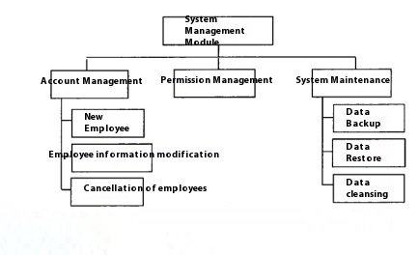

Figure 3.14 System Management Module Function Chart

3.2.5.1 Account management

Account management is mainly to manage the main information of employees, including login account, password, name, ID number, department, position, contact number, etc. Its function is mainly to create new employees, modify employee information, logout employees, etc.

This section focuses on password changes and the need to verify changes to newly added basic information during the process of changing information.

The password change flowchart is shown in Figure 3.15.

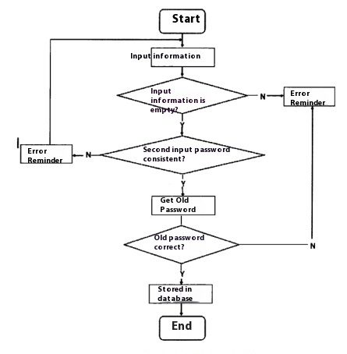

Figure 3.15 Password modification flow chart

The information verification workflow is shown in Figure 3.16:

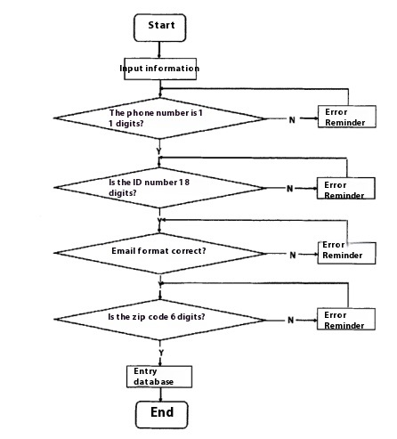

Figure 3.16 Flow chart of information verification

3.2.5.2 Rights management

The system administrator will assign appropriate permissions to each user, so that he or she can only see the data in the system and perform the operations that he or she is supposed to perform to ensure the security of the customer management system.

3.2.5.3 System maintenance

System maintenance is the maintenance of the data in this system, some routine daily function check, in order to ensure the security of the system, the system administrator of the system programme to do off-site backup, the database is a regular alternative to the backup, in addition to provide data restore, data compression, data cleaning functions.

3.3 System database setup

Database in the customer information management system in the status of a pivotal, database design structure and the quality of the advantages and disadvantages of the customer management system can have a direct impact on the efficiency of the work of the system and the implementation of the effect. Design of the database, the need to use the most optimal and least database tables to achieve the functional requirements, customer management system database design principles: the establishment of the database management system in the logic to be consistent, while in the physical to maintain relative independence, so as to ensure that the system to achieve the normal exchange of data.

3.3.1 E-R modelling

E-R modelling is the process of analysing and designing the data present in the department in the real world entity situation managed by the system, analysing the attributes of the entities as well as the relationship of these entities to clear the need of the data in the system. By analysing the requirements of the customer management system, we have designed the entities which include: basic customer information, customer consumption information, employees, product information, product push, competitors, complaints and fault reporting. The overall E-R diagram of the system is shown in Figure 3.17:

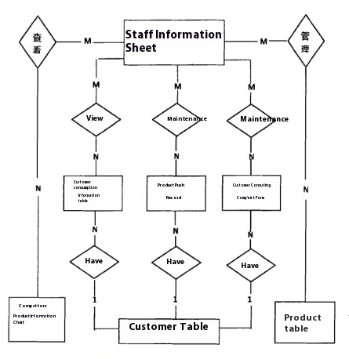

Figure 3.17 System overall E-R diagram

Each entity contains different specific information, based on the interaction between entities to promote data mobility, the correspondence between entities: an employee corresponds to a role, a role corresponds to multiple permissions a customer corresponds to a consumer information, a customer has more than one after-sales records, more than one product push history, and so on.

Below is the E-R diagram for each entity

(1) Basic customer information entity

The basic customer information mainly covers customer number, name, gender, age, ID number, address, contact number, education level, and the specific entity attributes of the basic customer information can be understood in the following figure of 3.18:

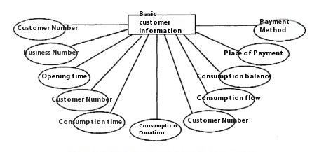

Figure 3.18 Basic Customer Information Entity Properties

(2) Customer consumption information entities

For the telecommunication industry, the customer consumption information includes the type of service, consumption situation (including consumption time, consumption duration, consumption flow), and tariff situation (balance, payment outlet, payment style, payment amount), etc. Its entity attribute diagram is shown in Figure 3.19:

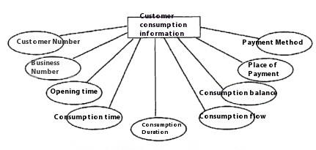

Figure 3.19 Customer Consumption Information Entity Attribute

(3) Employee information entities

Employees are the staff of the telecommunication company and each employee has attributes such as employee number, name, login password, joining time, employee role, etc., and its employee information entity attribute diagram is shown in Figure 3.20:

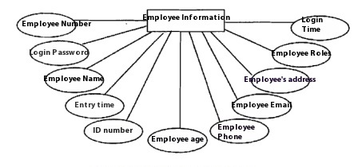

Figure 3.20 Employee information entity attribute diagram

(4) Product information entities

Product is the basis of sales, product information mainly covers the cost, number, name, network traffic tariffs free call length, etc., and its product information entity attribute diagram as shown in Figure 3.21:

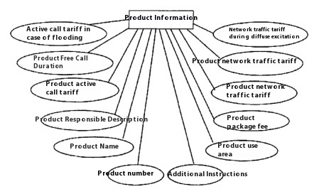

Figure 3.21 Product Information Entity Attribute

(5) Product push entities

Product Push is used to record the push information of the product carried out by the sales staff, specifically including the push serial number, customer, push time, staff number, push product number, etc., the product push entity attribute map as shown in Figure 3.22:

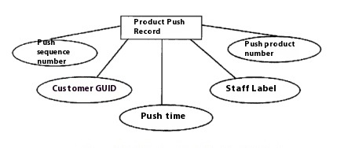

Figure 3.22 Product Push Entity Attribute

(6) Competitor entities

Competitors' product information is an important reference information for our product design, specifically including competitors' labels, key employees, business types, business sales, number of customers, promotional programmes, etc. The competitors' entity attribute map is shown in Figure 3.23:

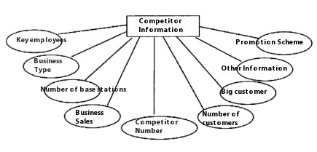

Figure 3.23 Competitor Entity Attribute Chart

(7) Complaints and fault reporting entities

For the telecommunication industry, the complaint and fault reporting is mainly to record the content of customer complaints and reporting obstacles, specifically including customer label, customer name, time of complaint or repair, customer service personnel, business type, customer phone number, processing department and processing status, etc. The complaint and fault reporting entity attribute diagram is shown in Figure 3.24:

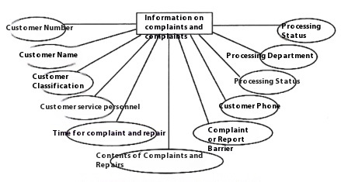

Figure 3.24 Attributes of Complaints and Failure Repairs Entities

3.3.2 Database table structure design

After designing the database E-R diagram, we can use the database table structure design to convert the previously designed conceptual structure into a data model that can be processed by the SQL Server 2008 database system, the specific database table form design is as follows.

(1) Basic customer information form

This table mainly stores the basic data information of each customer, the customer number in the table is the primary key, the other foreign key, the customer basic data database table design as shown in Table 3.2:

|  |  |  |  |  |
| --- | --- | --- | --- | --- |
| Table 3.2 Customer Basic Information Sheet | | | | |
| field name | Chinese Name of Field | Field type | Can be null | note |
| KHId | Customer Number | Int | × | primary key |
| Name | Name and surname | Varchar(50) | × |  |
| Gender | Distinguishing between the sexes | Char(2) | × |  |
| Age | (A person's) age | Int | × |  |
| Idcard | I.D. number | Varchar(18) | × |  |
| Address | Address | Varchar(80) | × |  |
| Phone | Telephone number | Varchar(50) | × |  |
| Education | Educational attainment | Varchar(50) | √ |  |
| Job | Careers | Varchar(50) | √ |  |
| Income | Incomes | Int | √ | foreign key |
| Category | Client Classification | Int | × |  |

(2) Customer consumption information form

This table mainly stores the customer's consumption information, which is convenient for users to query the consumption situation and also provides data support for analysts to analyse the customer's consumption behaviour. The customer number and business number in the table are the main keys, and the customer consumption information database table is designed as shown in Table 3.3:

|  |  |  |  |  |
| --- | --- | --- | --- | --- |
| Table 3.3 Customer consumption information table | | | | |
| field name | Chinese Name of Field | Field type | Can be null | note |
| KHId | Customer Number | Int | × | primary key |
| Product id | Business Number | Int | × | primary key |
| Start date | Opening hours | Date | √ |  |
| Consume time | Consumption time | Datetime | √ |  |
| Consume long | Duration of consumption | Int | √ |  |
| Consume flow | Consumer traffic | Float | √ |  |
| Balance | Consumer balance | Float | √ |  |
| Pay_place | Payment location | Int | √ |  |
| Pay_how | Payment Methods | Int | √ |  |

(3) Employee Information Sheet

This table is to record and organise the employees within the company, mainly storing the basic information of the employees. Among them, Employee Number is the primary key and Employee Role is the foreign key, associated with the Role table. The employee information database table design is shown in Table 3.4:

|  |  |  |  |  |
| --- | --- | --- | --- | --- |
| Table 3.4 Employee Information Sheet | | | | |
| field name | Chinese Name of Field | Field type | Can be null | note |
| OpeId | Employee Number | Int | X | primary key |
| OpePW | Employee Login Password | Nvarchar(10) | X | Default 123456 |
| OpeName | Employee Name | Nvarchar(20) | X |  |
| OperEmploiedDate | Employee Onboarding Time | Datetime | X |  |
| OpePerID | Employee ID number | Nvarchar(18) | X |  |
| OpeAge | Age of employees | Int | X |  |
| OpeTel | Employee Phone | Nvarchar(11) | X |  |
| OpeEmail | Staff Email | Nvarchar(40) | √ |  |
| OpeAddress | Employee Address | Nvarchar(100) | √ |  |
| Role_mum | Employee Roles | Nvarchar(10) | X |  |
| OpeJLastLoadTime | Last login time | Datetime | X |  |

(4) Product Information Sheet

The product information table mainly contains the detailed information of the products launched externally by the telecommunication operator company, in which the product number is the primary key and the product usage area is the foreign key, and the product information database table is designed as shown in Table 3.5:

|  |  |  |  |  |
| --- | --- | --- | --- | --- |
| Table 3.5 Product Information Sheet | | | | |
| field name | Chinese Name of Field | Field type | Can be null | note |
| ProlD | Product Number | Int | X | primary key |
| ProName | Diethylammonium chloride | Nvarchar(50) | X |  |
| Pro_Base | Product package cost | Float | X |  |
| CallFee | Product unsolicited call rates | Float | √ | Unit:￥/Min |
| DataFee | Product network traffic tariffs | Float | √ | Unit:￥/G |
| BeCallFee | Product passive call tariffs | Float | √ | Unit:￥/Min |
| ProFreeData | Free web traffic for products | Float | √ | Unit:G |
| ProFreeDruing | Product Free Calling Hours | Float | √ | Unit:Min |
| SpecCallFee | Unsolicited call rates in unusual circumstances | Float | √ | Unit:￥/Min |
| SpecBeCallFee | Passive call tariffs for abnormal conditions | Float | √ | Unit:￥/Min |
| SpecDateFee | Network traffic tariffs in unusual circumstances | Float | √ | Unit:￥/G |
| RoamingCallFee | Unsolicited call rates while roaming | Float | √ | Unit:￥/Min |
| RoamingDateFee | Network traffic tariffs when roaming | Float | √ | Unit:￥/G |
| AreaNum | Product use area | Nvarchar(50) | √ |  |
| Comment | Additional Notes | Nvarchar(200) | √ |  |
| Addition | Product Responsibility Statement | Nvarchar(200) | √ |  |

(5) Product Push Record Sheet

Product push record table is mainly to facilitate the sales staff to view the product push information, which push the serial number is the primary key; customer is a foreign key, associated with the customer table; staff number is a foreign key, associated with the staff table; push the product number is a foreign key, associated with the product table. Product push record database table design as shown in Table 3.6.

|  |  |  |  |  |
| --- | --- | --- | --- | --- |
| Table 3.6 Product Push Record Sheet | | | | |
| field name | Chinese Name of Field | Field type | Can be null | note |
| Push_Num | Push serial number | Nvarchar(30) | X | primary key |
| GUID | Client GUID | Nvarchar(16) | X | Foreign key, associated customer table |
| Push_Date | push time | Datetime | X |  |
| OpelD | Staff number | Nvarchar(20) | X | Foreign key, related to employee table |
| ProGUID | Push Product Number | Nvarchar(36) | X | Foreign key, related products table |

(6) Competitor Information Sheet

The competitor information table is mainly used to manage information about competitors, i.e. other operators' products, where competitor number is the primary key, and the competitor database table is designed as shown in Table 3.7:

|  |  |  |  |  |
| --- | --- | --- | --- | --- |
| Table 3.7 Competitor Information Table | | | | |
| field name | Chinese Name of Field | Field type | Can be null | note |
| Competitor_ID | Competitor Number | Int | X | primary key |
| Employee | Key Employees | Int | √ |  |
| Product | Type of business | Int | X |  |
| Sale | Business sales | Float | X |  |
| Customer_Num | Number of clients | Int | √ |  |
| Big_Customer | Major client | int | √ |  |
| Promotion | Promotional Programmes | Nvarchar(30) | √ |  |
| memo | Other information | Text | √ |  |

(7) Complaints and fault reporting information form

Complaints and fault repair information table is mainly to record customer complaints and fault repair, in which the customer number is the primary key, customer service personnel is a foreign key, management staff information table. Complaints and fault repair database tables are designed as shown in Table 3.8.

|  |  |  |  |  |
| --- | --- | --- | --- | --- |
| Table 3.8 Complaints and fault reporting information table | | | | |
| field name | Chinese Name of Field | Field type | Can be null | note |
| Customer_Id | Customer Number | Int | x | primary key |
| Name | Client name | Nvarchar(30) | x | Foreign key, associated customer table |
| Category | Client Classification | Int | x |  |
| Time | Complaint and repair time | Datetime | x |  |
| Service_Id | Customer service personnel | Int | x | Foreign key, associated with the Employee table |
| Product Id | Business Type | Int | x |  |
| Isrepair | Complaints or repairs | Int | x |  |
| Content | Complaints or repairs | Text | √ |  |
| Phonenumber | Client's telephone number | Nvarchar(30) | √ |  |
| Partment | Processing unit | Int | √ |  |
| State | Pprocessing state | Int | x |  |

This chapter is the central part of the system design, based on the previous one child system requirements analysis as well as the guidance of the system design principles, the customer management system is designed in detail. The design work is firstly the overall architecture design of the system, which adopts the B/S (browser/server) three-layer logic architecture: followed by the design of the system function module, which is the framework of the system, including the system login, customer information management, sales management, after-sales service management, and system management of the five parts: finally, the design of the system database, including the E-R modelling and the design of the database table structure.

**4. System implementation and key technologies**

Through the second chapter of the system requirements analysis, the third chapter of the detailed design of the system, this chapter will be the specific implementation of the previous business, including the development environment of the system, the implementation of each function, the system implementation process is mainly through the implementation of the interface to describe its specific functions.

4.1 System development environment

The specific system implementation environment can be understood in Figure 4.1 below:

|  |  |  |  |
| --- | --- | --- | --- |
| Table 4.1 System realisation environment | | | |
| operating system | programming language | comprehensive database | development environment (computer) |
| Windows 7 | JAVA | SQL Server 2008 | Visual Studio 2010 |

4.2 Login Module Implementation

The login screen of this customer management system, the specific user login screen can be seen in Figure 4.1 below.

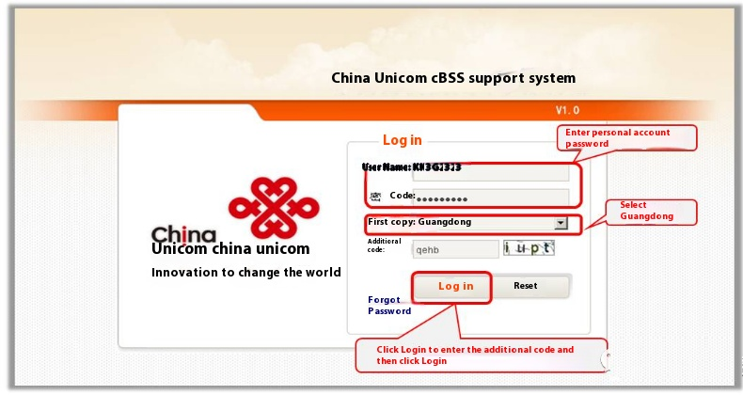

Figure 4.1 User login screen

After entering the exact user name and password in the corresponding text box on the page, you can enter the login system. At the initial stage of the system setup, the set customer level users access the system through the B/S way. The login process is a complex authentication process that involves 4 steps.

(1) Verify that the user enters a user name and login password

The validation process is to determine whether the username and password are empty and of the right length, and whether there are any errors in the format of the username and password.

(2) Verify that there are no errors in the user name and login code.

After obtaining the user name and password, it is necessary to judge whether the entered user name and login password match or not, in order to improve the security of the system, all user passwords in this system are encrypted with MD5.

(3) Login and load global storage implementation

If you verify that the user name and password match, you can normally access the information that is open to the public in this system, load user permissions, and load the user global cache. The user cache content mainly involves three main information: the user's account number, login time and user role.

The core code to implement the login process is as follows.

protected void Button1_Click(object sender, EventArgs e)

{

if (string .Compare(TextBox1.Text.Session["code"].ToString(),true)! =

{

Response.Write("<script>alert("CAPTCHA error! </script>");

return;

}

string UserName = tbx_uid.Text.Trim();

string PassWord = tbx_upassword.Text.Trim();

Session ["username"]=User Name;

Model.T_USERmodel myUserEntity = new Model.T_USERmodel();

myUserEntity.USERNAME = UserName;

myUserEntity.PASSWORD = PassWord;

myUserEntity.USERID="";

BLL.T_userbll myUser = new BLL.T_userbll().

myUser.myUserEntity = myUserEntity;

if (string.IsNullOrEmpty(UserName) ll UserName ="");

{

Response.Write("<script>alert('Please enter username!') /</script>");;

return;

}

int Value -myUser.JudgeUser();

switch (Value)

{

case 0.

break;

case -1.

Response.Write("<script>alert('The username or password you entered is incorrect! Please re-enter it')</script>");;

break

case 100

Response.Write("<script>alert('User does not exist! ')</script>");

break;

default

Response.Write("<script>alert('The application generated an error! ')</script>");;

Break.

}

4.3 Customer Information Management Module Implementation

The system realises the management of customer information, which includes the implementation of four parts: basic customer information management, consumption information management, contact information management and lost customer management.

(1) Realisation of basic customer information management

Detailed basic customer information and package processing can be found in 4.2 in the following figure.

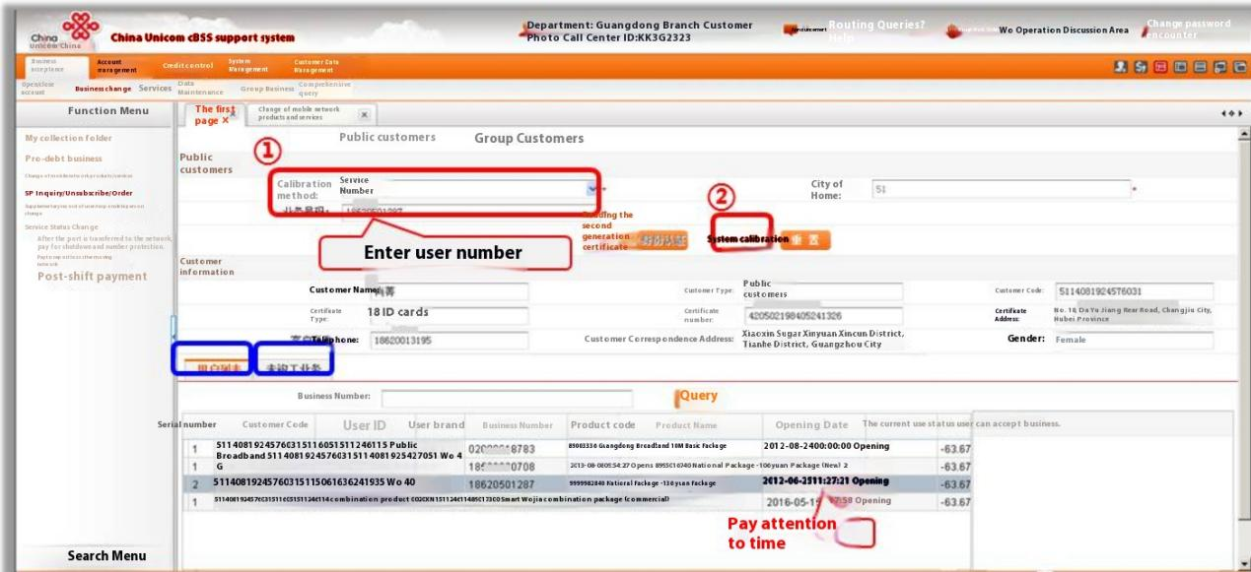

Figure 4.2 Basic customer information and package processing

In Figure 4.2, you can through the customer name, account number, ID card information or customer number can be queried to the user's basic information, but also can be queried to the user to accept the package situation.

In the business acceptance, you can open an account, modify user information, and so on.

Operation specific account opening and user information modification operations can be found in the following figure 4.3.

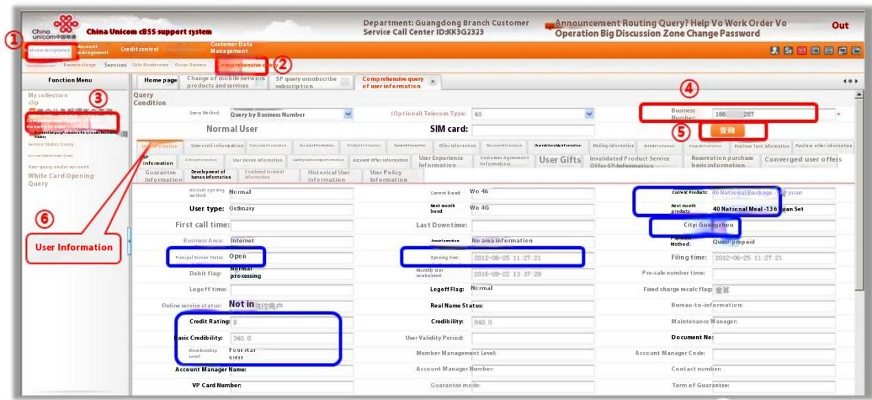

Figure 4.3 Operation of opening an account and modifying user information

(2) Customer consumption information management realisation

You can query the consumption of the user's package, as well as payment information, general ledger query, real-time balance and other information, the specific implementation is shown in Figure 4.4.

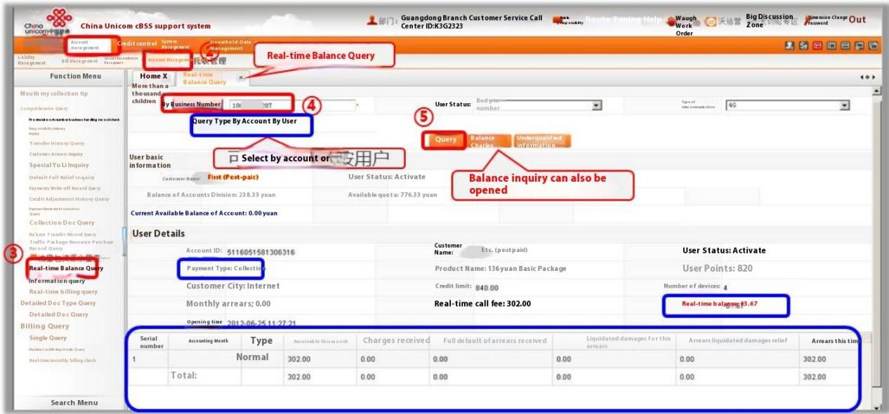

Figure 4.4 Query customer consumption information graph

(3) Contact information management realisation

Contact information is the most important information that salespeople want to obtain, which contains business opportunities. Including contact name, contact phone number, contact address, etc., as shown in Figure 4.5:

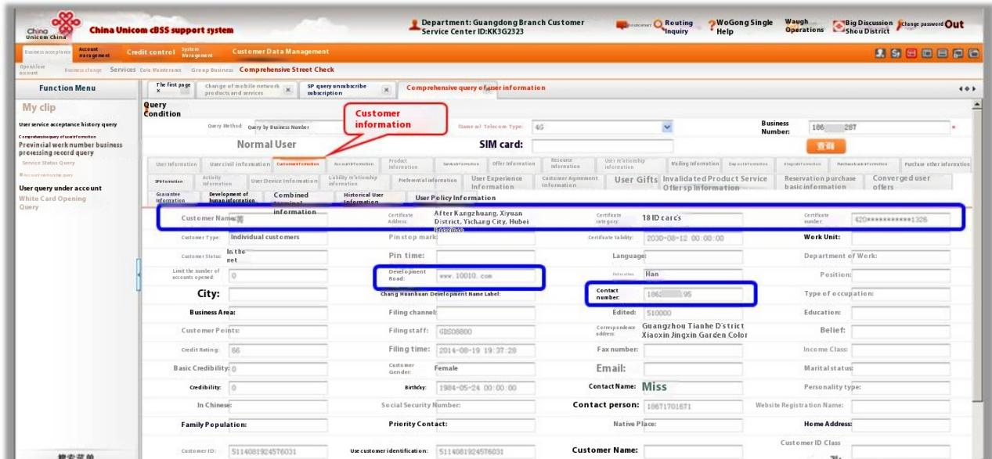

Figure 4.5 Query Customer Contact Information Chart

(4) Churn customer management realisation

Churn management focuses on reducing customer churn by analysing the reasons why customers leave the network and taking appropriate customer retention measures to encourage this. Specific churn management can be understood in Figure 4.6 below.

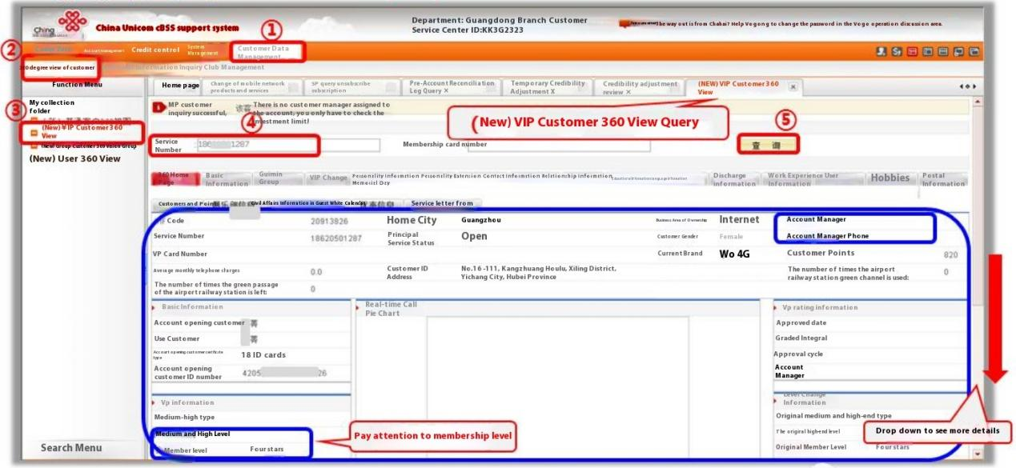

Figure 4.6 Churn Customer Management

4.4 Market Management Module Implementation

The implementation of the market management module is specifically described in three parts: customer statistics and analysis implementation, product design implementation, and precision marketing implementation.

(1) Client integration and sub-implementation

According to the previously mentioned fast clustering method GK-means algorithm for customer segmentation, through the demand analysis, the K value of the initial value set in the range of 2 < K < 5, after the algorithm's continuous debugging, the final debugging results to determine the K value of 3, has been repeated 150 times the operation before the collection, i.e., all the objects can not be re-allocated until.

On the basis of combining business understanding, we screen out the variables needed for customer analysis from hundreds of variables. In this thesis, we focus on choosing customer value and customer behaviour as attributes, and according to the selected segmentation variables, they are mainly classified into the following sub-categories: monthly basic fee, monthly voice consumption, local call fee, long-distance call fee, roaming call fee, local call fee, intra-provincial long-distance call duration, domestic long-distance call duration, international long-distance call duration, and so on. call duration, international call duration, Internet access fee, busy time Internet traffic and idle time Internet traffic, etc. The clustered customer groups are mainly divided into 3 types: frequent Internet users, frequent call users and local users. The detailed results of the clustering segmentation can be found in the following table 4.2.

|  |  |  |  |  |
| --- | --- | --- | --- | --- |
| Table 4.2 Cluster segmentation results | | | | |
| property name | unit (of measure) | Internet-intensive | talkative | Local Popular |
| Basic monthly fee | ￥/Month | 56.5 | 96.4 | 72.3 |
| Monthly Voice Consumption | ￥/Month | 11.6 | 69.3 | 45.2 |
| local call charge | ￥/Month | 9.6 | 45.2 | 22.1 |
| Long distance call charges | ￥/Month | 1.1 | 18.9 | 15.3 |
| roaming call charge | ￥/Month | 0.9 | 5.2 | 7.8 |
| local airtime | Min/Month | 600 | 1100 | 258 |
| Provincial Long Distance Call Duration | Min/Month | 50 | 189 | 101 |
| Domestic Long Distance Calls | Min/Month | 31 | 65 | 42 |
| International airtime | Min/Month | 3 | 6 | 4 |
| Provincial roaming airtime | Min/Month | 45 | 120 | 84 |
| Domestic roaming airtime | Min/Month | 25 | 51 | 38 |
| international roaming call time | Min/Month | 2 | 18 | 2 |
| Internet access charges | Min/Month | 81 | 15 | 45 |
| Busy-time Internet traffic | G/Month | 120 | 50 | 40 |
| idle Internet traffic | G/Month | 60 | 30 | 20 |

(2) Product design realisation

According to the results of the previous statistical customer segmentation, in the design of products and services combined with the company's bundled marketing strategy, designed for the three types of customer groups to design packages to be targeted to meet the different needs of the three types of customer groups, so that not only can improve the brand advantage of the enterprise, but also reduce product development and marketing costs detailed product design content can be in the following table in 4.2 to understand:

|  |  |  |  |
| --- | --- | --- | --- |
| Table 4.3 Product design | | | |
| Package name | Practical Customers | Package Use | Package contents |
| 5G Dragon Diamond Card | Internet-intensive | 160 RMB/Month | Includes 1000 domestic voice dialling minutes, 150GB domestic traffic, domestic calls are free of charge; caller ID is included; voice is charged at RMB 0.15/minute in excess, traffic is charged at RMB 3/G in excess, and domestic point-to-point SMS and MMS are charged at RMB 0.10/item. |
| 5G Dragon Gold Card | talkative | 80 RMB/Month | Includes 2000 domestic voice dialling minutes, 60GB domestic traffic, free domestic calls; includes caller ID; voice exceeds the portion of 0.15 yuan/minute charge, traffic exceeds the portion of 3 yuan/G charge, domestic point-to-point short, MMS at 0.10 yuan/article charge. |
| 5G Dragon Silver Card | Local Popular | 60 RMB/Month | Includes 7000 domestic voice dialling minutes, 40GB domestic traffic, free domestic calls; includes caller ID; voice exceeds the portion of 0.15 yuan/minute charge, traffic exceeds the portion of 3 yuan/G charge, domestic point-to-point short, MMS at 0.10 yuan/article charge. |

(3) Precision marketing realisation

Precision marketing can greatly enhance the value of customers, realise the "one-to-one" marketing mode, and give full consideration to the user's individual characteristics. Through the previous customer segmentation results, for different types of customer groups to apply the service strategy, so that users feel their own distinctive personalised service, the specific service strategy can be understood in the following table 4.4.

|  |  |  |  |
| --- | --- | --- | --- |
| Table 4.4 Service Strategy | | | |
|  | Internet-intensive | talkative | Local Popular |
| User characteristics | High traffic demand | High voice requirements | Relatively balanced traffic demand and voice demand |
| Featured Packages | 5G Dragon Diamond Card | 5G Dragon Gold Card | 5G Dragon Silver Card |
| service strategy | For the young group of frequent Internet users, who often do not have enough traffic, you can introduce a 7-day 10G traffic pack for just an additional 10 RMB. | The formulation of the package long-distance and local calls is a price, while the national roaming reception is free, in addition to frequent calls to the user points will be relatively high, can be designed to exchange points for love Qiyi, Tencent video VIP card and other activities to attract users! | To meet customer demand for local telecommunications information, such as additional busy message secretary, caller alerts, weather forecasts, etc., in addition to adding a number of time-sensitive and practical gifts, using the customer to chase the psychology of preferential treatment, to promote the customer to place orders |

4.5 After-sales service management module implementation

The implementation of the after-sales service management module is elaborated in two parts, namely, the implementation of customer complaints and fault reporting, and the implementation of technical support.

(1) Customer complaints and fault reporting realised

The CRM system has a CRM one-click trouble-shooting button, which can be tapped to handle related enquiries, complaints and trouble-shooting, and the implementation of specific customer complaints and trouble-shooting can be learnt in the following figure 4.7.

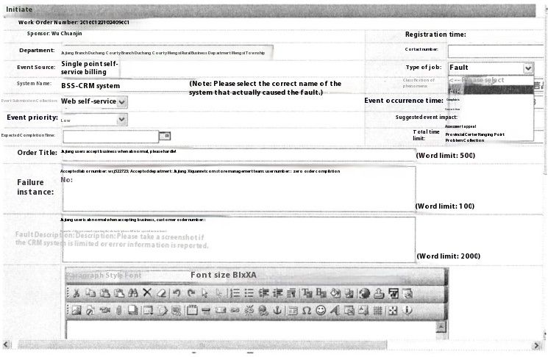

Figure 4.7 Customer complaints and fault reporting realisation

(2) Technical realisation

Aggregate the knowledge of service personnel in the process of business processing experience, service answering skills, etc., and establish a channel even for acquiring the knowledge, through which the service personnel can quickly provide answers that meet the customer's needs at any time. Specific technical support implementations can be found in 4.8 below.

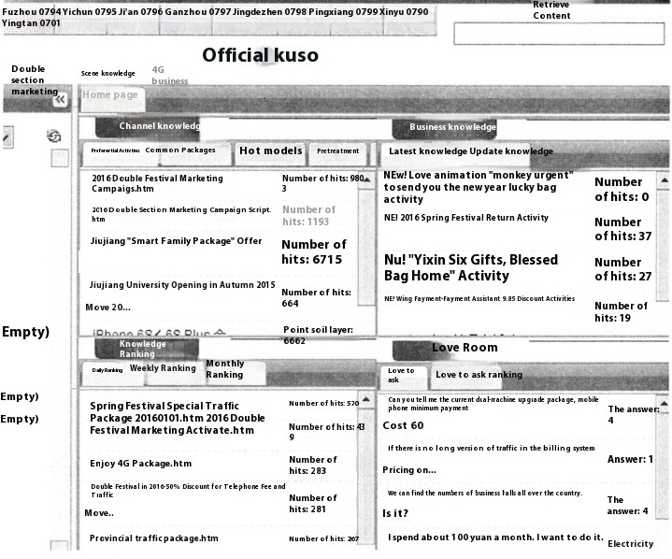

Figure 4.8 Technical support realisation

4.6 System management module implementation

The implementation of the system management module is specifically described in three parts: account management implementation, permission management implementation, and system maintenance implementation.

(1) Account Management Realisation

The system administrator can manage and modify the basic information of the account, including the name of the employee, the department he/she belongs to, and the password, etc. The specific implementation of the account management can be understood in the following figure 4.9:

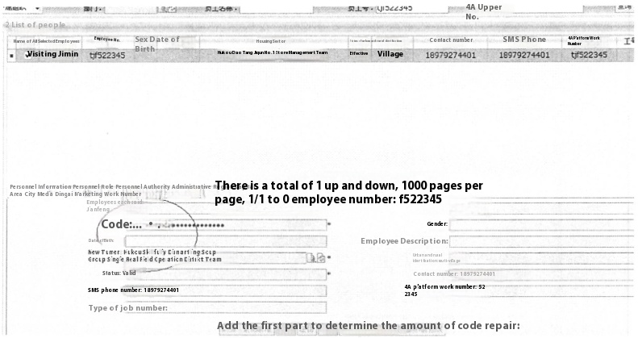

Figure 4.9 Account Management Implementation

(2) Rights Management Implementation

The executor of the rights management is the system administrator, and the management rights are mainly based on the differences in the scope of work of the employees and the differences in the roles to assign the corresponding rights, the specific implementation of the rights management can be understood in the following figure in 4.10:

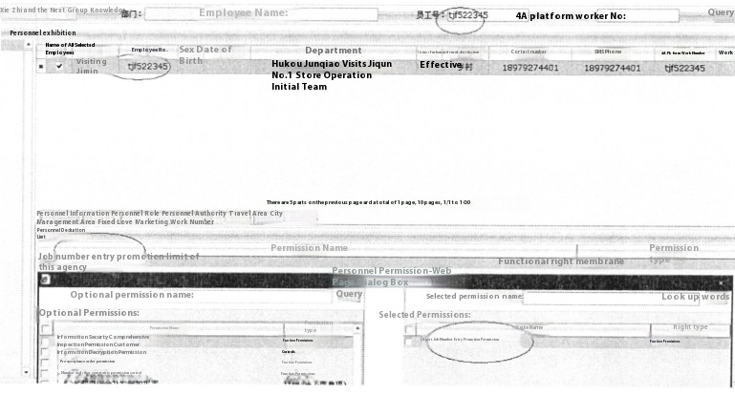

Figure 4.10 Permission Management Implementation

(3) System maintenance realisation

The data of the CRM system is very important, and the backup of the database is a very important part of the system maintenance work. The implementation of system maintenance focuses on two aspects of data backup and data recovery.

Backups of the CRM system are generally required to be made at least once a week, and the backup file must be saved to another machine, with at least two machines retaining that backup. Specific system data backups can be found in Figure 4.11 below.

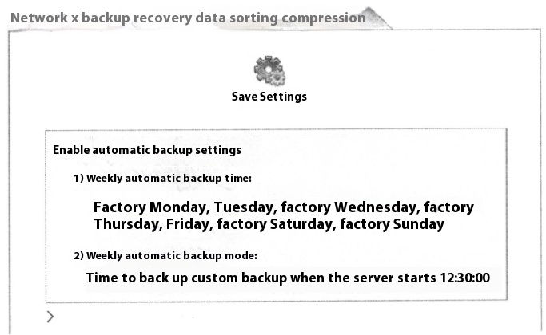

Figure 4.11 System Data Backup

Data recovery is simple when the data has been backed up. A specific example of data recovery can be found in figure 4.12 below.

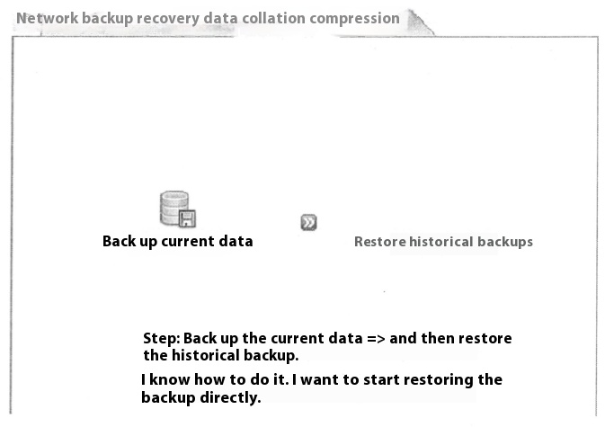

Figure 4.12 System Data Recovery

4.7 Summary of the chapter

This chapter mainly introduces the telecom customer management system development environment and the implementation of functional modules, specifically covering five parts: (1) login (2) customer information management (3) sales management (4) after-sales service management (5) system management, and supplemented with system screenshots for its detailed description.

**5. System testing**

Customer relationship management system requires both to be able to run accurately and stably, but also requires as soon as possible on the line, the early formation of productivity, but for any software system, it is impossible to all the functions are designed very perfectly, there will inevitably be a number of gaps in the design and implementation. Therefore, in the construction process of the system, in order to verify that the new system can achieve the design performance objectives, it is necessary to carry out a comprehensive testing of the system to find the defects, and then carry out detailed improvements. Software testing is not only to verify whether the software development code is correct, but also includes the development of whether it is reasonable, whether to meet the development of some of the software quality requirements set before the test, whether it is consistent with the user's habits and so on.

The testing was led by the in-house Digitalisation Department, which together with the Marketing Department and ASIMCO Technologies formed a testing team to design and implement the testing of the system.

5.1 System test environment

The specific system test environment can be found in Table 5.1 below.

|  |  |
| --- | --- |
| Table 5.1 System Test Environment | |
| System Test Environment | |
| Tester | CPU Model: Core i5 2400S Memory Capacity: 4GB Memory Capacity: 4GB Hard Drive Capacity: 500GB Hard Drive Capacity: 500GB Hard Drive Speed: 7200 RPM, Video Memory Capacity: 512MB; Optical Drive Type: DVD-R |
| Server (computer) | Application Server: Product Name IBM X3650-7979R01;L2 Cache Capacity:12MB;Memory Type:ECC;Blade Server Architecture:2Brand: IBM;IBI Server Model: System X3650;Interface Type: SASMaximum Number of CPUs Supported:2,Standard Memory:2GB;Hard Disk Capacity:146GBProcessor Frequency:3.33GHz  Database Server:Product Name:IBM System x3100 434842C;L2 Cache:4MB;Memory Type:DDR2:Blade Server Architecture:2UIBN Server Model:System 3100 434842C,Interface Type:SATAMaximum Number of CPUs Supported:1;Standard Memory: 1GBHard Drive Capacity. 160GB;Processor frequency:2.28GHz. |
| Test content | Functional testing, performance testing |
| Test Methods | Black Box Testing Methodology |
| Test Tools | (1) QIP: an automated testing tool;  (2)Junit;a regression testing framework;  (3) LoadRunner: a load testing tool that predicts system behaviour and performance. |
| Test site | Self use billing and accounting data center |

5.2 Functional Testing

Functional testing is carried out using the black-box method. Black-box testing refers to the fact that based on the system's requirements and functions, the programme is regarded as a black box that cannot be opened, and the internal design and code of the system are not taken into consideration; only the use of the programme's functions is strictly checked to see whether the programme is able to receive the precise output information generated after inputting the data, and the real output information of the system is compared with the predetermined output information through the comparison with the predetermined output information. By comparing the real output information of the system with the intended output information, the functionality of the system is judged to be complete.

5.2.1 Functional Test Case Design

A test case is a set of variables or conditions that a system tester enters or selects to see if the system works correctly.

(1) Customer Test Cases

Detailed customer test cases can be found in Table 5.2 below:

|  |  |  |  |
| --- | --- | --- | --- |
| Table 5.2 Customer Test Cases | | | |
| Test Item Name | | Customer management system for telecommunication companies | |
| test function | | customer testing | |
| Test Case Number | | Test 001 | |
| test purpose | | Test customer login, personal information enquiry and editing functions | |
| Test Case Description | Procedure and data | Expected results | Whether the end result meets expectations |
| Implement user login | 1. Check the Customer Portal on the login screen and enter the correct user name and login password;  2. Input the wrong user information in the user portal. | 1. Login successfully, jump to the user function interface.  2. Failed to log in, jump to the new interface, displaying the message "The information you have entered is incorrect, please re-enter". | be |
| Inquiry of personal information of users | Click on the corresponding module in the login module | Jump to the appropriate screen and display the latest relevant information | be |
| Enabling editing of information | Click on the corresponding module in the login module | Jump to the corresponding module, the user can submit the corresponding new content and get the system response, data storage into the database, to achieve the data update | be |

(2) Staff to make test cases

Staff test cases are shown in Table 5.3:

|  |  |  |  |
| --- | --- | --- | --- |
| Table 5.3 Staff Test Case List | | | |
| Test Item Name | | client management system | |
| test function | | Worker testing | |
| Test Case Number | | Test_002 | |
| test purpose | Testing of staff logins, maintenance of customer information and statistical analyses of customers | | |
| Test Case Description | Procedure and data | Expected results | Whether the actual results are as expected |
| Achievement of staff login | 1. Check the Staff Portal on the login screen and enter the correct user name and password;  2. Enter incorrect user information in the staff portal | 1. Login successfully, jump to the administrator function interface.  2. Failed to log in, jump to a new interface displaying the message "The information you have entered is incorrect, please re-enter". | be |
| Enabling staff to maintain client information | Click on the corresponding module in the main screen | Jump to the corresponding module, and provide the corresponding add, delete, modify and other operations interface, click the operation | be |
| Realisation of statistical analyses of clients by staff | Click on the corresponding module in the login module | Jump to the corresponding module, and provide the corresponding modification interface, click on the operation to achieve the database update | be |

(3) System Administrator Test Cases

Detailed system administrator test cases can be found in Table 5.4 below:

|  |  |  |  |
| --- | --- | --- | --- |
| Table 5.4 System Administrator Test Cases | | | |
| Test Item Name | | Customer management system for telecommunication companies | |
| test function | | Worker testing | |
| Test Case Number | | Test 003 | |
| test purpose | Test administrator login, administrator's management of rights and system maintenance functions | | |
| Test Case Description | Procedure and data | Expected results | Whether the end result meets expectations |
| Implement administrator login | 1. Select the administrator portal in the login screen, and enter the correct user name and user password of the administrator.  2. Input the wrong user information in the administrator portal. | 1. Login successfully, jump to the administrator function interface.  2. Failed to log in, jump to a new interface displaying the message "The information you have entered is incorrect, please re-enter". | be |
| Enabling administrators to manage permissions | Click on the corresponding module in the main screen | Jump to the corresponding module, and provide the corresponding add, delete, modify and other operations interface, click on the operation to achieve the database update | be |
| Enabling system maintenance | Click on the corresponding module in the login module | Jump to the corresponding module, and provide the corresponding modification interface, click on the operation to achieve the database update | be |

5.2.2 Functional test results

Functional testing is mainly to verify the correctness of the system, according to the test cases, while with the system's strict testing process, the system's functionality to test. In the test found a total of 6 general errors, 15 minor errors, these errors are concentrated in the upload of user information often error prompts, connecting to the database error, page can not be refreshed, etc., through the information and consulting engineers, these errors were solved, and the system finally passed the test. The test results show that the system is able to receive a relatively large amount of traffic access, and at the same time the database access is relatively smooth, through the test results, the system in the functionality of the implementation of the system has fully met the expected goals.

5.3 Performance testing

Performance testing is mainly to test the operation of the system under certain conditions, such as testing the maximum number of concurrency or the maximum amount of data, as well as the system with the amount of data and the number of users of the system and other changes in system performance.

5.3.1 Performance Test Case Design

Stress testing is mainly to test the maximum number of system clients that the client management system can withstand and the overall performance of the application system. The testing tool is LoadRunner, which is a load testing tool that can well test the performance standard level and system behaviour. The maximum number of users required by the system is 1,000 people online at the same time the maximum number of concurrent users is 500 people, the number of concurrent users by a certain step increment, after 60 minutes to reach the maximum number of concurrent users 500 people. Specific concurrent user test cases can be found in Table 5.5 below.

|  |  |  |  |
| --- | --- | --- | --- |
| Table 5.5 Concurrent User Test Use Cases | | | |
| Test Item Name | | client management system | |
| test function | | Maximum concurrent user logins | |
| Test Case Number | | Test_004 | |
| test purpose | Test the maximum number of concurrent accesses that the system can handle. | | |
| pre-conditions | Virtual mass user login at the same time | | |
| move | importation | Desired performance (average) | Actual performance (average) |
| 1 | 100 people | 0.116 seconds | 0.108 seconds |
| 2 | 300 people | 0.323 seconds | 0.307 seconds |
| 3 | 600 people | 0.589 seconds | 0.586 seconds |
| 4 | 1000 people | 1.753 seconds | 1.751 seconds |

5.3.2 Performance test results

The principles by which the response time of a system should be judged can be seen in Table 5.6 below.

|  |  |  |
| --- | --- | --- |
| Table 5.6 Judgement principles | | |
| System business response time | evaluations | User perception of the system |
| Less than 2 seconds | talented | It feels good. |
| Between 2-5 seconds | favourable | Feelings are average. |
| Between 5-10 seconds | pass a test | accept sth. reluctantly |
| Over 10 seconds. | fail | unacceptable |

According to the judgement principle table, it can be seen that the performance test result of the system is less than 2 seconds, this response time range will make the user feel good about the system, especially in the simulation of the maximum concurrent number of 1,000 people at the same time logging in to the system database, based on the system's monitoring procedures to understand the performance of the servers with or without the stability of the situation, so that the system's performance basically meets the projected goals.

System testing is a crucial part of the development process of the telecom customer management system, and it is also an important guarantee for the success of the system implementation. This chapter on the system testing process to develop a more detailed and specific introduction, first of all one by one introduced the system test environment, and then through the test cases to test the system's functionality and performance, the system test is completed to correct the errors and exceptions in the testing process, so that the customer management system is more in line with the actual business operations to improve the user's ease of use. Through the results of the test, the system test results and the expected results of the system basically match, can be put into use.

**6. Conclusion**

6.1 Summary

The core of competition in the telecom operator service market is the maintenance and expansion of customer relationships, improving service quality and customer satisfaction is the goal of all operators, and the connotation of market competition determines the importance of customer relationship management for telecom operators. The design of CRM in telecom operator industry must take into full consideration the characteristics of massive customer data and many business systems in telecom operator industry. For this reason, enterprises need to establish a customer relationship management system which is suitable for the competitive needs and business characteristics of the enterprise, and help the enterprise to improve the sales performance and enhance the value of the customers.

This paper discusses the design and implementation of the customer management system based on this background, firstly, according to the background of the project and the current situation of domestic and international research, the main work of this paper is described and then the demand mining of the software system is carried out according to the actual needs of the customer management business: after that, based on the hybrid mode of B/S and C/S, the system architecture and the various functional modules of the system are designed and the database design scheme of the customer management system is given. After that, based on B/S and C/S hybrid model, the system architecture and each functional module of the system are designed, and the database design scheme of the customer management system is given. Then, in the process of system implementation, JAVA language is used, and under the MVC design mode, the functions of four modules of the system, namely, the customer information management, market management, after-sales service management, and system management are realised: finally, the functionality and performance testing of the system are completed through the design of test cases.

In the research process of this thesis, we follow the requirements of software engineering and implement it step by step. In the development of the system, we have a deeper understanding of the B/S and C/S hybrid model, SQL Server database, JAVA programming language and Visual Studio 2010 development environment, through the theory to practice, and then from practice to theory of the whole process of the overall software project development process has a more detailed understanding of the system and the global perspective to analyse and solve the problems faced, these gains will be able to give me a positive and far-reaching impact on my future work. I have learnt to analyse and solve problems in a systematic and global perspective, which will have a positive and far-reaching impact on my future work. Due to my research level and time constraints, although the research work has achieved the expected purpose, but there are still deficiencies in the depth and breadth of the research, and there is still room for further in-depth research in many areas.

(1) Due to the lack of experience in the development of the system, the system in the preparation of the source code in the process of creating a residual code how to refactor the source code, which is the subsequent work to be considered.

(2) The design of individual business subsystems needs to be improved. For example, for some potential users who cannot be installed due to the inability to expand resources, the number of these users and their installed addresses can be counted in the system to facilitate the counting of the number of users who have the need for installation in a certain region during this period of time, and if the number of users reaches a certain size, an order can be placed to apply for capacity expansion instantly.

(3) Due to the limited processing capacity of the system, and the small size of the sample data, the test done in this paper can only be considered as a small-scale simulation test, and the test results may have some errors with the real data level.

6.2 Outlook

China's telecoms operators have entered an unprecedented new stage, the focus of competition in how to fight for more customers, customer relationship management is able to solve this problem, it is the operator to significantly improve user satisfaction and loyalty of the effective tools, but also able to enhance user satisfaction and loyalty at the same time to enhance corporate profits, so it is an effective tool for market advantage. CRM for telecommunications operators industry, is a good medicine good medicine bitter taste, but the disease. CRM implementation and development process is complex and long, after all, the relationship between the business philosophy and service awareness of the staff and the overall mode of operation of the overall transformation of the enterprise. For the future trend of customer relationship management system, future development should pay attention to the following aspects.

(1) Do a good job of organising data, CRM data including customer information and business information, should be planned and prepared in advance to clean up the data, do a good job of investigating and mapping the classification of various types of data in the existing system, to ensure the accuracy and completeness of the data, at the same time, the continuous development of data mining technology, from a large number of data sources to extract credible, novel, and contribute to the good operation of the information, will certainly further promote the telecommunication industry to carry out precision marketing.

(2) Gradually improve and perfect the system functions to provide strong support for the launch of new telecommunications services, CRM system design and development process should also take into account the flexibility of the support of new services in the future, such as the recent launch of the "cloud business card", "digital advertising", "hang-up SMS" and other value-added services need to be supported by the CRM system, which requires good scalability and extensibility, For example, the recently launched "Cloud Business Card", "Digital Rui Advertisement", "Hang-up SMS" and other value-added services need to be supported by the CRM system, which requires the CRM system to have good scalability and extensibility.

(3) Change the staff's business philosophy and establish the concept of "customer-centred, providing excellent communication services". The prerequisite for the implementation of CRM is that all employees must establish a customer-centric business and service concepts, imagine, if the staff and customer communication with negative emotions, even with the most advanced technology and marketing programmes can not improve the quality of service, so it is very important to strengthen the training of employees, so that employees will be "customer service" as the core concept as their own code of conduct. Therefore, it is very important to strengthen the training for the staff, so that they can take the concept of "serving customers" as the core of their behaviour.

(4) The focus of work shifted to customer brand management, back-end technicians to provide effective technical support company in the gradual consumer-centric business operation theory shift, for different customer groups launched different customised services, the demand for customer management system is reflected in the realization of a unified view of the customer management, customer segmentation, customer contact management, precision marketing and so on.

**References**

[1] Chen, Caixia , L. Geng , and S. Zhou . "Design and implementation of bank CRM system based on decision tree algorithm (Retraction of Vol 33, Pg 8237, 2021)." Neural computing & applications (2023).

[2]https://orcid.org/0000-0001-6318-2516PukasAnettaanetta.pukas@ue.wroc.plDepartment of Marketing, Faculty of Management,Wroclaw University of Economics and Business,Komandorska 118/120,53-345Wrocław,Poland. "Dynamika Otoczenia-Wpyw na Przewag Konkurencyjn Firmy Usugowej z Perspektywy Dynamicznych Zdolnoci CRM." Marketing of Scientific and Research Organizations 49.3(2023):101-122.

[3] Peng, Shuqin, Xiang Qingxiong, and Qingwei Sun. "Research on the Integration Method of ERP/SCM/CRM Management System for Intelligent Manufacturing of Furniture." Manufacturing Automation 45.12 (2023): 18-21.

[4] Gao, Shan. "Analysis of Customer Relationship Management in Enterprise Marketing." SME Management and Technology 6 (2023): 61-63.

[5] Lu, Ji Ju. "A Study on the Application of Data Mining Technology in Commercial Bank Customer Relationship Management under the Background of Big Data — Taking ZG Bank as an Example." Industrial Science and Technology Innovation 5.1 (2023): 71-74.

[6] Yu, Xin. "Analysis of Enterprise Marketing Strategies Based on Customer Relationship Management." National Economic Circulation 20 (2023): 8-11.

[7] Cao, Dongliang, and Zhuge Bin. "Hospital Management System Based on JAVA." (2022).

[8] Jin, Zhenhua, et al. "A Configuration Device for Enterprise Information Management System Based on JavaWeb.", CN201910942985.2. 2022.

[9] Dong, Wenqing. "Student Information Management System Based on Java Web." Electronic Technology and Software Engineering 3 (2023): 216-220.

[10] Ouyang, Guixiu. "Design and Implementation of Database Management System Based on Java and MySQL." Information Recording Materials 23.9 (2022): 240-242.

[11] Guo, Jingjing, and Liu Xuebiao. "Design and Application of Parameter Setting Management System Based on Java." Shanxi Electronic Technology 4 (2023): 54-56.

[12] Shen, Jiacheng, et al. "Design and Implementation of Garbage Classification Management System Based on Java." Computer Science and Application 13.3 (2023): 10.

[13] Si, Xiaolong. "Design and Development of Warehouse Management System Based on Java and SQL Server." Science and Technology Innovation and Productivity 1 (2023): 71-74.

[14] Qiao, Yun Ge Ling. "Design of University Archives Management System Based on B/S Structure and JAVA Programming Technology." Wireless Internet Technology 20.2 (2023): 52-54.

[15] Chen, Haotian. "The Role and Development of Java-based Hospital Information Management System in Daily Operation of Hospitals." Chinese Science and Technology Journal Database (Full Text Edition) Engineering Technology 4 (2022): 63-66.

[16] Li, Baojun, and He Yuhua. "A Configuration Management System and Method Based on JAVA Configuration Center.", CN116302063A.

[17] Yang, Shiyong. "Design and Implementation of Object Storage Management System Based on Java." Electronic Technology and Software Engineering 004 (2022): 000.

[18] Liu, Yihui, and Ke Siyi. "Customized Interactive Data Management Method, System, Storage Medium Based on Java Language.", CN202210963669.5. 2022.

[19] Xue, Hang, et al. "University Teacher Workload Management System Based on B/S." Information Technology 47.5 (2023): 25-31.

[20] Li, Wenbin. "Distributed Environment Java Object Monitoring Management System and Method.", CN201910752790.1. 2022.

[21] Bai, Zhao, Wang Shenwu, and Wang Mengyang. "Research on Civil Aviation Customer Segmentation Based on Improved RFM Model and Clustering Algorithm." Science and Technology and Industry 23.19 (2023): 200-203.

[22] Wei, Jianbing. "Customer Segmentation Research Based on K-means Algorithm RFM Model." Computer Knowledge and Technology: Academic Edition 19.13 (2023): 73-75.

[23] Yang, Pengfei. "Consumer Segmentation Research of Footwear E-commerce Based on K-means Clustering Algorithm." China Leather 52.1 (2023): 4.

[24] Tang, Xin. "Research on the Application of Optimized K-means Clustering Algorithm in Customer Segmentation." Intelligent Computer and Application 13.9 (2023): 194-196.

[25] Lv, Lu. "Research on the Application of Data Mining Technology in Customer Segmentation." Knowledge Economy 24 (2023): 3-7.

[26] Nie, Wenjing. "Analysis of Marketing Strategies for Telecommunications Operators in the 5G Era." Business Observation 9.20 (2023): 52-54.

[27] Zhang, Yinghui. "Exploration of the Design and Implementation of Telecommunications Operator CRM System." Information Recording Materials 24.9 (2023): 56-58.

[28] He, Qiaozhi. "A Brief Discussion on Telecommunications Operators Helping Enterprises with Digital Transformation." Economist 11 (2023): 281-282.

[29] Nie, Wenjing. "Research on the Business Transformation and Innovation of Telecommunications Operators under the Background of the Digital Economy." Business Observation 9.17 (2023): 89-91.

[30] Huang, Qinhong. "Digitalization Empowers Operators with New Vitality in Traditional Personal, Family, and Enterprise Markets." Communication World 14 (2023): 36-39.

[31] Cai, Gaolou, and Jin Ye. "Promoting the Digital Transformation of Telecommunications Operators with Systematic Thinking." China Telecommunications Industry 5 (2023): 32-35.

Acknowledgements

I have spent almost two years of my Master's programme at Mykola Gogol Nizhyn State University. I would like to express my deepest gratitude to the university and to all the nice teachers who have helped me at the end of my studies.

I would like to thank Dr. Kazachkov Ivan Vasyliovych for providing me with a learning environment full of challenges and opportunities. Here, I received professional computer science education, expanded my knowledge field and improved my skills. I am deeply inspired and benefited from the rigorous attitude and profound academic attainments of Dr. Kazachkov Ivan Vasyliovych.

I am grateful to mMykola Gogol Nizhyn State University for providing me with a multicultural campus environment. Here I met students from abroad, learnt about different cultures and values, broadened my horizons and enriched my life experience.

I would like to thank all the teachers for providing me with a learning atmosphere full of support and encouragement. Here, I feel that the school cares about and respects the students, and any learning difficulties can be helped and solved in time.

Here, I not only learnt professional knowledge, but also learned how to grow, how to face challenges and how to realise myself. I will always cherish my time at Mykola Gogol Nizhyn State University.