Ministry of Education and Science of Ukraine
Nizhyn Mykola Gogol State University

Educational and Scientific Institute of Natural and Mathematical Sciences,
medical and biological sciences and information technologies

Department of information technologies, physical, mathematical and
economic sciences

Educational program: Computer science
Specialty: 122 Computer science

QUALIFICATION WORK
to obtain a master's degree

Development and maintaining of the electronic commerce
(e-commerce) systems with examples of application

By the magister student Huang Zhong Nan

Supervisor:
Kazachkov Ivan,
doctor of technical sciences, professor

Admitted to the defense: : 2024
Head of the department
Prof. Kazachkov I.V.

Nizhyn − 2024

Abstract

The Design and Implementation of Cross order E-commerce Platform Based on J2EE
At the beginning of 2015, with the level of consumer awareness and
Consumption of domestic consumers continues to increase, more and more people are interested in foreign products, over online shopping mass into the public eye, the country provides large and good policies to import trade, Free Trade Zone continues to be established, Cross order e-commerce suppliers appear in large numbers Emergence of cross border electronic business platform to solve the problem and pay point overseas online shopping and long waiting times By understanding the real needs of users scoring the sea, to better improve business processes and better customer service for the sea Amoy, research and development of cross border electronic business platform has good application significance
We discuss the cross border electronic business platform in this paper, its core is combined to domestic policy, excite fully the cross border business and the domestic needs of users scoring the sea, by optimizing the user experience to improve the competitiveness of the platform The platform in this paper combines the main development of electronic business platform mode, the whole based on the development about MySQL+tomcat+nginx+mvc+spring development
In this paper, we introduce the status of the whole world about Cross order e-commerce, while describing the required technology used to develop our platform and the used technology in this paper This paper analyzes and explains in details about the system of the needs of the analysis, system design and implementation of several parts based on related research and application of the results, but also on the future development of the platform capabilities to do good bedding Through needs analysis, confirmed that the main module function background management systems, including six modules of access management, product management, order management, membership management, promotions management, statistical analysis six functional modules and so on in version 1.0 Because we will continue

To add new functions in latter version, we have to consider which part of the business in needs analysis, including consumer community, Docking Bonded ERP system At the same time when the product line is continuously enriched, we will join the thematic management, information management In addition, the system will receive to WeChat, develop the WeChat mall and WeChat management In the system design, describe in details design of the overall architecture of the system, the control layer design, business logic layer design, persistence layer design, which includes the system design of background management system and front end mall display system System is consistently fast iterative development, particularly in the development of WAP and mobile side, are shared background management systems, when designing the system, the database that wants to develop some of the functions involved also joined in the future Finally, on the system implementation, this paper shows the various functional modules mainly achieve code and final display function interface
The entire project development workload, including three subsystems of
Background systems, front end small system, and WAP end small system The project was co developed by the team of four My main work in the project includes the overall system requirements analysis, design and development of back end management system module product management, order management module, membership management module, and statistical analysis module features four modules
The system is being developed and operated as a project in order to optimize the electronic business platform functionality and improve user experience, right in the sea Amoy market accounted for a place We believe that in the era of popular sea Amoy, Amoy sea users through this platform will be able to stay at home to buy a good product all over the world

Keywords:
Overseas Online Shopping, Cross border Electronic Business Platform, J2EE, MVC pattern, Spring

Резюме
Дизайн і реалізація перехресткової платформи електронної торгівлі на основі J2EE
На початку 2015 року, з постійним покращенням свідомості домашніх споживачів і рівня споживання, все більше людей звернуло увагу на іноземні продукти, а закордонні покупки взяли увагу на громадський погляд на велику масштабу. Країна формулювала велику кількість приємних політик для імпортової торгівлі, а постійне встановлення обов'язаних зон призвело до виявлення великої кількості внутрішнього через кордон-електронного торгівлі. Виявлення через кордонні платформи електронної торгівлі вирішило точки болю складних операцій і довгий час чекання для заземних користувачів Таобао. Зрозумінням реальних потреб корисників електронної торгівлі за кордоном, покращенням бізнес-процесів і кращим служенням їх, дослідженням та розвитком через кордон платформ електронної торгівлі має великий практичний значення.
Основною платформою через кордон електронного торгівля, дослідженою в цій статті, є поєднання національних політик, повне використання потреб через кордон бізнесу та домашніх кордонів за кордоном електронного торгівля, а також поліпшення конкурентност Ця платформа об'єднує модель розвитку головних платформ електронного торгівлі і розробляється на основі MySQL+Tomcat+nginx+mvc+весни як цілої.
За допомогою цієї статті спочатку встановлено поточну внутрішню та міжнародну ситуацію через кордонний електронний торгівля, а також розроблено розробку відповідних технологій, потрібних для розвитку платформи, а також технологій, використани На основі відповідних досягнень досліджень досліджень і застосування було проведено детальний аналіз і пояснення потреб, системного дизайну і системної реалізації цієї системи, що створює хорошу основу для майбутнього розвитку функцій платфор За допомогою аналізу потреб версія 1. 0 підтвердила головні функції модуля системи керування сервером, зокрема керування входом до системи, керування продуктами, керування порядком, керування членами, керування сконтами і ста Завдяки постійному додаванню нових функцій у пізнішій стадії, деякі майбутні бізнеси також буде розглянуто у аналізі вимог, зокрема спільноти споживачів, інтеграції з системою ERP у об’ єднаних областях тощо. У той же час, як лінія продовжує збагачуватися, буде додано особливе керування та керування інформацією. Крім того, ми також з’ є У системному дизайні було детально встановлено загальний дизайн архітектури, дизайн шару керування, дизайн бізнес-логічного шару, дизайн шару постійності і дизайн бази даних системи, зокрема системний дизайн системи керування сервером і першої Система постійно розвивається повторно, особливо у розробці WAP і мобільних пристроїв, які вимагають спільної системи керування сервером. Тому під час дизайну системи включаються і бази даних, які займаються наступним розвитком певних функцій. Нарешті, з точки зору реалізації системи було пояснено головні коди реалізації кожного функціонального модуля, а також показано відповідні функціональні інтерфейси модуля.
Цей проект має велику роботу з розвитком, включаючи три підсистеми: система керування сервером, система переднього магазину і система магазину WAP. Цей проект розроблено у співпраці з командою з чотирьох людей. Мої головні робочі пакунки у проекті

Загальний аналіз потреб системи включає дизайн і розвиток чотирьох головних функцій модулів у системі керування сервером, зокрема модуль керування продуктами, модуль керування порядком, модуль керування членами і модуль
Ця система, як проект під час розвитку і операції, має за метою оптимізувати функції через кордонні платформи електронної торгівлі і покращити досвід користувачів, намагаючись зайняти місце на захопленному ринку електронної торгівлі. Я вважаю, що в епоху популярних онлайн-магазинів користувачі онлайн-магазинів можуть купити хороші продукти з усього світу, не залишаючи своїх будинків на цій платформі.

Ключові слова:
Заморські покупки, через кордон платформа електронного торгівля, J2EE, модель MVC, весна
catalogue
Chapter 1 Introduction one

1.1 Research Purpose and Significance of the Project one

1.2 Current Research Status at Home and Abroad two

1.2.1 Current Research Status Abroad two

1.2.2 Current Situation of Domestic Applications three

1.3 Main research content of this article: four

1.4 Organizational structure of this article four

Summary of Chapter 1.5 five

Chapter 2 Introduction to System Development Related Technologies six

2.1 System Development and Operating Environment six

2.2 Introduction to System Architecture six

2.3 Introduction to System Development Related Languages seven

2.4 Introduction to System Development Framework seven

Introduction to 2.5 System Frontend Development Technology eight

Introduction to 2.6 System Development WEB Server nine

Introduction to 2.7 System Development Database ten

2.8 Summary of this chapter twelve

Chapter 3 Overall Demand Analysis of Jipai Mall thirteen

3.1 Feasibility Analysis thirteen

3.1.1 Technical Feasibility Analysis thirteen

3.1.2 Economic Feasibility Analysis thirteen

3.1.3 Operational Feasibility Analysis fourteen

3.2 Requirements Analysis and Function List fourteen

3.2.1 Backend Management System Requirements Analysis fourteen

3.2.2 List of backend management system functions fifteen

3.2.3 Requirements Analysis of Frontend Mall Platform sixteen

3.2.4 List of front-end mall platform functions seventeen

3.3 Overall Business Process Analysis seventeen

3.3.1 Overall System Business Process Diagram seventeen

3.4 Summary of this chapter eighteen

Chapter 4 Jipai Mall System Design nineteen

4.1 System Design Objectives nineteen

4.2 System Architecture Design nineteen

4.2.1 System Use Case Model nineteen

4.2.2 Overall System Architecture twenty

4.3 Backend Management System Domain Model Design twenty-one

4.3.1 Control layer design twenty-two

4.3.2 Design of Business Logic Layer twenty-four

4.3.3 Persistent Layer Design twenty-seven

4.4 Front end Mall Platform Domain Model Design thirty

4.4.1 Control layer design thirty

4.5 System Database Design thirty-one

4.5.1 System Database E-R Diagram thirty-two

4.5.2 Key Data Entity Description thirty-four

4.6 Summary of this chapter forty

Chapter 5 Detailed Design and Implementation of Backend Management System forty-one

5.1 Implementation of Administrator Login Module forty-one

5.2 Implementation of Product Management Module forty-two

5.2.1 Product Management forty-two

5.2.2 Category Management forty-four

5.2.3 Inventory Management forty-four

5.2.4 Window Recommendations forty-five

5.3 Implementation of Order Management Module forty-seven

5.3.1 Order Management forty-seven

5.3.2 Shipment Management forty-eight

5.4 Implementation of Membership Management Module forty-nine

5.5 Implementation of Discount Management Module fifty

5.5.1 Coupon Management fifty

5.5.2 User Coupon Viewing fifty-one

5.5.3 Coupon Usage fifty-two

5.6 Implementation of Statistical Analysis Module fifty-three

5.6.1 Sales Data Report fifty-three

5.6.2 Customer Data Report fifty-four

5.6.3 Product Data Report fifty-four

5.7 Revised System Interface Display fifty-five

5.8 Summary of this chapter fifty-six

Chapter 6 Detailed Design and Implementation of Frontend Mall Platform fifty-seven

6.1 Implementation of User Login/Registration Module fifty-seven

6.2 Implementation of Product Display Logic Module fifty-eight

6.3 Implementation of Product Classification Module fifty-nine

6.4 Implementation of Ordering Process Module sixty

6.5 Implementation of Personal Center Module sixty-one

6.6 WAP interface display sixty-one

6.7 Summary of this chapter sixty-three

Chapter 7 Summary and Outlook sixty-four

7.1 Summary sixty-four

7.2 Outlook sixty-four

References: sixty-six

Thank you sixty-nine

Chapter 1 Introduction

  - Research purpose and significance of the project

In 2015, online shopping entered the public eye on a large scale. With the continuous upgrading of people's consumption awareness and level, the public's interest in online shopping became increasingly strong. The favorable policies of the country towards import trade have led to the continuous establishment of domestic bonded zones, promoting the continuous expansion of the overseas shopping market. ^{[1]} The popularity of overseas purchasing on social media in 2014 has driven a large-scale growth in overseas shopping this year. Compared to domestic products, overseas products provide consumers with more peace of mind in terms of quality, leading to the emergence of cross-border e-commerce in China like mushrooms after rain. The 2015 Cross border E-commerce Trends Report released by Amazon China shows that the number of Chinese domestic consumers shopping on overseas platforms increased by more than six times in 2015 compared to 2014. Moreover, the consumption in the 10 months of 2015 reached the total of the past 20 years, and the overseas shopping market achieved explosive growth in China. ^{[2]} Amazon China's cross-border e-commerce report points out that cross-border shopping users have the following characteristics: first, young age, high education, and high income. According to the report data, nearly 80% of purchasing users are under the age of 35, and almost all cross-border shopping consumers have at least a bachelor's degree, with over half earning over 5000 yuan per month. Secondly, pay more attention to quality and price. Logistics speed is not the most concerning issue for these overseas Taobao users. Thirdly, it is mostly concentrated in developed coastal cities. Consumers in developed cities have relatively high quality and stronger ability to accept new things. ^{[3]} According to transaction data from Amazon China, out of the top 10 cities with the highest transaction volume, 9 cities are located in the south, especially in coastal cities such as Shenzhen, Xiamen, and Shanghai, while only Beijing is selected in the north.
According to the cross-border e-commerce report provided by Amazon China, the enthusiasm of domestic users for overseas shopping is constantly increasing, and the development space of the future cross-border buying market will be even greater ^{[4]}, providing a good opportunity for entering cross-border import e-commerce. The cross-border e-commerce platform studied and developed in this article is in line with the future development trend of this field in China and has broad development space. I have conducted a systematic study on the development of e-commerce platform systems through this paper, gaining a deeper understanding of the real needs of overseas Taobao users, in order to better improve system functions and serve overseas Taobao users. The research and development of cross-border e-commerce platforms have good research and application significance.

Current research status at home and abroad

    - Current research status abroad

According to the survey results of foreign institutions, the current research status of cross-border e-commerce in foreign countries mainly includes the following points: Europe has the largest market size; North America has the highest consumer recognition; Asia has the fastest development speed.
1、 Europe has the largest market size
As of June 2014, out of 820 million residents in Europe, there were 530 million internet users, and 259 million internet users had purchased goods online. European cross-border e-commerce buyers mainly come from the Netherlands, Latvia, Belgium, and other countries, where consumers particularly enjoy purchasing foreign products online. The e-commerce market size in Europe can reach over 35% of the global e-commerce market, while the e-commerce market size in North America closely follows, reaching 34%. According to data, the market size of EU e-commerce exceeded 300 billion euros in 2012, and has almost doubled as of this year. In recent years, the EU has introduced laws and policies to unify European payments, establish high transparency payment standards, and maximize the use of euros for payments in the European region. At the same time, it has introduced a rapid responsibility system between suppliers and consumers in some member countries to protect consumers, and has also made some improvements to the return items and policies of goods. All these legal measures have effectively promoted the development of cross-border e-commerce and increased the contribution of e-commerce to Europe's GDP from 5% to 10%. ^{[5]}
2、 North America has the highest consumer recognition
As of now, the United States has 325 million residents, 297 million internet users, and 218 million online shoppers. More than one-third of cross-border online consumers worldwide are concentrated in North America. According to the survey conducted by CyberSource, over half of American netizens receive orders from overseas. According to Nielsen's survey, the United States is the most popular cross-border market, followed by the United Kingdom, China, and others. The language characteristics of North America avoid language barriers in cross-border e-commerce, as online sales generally start with search, and various countries in North America use English for search. Keywords guide online sellers to reach designated online platforms for shopping. Currently, 88% of American netizens are shopping online, and it will continue to rise in the future, eventually reaching over 99%. ^{[6]}
Smart phones and the Internet are widely used in Canada, which is also one of the major markets for cross-border e-commerce in the United States. A big reason is that Canada's tax rates are much more favorable than those in the United States. In addition, the penetration rate of Canadian credit cards is also very high, with 81% of online payments being made through credit cards, which promotes Canada's growth
An important factor in promoting the development of cross-border finance in our country. ^{[7]}

3、 Asia has the fastest development speed
Japan and South Korea are undoubtedly the countries with the highest proportion of online shopping in Asia, reaching 80%. One quarter of Koreans and one fifth of Japanese online shoppers choose to shop overseas. China and India rank first and second in terms of internet growth and increment globally, respectively. Although the Internet penetration rate in India is only 8%, there are still 137 million Internet users in 2013. With the continuous penetration of the Internet in India, e-commerce is similar in the Indian market
When the opportunity is big, although the transaction volume in 2013 is only 100 million dollars, with India's
Increase investment and the transaction volume is expected to reach 260 billion US dollars by 2024. ^{[8]}

Domestic application status

At present, there are three main characteristics of cross-border e-commerce in China: domestic cross-border e-commerce is in a period of "wind"; Cross border e-commerce is currently in a policy dividend period; The development of import e-commerce is currently in a period of potential. ^{[9]}
1、 Domestic cross-border e-commerce is in a period of "wind"
In 2014 alone, the transaction volume of cross-border import e-commerce reached nearly 590 billion yuan, with an average annual growth rate of nearly 60%. There are over 5000 enterprises that operate cross-border e-commerce platforms, and as of this year, a large number of platforms and individual sellers engaged in overseas shopping have emerged. It is estimated that this year, the number of overseas shopping e-commerce platforms is expected to exceed 10000. And export e-commerce has also made great progress and breakthroughs. ^{[10]}
2、 Cross border e-commerce is currently in a policy dividend period
The dividends provided by national policies are also a major reason for promoting the growth of cross-border e-commerce. In the past year or two, the country has regarded cross-border e-commerce as a powerful way to drive industries. Provided many supportive policies and continuously expanded cross-border e-commerce pilot programs nationwide. In 2013, the State Council issued a notice on the implementation of policies to support cross-border e-commerce retail exports, which issued six measures to encourage the export of the national cross-border e-commerce retail industry. ^{[11]} Since 2015, the State Council has also issued multiple policy documents to encourage the rapid growth of cross-border e-commerce, such as the Guiding Opinions on Promoting the Healthy and Rapid Development of Cross border E-commerce, and proposed important measures to encourage the rapid growth of cross-border e-commerce in various aspects such as customs supervision. ^{[12]}
In addition, a large number of domestic bonded zones have been established, and individual merchants or cross-border e-commerce platforms import hot selling products into the domestic bonded zones in advance according to user needs. After consumers pay and place orders on the platform, the bonded zones quickly ship the products purchased by users, shortening the time for large quantities and reducing logistics costs. This approach is almost no different from online shopping in China, and this model was well validated in 2015 with enormous potential.

3、 The development of import e-commerce is currently in a period of potential
In 2014, the proportion of export e-commerce exceeded 85%, while imports were less than 15%. It can be seen that cross-border import e-commerce is in the early stage of development, and there is still a lot of room for development in the future. With the continuous improvement of national import tax rates and logistics supporting facilities, import e-commerce will become a major growth point for cross-border e-commerce. And export e-commerce will still dominate, accounting for over 75% in the next three years. ^{[13]}
The core advantages of cross-border e-commerce lie in ensuring authenticity, price advantages, a sound logistics system, and after-sales service. The mainstream model of cross-border e-commerce in China in the future mainly includes the "platform+self operation" model. As a platform that facilitates transactions between buyers and sellers, its core competitiveness lies in the rich product categories. The requirements for self operation are higher, requiring sufficient funds to hoard goods and a keen sense of smell to grasp market trends. Therefore, taking into account the advantages of both, adopting a "platform+self operation" model in future import e-commerce can effectively provide multiple guarantees of quality and service. [14]

The main research content of this article

This article conducts research on the background and user needs of the project, analyzes the requirements of cross-border e-commerce platforms, combines software engineering theory, utilizes J2EE development technology, database technology, and web front-end technology to develop a complete and operational e-commerce platform system, committed to bringing the ultimate overseas shopping experience to users who have a strong demand for overseas products in China. The system is developed using Eclipse development tools, and is based on MySQL+Tomcat+nginx+mvc+spring for overall development. Jipai Mall adopts the above software tools and design patterns because they each have different advantages and are suitable for the development needs of this system. Therefore, the above patterns are adopted for development.

Organizational structure of this article

Chapter 1: Introduction. Mainly, the research background of the topic was elaborated, and the current market and research status were introduced. At the same time, the main work content of this article was also introduced.
Chapter 2: An introduction to the relevant technologies used in system development. Introduced mainstream development technologies for e-commerce platforms, and selected appropriate development technologies based on system requirements.
Chapter 3: Demand Analysis of Jipai Mall. Through user research and personal understanding of cross-border platforms, a requirement analysis was conducted, and a summary of the main functions was designed. A detailed analysis of the overall business process of the system was conducted.

Chapter 4: System Design of Jipai Mall. Including design objectives, overall design, functional design, database design, etc.
Chapter 5: Detailed Design and Implementation of the Backend Management System for Jipai Mall. Including user login, product management, order management, membership management, discount management, statistical analysis, etc.
Chapter 6: Detailed Design and Implementation of Frontend Page Display for Jipai Mall. Including user login process, transaction line, product display logic design, product classification module design, personal center module design, etc.
Chapter 7: Summary and Outlook.

Summary of this chapter

This chapter mainly elaborates on the research purpose and significance of the paper, the current research and application status of the topic at home and abroad, briefly introduces the development status of imported cross-border e-commerce in China, and the urgent problems that domestic overseas e-commerce users urgently need to solve. Finally, a brief introduction was given to the main research content and organizational structure of this article.

Chapter 2 Introduction to System Development Related Technologies

The project in this paper is an actual operational project, and the system is developed using Eclipse development tools. The overall development is based on MySQL+Tomcat+nginx+mvc+spring. Jipai Mall adopts the above software tools and design patterns because they each have different advantages and are suitable for the development needs of this system. Therefore, the above patterns are adopted for development. The following will provide a brief explanation of the relevant development technologies involved in the system.

System development and operating environment

System development environment:
Development tool: Eclipse JDK7.0
Web server: Tomcat 6.0.32 Database server: MySQL 6.0.11 System operating environment:
Operating System: Window 8
Operating environment: JDK7.0

Introduction to the System Architecture

After years of development, the mainstream system architecture used in e-commerce mainly includes three layers: presentation layer, business logic layer, and data access layer. ^{[15]}
Presentation layer (UI): The main responsibility of the presentation layer is to accept user requests, collect and display data, and after collection, it is usually submitted to the business logic layer as an entity object for processing.
Business Logic Layer (BLL): The business logic layer implements the operation and processing of data business logic in the data layer.
Data Access Layer (DAL): The DAL directly processes the database, including adding, deleting, modifying, and querying data.
Characteristics and advantages of a three-layer architecture system:
Features: Strong scalability, strong scalability, and load balancing.

Advantages: 1. Better maintenance and expansion. 2. Convenient division of labor and cooperation. 3. The dependency between layers is reduced, and development is more standardized. [16]

Introduction to System Development Related Languages

At present, the widely used e-commerce website development technologies include ASP, PHP, JSP, etc NET, and the mainstream development languages for e-commerce platforms mainly include the following three types: Java NET and PHP. ^{[17]}
The above three technologies can all be used to develop commonly used web applications. The specific difference is that when dealing with very complex underlying business, PHP is not as efficient as the other two. However, PHP has effects in the presentation layer that other two cannot achieve. Therefore, many comprehensive large-scale applications on the market, including the mall to be developed in this paper, usually choose data access layer and business logic layer technologies
JAVA and NET, and PHP is used for the presentation layer.
Java: As the leader of enterprise applications, Java has excellent versatility, efficiency, and portability. However, it has a long development cycle, high costs, and high requirements for enterprises. ^{[18]}
. NET: NET was developed by Microsoft and has a relatively short development cycle compared to Java, but NET is not open-source, and its ability to handle complex business is comparable to Java. ^{[19]}
PHP: Mainly suitable for web development. PHP embeds programs into HTML documents for execution, resulting in high execution efficiency. PHP makes the code run faster by executing compiled code.
[20] However, PHP's positioning makes it unsuitable for developing large business websites.
Based on the above analysis, the project mentioned in this article, as a medium-sized cross-border e-commerce website, mainly uses Java language for the construction of the backend management system, and uses JSP and JS for the design of the front-end mall.

Introduction to System Development Framework

Java currently has three main sections, including J2SE, J2ME, and J2EE.
J2SE is mainly used for programming desktop application software, J2ME is applied in the development of embedded systems such as mobile phones, and J2EE is mainly used for distributed network program development, such as the application system to be developed in this article. [21]
In the actual development process of the web three-tier architecture mentioned in section 2.2, there may be some presentation layers and business operations encountered
A new pattern is introduced to address issues that cannot be well handled by the business logic layer, integrating the UI layer with the business logic

Separation of layers. This pattern is known as the MVC pattern.
The project in this article adopts the MVC (Model View Controller) mode. MVC, as a software design pattern, can effectively achieve the separation of UI layer and business logic layer. The MVC pattern forcibly separates the input, processing, and output parts of an application. MVC divides the application into three parts: model, view, and controller. ^{[22]}
Model: A model is the main body of an application that maintains data and provides access methods for the data. View: A view is an interface that allows users to see data.
Controller: The controller mainly processes user commands and program events based on user input. [23]
Java web has many excellent frameworks, such as Struts and Spring in the control layer, Struts Tiles and JSTL in the display layer, and Hibernate in the data persistence layer.
In this article, Struts is mainly used in the control layer, Spring is used in the business logic layer, and Hibernate is used in the data persistence layer. The combination of the three greatly improves performance, resulting in outstanding performance. This is the classic SSH architecture. ^{[24]}

Introduction to front-end system development technology

The front-end web development technology is divided into static web page technology and dynamic web page technology. Static web page technology: HTML, CSS, DOM, ActiveX, Java Applet Dynamic web page technology: JavaScript, AJAX, CGI, JSP
HTML: Hypertext Markup Language, is the fundamental language for web development, and various elements on web pages are connected through HTML. HTML is called Hypertext Markup Language because it contains so-called "hyperlink" points in the text. ^{[25]}
CSS: Cascading style sheets are designed to separate page content and style, with content arranged in HTML
And store the style through CSS documents. In this way, it can greatly improve work efficiency.
[26]

DOM: Document Object Model, which treats every element in a webpage as an object, allowing each element to be edited and retrieved. DOM technology can dynamically display pages and improve their interactivity. ^{[27]}
Java Applet: It is actually a small application written in Java language, used to enhance the functionality of web browsers, directly embedded in web pages, producing good multimedia effects, but with slow execution speed. ^{[28]}

JavaScript: JavaScript is a lightweight object-oriented and event driven scripting language widely used in web application development, adding dynamic functionality to HTML web pages and generating more interactive behavior. ^{[29]}
AJAX: Asynchronous JavaScript and XML are web development techniques for creating interactive web applications. The principle is to achieve asynchronous updates of web pages by exchanging a small amount of data with the server. AJAX can update a certain part of a webpage without reloading the entire webpage. ^{[30]}
JSP (Java Server Pages): A dynamic web technology standard whose main purpose is to separate presentation logic from Servlets and insert Java code into static HTML pages to generate dynamic data and code. [31]
Based on the above introduction and analysis, according to the needs of the system in the paper, we mainly use JSP and
JavaScript is used for interactive design and development of front-end page malls. The commonly used development frameworks in JS include Prototype, jQuery, YUI, Ext JS, etc. The following is a comparison of the features of several JS frameworks. As shown in Table 2.1:
Table 2.1 Comparison of Several JS Frameworks

 | JQuery | Prototype | Ext-JS | YUI
DOM Unextended | Y | N | Y | Y
Data retrieval | Y | Y | Y | Y
Rich Text Editor | With plugin | N | Y | Y
Drag and drop | Y | Y | Y | Y
Input form | With plugin | Y | Y | Y
Animation | Y | Y | Y | Y
Event handling | Y | Y | Y | Y
Automation tools | With plugin | Y | Y | Y
Accessibility | Y | Y | N | Y

Introduction to System Development WEB Server

At present, commonly used web servers include Tomcat, WebLogic, WebSpheres, and JBoss.
Tomcat: Tomcat is a core project of the Apache Software Foundation. Due to its free, excellent performance, and lightweight nature, it is currently a widely used web application server. ^{[32]}
WebSpheres: WebSpheres are IBM's software platform, which is an open and relatively fully functional web

Application server. IBM provides reliable, flexible, and robust integrated software. ^{[33]}
WebLogic: WebLogic is produced by Bea Corporation in the United States and is a standard based, multifunctional J2EE platform
Architecture server, developed in pure Java. ^{[34]}
JBoss: JBoss application server is based on open source J2EE, and its core service content is only a server that manages EJBs. JBoss does not include web containers that support Servlet/JSP pages. ^{[35]}
In this paper, we mainly use Tomcat as the web server, based on its free and good performance.

Introduction to System Development Database

At present, there are two types of database technologies: relational databases and non relational databases. The commonly used relational databases include MySQL, SQL Server, Oracle, DB2, Sybase, etc; Commonly used non relational databases include Redis, Flare, MongoDB, CouchDB, etc. Relational databases can maintain data consistency, which is also the biggest advantage of relational databases. However, relational databases also have many shortcomings, such as not being good at writing large amounts of data. Non relational databases make up for these shortcomings, and their advantage is the ease of data dispersion.
As the core of data management systems, relational databases are currently commonly used in technologically advanced products. The commonly used relational databases mentioned above support multiple operating systems, such as
UNIX, Windows, etc., only have different levels of support. IBM's DB2 only supports OS/400 operating systems. Due to space limitations, this article only introduces three types of relational databases: Oracle, SQL Server, and MySQL.
- Oracle
When it comes to databases, the first thing that comes to mind for everyone is definitely Oracle databases. The Oracle database system is powerful, easy to use, supports numerous system platforms, and has strong portability. Currently, Oracle products are suitable for dozens of different models and are the most popular database. ^{[36]}
Oracle databases have the following advantages.
(1) Strong compatibility
The strong compatibility of Oracle products lies in its adoption of the international standard SQL database query language, which means that product applications developed by users using Oracle can be widely run in SQL databases.
(2) High portability

Oracle's products have a large number of data workstations, regardless of hardware or operating system changes,
Oracle products can all run well. It can be installed on dozens of different models and operate on multiple operating systems. [37]
In addition, Oracle also has advantages such as high productivity and good openness.
- SQL Server
SQL Server has its unique advantage in storing data in web applications, providing enterprise level data management using integrated business intelligence (BI) tools. It is a database management system developed by Microsoft.
The latest version currently available is SQL Server 2014. Compared to SQL Server 2008 and SQL Server 2012, SQL Server 2014 has made significant improvements in memory technology and cloud integration
Server 2008, due to its many new features and improvements, is currently the most powerful and comprehensive SQL
Server version. Its main characteristics are trustworthiness, efficiency, and intelligence.
SQL Server provides numerous web and e-commerce features, making it easy and secure to read data through the web. It also has high sensitivity, security, and web-based features in application management. SQL Server databases allow users to develop using various programming languages, making them particularly convenient for database development, as they are highly favored by users. ^{[38]}
- MySQL
Due to its free and open-source nature, MySQL, despite its many shortcomings compared to large databases, is still the most popular open-source SQL database management system currently available. Using MySQL for enterprises can greatly reduce costs.
MySQL is a multi-user, multi-threaded SQL database server, and its speed and robustness help MySQL better serve a wide range of users. The SQL language it uses is the most commonly used standardized language for accessing databases. Linux+Apache+Nginx+MySQL+PHP can form a free and stable website system. This is also basically the key technology used in this paper.
Compared to other database management systems, MySQL has the following advantages:
  - MySQL is free and open source.
  - MySQL server supports high concurrency for multiple threads and users. (3) MySQL servers are particularly user-friendly. (4) The simple, efficient, and reliable features of MySQL are also one of its advantages. ^{[39}]

In summary, considering the needs and costs of Jipai Mall, as well as ease of use and performance, the MySQL database system was ultimately chosen in this paper.

Summary of this chapter

This chapter mainly introduces the system development related technologies in the paper, starting from the development and running environment required by the system, to the architecture used in system development, and briefly introduces the development language and related technologies used in system development. Finally, Java is chosen as the basic language for development. At the same time, the framework used for system development was introduced, mainly using MVC development mode and SSH framework structure. Finally, the technology adopted by the system, mainstream web servers, and mainstream databases were introduced. On this basis, a brief analysis was conducted on the advantages and disadvantages of various technologies, as well as the reasons for the final choice of technology.

Chapter 3 Overall Demand Analysis of Jipai Mall

  - Feasibility analysis

Jipai Mall needs to achieve the goal of continuously improving its functions. Therefore, in the process of research and development, in order to complete the research more efficiently, it is necessary to analyze the entire research process. This article mainly analyzes the Jipai Mall in detail from the aspects of technology, economy, operation, etc., to ensure the smooth completion of this project and achieve sustainable iterative development of the mall in the future.

Technical feasibility analysis

Jipai Mall consists of two main parts, the first part is the backend management system, and the second part is the front-end mall platform. The system in the paper is an operational project jointly built by the project technical team. The web server uses Tomcat, the backend database uses MySQL, and the development process uses J2EE technology. The design pattern adopts MVC mode, and the front-end uses jQuery library in JS. Therefore, during the system development process, the company's technology is sufficient to support the overall development of the project.
The system adopts a modular design and object-oriented approach, ensuring compatibility and future scalability for development, which is highly convenient for future maintenance work. At the same time, as the project in this paper is only a preliminary stage project, considering the convenience and feasibility of future development, sufficient preparation has been made for subsequent development based on the completion of the functional modules in this stage of the paper. There is huge space for subsequent development, which can achieve rapid iterative development. At the same time, the technology and methods implemented are also feasible and simple, ensuring the smooth progress of subsequent development.

Economic feasibility analysis

Economic feasibility analysis mainly involves analyzing the development costs and future benefits required for the system development in this paper, roughly estimating the costs required during the development process and the benefits that can be achieved through system development, in order to determine whether the system to be developed can have economic conditions for development in the next few months.
The system in the paper, as a project in development and operation, is supported by angel investment funds and is

The servers and hardware equipment required for the system can be purchased. Before the system development, the servers have been purchased for 3 years
Two names, 5 required computers, and a local area network has also been built. Therefore, the project developed in this article is highly feasible from an economic perspective.

Operational feasibility analysis

In 2015, as the first year of overseas shopping, cross-border e-commerce emerged like mushrooms. In 2014, 15.3% of domestic online shopping users had experience with overseas shopping, and this proportion reached 35% in 2015. In the coming years, this proportion will continue to expand, and there is huge potential for future growth. And this depends on the continuous upgrading of consumer attitudes among domestic consumers, the increasing demand for product quality, strong support from the government for cross-border e-commerce, and the establishment of domestic bonded zones. Therefore, the cross-border e-commerce platform developed in the paper has great operational space in the future, while meeting the needs of some overseas Taobao users. Users can place orders easily and conveniently, receive goods quickly, and do not need to be as cumbersome and wait for a long time as purchasing agents, making it a major trend in future e-commerce. Therefore, the system developed in this paper has strong operational feasibility.

Requirement analysis and feature list

The accuracy of a project's requirements analysis determines whether the developed product can meet the needs of users in the market, whether it can be effectively disseminated, and whether the project and the company's life and death are determined. At the same time, the requirement analysis of the project is also the foundation of designing the database. Whether the final results accurately reflect the actual needs of users will greatly affect the design and development of subsequent stages, and directly affect the final goals and presentation results of the project. Based on previous user and market research, the system conducted a requirement analysis for the first version of the mall. This includes requirement analysis for two parts: the backend management system and the front-end mall platform.

Analysis of backend management system requirements

This article provides a detailed requirement analysis of the Jipai Mall system, focusing on the basic attributes and requirements of imported e-commerce. The backend management system of the mall should be able to perform the following tasks:
1. Perform product management, including adding products, editing products, listing and delisting them, inventory and sales management, recommendation, category management, etc. At the same time, products can also be searched based on different conditions.

2. Process product orders, including exporting orders, querying orders based on different conditions, shipping, handling after-sales, etc.
3. Manage members, including member ID, registration time, phone number, nickname, and querying members based on different conditions.
4. Publish various promotional activities, including coupons, limited time promotions, bargaining activities, etc. You can also view user coupons and their usage status.
5. Conduct statistical analysis, including sales data reports, customer data reports, product data reports, etc.
6. Other functions. For example, homepage banner advertising management, special topic management, and connecting with WeChat.

List of backend management system functions

Based on the requirement analysis of the backend management system in the previous section, it can be concluded that the backend management system should have the following major functions:
Login management, product management, order management, membership management, discount management, statistical analysis. Account management: In the initial version, you only need to log in with a username and password in the backend database.
The product management functions include: adding products, products for sale, products in the warehouse, inventory management, window recommendations, category management, and product queries.
The order management function includes: order query, export orders, batch shipment, and logistics tracking. The membership management function includes: registration member inquiry, etc.
The discount management function includes: adding coupons, viewing user coupons, etc. Statistical analysis function: sales statistics, order statistics.
In addition, we have also designed corresponding functions for versions after 1.0, including WeChat management module, Geek community module, special management module, information management module, procurement management module, etc. The basic architecture of the backend management system is shown in Figure 3.1:

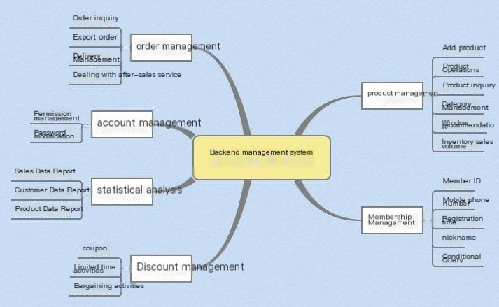

Figure 3.1 Architecture diagram of backend management system 1.0
Due to the presence of WeChat and mobile apps after the front-end mall, as well as the integration of orders from e-commerce platforms such as Pocket Shopping, Mogujie, and Chuchu Street into the backend management system, it is necessary to consider how to obtain authorization from WeChat public platforms and various third-party platforms to ensure that orders from various channels can be integrated into one system. With the continuous enrichment of products, thematic management has become particularly important, and this functional module has also been added to the later versions in requirement analysis. Procurement management is to facilitate reconciliation with finance and ensure consistency in system inventory and sales.

Analysis of front-end mall platform requirements

After explaining the requirements analysis and function list of the backend management system, the following analysis was conducted based on the previous backend requirements analysis:
1. Users can log in and register.
2. Users can view their orders and track them in the personal center.
3. The product details page displays information uploaded by the backend management system.
4. Transaction Line: Users can add products to their shopping cart, make direct purchases, fill in delivery information, make payments, confirm receipt, and provide feedback throughout the entire process.
5. Corresponding promotional activities, etc.
6. Other features, such as recommending products based on user behavior, allowing users to chat and comment in consumer communities, searching for products, viewing products by topic, and signing in to earn points.

In the process of requirement analysis, the functionality of multiple versions of the mall is taken into consideration, making it more convenient for iterative delivery in the subsequent system design and development process.

List of front-end mall platform functions

Based on the requirements analysis of the front-end shopping platform in the previous section, it can be concluded that the front-end shopping platform should have the following major functions: registration and login function, transaction line, personal center, and search function.
1. Registration and login: You need to register with a mobile phone number, or you can log in directly through WeChat or QQ.
2. The transaction line function includes: product selection ->specifications, quantity ->add to shopping cart ->confirm receipt information ->
Payment ->Confirm receipt ->Review.
3. The functions of the personal center include: order list, my favorites, account management, discount management, address management, and my shopping cart.
4. Search function: able to search for products based on keywords.

3.3 Overall Business Process Analysis

3.3.1 Overall System Business Process Diagram

The backend management system and front-end mall platform need to be organically integrated. After users register in the mall front-end, the backend database can record user data, and member management can view the user information. Upload products in the background, and the front-end can display product details, including product name, abstract, details, price, country, brand, etc. Users can view product reviews in the comments management section of the backend. Users can browse products on the front-end, view specific details, add them to the shopping cart, fill in the shipping information, and then pay and place an order. After placing an order, the backend order management can view the user's order information, change prices, cancel orders, and other operations. In addition, the user's personal center can manage receiving information, query orders, track logistics, and more. On the other hand, the backend can also view user orders, track logistics, and more.
After analysis, the overall process of the system is shown in Figure 3.2:

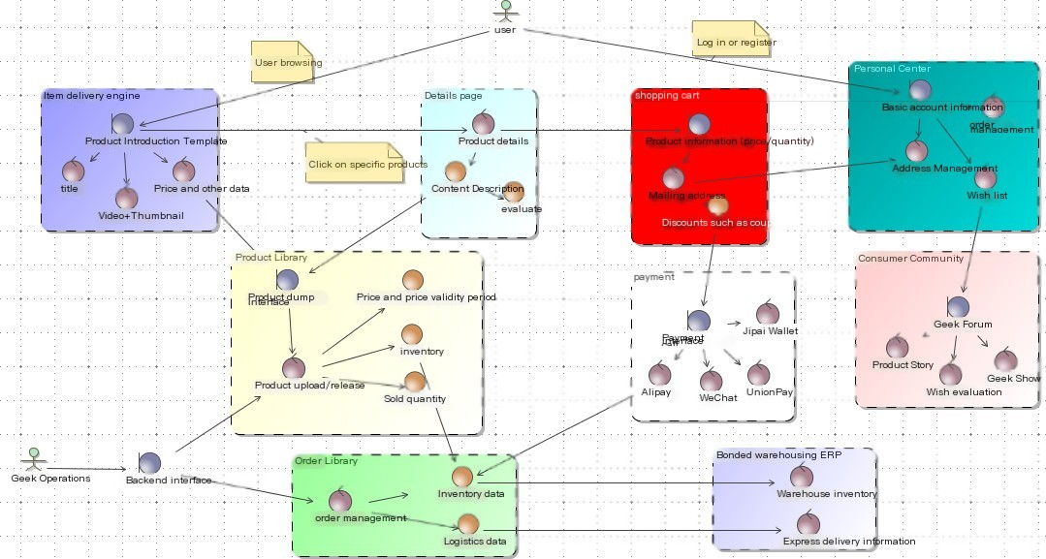
Figure 3.2 Overall System Flowchart
In the overall flowchart, the expectation of the system is to feature video shopping guides and community experience sharing, while also connecting with the bonded zone warehouse ERP, consumer communities, and so on. The version in the paper, as the first issue, did not involve these major functionalities in the system implementation, but laid a good foundation for later development in the system design.

3.4 Summary of this chapter

This chapter mainly conducts a requirement analysis of the entire system, including feasibility analysis, detailed requirement analysis of the backend management system and front-end mall platform, and lists the required functions. At the same time, the overall flowchart of the entire system was provided, and a detailed analysis of the functions required for the later version of the system was also conducted, which played a significant role in the overall design, development, and implementation of the subsequent system.

Chapter 4 Jipai Mall System Design

  - Design objectives of the system

(1) Throughput
Capable of carrying 10 million PV views per day and 10000 online transaction orders per day;
(2) Availability
The percentage of normal website running time, where the website can achieve 99.9% availability;
(3) Performance
Speed is the first user experience, do not let users wait, control the average response time to be less than 2 seconds, the most
Not exceeding 5 seconds in length;
(4) Scalable
When encountering high concurrency access, simply adding servers can expand the system's capacity and throughput;
(5) Security
User information security, product information security, and payment security ensure the confidentiality, integrity, and reliability of the system's core data.

System architecture design

    - System Use Case Model

Chapter 3 provides a very detailed analysis of the system's business requirements. The system is divided into consumer users and system operation administrators, and a use case model diagram of the system can be obtained. Each user can view and search for products without registration. After registration or login, they can join the shopping cart and place orders online. After registration, the system automatically records the user's information and generates the user's order in the background. The backend administrator can perform product management, category management, member management, order management, advertising management, and discount management, and the system automatically collects data. As shown in Figure 4.1.

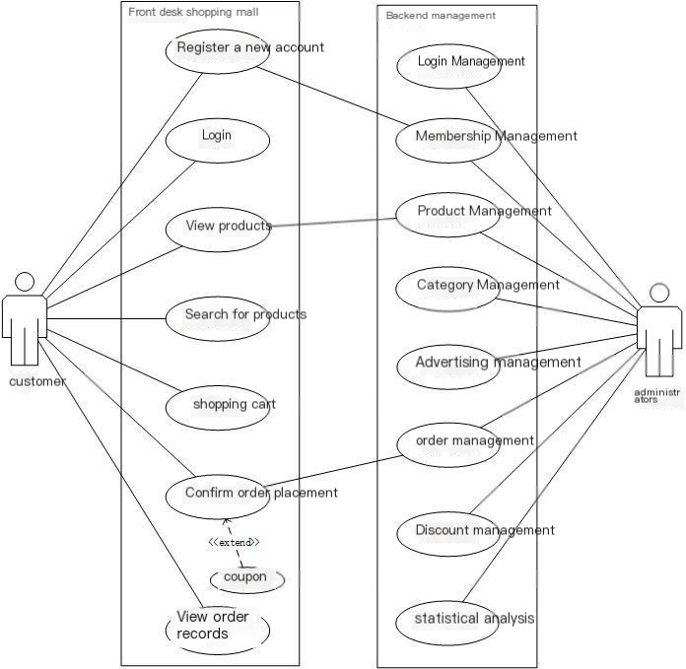

Figure 4.1 System Use Case Model

Overall system architecture

The backend management system and front-end mall platform both adopt the MVC software design pattern in terms of system architecture, adopting a 4-layer structure, mainly including the presentation layer, control layer, business logic layer, and data persistence layer. ^{[40]} The specific system architecture is shown in Figures 4.2 and 4.3.
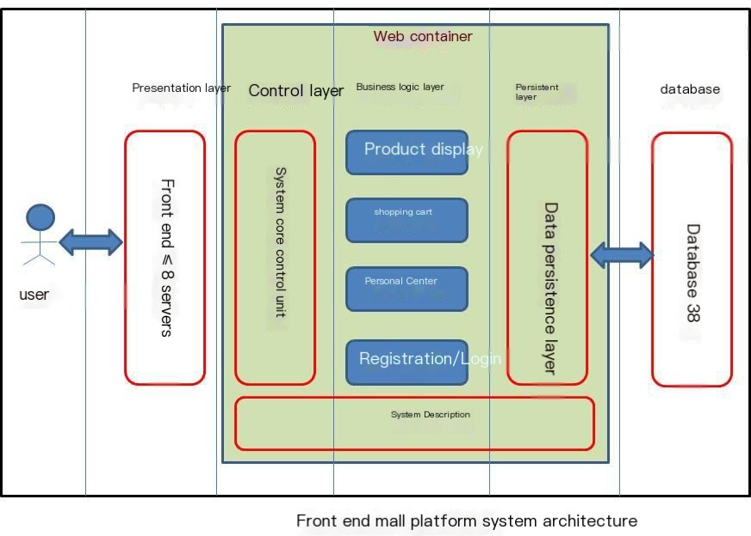

Figure 4.2 Front end Mall Platform System Architecture

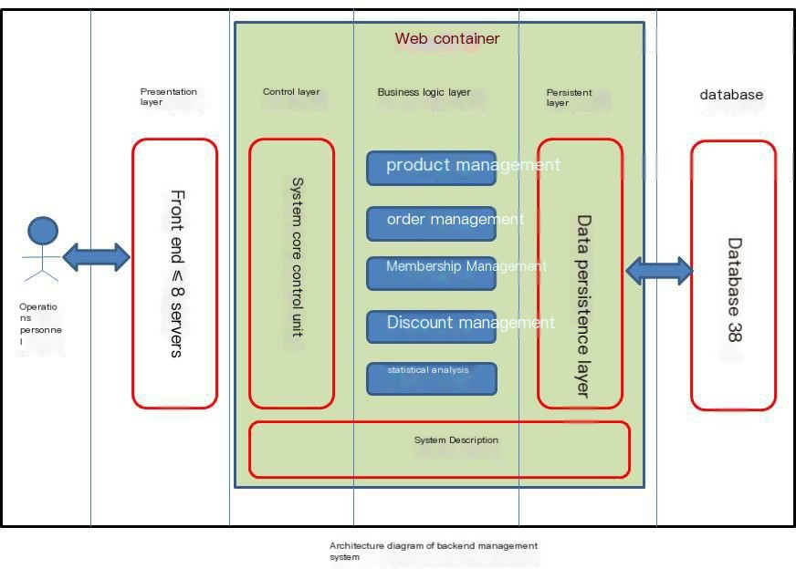

Figure 4.3 Backend Management System Architecture
Presentation layer: Display data from the database and receive data input from the user's front-end, providing users with interactive operations through an interface. Two independent subsystems have different URL entry interfaces. The system used in this article is JavaWeb technology. The main approach is to effectively separate the front-end page code from the back-end data processing code through JSP.
Control layer: The core control unit of the system, which actually transmits user page requests to the system backend through the control layer.
Business logic layer: As the most core part of the system, the business logic layer handles most of the system's functions, such as HTTP requests submitted by users through the presentation layer and database access processing. The business logic layer is the main computing unit of the system, handling user requests.
Data persistence layer: stores data in a database, provides data services for the business logic layer, and persistently manages data and data.

Design of Domain Model for Backend Management System

The class diagrams in system design are all drawn using Power Designer software.

Control layer design

The control layer class diagram is shown in Figure 4.4:
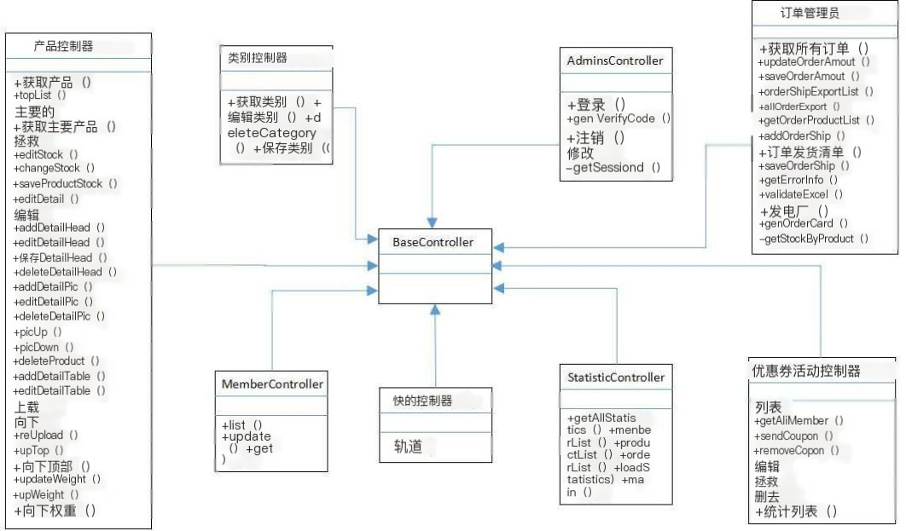

Figure 4.4 Backend Management System Control Layer Class Diagram
All classes in the control layer inherit from the base class BaseController, which includes AdminsController
Administrator management core control class, ProductController product management core control class
There are 8 key control classes, including CategoryController product classification core control class, OrderController order management core control class, KuaidiController express management core control class, MemberController member management core control class, CouponActivityController discount management core control class, StatisticController statistical analysis core control class. The specific method names and functional descriptions in each control class will be provided in the next section.

Description of each class in the control layer:
The specific description of the AdminsController administrator management core control class is shown in Table 4.1.
Table 4.1 Administrator Management Core Control Class

Method name | Function Description | Method name | Function Description
Login | User login | Modify | Password modification
GenVerifyCode | Verification code | GetSessionId | Obtain session ID
Logout | User logout
The specific description of the Product Controller product management core control class is shown in Table 4.2.

Table 4.2 Core Control Categories of Product Management

Method name | Function Description | Method name | Function Description
GetProducts | Obtain product view | DeleteDetailPic | Delete detailed images
TopList | Recommended product view | PicUp | Move image up
Main | Main page view | PicDown | Picture Down
GetMainProducts | Obtain main page products | DeleteProduct | Delete product
Save | Save product information | AddDetailTable | Add detail table
EditStock | Edit inventory | EditDetailTable | Edit detail table
ChangeStock | Modify inventory | SaveDetailHeadTable | Save details header table
SaveProductStock | Save inventory | DeleteDetailTable | Delete detail table
EditDetail | Edit product details | Upload | Listing
SaveDetail | Save product details | Down | Remove from shelves
Edit | Product Editing | ReUpload | Republish
AddDetailHead | Add detail header | UpTop | recommendation
EditDetailHead | Edit detail header | DownTop | Cancel recommendation
SaveDetailHead | Save details header | UpdateWeight | Modify weights
DeleteDetailHead | Delete detail header | UpWeight | Increase weight
AddDetailPic | Add detailed images | DownWeight | Reduce weight
EditDetailPic | Edit detailed images
The specific description of the core control class for CategoryController product classification is shown in Table 4.3.
Table 4.3 Core Control Categories for Product Classification

Method name | Function Description | Method name | Function Description
GetCategories | Obtain classification | DeleteCategory | Delete classification
EditCategory | Edit Classification | SaveCategory | Save Classification
The specific description of the OrderController order management core control class is shown in Table 4.4.
Table 4.4 Order Management Core Control Class

Method name | Function Description | Method name | Function Description
GetAllOrders | Get all orders | OrderShipList | List of delivery notes
UpdateOrderAmount | Modify order amount | SaveOrderShip | Save delivery note
SaveOrderAmount | Save order amount | GetErrorInfo | Get error information
OrderShipExportList | Export of delivery note | ValidateExcel | Verify Excel file
AllOrderExport | Export all orders | GenShip | Complete delivery note information
GetOrderProductlist | Order Product List | GenOrderIdCard | Complete ID card information
AddOrderShip | Add delivery note | GetStockByProduct | Corresponding inventory of products
The specific description of the KuaidiController express delivery management core control class is shown in Table 4.5.

Table 4.5 Core Control Categories of Express Delivery Management

Method name | Function Description | Method name | Function Description
Track | Logistics tracking
The specific description of the MemberController member management core control class is shown in Table 4.6.
Table 4.6 Member Management Core Control Class

Method name | Function Description | Method name | Function Description
List | Member List | Get | Obtain member information
Update | Update List
The specific description of the CouponActivityController discount management core control class is shown in Table 4.7.
Table 4.7 Core Control Categories for Preferential Management

Method name | Function Description | Method name | Function Description
List | Coupon List | Edit | Edit Coupon
GetAllMember | Get all members | Save | Save Coupon
SendCoupon | Send coupons to users | Delete | Delete coupon
RemoveCoupon | Remove user's coupon | StatisticsList | Coupon usage statistics
The specific description of the StatisticController statistical analysis core control class is shown in Table 4.8.
Table 4.8 Statistical Analysis Core Control Categories

Method name | Function Description | Method name | Function Description
GetAllStatistics | Obtain all data | Orderlist | Order statistics
Membership | Purchasing member statistics | LoadStatistics | Detailed statistical information
Productlist | Sales Product Statistics | Main | Main function

Business logic layer design

The business layer class diagram is shown in Figure 4.5:

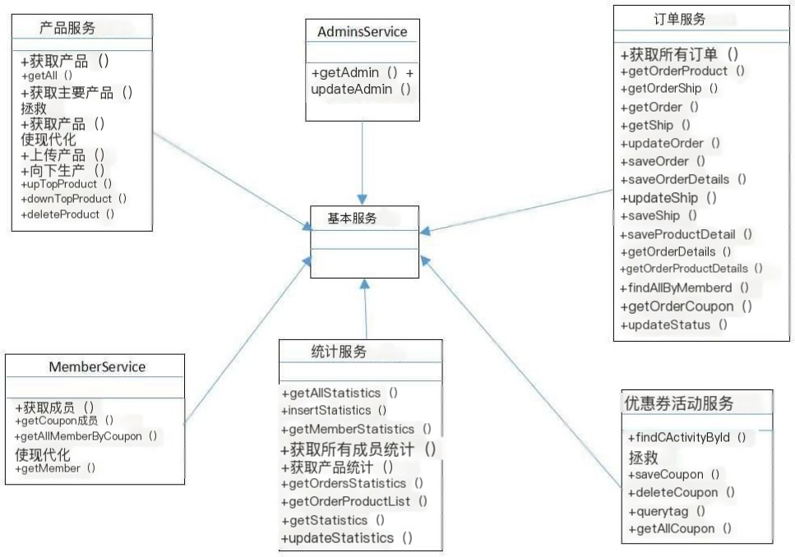
Figure 4.5 Business logic layer class diagram of backend management system
All classes in the business logic layer inherit from the base class BaseService, which includes six key business implementation classes: AdminsService administrator account password implementation class, ProductService product management implementation class, OrderService order management implementation class, MemberService member management implementation class, CouponActivityService coupon management implementation class, StatisticServicer statistical analysis implementation class, etc. The specific method names and functional descriptions in each business logic class will be explained below.

Description of each class in the business logic layer:
The specific description of the AdminsService administrator account password implementation class is shown in Table 4.9.
Table 4.9 Administrator Account Password Implementation Class

Method name | Function Description | Method name | Function Description
GetAdmin | Obtain username and password | UpdatAdmin | Update username and password
The specific description of the ProductService product management implementation class is shown in Table 4.10.
Table 4.10 Product Management Implementation Class

Method name | Function Description | Method name | Function Description
GetProducts | Obtain individual product information | GetMainProducts | Obtain all listed products
GetAll | Get all product information | UploadProduct | Product listing
GetProduct | Search for the product based on its ID | DownProduct | Product delisting
Save | Add product and save | UpTopProduct | Product recommendations to the homepage
Update | Update product information | DownTopProduct | Cancel product recommendation to homepage
 |  | DeleteProduct | Delete the product based on its ID
The specific description of the OrderService order management implementation class is shown in Table 4.11.

Table 4.11 Order Management Implementation Class

Method name | Function Description | Method name | Function Description
GetAllOrders | Obtain all orders | GetOrderShip | Obtain order logistics status information
UpdateOrder | Update order information | SaveOrderDetail | Save order details information
SaveOrder | Save order information | SaveProductDetail | Save order product information
UpdateShip | Update logistics information | GetOrderProduct | Obtain order product information
SaveShip | Save delivery information | FindAllByMemberId | Query all orders of a certain member
GetOrderDetail | Obtain order details | GetOrderCoupon | Monthly coupon usage
GetOrder | Obtain individual order information | UpdateStatus | Update order logistics status information
GetShip | Obtain logistics status information | GetOrderPorductDetail | Obtain order product details
The specific description of the MemberService membership management implementation class is shown in Table 4.12.
Table 4.12 Membership Management Implementation Class

Method name | Function Description |  | Method name | Function Description
GetMembers | Obtain all information from all members |  | Update | Update member information.
Method name |  | Function Description
GetCouponMembers |  | Obtain all information about members who have coupons
GetAllMemberByCoupon |  | Obtain information about members who have used coupons before
GetMember |  | Obtain all information of a single member based on conditions
The specific description of the CouponActivityService coupon management implementation class is shown in Table 4.13.
Table 4.13 Coupon Management Implementation Class

Method name | Function Description | Method name | Function Description
Save | Save promotional information | DeleteCoupon | Delete coupon
SaveCoupon | Save Coupon | Delete | Delete promotional activities
Querytag | Search for promotional activity codes
Method name |  | Function Description
GetAllCoupon |  | Query all coupons owned by users
FindCActivityById |  | Search for promotional activities based on activity ID
The specific description of the StatisticService statistical analysis implementation class is shown in Table 4.14.
Table 4.14 Statistical Analysis Implementation Classes

Method name | Function Description
GetAllStatistics | Obtain all sales data reports
InsertStatistics | Insert single sales data into the statistics table
GetMemberStatistics | Obtain the customer data report based on the member ID
GetAllMemberStatistics | Obtain all member purchase data reports
GetProductStatistics | Obtain sales product data report
GetOrdersStatistic | Obtain order sales data report
GetOrderPorductList | Obtain a list of product data for sales

GetStatistics | Obtain the monthly sales data report based on the month
UpdateStatistics | Update the sales statistics report of the database

Persistent layer design

The persistence layer class diagram is shown in Figure 4.6:
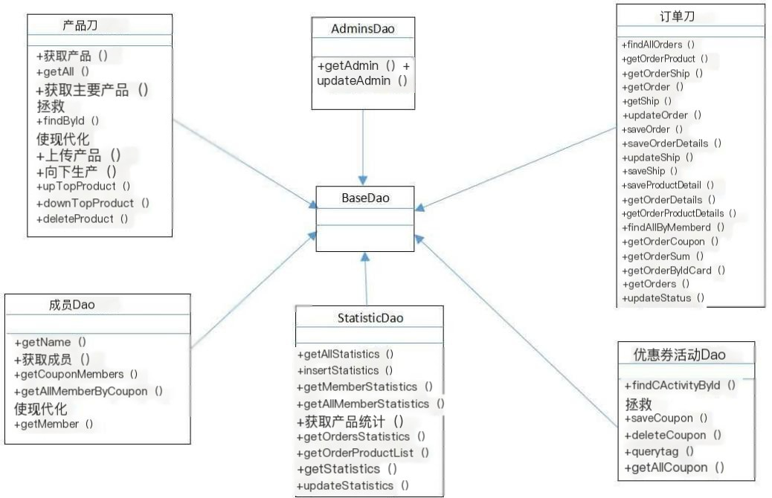
Figure 4.6 Persistence layer class diagram of backend management system
All classes in the data persistence layer inherit from the base class BaseDao, which includes six key database operation classes: AdminsDao Administrator Management Dao, ProductDao Product Management Dao, OrderDao Order Management Dao, MemberDao Member Management Dao, CouponActivityDao Discount Management Dao, StatisticDao Statistical Analysis Dao, etc. The specific method names and functional descriptions in each class will be explained in detail below.

Description of each class in the data persistence layer:
AdminsDao provides a specific description of database operations related to administrator accounts and passwords, as shown in Table 4.15.
Table 4.15 provides database operations related to administrator accounts and passwords

Method name | Function Description
GetAdmin | Retrieve username and password from the database
UpdatAdmin | Update username and password in the database
In the initial stage, the backend system was only used by internal personnel, so each username and password were directly added to the database, so AdminDao did not add administrator operations. The specific description of database operations related to product management provided by ProductDao is shown in Table 4.16.

Table 4.16 provides database operations related to product management

Method name | Function Description
GetProducts | Retrieve individual product information from the database
GetAll | Retrieve all product information from the database
GetMainProducts | Retrieve all listed products from the database
FindById | Query the product from the database based on its ID
Save | Save the newly added product information to the database
Continued Table 4.16 provides database operations related to product management

Update | Update product information and details
UploadProduct | Product listing, status=1
DownProduct | Product delisted, status=0
UpTopProduct | Product recommendation to homepage, isTop=1
DownTopProduct | Cancel product recommendation to homepage, isTop=0
DeleteProduct | Delete the entire product from the database

The specific description of database operations related to order management provided by OrderDao is shown in Table 4.17.
Table 4.17 provides database operations related to order management

Method name | Function Description
FindAllOrders | Query all order information (orders, members, express delivery, coupons)
GetOrderProduct | Retrieve product information from the database for orders
GetOrderShip | Retrieve order logistics status information from the database based on the order ID
GetOrder | Retrieve individual order information from the database based on the order ID
GetShip | Retrieve logistics status information from the database based on logistics ID
UpdateOrder | Update order information
SaveOrder | Save order information
SaveOrderDetail | Save order details information
UpdateShip | Update logistics information
SaveShip | Save the filled out courier information
SaveProductDetail | Save order product information
GetOrderDetail | Retrieve order details from the database
GetOrderPorductDetail | Retrieve product details from the database for orders
FindAllByMemberId | Search all orders of the member based on their ID
GetReceiverMobile | Retrieve the phone numbers of all recipients from the database
GetAllOrders | Retrieve all orders from the database
GetOrderCoupon | Obtain monthly coupon usage information from the database
GetOrderSum | Retrieve the total sales amount of all orders from the database
GetOrderByIdCard | Obtain the order information under the ID number according to the ID number
GetOrders | Get all orders
UpdateStatus | Update order logistics status information
MemberDao provides a specific description of database operations related to member management, as shown in Table 4.18.

Table 4.18 provides database operations related to member management

Method name | Function Description
GetName | Retrieve the member's WeChat nickname from the database
GetMembers | Retrieve all member information from the database
GetCouponMembers | Retrieve all information about members who have coupons from the database
GetAllMemberByCoupon | Retrieve member information that has used coupons from the database

Continued Table 4.18 provides database operations related to member management

Update | Update the data information in the member database.
GetMember | Retrieve all information of a single member from the database based on conditions

CouponActivityDao provides a specific description of database operations related to coupon management, as shown in Table 4.19.
Table 4.19 provides database operations related to coupon management

Method name | Function Description
FindCActivityById | Query the promotional activities in the database based on the activity ID
Save | Save promotional information to the database.
SaveCoupon | Save the coupon to the database
DeleteCoupon | Delete coupons from the database
Delete | Delete promotional activities from the database
Querytag | Search for promotional activity codes
GetAllCoupon | Retrieve all coupon information from the database
StatisticDao provides a specific description of database operations related to statistical analysis, as shown in Table 4.20.
Table 4.20 provides database operations related to statistical analysis

Method name | Function Description
GetAllStatistics | Obtain all sales data reports from the database
InsertStatistics | Insert single sales data into the statistics table
GetMemberStatistics | Obtain the customer data report from the database based on the member ID
GetAllMemberStatistics | Obtain all member purchase data reports from the database
GetProductStatistics | Obtain sales product data reports from the database
GetOrdersStatistic | Obtain order sales data report from database
GetOrderPorductList | Obtain a list of product data for sales from the database
GetStatistics | Retrieve the monthly sales data report from the database based on the month
UpdateStatistics | Update the sales statistics report of the database

Design of front-end mall platform domain model

    - Control layer design

The control layer class diagram is shown in Figure 4.7:
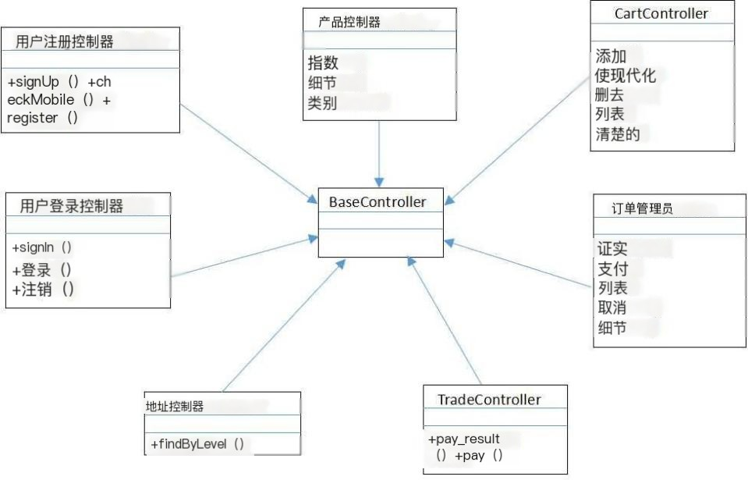

Figure 4.7 Front end Mall Platform Control Layer Class Diagram
All classes in the control layer, like the backend management system, also inherit from the base class BaseController, which includes the AddressController address management core control class, CartController shopping cart core control class, OrderController order core control class, ProductController product core control class
TradeController payment core control class, UserRegisterController user registration core control class
7 key control classes, including the UserLoginController user login core control class. The specific method names and function descriptions in each control class will be explained in detail below.

Description of each class in the control layer:
The specific description of the Address Management Core Control Class in AddressController is shown in Table 4.21.
Table 4.21 Address Management Core Control Class

Method name | Function Description | Method name | Function Description
FindByLevel | Obtain address information
The specific description of the CartController shopping cart core control class is shown in Table 4.22.
Table 4.22 Core Control Categories for Shopping Carts

Method name | Function Description | Method name | Function Description
Add | Add product | List | Shopping Cart List

Update | Update shopping cart | Clear | empty cart
Delete | Delete product
The specific description of the OrderController order core control class is shown in Table 4.23.
Table 4.23 Order Core Control Class

Method name | Function Description | Method name | Function Description
Confirm | acknowledgement of order | Cancel | Cancel order
Continued Table 4.23 Order Core Control Class

Pay | Confirm payment | Detail | order details
List | View orders

The specific description of the core control class of the ProductController product is shown in Table 4.24.
Table 4.24 Product Core Control Categories

Method name | Function Description | Method name | Function Description
Index | Product Catalog | Category | Product classification
Detail | Individual product details
The specific description of the TradeController payment core control class is shown in Table 4.25.
Table 4.25 Payment Core Control Class

Method name | Function Description | Method name | Function Description
Pay | payment | Pay_result | Payment return result
The specific description of the User RegisterController user registration core control class is shown in Table 4.26.
Table 4.26 User Registration Core Control Class

Method name | Function Description | Method name | Function Description
Signup | Jump to registration page | Register | User registration
Checkmobile | Verify phone
The specific description of the User Login Controller core control class is shown in Table 4.27.
Table 4.27 User Login Core Control Class

Method name | Function Description | Method name | Function Description
Signin | Jump to login page | Logout | Log out
Login | Login
Due to space limitations, the business logic layer design and persistence layer design of the front-end shopping platform will not be introduced here.

System database design

The quality of database design directly affects the efficiency of the entire system. A well-designed database that can

The most direct manifestation of effectively improving the storage efficiency of the entire database is the page's response speed when users add, delete, modify, or query the database. We need to organize a large amount of data in the system in some form so that it can be processed quickly, conveniently, and in a timely manner, including storage, maintenance, retrieval, and other functions. Therefore, database design is crucial.
Design a system database, which includes the following four processes: requirement analysis, conceptual design, logical design, and physical design. ^{[41]}
The conceptual design ultimately implemented the conceptual data model. Conceptual design, as an abstract existence, is actually the data information that users see. The currently commonly used method is to create entities composed of entities, attributes, and connections
- Relationship diagram, abbreviated as E-R diagram. ^{[42]}
Logic design is the process of transforming the E-R diagram obtained from conceptual design into a data model that supports database systems. [43]
This article uses MySQL as the system database, and in order to better manage the database, a database management tool called Navicat Premium is used. By connecting to MySQL, it is very convenient to view and operate all tables in the database.
The Navicat Premium interface is shown in Figure 4.8.
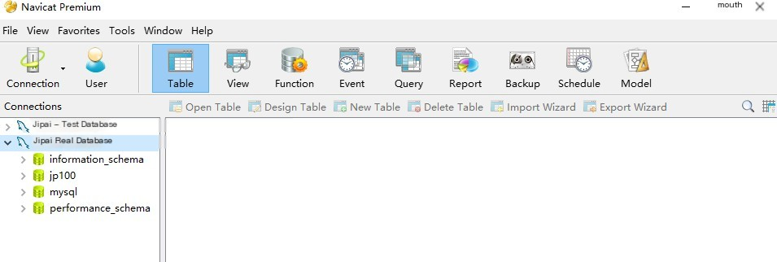
Figure 4.8 Navicat Premium Main Interface

E-R diagram of system database

The E-R diagram of the key tables in the system database is shown in Figure 4.9.

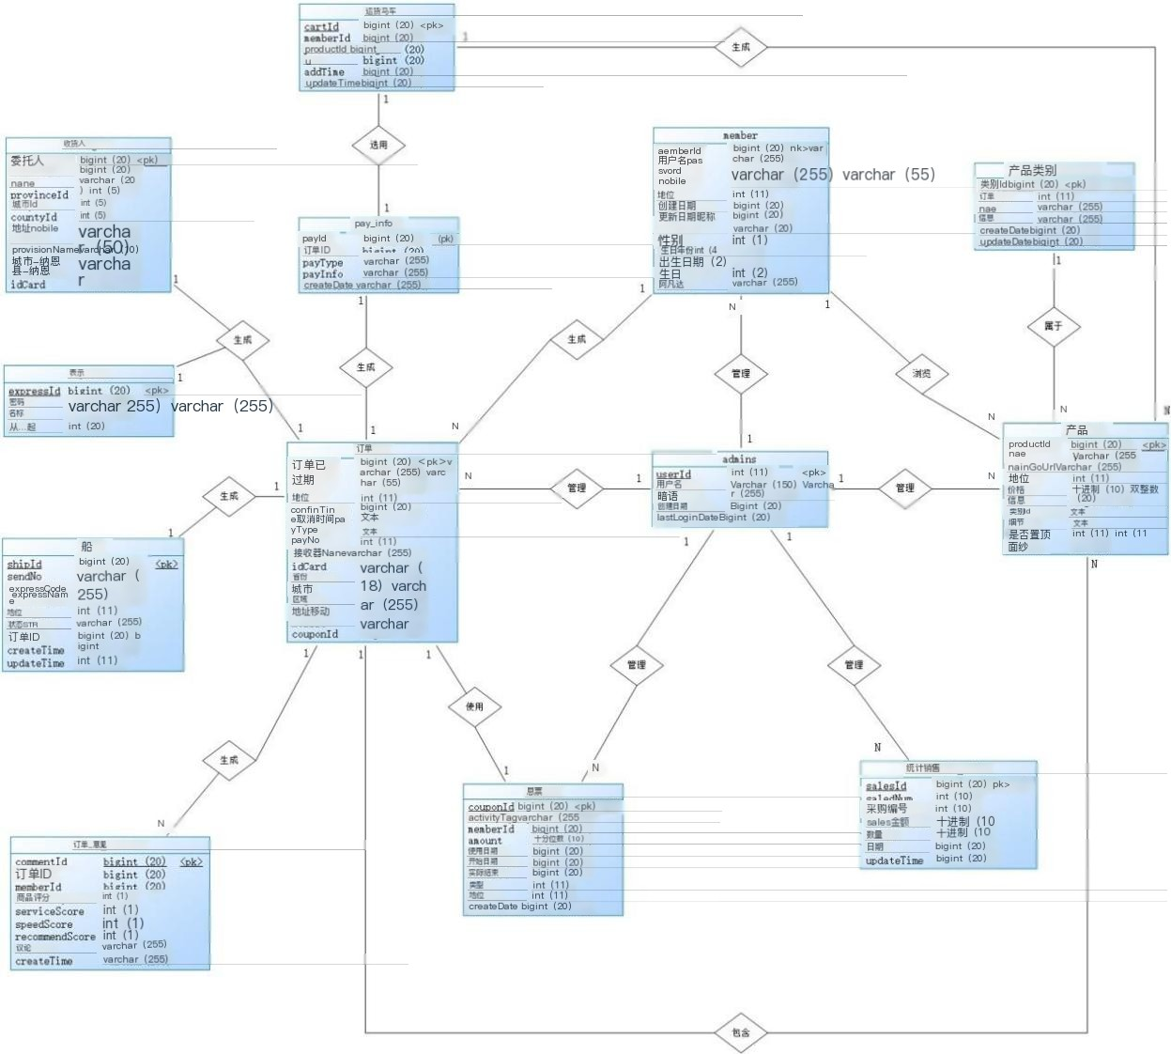

Figure 4.9 E-R diagram of key tables in the system database
In fact, this diagram adopts the physical modeling model of Power Designer, which constructs logical data tables that can be used in the database by combining real-world entities and their attributes. The key tables of the system are all reflected in this diagram.
Administrators can manage products, orders, members, coupons, statistical analysis, and more. The products have categories, and each product belongs to one category. Members can browse multiple products, then add them to the shopping cart, settle accounts, and form orders. Each user has multiple orders, each containing order details, recipient information, courier information, and logistics tracking information. Each order can only use one coupon, and the order can have multiple products, each corresponding to a review.
The relationships between each key table have been shown in the E-R diagram.
Considering the functionality of subsequent versions, while developing the first version, the key data entities involved will also be established in the database. This includes platforms such as weixin and weixin_menu for connecting with WeChat, as well as theme banner and theme topbg for special feature modules. Figure 4.9 shows the Navicat

All tables currently established in the entire Jipai Mall database in the Premium database software.
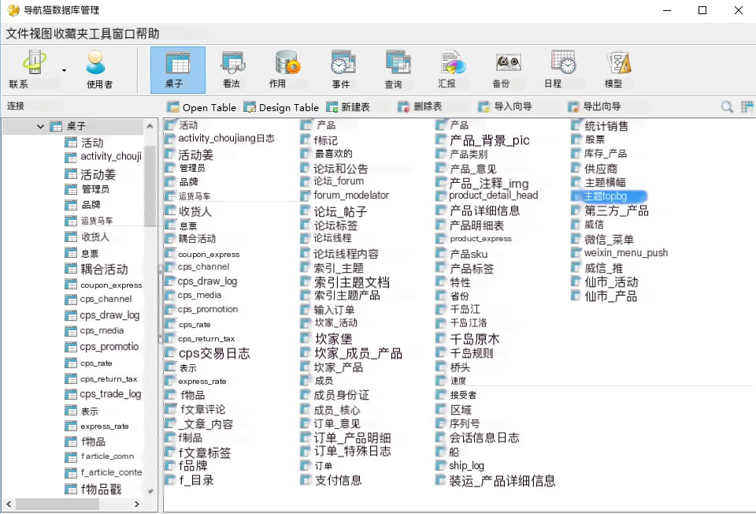
Figure 4.9 All tables in the system database

Key Data Entity Description

The system's key data entity table includes the following thirteen: operator table, product table, order table, member table, coupon table, statistical analysis table, product classification table, shopping cart table, payment method table, recipient information table, express delivery table, logistics information table, and user evaluation table.
The specific description of the Operations Personnel List (Admins) is shown in Table 4.28.
Table 4.28 Operations Personnel Table (Admins)

name | code | data type | Primary key | Is it empty | annotation
User ID | UserId | Int (11) | True | FALSE
user name | UserName | Varcar (150) | FALSE | True
password | Password | Varcar (255) | FALSE | True
Creation time | CreateDate | Bigint (20) | FALSE | True
Last login time | LastLoginDate | Bigint (20) | FALSE | True
The operator table contains usernames and passwords, with the primary key being the user ID, which is used to uniquely identify the user. The version usernames and passwords in this article were manually added to the database.
The specific description of the product list is shown in Table 4.29.
Table 4.29 Product List

name | code | data type | Primary key | Is it empty | annotation
Product ID | ProductId | Bigint (20) | True | FALSE

Continued Table 4.29 Product List

Product Name | Name | Varcar (255) | FALSE | True
Product main image address | MainLogoUrl | Varcar (255) | FALSE | True
Up and down shelf status | Status | Int (11) | FALSE | True
price | Price | Decimal (10) | FALSE | True
Classification | CategoryId | Bigint (20) | FALSE | FALSE
Product Summary | Info | Text | FALSE | True
Product details | Detail | Text | FALSE | True
Do you recommend it | IsTop | Int (11) | FALSE | True
weight | Weight | Int (11) | FALSE | True

The product table is a crucial table in the backend management system. The product ID serves as the unique identification of the product. In addition to the unique identification of the product ID, each product also includes the product name, main image, price, product category, summary, product details, etc. After creating a product, there is a status of being listed or not recommended, and recommendations have corresponding weights.
The specific description of the orders table is shown in Table 4.30.
Table 4.30 Order Table
name | code | data type | Primary key | Is it empty | annotation
Order ID | OrdersId | Bigint (20) | True | FALSE
User ID | MemberId | Varcar (255) | FALSE | FALSE
Order amount | Amount | Varcar (255) | FALSE | FALSE
Order status | Status | Int (11) | FALSE | True
Order confirmation time | ConfimTime | Bigint (20) | FALSE | FALSE
Order cancellation time | CancelTime | Text | FALSE | True
Payment type | PayType | Text | FALSE | True
Payment number | PayNo | Int (11) | FALSE | True
consignee | Receiver name | Varcar (255) | FALSE | True
ID number | IdCard | Varcar (18) | FALSE | True
province | Province | Varcar (255) | FALSE | True
city | City | Varcar (255) | FALSE | True
area | Region | Varcar (255) | FALSE | True
address | Address | Varcar (255) | FALSE | True
Mobile phone number | Mobile | Varcar (255) | FALSE | True
Coupon ID | CouponId | Bigint (20) | FALSE | True

After the user clicks to confirm the order, an order will be generated in the background, each order containing the order ID, the buyer's member ID, the corresponding order amount, and the status of the order (order confirmed (to be paid) 10, order cancelled 15, paid, in distribution 21, shipped 40, transaction ended 80), confirmed

The time of order recognition and cancellation, the corresponding payment type and payment number after payment, and of course, the buyer's shipping address. If a coupon is used, there will be corresponding coupon information.
The specific description of the shopping cart table is shown in Table 4.31.
Table 4.31 Shopping Cart Table

name | code | data type | Primary key | Is it empty | annotation
Shopping Cart ID | CartId | Bigint (20) | True | FALSE
User ID | MemberId | Bigint (20) | FALSE | FALSE
Product ID | ProductId | Bigint (20) | FALSE | FALSE
quantity | Num | Bigint (20) | FALSE | FALSE
Joined at | AddTime | Bigint (20) | FALSE | FALSE
Update time | UpdateTime | Bigint (20) | FALSE | FALSE
After adding the product to the shopping cart, the user will add shopping cart data to the shopping cart table, including shopping carts
ID, user ID, product ID and corresponding quantity, each product has a time to add to the shopping cart. The specific description of the product category table is shown in Table 4.32.
Table 4.32 Product Category Table (product_category)

name | code | data type | Primary key | Is it empty | annotation
Category ID | CategoryId | Bigint (20) | True | FALSE
Sort ID | Orders | Int (11) | FALSE | True
Category name | Name | Varchar (255) | FALSE | True
Category Introduction | Info | Varchar (255) | FALSE | True
Creation time | CreateDate | Bigint (20) | FALSE | True
Update time | UpdateDate | Bigint (20) | FALSE | FALSE
The backend management system can add product categories, and in the category table, there is a category ID to uniquely identify the category. Administrators can edit category names and introductions, and can also sort all categories, so the database table contains sorting IDs, category names, and category introductions. Simultaneously record the creation time and update time.
The specific description of the member information table is shown in Table 4.33.
Table 4.33 Member Information Table

name | code | data type | Primary key | Is it empty | annotation
User ID | MemberId | Bigint (20) | True | FALSE
user name | Username | Varchar (255) | FALSE | True
Login password | Password | Varchar (255) | FALSE | True
Register mobile phone | Mobile | Varchar (255) | FALSE | True
state | Status | Int (11) | FALSE | True
Creation time | CreateDate | Bigint (20) | FALSE | True
Update time | UpdateDate | Bigint (20) | FALSE | True

Continued Table 4.33 Member Information Table

WeChat nickname | NickName | Varchar (20) | FALSE | True
Gender | Gender | Int (1) | FALSE | True
Birth year | BirthdayYear | Int (4) | FALSE | True
Birth month | BirthdayMonth | Int (2) | FALSE | True
Birth date | Birthday | Int (2) | FALSE | True
Avatar | Avatar | Varchar (255) | FALSE | True

When users register, the database needs to record member information, which includes member ID (unique identification), member name (initial system default), registration phone number, login password, gender, and date of birth in the member information table
(optional) and avatar (default in the initial system), as it involves WeChat Mall, a WeChat nickname field has also been established, but it is not covered in this article.
The specific description of the payment information table (pay_info) is shown in Table 4.34.
Table 4.34 Payment Information Table (pay_info)

name | code | data type | Primary key | Is it empty | annotation
Payment ID | PayId | Bigint (20) | True | FALSE
Order ID | OrderId | Bigint (20) | FALSE | True
Payment method | PayType | Varchar (255) | FALSE | True
Payment information | PayInfo | Text | FALSE | True
Creation time | CreateDate | Bigint (20) | FALSE | True
When users make payments, payment information needs to be recorded. Therefore, the payment information table in the database records the payment ID, order ID, corresponding payment method, payment summary, and creation time.
The specific description of the consignee information table is shown in Table 4.35.
Table 4.35 Consignee Information Table

name | code | data type | Primary key | Is it empty | annotation
Recipient ID | ConsigneeId | Bigint (20) | True | FALSE
Member ID | MemberId | Bigint (20) | FALSE | True
Consignee Name | Name | Varchar (20) | FALSE | True
Province ID | ProvinceId | Int (5) | FALSE | True
City ID | CityId | Int (5) | FALSE | True
District ID | CountyId | Int (5) | FALSE | True
Receiving address | Address | Varchar (50) | FALSE | True

Continued Table 4.35 Consignee Information Table

Mobile phone number | Mobile | Varchar (50) | FALSE | True
Province name | ProvinceName | Varchar (10) | FALSE | True
City name | CityName | Varchar (10) | FALSE | True
District name | CountyName | Varchar (10) | FALSE | True
ID number | IdCard | Varchar (18) | FALSE | True

According to the operational requirements, the consignee information needs to be extracted separately. Therefore, a consignee information table has been established in the database. Each user can establish multiple receiving addresses. Each receiving address has a unique ID, corresponding to a member ID. Other fields are regular receiving address fields, including provinces, cities, addresses and mobile phone numbers. Due to customs needs, there are also ID number fields.
The specific description of the sales statistics table (statistic_sales) is shown in Table 4.36.
Table 4.36 Sales Statistics (statistic_sales)

name | code | data type | Primary key | Is it empty | annotation
Statistical ID | SalesId | Bigint (20) | True | FALSE
sales volume | SaledNum | Int (10) | FALSE | True
Number of buyers | PurchaseNum | Int (10) | FALSE | True
Sales revenue | SalesAmount | Decimal (10) | FALSE | True
Actual amount received | Amount | Decimal (10) | FALSE | True
Sales date | Date | Bigint (20) | FALSE | True
Update time | UpdateTime | Bigint (20) | FALSE | True
The system version 1.0 only records the number of units sold, number of buyers, total sales revenue, and actual amount received per day. Simultaneously record the total monthly sales situation.
The specific description of the coupon form is shown in Table 4.37.
Table 4.37 Coupon Table

name | code | data type | Primary key | Is it empty | annotation
Coupon ID | CouponId | Bigint (20) | True | FALSE
Activity tags | ActivityTag | Varchar (255) | FALSE | True
Member ID | MemberId | Bigint (20) | FALSE | FALSE
Coupon amount | Amount | Decimal (10) | FALSE | FALSE
Usage time | UseDate | Bigint (20) | FALSE | True

Continued Table 4.37 Coupon Table

Start date | StartDate | Bigint (20) | FALSE | True
End time | EndDate | Bigint (20) | FALSE | True
Coupon type | Type | Int (11) | FALSE | True
Coupon status | Status | Int (11) | FALSE | True
Creation time | CreateDate | Bigint (20) | FALSE | True

In the database, each coupon should have a unique ID, creation time, assigned to which user, corresponding discount amount, type (universal coupon, split coupon, full coupon, etc.), validity period, user usage time of the coupon, and corresponding status (unused, used, expired).
The specific description of the express company table is shown in Table 4.38.
Table 4.38 Express Company Table (Express)

name | code | data type | Primary key | Is it empty | annotation
Table ID | ExpressId | Bigint (20) | True | FALSE
Express code | Code | Varchar (255) | FALSE | True
Express name | Name | Varchar (255) | FALSE | True
Express template | From | Int (20) | FALSE | True
Due to the system calling the interface of Express 100, a table needs to be established in the database to record each courier company. Therefore, the table contains the courier ID (unique identification), the corresponding code for each courier, the courier name, and the courier template.
The specific description of the user evaluation form (order-comment) is shown in Table 4.39.
Table 4.39 User Evaluation Form (order-comment)

name | code | data type | Primary key | Is it empty | annotation
Primary Key ID | CommentId | Bigint (20) | True | FALSE
Order ID | OrderId | Bigint (20) | FALSE | True
Member ID | MemberId | Bigint (20) | FALSE | True
Quality scoring | CommodityScore | Int (1) | FALSE | True
Service rating | ServiceScore | Int (1) | FALSE | True
Logistics speed | SpeedScore | Int (1) | FALSE | True
Recommendation index | RecommendadScore | Int (1) | FALSE | True
evaluate | Comment | Varchar (255) | FALSE | True
Creation time | CreateTime | Bigint (11) | FALSE | True
After the user confirms receipt, they can evaluate the product, and the database records the user's evaluation content, including

Unique identification, order ID, member ID, quality rating, service rating, logistics speed, and evaluation content, while recording the time when the evaluation was created.
The specific description of the logistics information table (ship) is shown in Table 4.40.
Table 4.40 Logistics Information Table (Ship)

name | code | data type | Primary key | Is it empty | annotation
Logistics ID | ShipId | Bigint (20) | True | FALSE
Express tracking number | SendNo | Varchar (255) | FALSE | True
Express code | ExpressCode | Varchar (255) | FALSE | True
Express name | ExpressName | Varchar (255) | FALSE | True
Shipment status | Status | Int (11) | FALSE | True
Status Description | StatusStr | Varchar (255) | FALSE | True
Order number | OrderId | Bigint (20) | FALSE | FALSE
Creation time | CreateTime | Bigint (20) | FALSE | FALSE
Update type | UpdateTime | Int (11) | FALSE | FALSE
The system will call the express delivery 100 interface. When the operator fills in the express delivery tracking number in the system, the system obtains logistics information through the called interface. Therefore, in the database, it is necessary to record the courier ID (unique identification), courier company name and tracking number, shipping status (01 in stock, 10 in stock, 20 shipped, 21 failed to ship, 30 in logistics delivery, 40 confirmed receipt), and the order number corresponding to this courier tracking number.

4.6 Summary of this chapter

This chapter is one of the focuses of this article. 4.1 describes the goals of system design, and 4.2 describes the use case model and overall architecture of the system. Sections 4.3 to 4.5 provide a detailed description of the design of the domain model and database in the system architecture, in addition to the presentation layer. Almost all the key control classes, implementation classes, data access classes, and key tables in the database involved in the system are described in detail. This provides a good implementation foundation for the system implementation in Chapter 5.

Chapter 5 Detailed Design and Implementation of Backend Management System

  - Implementation of administrator login module

The backend operation personnel input their own account password, click login, and if the account password is correct, the login is successful. If the account and password are inconsistent, a verification code needs to be filled in when entering the password again. After the user successfully logs in, they can log out and change their password. Due to space limitations, only the implementation and key code of the login module will be shown here. The login page is shown in Figure 5.1.
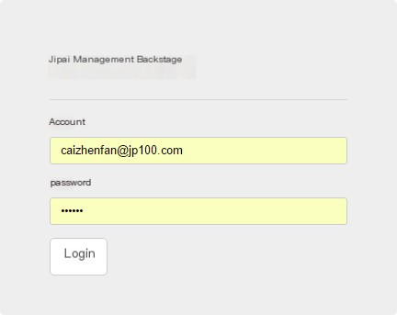
Figure 5.1 Login Interface

The core code implementation for user login is as follows:
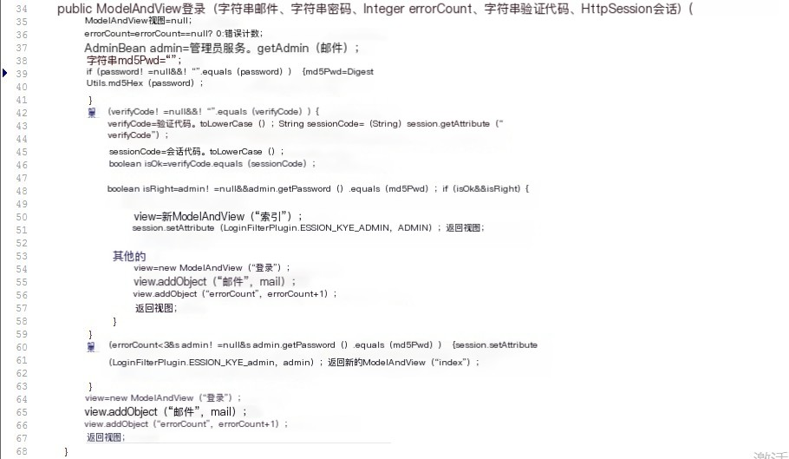

Implementation of Product Management Module

Administrators can add products, list and remove products, recommend and cancel recommendations, delete products, edit product information, and query products based on different conditions in the product management function.

Product Management

1) Add products. Adding products involves two major steps: editing basic information and editing product details. The basic information includes the following content: product title, category, country, price, product main image, inventory level, product number, and product introduction. Product details can be added with a header, and images can be added later.
2) Search criteria: Product ID, Product Title, Category, Country.
3) Product list items: Product ID, Product title, Product main image, Country, Price, Category, Inventory, Status, Operation. The operations include editing, listing (for products in the warehouse), delisting (for products for sale), recommending, and deleting.
Figure 5.2 shows the interface of product management.

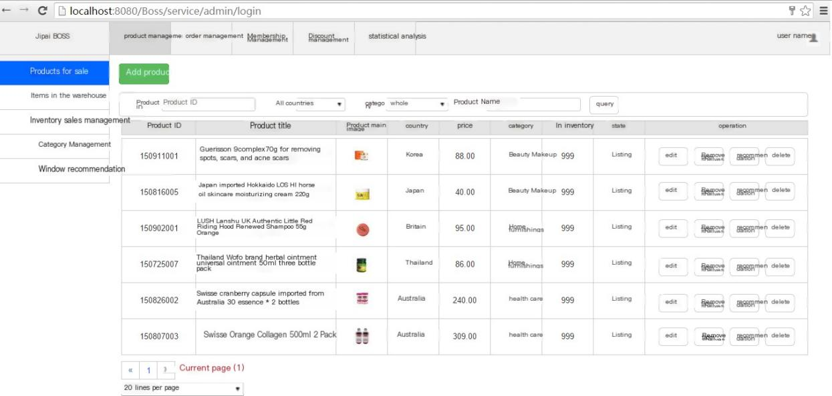

Figure 5.2 Product Management Interface
Adding and editing products are the same method edit(), which determines whether the administrator clicks the edit button or the add product button by checking whether the passed in product ID parameter is empty. The returned view is a ModelAndView. The key code is as follows:
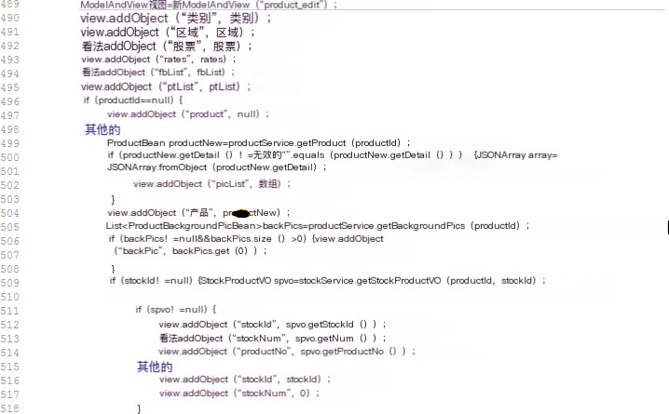
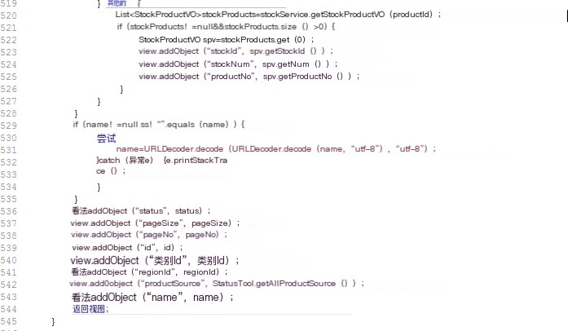

And other functions, such as listing and delisting, are achieved by setting the product's status. If the status is 1, it will be listed, and if the status is 0, it will be delisted. The listed products are displayed in the list of products for sale, while the delisted products are displayed in the list of products in the warehouse.

Category management

Administrators can classify each product and add categories to the category management, including category name, category sorting, and category introduction. The query criteria include category number and category name. Figure 5.3 shows the interface for category management.
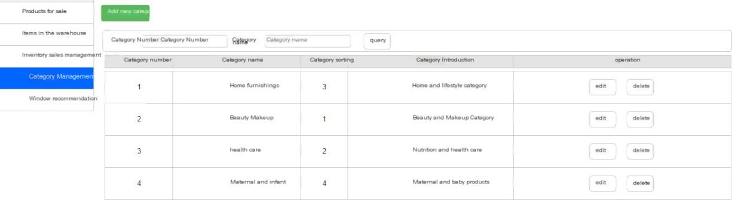

Figure 5.3 Category Management Interface
Just like adding product features, adding new categories and editing categories are also the same method
EditCategory() also returns a ModelAndView view. Control class by calling
The getCategory() method of the baseDataService class continues to call the getCategory (id) in baseDao
Perform operations on the database using SQL statements in. The key code is as follows:
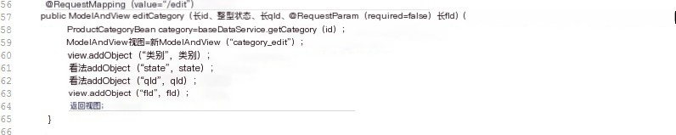

Inventory management

Administrators can modify product inventory, including displaying inventory quantity, displaying sales volume, actual inventory, and actual sales volume. Only product ID can be used for querying, and the inventory management interface is shown in Figure 5.4.

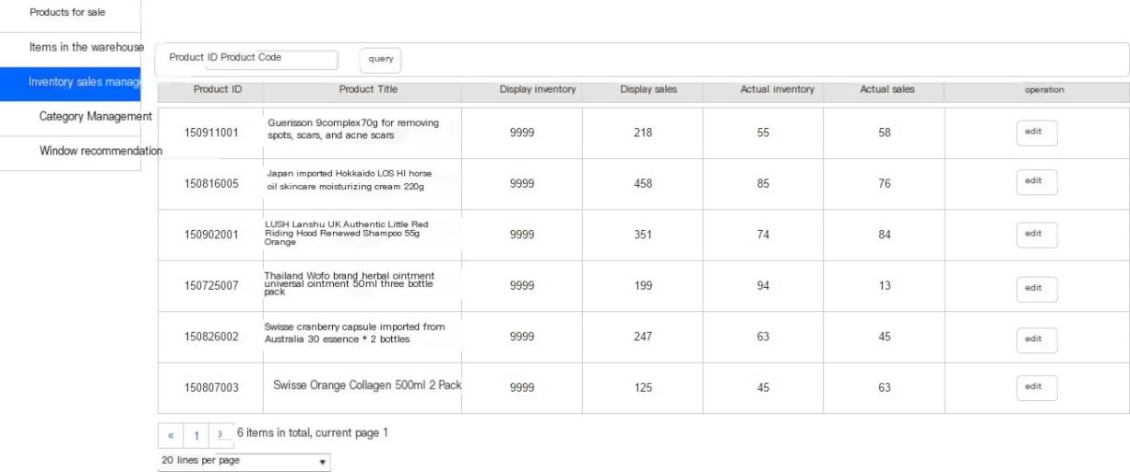
Figure 5.4 Inventory Management Interface

The inventory editing interface is shown in Figure 5.5.
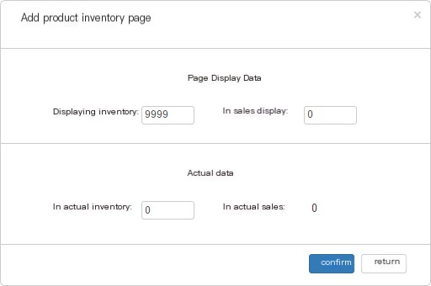

Figure 5.5 Edit Inventory Interface

Window recommendation

The recommended products in the window are those placed on the homepage of the front-end of the mall. Clicking "Recommend" on the products for sale will enter the recommended product list in the window. You can cancel the recommendation, increase the weight, decrease the weight, and modify the weight of the recommended products. The window recommendation interface is shown in Figure 5.6.

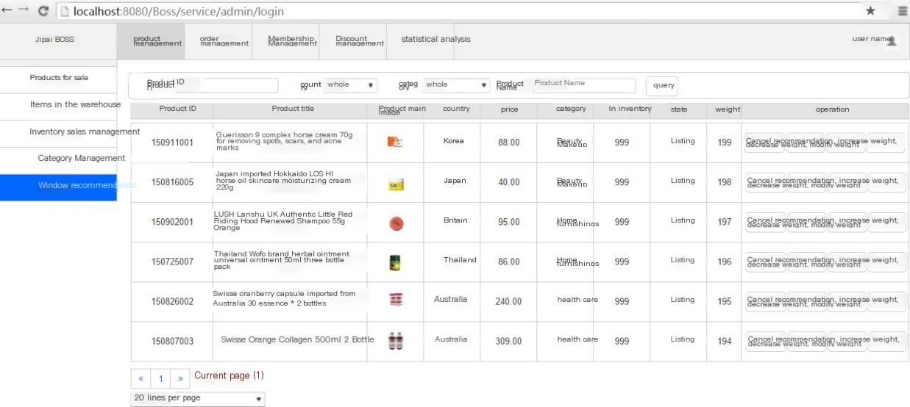

Figure 5.6 Window Recommendation Interface
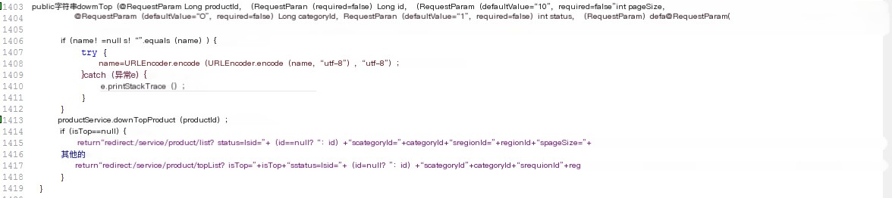
Cancel the recommendation to call the downTop() method. The core code is as follows:
Increase and decrease weights by 1 each time, while modifying weights allows for arbitrary weight settings.
Increase the weight and call the upWeight() method. The core code is as follows:
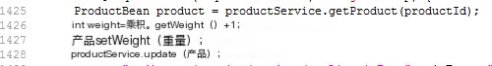
Reduce the weight and call the downWeight() method. The core code is as follows:
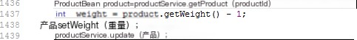
Modify the weight and call the updateWeight() method. The core code is as follows:


Implementation of Order Management Module

    - Order Management

Order management, as the most important functional module of this system, includes order information such as date, order number, product title, main image, purchase quantity, unit price, actual paid price, coupon amount used, phone number, recipient name, WeChat nickname, transaction status (order confirmed, distribution in progress, logistics delivery in progress, transaction ended), payment time, and tracking number. Clicking on the order number can also view the user's receiving information.
The query criteria for orders include: mobile phone number, recipient name, nickname, order number, order placement time, and order transaction status. As shown in Table 5.1.
Table 5.1 Order Transaction Status

Transaction status | Optional operations
Order confirmed (to be paid) | Cancel order, confirm payment, modify payment amount
In distribution | Select the courier and fill in the tracking number to confirm that it has been shipped
Logistics in transit | Modify the courier and tracking number, confirm that the shipment has been made
Transaction closed | exception handling
The order management interface is shown in Figure 5.7.
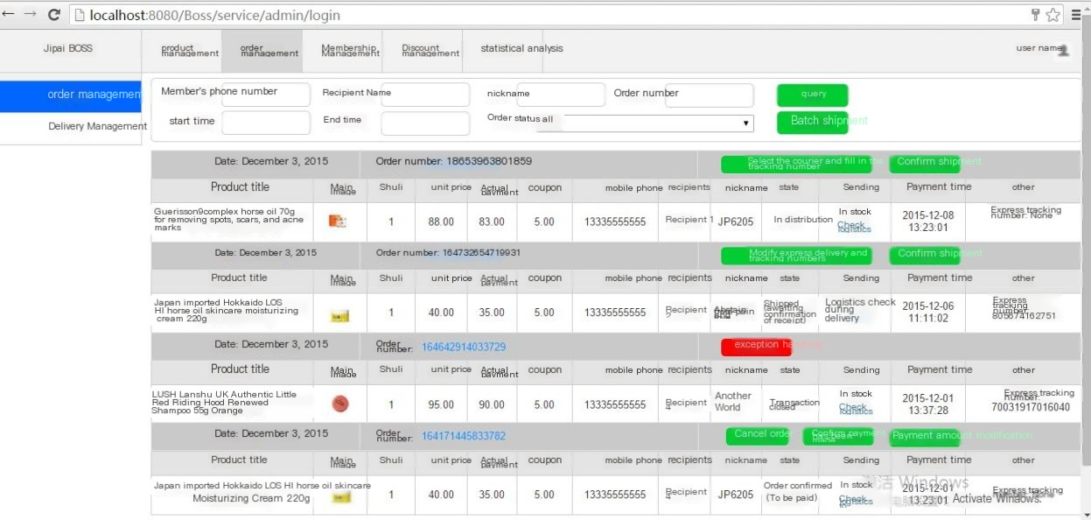
Figure 5.7 Order Management Interface
Click "Select the courier and fill in the tracking number" to pop up a window. After filling in, click "Confirm" and the courier tracking number will be displayed in the order list, as shown in Figure 5.8.

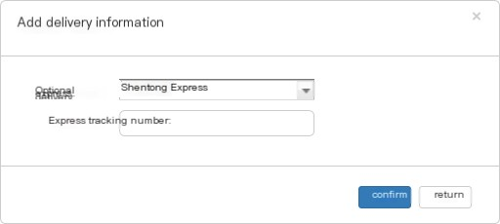

Figure 5.8: Interface for selecting a courier and filling in the tracking number
Click on the order number to enter the recipient's receiving information, as shown in Figure 5.9.
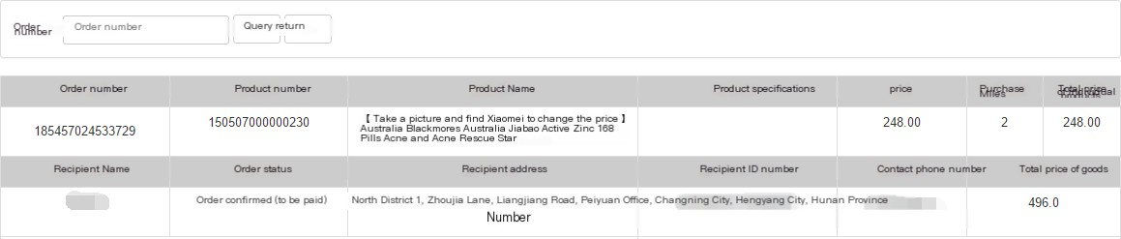
Figure 5.9 Receiver Information Interface
Move the mouse to "Check Logistics" to view logistics information, as shown in Figure 5.10.
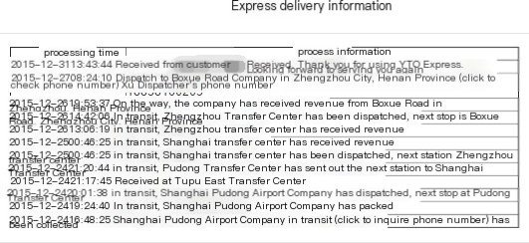

Figure 5.10 Logistics Information Interface

Shipment Management

Shipment management is a function that lists orders in the distribution system, aimed at helping administrators export orders that have not yet been shipped. Administrators can export orders that need to be shipped in an Excel spreadsheet. You can also ship in bulk and import an Excel spreadsheet. The delivery management interface is shown in Figure 5.11.

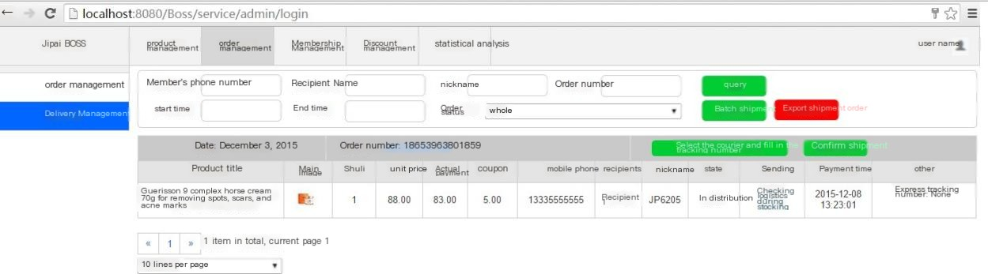

Figure 5.11 Delivery Management Interface

Implementation of Membership Management Module

Due to the two methods of user registration from mobile phone number and direct login through WeChat, when a user logs in directly through WeChat, the UnionID mechanism of WeChat is used to obtain the user's OpenID to determine whether they are a WeChat user. And obtain basic user information, including nickname, avatar, gender, city, language, and following time.
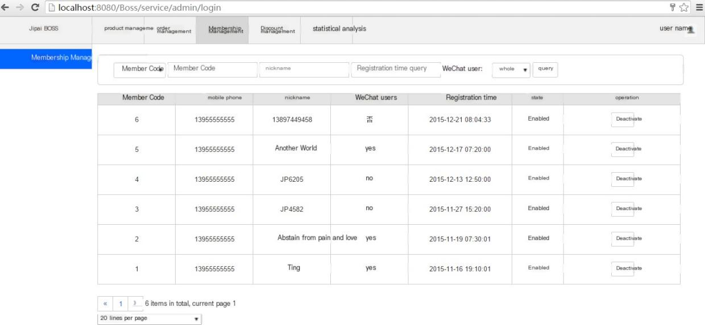
Members can be queried based on their ID, registered phone number, nickname, registration time, and whether they are WeChat users. The member management interface is shown in Figure 5.12.
Figure 5.12 Member Management Interface

The key core code is as follows:
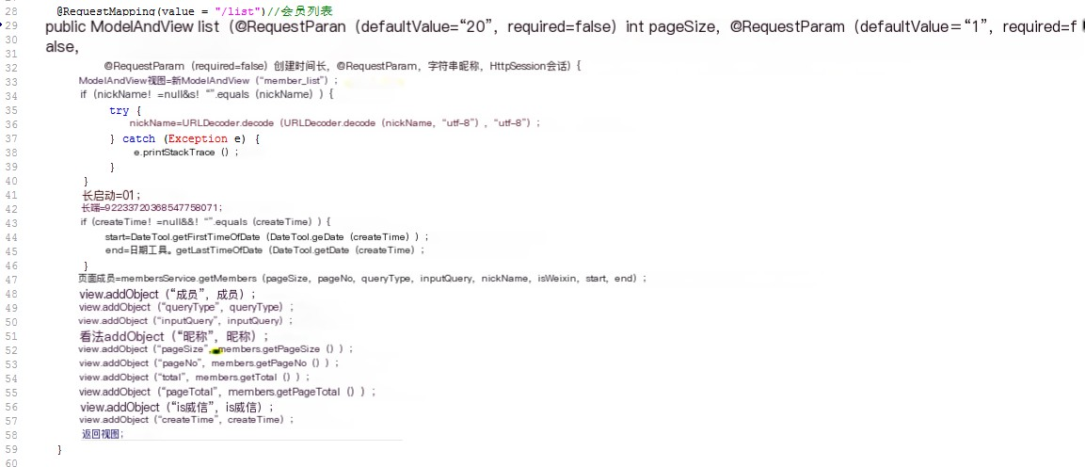

Implementation of discount management module

Administrators can create coupons and directly send them to users for modification and deletion. At the same time, users can also view their coupons and their usage status. Coupons can also be divided into large split coupons, universal coupons, administrator allocated coupons, and other types.

Coupon Management

Coupon types: large split coupon, universal coupon, administrator allocated coupon.
When sending coupons directly, a member list will pop up, select the recipient, and click "Send" to proceed. The coupon management interface is shown in Figure 5.13.
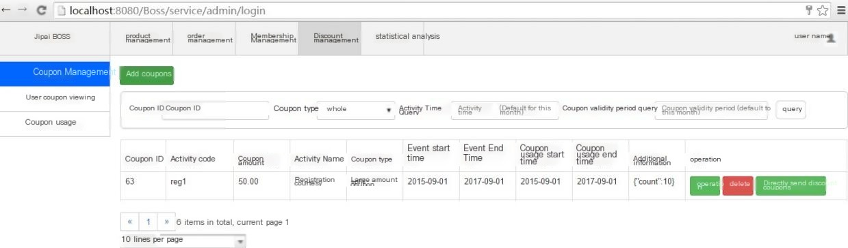

Figure 5.13 Coupon Management Interface
The interface for adding coupons is shown in Figure 5.14.

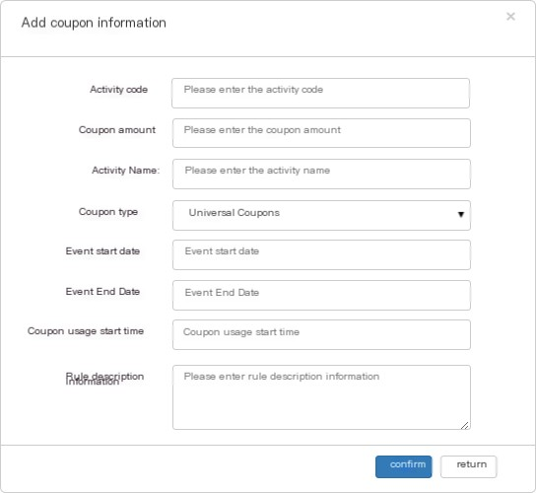

Figure 5.14 Add Coupon Interface
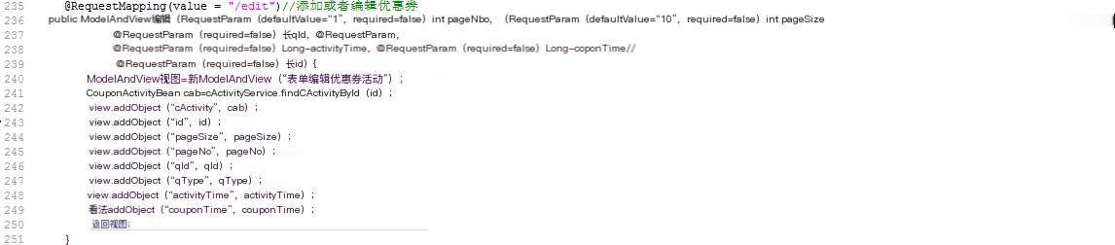
Add/Edit Coupon: Call the edit() method in the CouponActivityController class to determine whether to add or edit the coupon based on whether the coupon ID is empty. The core code is as follows:

To send coupons to users, it is necessary to obtain the activity ID of the couponActivity. Sending coupons is to add the data to the coupon table.

User coupon viewing

To view user coupons, you need to first obtain a list of user information, which can be queried based on conditions. Retrieve the user list by calling the list() method in the CouponActivityController class, which is consistent with the method used in section 5.4 to obtain the member list. The user coupon viewing interface is shown in Figure 5.15.

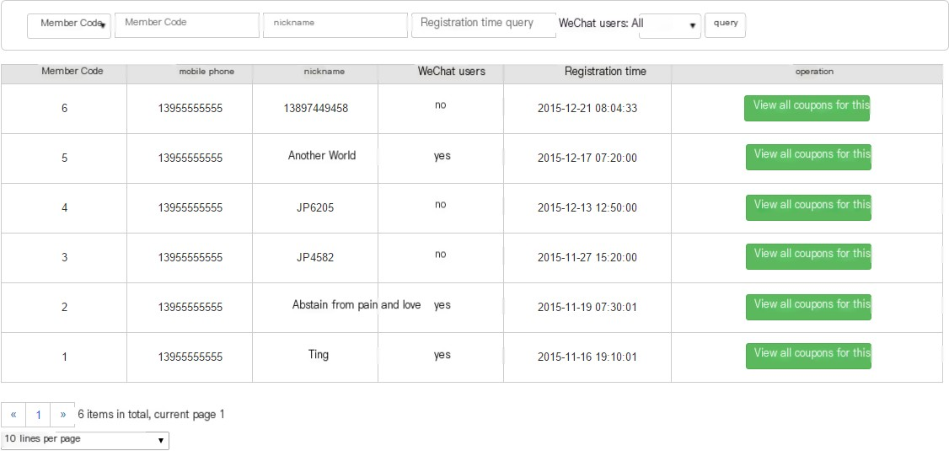

Figure 5.15 User Coupon Viewing Interface
View user coupons and call the checkCoupon() method in the CouponActivityController class. The core code is as follows:
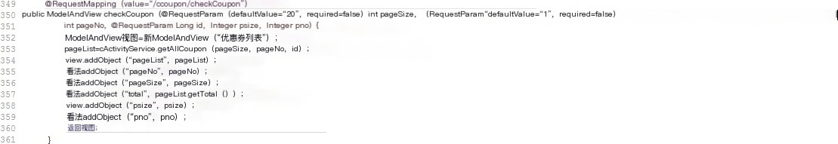

Coupon usage

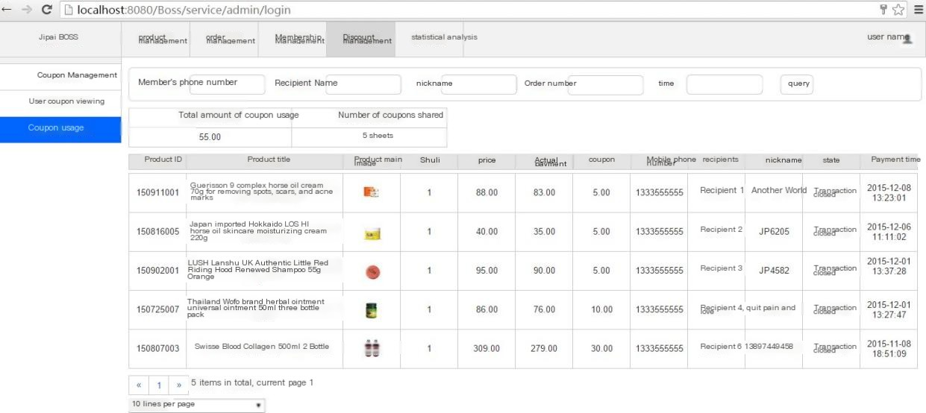
The usage of coupons defaults to the current month. You can search based on different conditions, including member phone number, recipient name, nickname, order number, month, and other conditions. Simultaneously count the total amount and number of coupons used for the month. The coupon usage interface is shown in Figure 5.16.

Figure 5.16 Coupon Usage Interface

Call the statisticsList() method in the CouponActivityController class to determine the usage of coupons. First, determine the time of the month, then obtain the recipient's name and WeChat nickname, and finally obtain a list of coupons used by the user. At the same time, calculate the amount of shared coupons used. The core code is as follows:
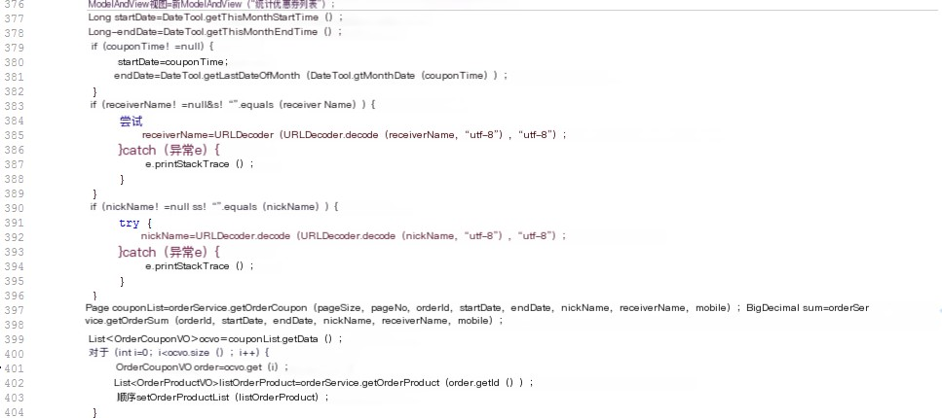

Implementation of statistical analysis module

    - Sales Data Report

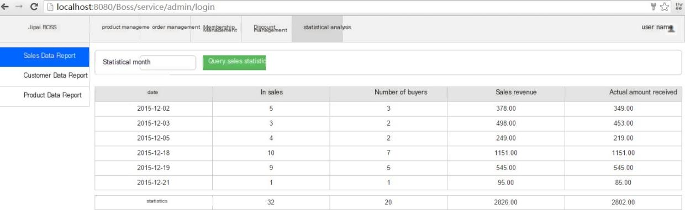
The sales data report defaults to statistics of the current month's sales data, including daily sales volume, number of buyers, sales revenue, and actual received amount. Finally, calculate the total sales volume, total number of buyers, total sales revenue, and total actual received amount from the current month to the current day. The sales data report interface is shown in Figure 5.17.

Figure 5.17 Sales Data Report

Obtain sales data statistics from the database, with the core code as follows:
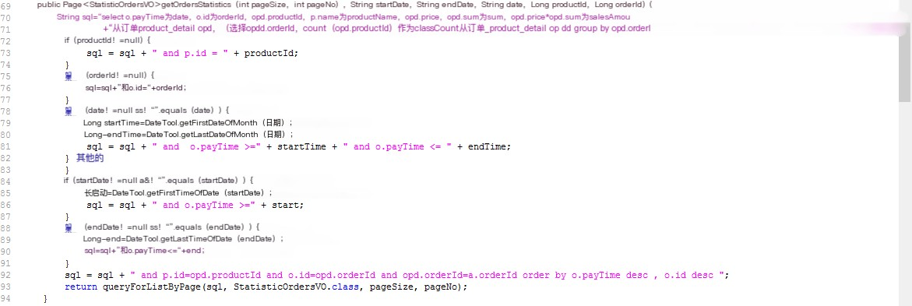

Customer Data Report

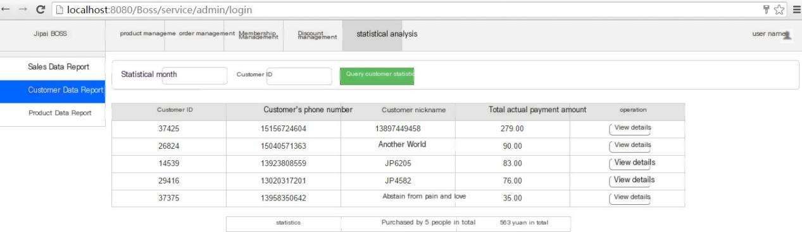
Customer data is actually the total amount spent by users who have purchased products each month. Click "View Details" to view the specific purchase date and amount of the user. The customer sales report interface is shown in Figure 5.18.

Figure 5.18 Customer Data Report Interface
Obtain customer data statistics from the database, with the core code as follows:
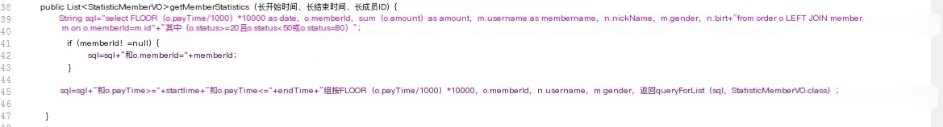

Product Data Report

Product data report, which tracks the sales performance of a single product over a certain period of time. Simultaneously record all sales records of all products throughout their history. By filtering query criteria, individual product sales can be viewed

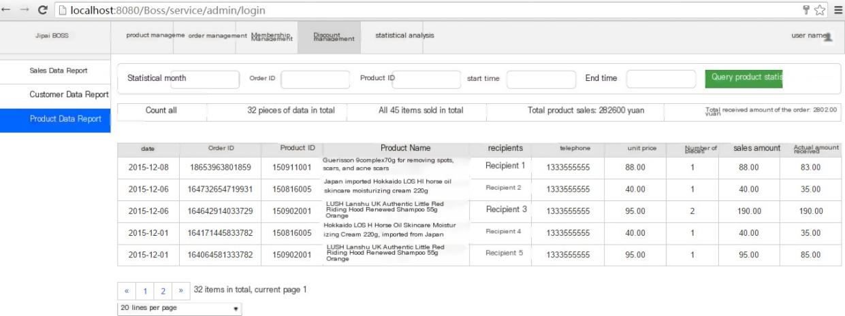

Figure 5.19 Product Data Report Interface
Obtain product data statistics from the database, with the core code as follows
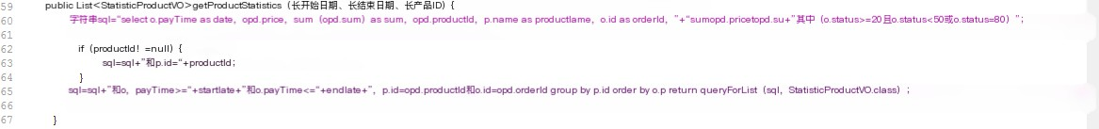

Revised system interface display

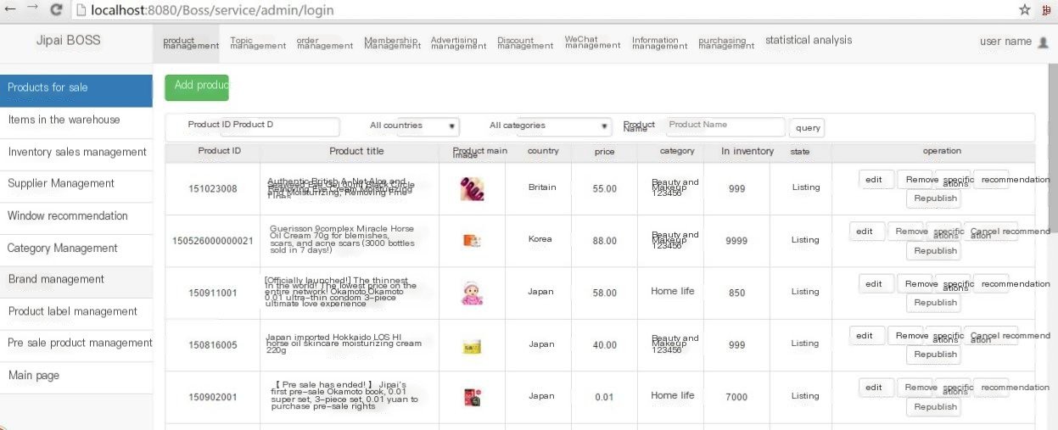
With the increase of demand, the functions of the backend management system are constantly enriched, and the development of subsequent versions has been laid the groundwork during requirement analysis and system design. Due to the limited length of the paper, only partial interfaces can be displayed. The new version of the backend management system has added many functions, including thematic management derived from requirement analysis, advertising management, WeChat management, information management, and procurement management. The revised system interface is shown in Figure 5.20.

Figure 5.20 Revised backend management system interface

Summary of this chapter

The interface implementation of the backend management system for Jipai Mall is the main content of this chapter and the core focus of this article. The system is mainly based on the system requirements analysis in Chapter 3 and the detailed design and programming implementation of each layer in Chapter 4. This article mainly elaborates on the interface display and some core codes of the six major functions implemented in the backend management system. It includes six functional modules: login management, product management, order management, membership management, discount management, and statistical analysis management. At the same time, a brief presentation and explanation were provided for versions of the backend management system after 1.0.

Chapter 6 Detailed Design and Implementation of Frontend Mall Platform

Due to the limited length of the paper, the key codes and implementation interfaces for the detailed design of the front-end mall are not provided one by one. The display details of the front-end mall page can be found at www.jp100.com.

Implementation of User Login/Registration Module

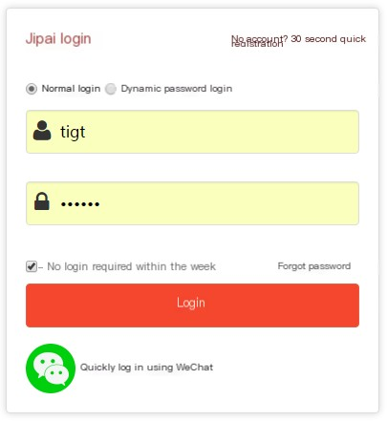
Users can choose three login methods: regular login, dynamic password login, and WeChat login. For regular login, simply enter your account and password. For dynamic password login, you can send a password to your phone number to log in. For WeChat login, you need to scan the QR code of Jipai Mall to log in. The login interface is shown in Figure 6.1
Figure 6.1 User Login Interface
Users need to fill in their phone number, verification code, SMS verification code, and two passwords to register. The system needs to check if the two password inputs are consistent, and if they are not consistent, an error message will be displayed. You can also skip registration and log in using WeChat. The registration interface is shown in Figure 6.2.

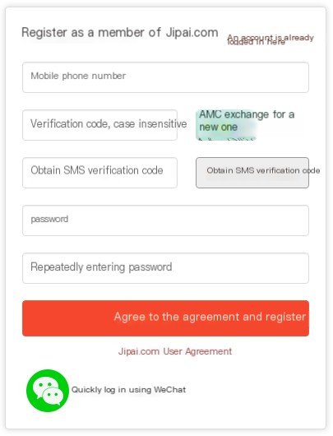

Figure 6.2 User Registration Interface

Implementation of product display logic module

The products displayed on the homepage of the mall are the recommended products. The recommended products include background images, and clicking on the product will enter the product details. The product details include the title, abstract, product details, and reviews (the review function is not included in this paper). The product details are all images. The recommended product list page on the homepage is shown in Figure 6.3. yield
The product details page is shown in Figures 6.4 and 6.5.

Figure 6.3 Homepage Recommended Product List Page

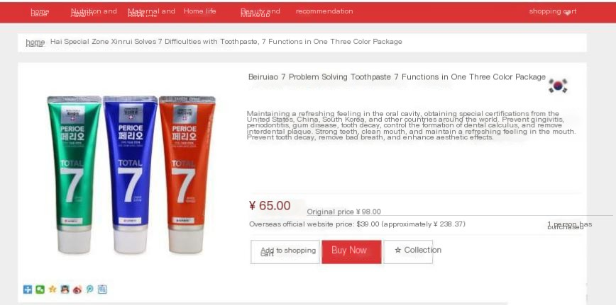


Figure 6.4 Product Details Page (1)
Figure 6.5 Product Details Page (2)

Product classification module implementation

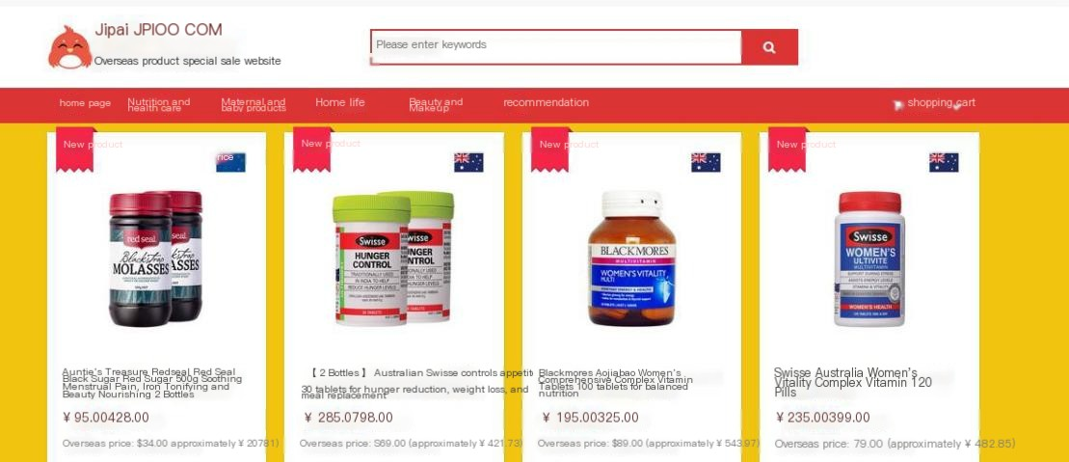
After categorizing each product in the backend, clicking on the corresponding category in the front-end mall will display the corresponding products to users in a list format. The product classification interface is shown in Figure 6.6.
Figure 6.6 Product Classification Interface

Implementation of the ordering process module

Order process: Select product ->Add to cart ->Go to checkout ->Select shipping address ->Confirm transaction ->Payment ->Payment successful.
The shopping cart page is shown in Figure 6.7.
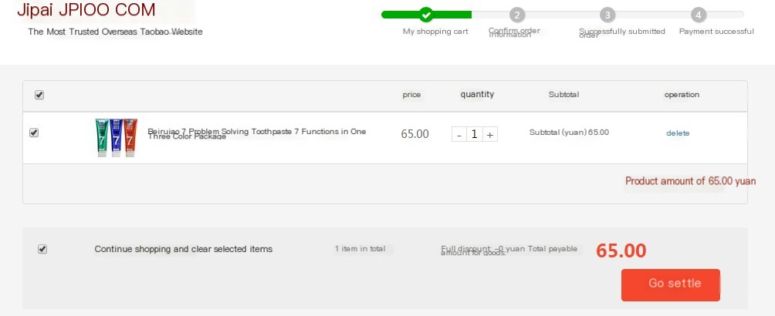
Figure 6.7 Shopping Cart Interface
The confirmation of receipt information page is shown in Figure 6.8.
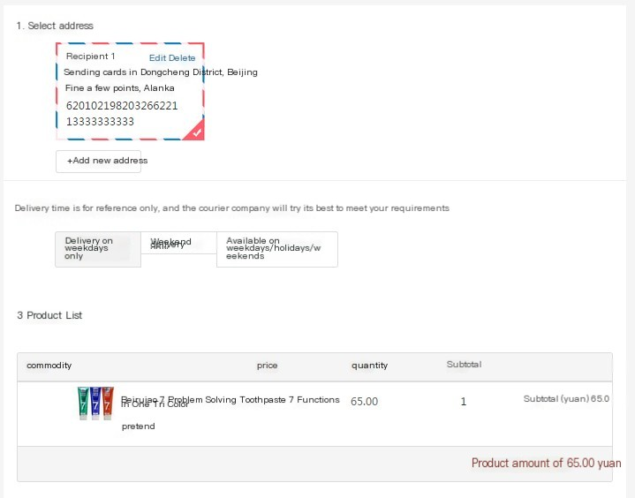
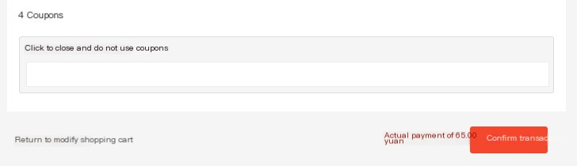

Figure 6.8 Confirmation of Receipt Information Interface

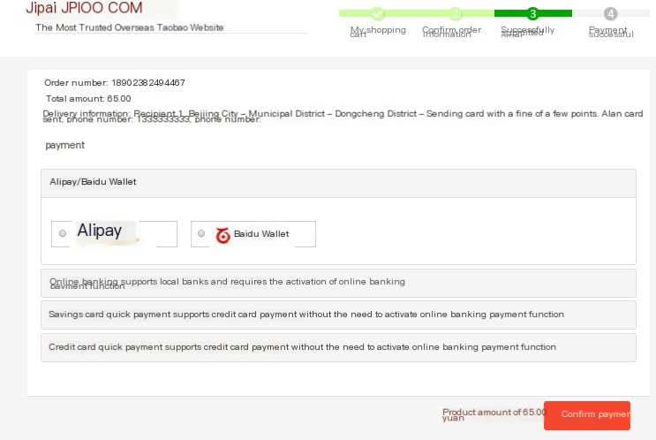
The confirmation transaction interface is shown in Figure 6.9.
Figure 6.9 Confirmation Transaction Interface

Implementation of Personal Center Module

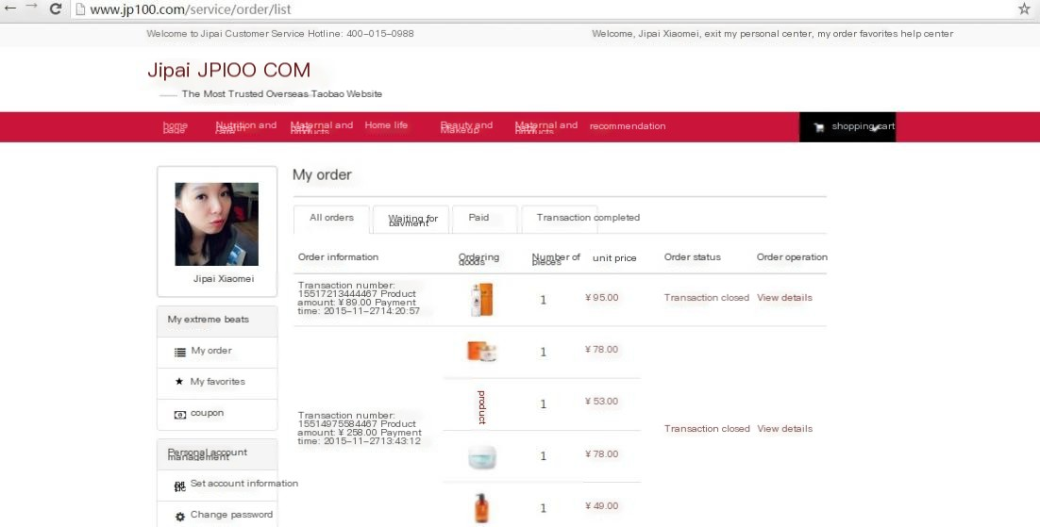
My personal center includes my extreme photos and personal account management. My extreme photos include my orders and coupons; Personal account management includes setting account information, changing passwords, and managing shipping addresses. Order types include: All Orders, Pending Payment, Paid, and Transaction Completed. The personal center page is shown in Figure 6.10.

Figure 6.10 Personal Center Page

WAP interface display

With the popularity of smart phones and WeChat, mobile Internet will become the mainstream in the future. WAP end shopping malls are particularly important. Users can register or place orders for purchases on both PC and WAP platforms through the backend management system. Due to limited space, only some pages on the WAP side will be displayed. WAP homepage&dedicated

The question page is shown in Figure 6.11, and the WAP search page and WAP product list page are respectively shown in Figure 6.12.
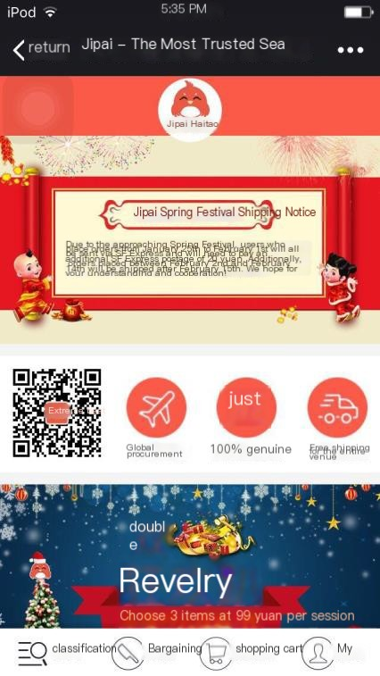

Figure 6.11 WAP Homepage&WAP Topic Page

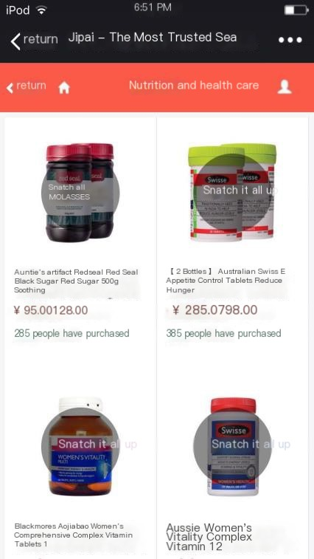
Figure 6.12 WAP search page&WAP product list page
In the backend management system, advertising images can be added to the WAP homepage, and WAP themed images can also be added. Each themed product has associated products, which can be obtained from the product list. User clicks on thematic map

Enter the special product list page. At the same time, the bottom menu can also search by product name and view products under that category by product category.

Summary of this chapter

The implementation of the front-end interface of Jipai Mall is the main content of this chapter. The system is mainly based on the system requirements analysis in Chapter 3 and the detailed design and programming implementation of each layer in Chapter 4. Mainly elaborated on the interface display of the five major functional modules implemented in the front-end mall. Includes 5 major functional modules: user login/registration, product display logic, product classification, ordering process, and personal center. At the same time, a brief display of the interface of the WAP end mall was provided.

Chapter 7 Summary and Outlook

7.1 Summary

As the hottest emerging market in 2015, overseas e-commerce has great development prospects. How to help overseas e-commerce users better complete overseas product shopping on the platform, improve the supply chain, enhance the entire shopping process experience, and enable users to easily obtain globally selected products without leaving their homes is what all cross-border e-commerce needs to do. In the development of the entire Jipai Mall, this article first analyzes the future market prospects of cross-border e-commerce, and at the same time, analyzes the functional requirements of cross-border e-commerce platforms, selects the required development technologies, uses MySQL database, MVC design mode, and J2EE development language. Through rigorous paper work planning, the platform developed in this article has undergone sufficient system design based on requirement analysis, and ultimately fully implemented the first version of the platform. This article mainly completed the following work:
1、 This article provides a certain explanation of the current global market and domestic development status of cross-border e-commerce, and clarifies the practical value and significance of the work in this article.
2、 A detailed introduction was given to the relevant technologies currently adopted by mainstream e-commerce platforms, a brief analysis was conducted on the advantages and disadvantages of various technologies, and the reasons for ultimately choosing the technology to be adopted were given.
3、 A detailed requirement analysis was conducted on the backend management system and front-end mall platform involved in this article, and corresponding functional lists and overall business process diagrams were listed.
4、 Through a detailed requirement analysis and a list of features, a detailed system design was carried out for the backend management system and front-end mall platform of the entire mall, including design objectives, system use case models, domain model designs, database designs, etc. A good foundation was also laid for the design of later versions.
5、 On the basis of requirement analysis and system design, various functional modules of the backend management system and front-end mall platform were implemented, and the interfaces of each function were displayed, as well as some functional module interfaces on the WAP end.

7.2 Outlook

Due to the temporary development and implementation of version 1.0 and later versions of Jipai Mall in this paper, we aim to increase user stickiness to the platform, enjoy more interesting shopping, improve delivery speed, and improve the supply chain

Therefore, more requirement analysis and iterative development are needed. Although the paper has analyzed and designed some new features, it is far from enough and has not been developed. Therefore, in future work, there are mainly the following ideas for the platform:
1、 Design and develop more interesting marketing features, such as check-in, lottery, membership level, bargaining, and other marketing activities.
2、 Design a process that allows users to browse and shop more effectively, such as adding themes and tags to products, and adding search functionality on the front-end.
3、 Enhance user stickiness to the platform, such as reverse bidding, premium guessing, and other modes.
4、 Improving the supply chain and integrating the backend management system with the bonded zone delivery system can enable faster delivery and shorten the waiting time for users to receive goods.

References

[1] Wang Wailian, Wang Mingyu, Liu Shuzhen. Analysis and Suggestions on the Current Situation of Cross border E-commerce in China [J], E-commerce. 2013, (9): 23-24
[2] Lv Nanfang (2015). Chinese consumers' overseas shopping expenses have increased sixfold [DB/OL], 2015-12-10
[3] Airui Consulting. 2014 China Cross border E-commerce Industry Research Report [R]. Beijing: Airui Consulting, 2015 [4] Amazon China 2015 Cross border E-commerce Trends Report [R] Beijing: Amazon China, 2015 [5] Zhongyan.com. Analysis of the Development Status of Global Cross border E-commerce Market [DB/OL]. Beijing: Industry Research in China
Net, 2014-7-10
[6] China E-commerce Research Center. Detailed Explanation on the Development Status and Regulation of Global Cross border E-commerce [DB/OL]. Beijing: China Outsourcing Network, 2015-9-5
[7] China E-commerce Research Center. 2013 Global Cross border E-commerce Report [R]. Beijing: China E-commerce Research Network, 2014-7-4
[8] Zhongyanwang. Analysis of the Development Status of Global Cross border E-commerce Market [DB/OL]. Beijing: China Industry Research Network, 2014-7-10
[9] Zheng Xiaying. Current Development Trends and Main Platform Development Strategies of Cross border E-commerce in China [D], China E-commerce Network, 2015
[10] China E-commerce Research Center. Analysis: Current Status, Trends, and Countermeasures of Cross border E-commerce Development in China [R], North
Beijing: China E-commerce Research Network, 2015 [11] Notice of the General Office of the State Council on Implementing Policy Opinions on Supporting Retail Exports of Cross border E-commerce
[R] Beijing: General Office of the State Council, 2013 (No. 89) [12] Guiding Opinions of the General Office of the State Council on Promoting the Healthy and Rapid Development of Cross border E-commerce [R], Beijing:
General Office of the State Council, 2015 (No. 46) [13] Zi Meng, Lin Haoran, Tong Lan. Policy dividends released, ushering in the golden age of cross-border e-commerce - cross-border e-commerce
Industry Special Report [R]. Shanghai: Guotai Junan Research Institute, 2015
[14] China E-commerce Research Center. Analysis: Current Situation, Trends, and Countermeasures of Cross border E-commerce Development in China [R]. Beijing: China E-commerce Research Network, 2015
[15] Li Shujie, Li Zhigang B/S three-layer architecture pattern [J]. Journal of Hebei University of Technology,
2002.05:25-28,34

[16] Yu Chunfeng, Chen Gang. Application of Multilayer Distributed Structure Based on B/S [J]. Computer and Modernization,
2002,11:52,57
[17] BOE Common Technologies for E-commerce Website Construction [R]. BOE, 2014-2-13:11
- John Hunt, Chris Loftus. Proficient in J2EE Java enterprise applications [M]. Beijing: Tsinghua University Press, 2004
- Stephen Walther ASP NET 2.0 Reveals [M] Beijing: People's Posts and Telecommunications Publishing House, 2007 [20] Gao Xiuyun Development of FCS System Graphical Control Configuration Software and WEB Release [D]. Shandong University, 2013
Hong Ling, Han Chengbing Application of Java related technologies in e-commerce systems [J]. Modernization of shopping malls. 2009 (3)
[22] Bear water is gentle Design and Implementation of a Mobile Learning Platform Based on Android System [D]. Beijing: Beijing University of Posts and Telecommunications, 2012
[23] Sun Lei Research and Application of MVC Design Pattern [D]. Shaanxi: Xi'an University of Electronic Science and Technology, 2007
[24] Yu Zhanlin, Li Zhongqiu, Ren Yongchang SSH Framework Implementation of MVC Architecture for E-commerce Software Platform [J] Computer Technology and Development. 2012 (10)
[25] Cbuck Musciano, Bll Kennedy HTML&XHTML: The Definitive Guide [M]
Beijing: Tsinghua University Press, 2007 [26] W3school Introduction to CSS http://www.w3school.com.cn/css/css_intro.asp [27] Jeremy Keith JavaScript DOM Programming Art [M] Beijing: People's Posts and Telecommunications Publishing House, 2007
Mixi Peak, Fan Kaiyuan Research on the Application of Java Applet in Network Courseware Development [J] Journal of Heze Normal College, 2003 (5)
Flanagan Javascript Authoritative Guide [M]. Beijing: Machinery Industry Press, 2007
Feng Zhenxing Research on the Application of Ajax Technology in Web Systems [D] Beijing: Beijing Forestry University, 2008
[31] Wen Yongping. Development of an e-commerce website based on JSP [J] Information Security and Technology, 2011 (11)
[32] Brilliance. tomcat Authoritative Guide [M] Beijing: China Electric Power Press, 2009 Anonymous IBM WebSphereSMash Featured as Sugar Forge Project of the
Month [J] Wireless News, 2008
- Anonymous BEA announced BEA WebLogic Server 10 Availability [J]
Wireless News, 2008, pp.n/a
- Anonymous Atsec information security; JBoss Enterprise Application Platform Accepted for Common Criteria Evaluation [J] Computer Technology Journal, 2008

[36] Yan Shuanghe. Design and Implementation of Degree Information Management System Master's and Doctoral Subsystems [D]. Jilin University, 2015 [37] Wang Junhong. Design and Implementation of Enterprise Financial Management Information System [D]. Jilin University, 2015
Yue Fuqiang, Luo Yingming, Han De, Qin Guang SQL Server 2005: From Introduction to Practice [M]. Beijing: Tsinghua University Press, 2009
Dong Jiying, Yan Zhiwei, Liang Zhengyu Comparison of SQLite, MySQL, and PostgreSQL relational database management systems [J] Database and Information Management, 2014 (14)
[40] Luzhou; Han Yaokun. Research and Implementation of a General E-commerce Platform Based on Struts2 [J]. Computer Programming Skills and Maintenance, 2012 (22): 61-62
[41] Yan Tan. Building a Vehicle Management System Based on Java EE [J] Journal of Hainan Radio and Television University, 2010 (04)
[42] Han Shuang. Design and Implementation of Student Information Management System [D]. Tianjin Normal University, 2015
[43] Duan Yuanzhi. Database Design Methods [J]. Jiangxi: Journal of Nanchang Institute of Education, 2005 (12)

Thanks

Thanks

In the blink of an eye, three years of graduate life are coming to an end. The teachers and senior brothers in the entire computational intelligence laboratory have provided me with too much help in the past three years, especially my supervisor Wang Zhe and supervisor Xu Hao. In the process of writing the paper, from the opening of the topic to the provision of reference materials, to the overall structure and development process of the paper, many problems encountered cannot be separated from the careful guidance of Wang Zhe and Xu Hao. Here, on behalf of myself, I would like to express my sincere gratitude to the two teachers!
In addition, I would like to express my gratitude to my colleagues in the company for their selfless assistance during the internship, especially in terms of feature implementation. The development colleagues provided great assistance, and without your help, the functions mentioned in the paper would not have been able to be implemented on time. Thank you for helping me successfully complete my studies.
At the same time, I would like to express my gratitude to Jilin University for providing me with intangible value education during my seven years of study, and to the leaders and their loved ones for their continuous support.
Finally, thank you to the reviewing teacher. Thank you for taking the time out of your busy schedule to review my paper. Thank you!

